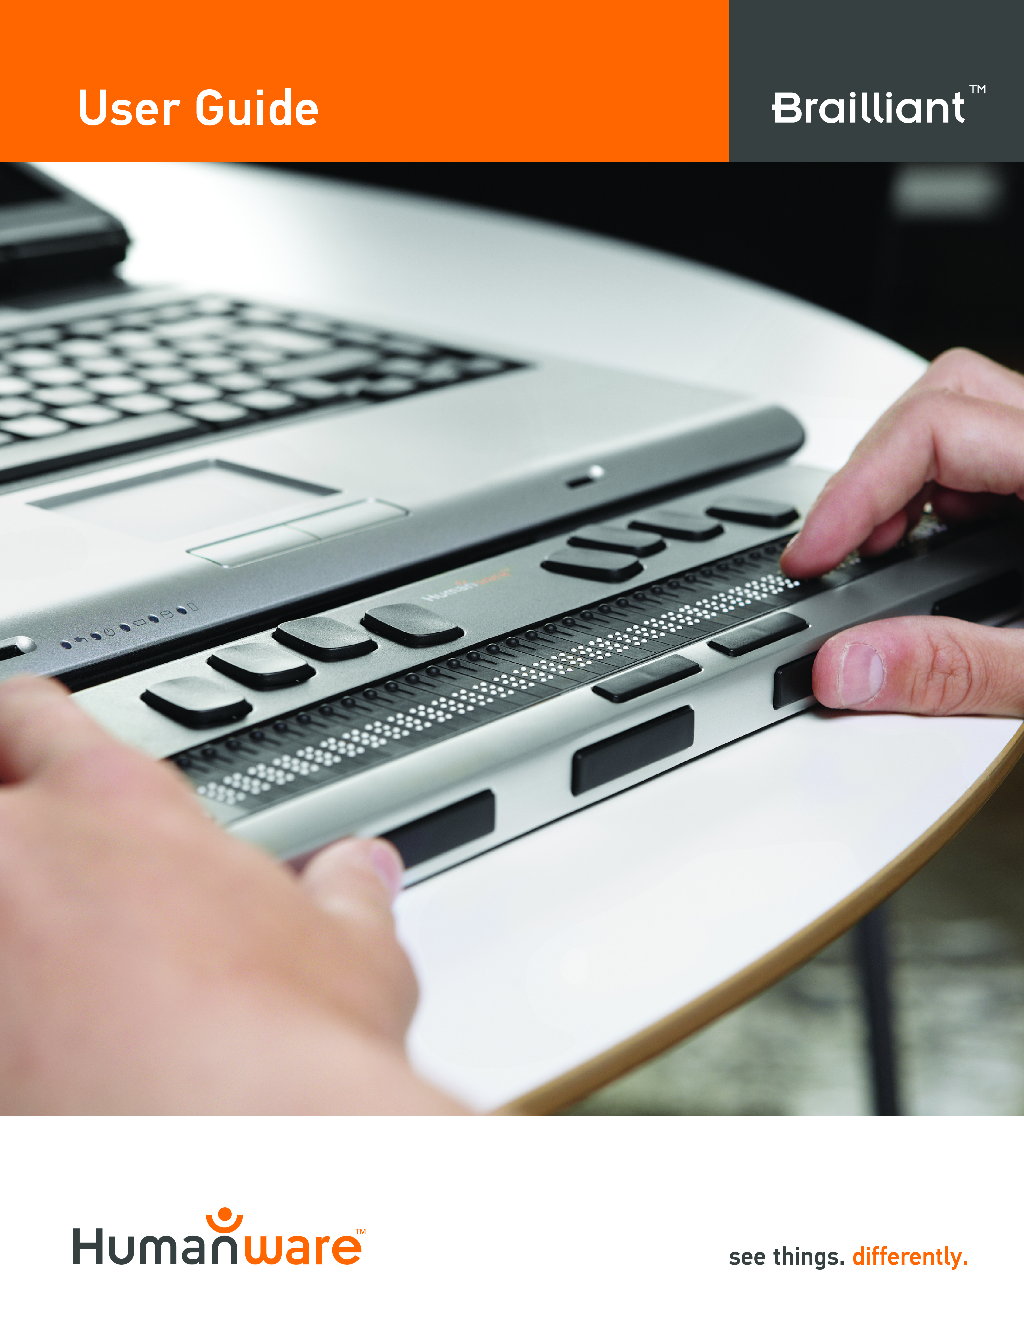

Brailliant
BI 32 - BI 40 - B 80
User Guide by HumanWare

Version 8, 2014-07-30

End user License Agreement
By using this product (Brailliant) you agree to the following minimum terms.
      - License Grant. HumanWare grants to End User a non-exclusive, non-transferable right and license to use the Software on this product.
      - Ownership of Software. End User acknowledges that HumanWare retain all right, title and interest in and to the original, and any copies, of software which is incorporated into this product. End User agrees not to: modify, port, translate, decompile, disassemble, reverse engineer, or make public in any way the software of this Product.

©Copyright 2011. All rights reserved, Technologies HumanWare Inc.
This manual is protected by copyright belonging to Technologies HumanWare Inc., with all rights reserved. According to copyright law, the manual may not be copied in whole or in part, without written consent from Technologies HumanWare Inc.

Every effort has been made to ensure that the information contained in this publication is correct at the time of issue. Neither Technologies HumanWare Inc. or its subsidiaries HumanWare USA Inc., HumanWare Europe Limited, or HumanWare Australia Pty Limited, nor its agents, assume any responsibility for errors or omissions. Nor is any liability assumed for damages resulting from the use of the information contained herein.

Important Safety Instructions
Follow all warnings, cautions, and instructions marked on the product.
Carefully read the instructions described in this user guide prior to using the Brailliant.
Only use or store the Brailliant on stable and solid surfaces.
Keep away from water or high humidity. Do not submerge.
Only use cables provided with the Brailliant.
The power supply cord is a disconnect device for pluggable equipment. The socket-outlet should be installed near the equipment, and be easily accessible.
This product should be operated from the type of power indicated on the marking label. If you are not sure of the type of power available, consult your dealer or local power company.
Refer all servicing of this product to qualified service personnel. Do not attempt to service it yourself, as opening or removing covers may expose you to dangerous voltage points or other risks.
The above exclamation point within an equilateral triangle is intended to inform the user to the presence of important operating and maintenance (servicing) instructions in the literature accompanying the appliance.

Electromagnetic compatibility: The use of accessories and cables other than those specified by HumanWare may result in increased emissions or decreased immunity of the Brailliant.
Placement of equipment: The Brailliant should not be used stacked with other equipment.
FCC, IC and CSA label location
The FCC, IC and CSA logos and number are located under the device.
FCC Warning
This equipment has been tested and found to comply with the limits for a Class B digital device, pursuant to part 15 of the FCC Rules. These limits are designed to provide reasonable protection against harmful interference in a residential installation. This equipment generates and can radiate radio frequency energy and, if not installed and used in accordance with the instructions, may cause harmful interference to radio communications. However, there is no guarantee that interference will not occur in a particular installation. If this equipment does cause harmful interference to radio or television reception, which can be det ermined by turning the equipment off and on, the user is encouraged to try to correct the interference by one or more of the following measures:
—Reorient or relocate the receiving antenna.
—Increase the separation between the equipment and receiver.
—Connect the equipment into an outlet on a circuit different from that to which the receiver is connected.
—Consult the dealer or an experienced radio/TV technician for help.
Notice for Canada
This Class B digital apparatus meets all requirements of the Canadian Interference-Causing Equipment regulations.
Disposal
At the end of the life of the Brailliant, its internal components must be disposed in compliance with the local authorities.
The Brailliant contains no hazardous materials. For disposal, return to HumanWare or follow local governing ordinances or hospital procedure.
Environmental
Operating Temperature 10 to 40º C
Transport & Storage Temperature -20 to 60º C
Operating Humidity 20% to 80% (RH)
Transport & Storage Humidity 10% to 95% (RH)
Operating Altitude -200 to 2000 m
Transport & Storage Altitude -200 to 12 000 m
Transport & Storage Barometric Pressure 70-103 kPa

Table of Contents
1. Overview of Brailliant 1
1.1 Introduction 1
1.2 Unpacking the Brailliant 1
1.3 Physical Description 1
1.4 Charging the Battery 3
1.5 Powering On/Off Brailliant 3
2. Brailliant Installation and connectivity 4
2.1 Interface Ports 4
2.2 Connecting to a PC or Notebook 5
2.3 Pairing Brailliant with a mobile phone 6
3. Menu 6
3.1 Model 7
3.2 Battery Level 7
3.3 Channel (toggle) 7
3.4 Serial Number 7
3.5 Firmware 8
3.6 Auto Power Off (toggle) 8
3.7 USB Charge (toggle) 8
3.8 Sound (toggle) 8
3.9 Bluetooth Name 9
3.10 Bluetooth PIN 9
3.11 Protocol (toggle) 9
3.12 Braille Test (activation) 9
3.13 Restore Default Settings (activation) 10
3.14 Braille Keyboard (Toggle) 10
4. Technical Specifications 11
5. Manufacturer Warranty 12
6. Customer support 12

Overview of Brailliant

Introduction
Congratulations on your purchase of the Brailliant, the new Braille display from HumanWare. There are three different models available: the BI 32 and BI 40 models have, respectively, a 32-cell and a 40-cell Braille display, and a Braille keyboard. The B 80 model has an 80-cell Braille display but no Braille keyboard.

Unpacking the Brailliant
The package contains the following items:
- Brailliant unit
- USB cable
- AC adaptor
- Companion CD
- Documentation
- Carrying case (BI 32 and BI 40 models only)

Physical Description
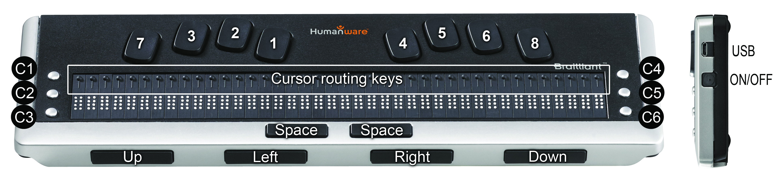
Figure 1: Brailliant 40
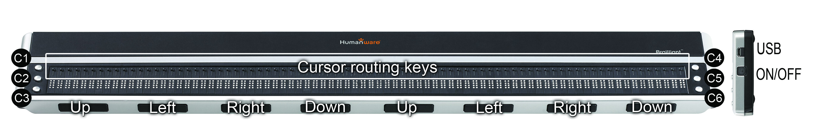
Figure 2: Brailliant 80

Brailliant models include the following features:
Top surface
Braille display
The Braille display is located on the top surface, near the front. Depending on the model you have, the Braille display will be comprised of 32, 40, or 80 Braille cells. Behind each Braille cell is a small button known as the cursor routing key.

Command keys
The Command keys can be found on either side of the Braille display, three to the left and three to the right. On the left, starting from the back, are C1, C2 and C3, which is the one nearest you. On the right side, you will find C4, C5 and C6 nearest you.

Braille Keyboard (not on Brailliant 80)
The 8 keys of Braille Keyboard are located above the Braille display. The left-hand key is called BACKSPACE, or sometimes dot 7, and the right-hand key is called ENTER, or dot 8. The two Space bars are located in the middle, just below the Braille display. Both behave as normal space bars.
The Braille keyboard and command keys can be used to type Braille or perform commands. The commands depend on the screen reader used.

Front Edge
Thumb keys
The keys facing you are normally operated by your thumbs so we call them "Thumb keys" to differentiate them from the main keyboard keys. The Brailliant 32 and 40 models both have 4 thumb keys, while the Brailliant 80 has 8.These thumb keys are used in conjunction with the Braille display when reading and navigating. They can be operated using your thumbs without moving your fingers from the Braille display.

The thumb keys are named as follows: UP, LEFT, RIGHT and DOWN. Note that the B 80 model has 2 sets of thumb keys. UP and DOWN are used to navigate by line, LEFT and RIGHT are used to move left or right by display length.

Right Edge
Power button
The Power button is slightly recessed and is located near the middle on the right edge. To turn the device on or off, press and hold this button for approximately 1 second. Brailliant will confirm power on and off with a beep.

Micro USB port
At the rear corner, next to the Power button, you will find the rectangular plug for the USB. Use the cable that came with your Braille display to connect via USB to a PC. You can also charge the Brailliant's battery through USB.

Note: Functionality of Brailliant keys depends on the screen reader used.

IMPORTANT: Before connecting the Brailliant to your computer, be sure to install the USB driver included on the Brailliant Companion CD. Depending on the screen reader you are using, the installation of an additional driver may be required. After performing the driver installation, you should connect the device to the PC to charge the battery. You can use your Brailliant while charging the battery.

Charging the Battery
IMPORTANT: Prior to first use, you must charge the device for minimum of 8 hours without use. After first use, it will take 4 hours to fully charge the battery.
Brailliant has a built-in rechargeable Lithium Ion battery. To charge the battery, connect Brailliant via USB to your PC or AC adaptor. Battery life of your Notebook will not be affected significantly as the current used is very low. Brailliant beeps when connected to power. You can use the Brailliant while charging. You can view the battery status in the internal menu. Once fully charged, the Brailliant is ready for 20 hours of continuous operation on Bluetooth.

You can also use any universal USB AC adapter to charge the Brailliant. Just insert the USB cable rectangular connector in the adapter’s USB plug and insert the micro USB in the small plug into the USB socket on the right side of Brailliant and plug the adapter into an AC outlet.

Connecting the AC adapter or the USB cable attached to your computer while the device is turned off will wake it up and "Charging…" will be displayed. It will switch off again when charged completely.

Please fully charge your Braille display before the first use.

Brailliant's battery management system includes a battery protection circuitry that prevents it from being damaged by total discharge. If the battery is low, Brailliant will warn you by beeping before it switches off automatically. If you cannot charge the battery at that time, the device will automatically switch off in a few minutes.

Never try to replace the battery yourself. This will likely damage the device and void the warranty. If your device is in need of repair, please contact your local dealer or HumanWare.

Powering On/Off Brailliant
Holding the Power button for approximately 1 second will turn on/off the device. A beep will be heard.

When holding the Power button for approximately 10 seconds the device will reset.
If there is no action on the device (no communication with the PC and no user action on the buttons) the device will turn off after the "auto-power-off" period expires. This counter/period will reset every time data is received from the PC or a user action occurs.

If the device is turned off and the USB cable is plugged in, the device will wake up. If the battery is low, charging will start.

Brailliant Installation and connectivity

Interface Ports
Depending on the operating system, you can connect Brailliant via various interfaces to your PC. Use the USB port to communicate with PCs or Notebooks or the built-in Bluetooth interface for your mobile devices. If you use USB to connect to a Notebook or PC, the Brailliant battery will be recharged in the process.

USB Port
USB connectivity is supported by Windows computers (32 and 64 bits)

Plug the rectangular USB Connector into your PC. Plug the small Micro USB Plug at the other end of the USB cable into the Brailliant USB port. This is the small rectangular socket on the left side.

Please install the Brailliant device drivers prior to connecting the Braille display to your PC. You will find the drivers on the installation CD.
Then, when you connect Brailliant for the first time, it will be recognized automatically.

Once the Brailliant has been connected to the USB port and the driver installed from the CD supplied, the Braille display will be connected as if it was connected to a serial port; the driver is simulating a so-called virtual serial port. This has the advantage that Brailliant can be used with screen readers that can only support serial Braille displays.

Installing this driver means that one USB port on the computer will be perceived as a serial port, e.g. as COM3. To ascertain which virtual COM-port has been created, go to the Start menu on the PC, select Settings > Control Panel > System; on the 'Hardware' tab select 'Device manager' and look through the list of ports.

If using JAWS, set the USB channel to Auto and install the JAWS driver.

Bluetooth Interface
Bluetooth is a wireless connection. Similar to USB, Bluetooth simulates a virtual COM port.

Wireless technology, along with Brailliant's long battery life, provide total freedom and independence from wires within the range of a Bluetooth connection. Bluetooth is now a common interface for mobile phones, PDAs and Notebook PCs. PCs can be upgraded with Bluetooth using a so-called Bluetooth USB Dongle which installs automatically on Windows 7, VISTA, XP Service Pack 2 and above when plugged in.

When two Bluetooth devices are connected for the first time, they have to be "paired". This is for security reasons. The devices exchange a PIN code. Later, the devices will recognize each other automatically, if allowed by the user.

In the Bluetooth environment of a PC you will find Brailliant as:
Brailliant

The Bluetooth Name can be modified by the user in the Internal menu of the unit.

The Bluetooth PIN that has to be sent to the Brailliant is 1111.

The Bluetooth device class is Display.

Connecting to a PC or Notebook
Brailliant can be used as a Braille display with popular PC screen readers such as JAWS, Window-Eyes, etc. The PC or Notebook must provide either USB or a wireless Bluetooth interface (built-in or by using a USB Bluetooth dongle). We recommend Windows 7, VISTA, and XP Service Pack 2 for Bluetooth because they automatically detect and install Bluetooth hardware.

How to find out which virtual serial port is provided by a Bluetooth or USB interface in Windows:

- Open Control Panel (Start/Settings/Control Panel)
- Select “System” from the list
- In the Window now opening, select the tab "Hardware"
- On this tab, click on "Device manager"
- In the Device manager's tree view, open the branch "Ports (COM and LPT)"
- Search for something similar to "standard serial over Bluetooth port (COM 13)". There may be more of these. Take note of the number after the COM.
- This number is the number of the virtual COM port the device is connected to. The screen reader wants to know this port.

On Bluetooth you will see two ports, one outgoing and one incoming. The outgoing port is the one we want to use to connect.
When connected using Bluetooth, the serial port used by your device may also be found in the Properties of your connected device in the Bluetooth Manager.

Some screen readers do not support higher values of COM Ports. In that case you may want to change the port number. Do this by selecting the "Port (COM and LPT)" branch in Device manager as described above, and right-click on the Port you want to change (Shift F10 will do the same). The context menu opens and you can click on "Properties". Then click on the tab "Port settings" and click on the "Advanced" button. In the Window now opening is a List Box "COM Port Number" where you can choose a free port number. Numbers not available will be marked.

JAWS
A JAWS driver is included on the Brailliant installation CD. The latest version can be downloaded from our website's support section:
www.humanware.com

Installation instructions are included in the driver package.

Window-Eyes
Window-Eyes supports Brailliant with its own driver. Please find the latest version of Window-Eyes at:
www.gwmicro.com

Other Screen Readers
Brailliant is compatible with other screen readers. Please consult our website's support page for additional information: http://www.humanware.com

Pairing Brailliant with a mobile phone
The Brailliant can be paired with mobile phones as a Bluetooth Braille display. The pairing has to be initialized from the phone, just as you would to pair with any other keyboard or Bluetooth device.

For more information, refer to your mobile phone screen reader user guide.

Menu
The Brailliant’s Menu is activated when the unit is powered on. The menu has two modes. When first powered on, the menu is in a basic, read-only mode providing basic information about the device. No settings can be changed when the unit is in this mode. To toggle to the advanced menu, where settings can be changed, double tap the power button. A low tone will be heard indicating that the mode has been changed. Double tap the power button a second time to clear the display and switch back to using a connected computer or smart phone. At any time, while using the Brailliant with another device, simply double tap the power button to re-enter the menu.
While in the menus, use the UP / DOWN thumb keys to navigate the menu. The LEFT and RIGHT thumb keys are used to perform various actions depending on the type of menu. There are 4 different types of menu items:

Read only: System provides information that cannot be modified.

Toggle: Allows you to toggle settings using the LEFT and RIGHT thumb keys.

Activation: Allows you to activate an action. The LEFT and RIGHT thumb keys are used to perform the action.
Text: Text menu item can be edited by pressing the cursor key above the cell. The LEFT and RIGHT thumb keys cancel text edition.

Model
This option displays device model information.
HumanWare Brailliant BI 32
HumanWare Brailliant BI 40
HumanWare Brailliant B 80

⡓⠥⠍⠁⠝⡺⠁⠗⠑⠀⡃⠗⠁⠊⠇⠇⠊⠁⠝⠞ ⡃⡊⠀⠲⠴

Battery Level
This option displays battery charge information.
Battery Level: 80%
⡃⠁⠞⠞⠑⠗⠽⠀⡇⠑⠧⠑⠇⠱ ⠦⠴⠩

Channel (toggle)
This option allows you to select the communication channel used to communicate with your computer. Options include: Automatic, USB and Bluetooth.
Channel: auto
⡉⠓⠁⠝⠝⠑⠇⠱⠀⠁⠥⠞⠕

Serial Number
This option displays the device's serial number.
Serial Number: xx-xxxx-xxxxxx
⡎⠑⠗⠊⠁⠇⠀⡝⠥⠍⠃⠑⠗⠱
⠭⠭⠤⠭⠭⠭⠭⠤⠭⠭⠭⠭⠭⠭

Firmware
This option displays the device's firmware version.
Firmware: x.y.z
⡋⠊⠗⠍⠺⠁⠗⠑⠱ ⠭⠨⠽⠨⠵

Auto Power Off (toggle)
This option allows you to set an idle time limit before the unit powers down. You may select from the following settings: Disabled, 5 minutes, 15 minutes, 30 minutes, 1 hour.
Auto Power Off: 15 min
⡁⠥⠞⠕⠀⡏⠕⠺⠑⠗⠀⡕⠋⠋⠱ ⠂⠢⠀⠍⠊⠝

USB Charge (toggle)
This option allows you to determine if USB charging is permitted. You may want to set this option to OFF if you are connected to a laptop running low on battery power.
USB Charge: on
⡥⡎⡃⠀⡉⠓⠁⠗⠛⠑⠱ ⠕⠝

Sound (toggle)
This option allows you to set whether the device can emit sounds.
Sound: on
⡎⠕⠥⠝⠙⠱ ⠕⠝

Bluetooth Name
This option allows you to display and modify the Bluetooth name of the device.
Bluetooth Name: Brailliant
⡃⠇⠥⠑⠞⠕⠕⠞⠓⠀⡝⠁⠍⠑⠱

⡃⠗⠁⠊⠇⠇⠊⠁⠝⠞

Bluetooth PIN
This option displays the Bluetooth PIN used for pairing with other devices.
Bluetooth PIN: 1111
⡃⠇⠥⠑⠞⠕⠕⠞⠓⠀⡏⡊⡝⠱ ⠂ ⠂ ⠂ ⠂

Protocol (toggle)
This option allows you to select the active communication protocol. Settings include: HumanWare and OpenBraille.
Protocol: HumanWare
⡏⠗⠕⠞⠕⠉⠕⠇⠱ ⡓⠥⠍⠁⠝⡺⠁⠗⠑

Braille Test (activation)
This option allows you to activate the Braille display test procedure.
The test will perform the following actions.
⡃⠗⠁⠊⠇⠇⠑ ⡞⠑⠎⠞

Line test: 10 iterations of the following
- All cells activate only dots 1 and 4
- All cells activate only dots 2 and 5
- All cells activate only dots 3 and 6
- All cells activate only dots 7 and 8

Column test: 4 iterations of the following
- Activate only dots 1,2,3 and 7 on each cell individually
- Activate only dots 4,5,6 and 8 on each cell individually

All test: 1 of the following
- Activate all dots
- Deactivate all dots
- Activate all dots
These tests will loop until you exit the menu or move to a different menu item.

Restore Default Settings (activation)
This option allows you to restore the unit to default settings. The default settings are as follows:
⡗⠑⠎⠞⠕⠗⠑ ⡙⠑⠋⠁⠥⠇⠞ ⡎⠑⠞⠞⠊⠝⠛⠎
Channel: Auto
⡉⠓⠁⠝⠝⠑⠇⠱ ⠁⠥⠞⠕
Protocol: HumanWare
⡏⠗⠕⠞⠕⠉⠕⠇⠱ ⡓⠥⠍⠁⠝⡺⠁⠗⠑
Auto Power Off: disabled
⡁⠥⠞⠕⠀⡏⠕⠺⠑⠗⠀⡕⠋⠋⠱ ⠙⠊⠎⠁⠃⠇⠑⠙
USB Charge: on
⡥⡎⡃⠀⡉⠓⠁⠗⠛⠑⠱ ⠕⠝
Sound: on
⡎⠕⠥⠝⠙⠱ ⠕⠝
Bluetooth Name: Brailliant
⡃⠇⠥⠑⠞⠕⠕⠞⠓⠀⡝⠁⠍⠑⠱

⡃⠗⠁⠊⠇⠇⠊⠁⠝⠞
Bluetooth PIN: 1111
⡃⠇⠥⠑⠞⠕⠕⠞⠓⠀⡏⡊⡝⠱ ⠂ ⠂ ⠂ ⠂

Braille Keyboard (Toggle)

Technical Specifications
Navigation components
4 Thumb keys (8 on B 80 model)
6 Command keys
8-key Braille keyboard (on BI 32 and BI 40 models only)
2 Space bars (on BI 32 and BI 40 models only)
Cursor routing keys
32, 40 or 80 Braille cells depending on model

Long-life battery
Lasts up to 20 hours with Bluetooth
Recharges from PC through USB port
Auto-shut off
Lithium-ion polymer battery
Compatible with any standard USB A/C adapter
Capacity: 1000mAh
Voltage rating: 3.7V

Connectivity
USB 2.0
Bluetooth V2.1 + EDR Class 2

Portability
BI 32: 26 x 8.7 x 1.8 cm / 524 g
(10.2’’ x 3.4’’x 0.7'' / 1.15 lbs)

BI 40: 31 x 8.7 x 1.8 cm / 650 g
(12.2'' x 3.4'' x 0.7'' / 1.43 lbs)

B 80: 56.5 x 7.8 x 1.8 cm / 1070 g
(22.3'' x 3.1'' x 0.7'' / 2.35 lbs)

Compatibility
Windows computers (32 and 64 bits)
JAWS 10 and later, Window-Eyes 7.5.2 and other screen readers
Apple products with iOS 5 and VoiceOver (MAC, iPhone, iPad, iPod Touch)

Manufacturer Warranty

This device is a high quality product, built and packaged with care. All units and components are guaranteed against any operational defects for 2 years for all countries.

Warranty covers all parts (except battery) and labor. If any defect should occur, please contact your local distributor or the manufacturer technical assistance line.
Note: Warranty terms may periodically change, please consult our website for the latest information.

Conditions and Limitations:
Please keep your bill of purchase in a safe place as it may be required for a warranty repair or replacement. Please retain your original. If the unit has to be returned, please use the original packaging. This warranty applies to all cases where the damage is not a result of improper use, mistreatment, negligence or acts of God.

North America: In addition to the warranty, you can also purchase a Service Contract to prolong coverage for one year and also benefit from the cleaning service. Please refer to our web site: http://www.humanware.com/
Or contact us by E-mail at us.info@humanware.com or call 1(800) 722-3393

Customer support
For customer support, please contact the HumanWare office nearest you or view our web site at: www.humanware.com

North America: 1(800) 722-3393 or send an email to us.support@humanware.com
Europe: (0044) 1933 415800 or send an email to eu.support@humanware.com
Australia / Asia: (02) 9686 2600 or send an email to au.sales@humanware.com

REV 05

