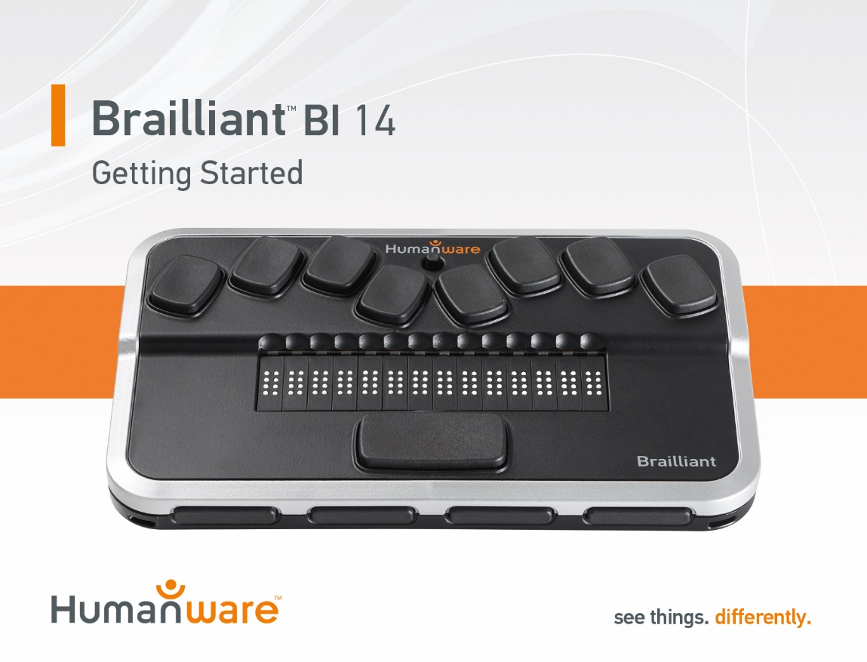

Quick Start Guide
Thank you for purchasing the Brailliant BI 14 braille display. This display combines a comfortable and simple braille display experience with efficient note taking and synchronization.
Prior to using your Brailliant, make sure it is charged completely. Connect the small end of the included micro-USB cable to the port located on the left edge of the Brailliant, just in front of the power button. Plug the larger end of the cable into the included wall charger and plug into the wall. You should see “Charging” on the display. Note you can use other USB wall chargers but charging speeds may be slower.
When charged, you can turn on your Brailliant by holding the power button located on the left edge of the device, just behind the charging port, for 3 seconds. Hold the power button again to turn the device off.
On the front edge of the Brailliant you will find HumanWare’s signature thumb keys. The two outer keys are Previous and Next, navigating you to the previous or next items, and the two inner keys are Left and Right. These inner keys pan the display left or right. Above each of the 14 braille cells are cursor router touch sensors. Simply slide your finger up from a cell to touch the cursor router sensor. You can configure the sensitivity in the settings menu.
Near the braille input keys Dots 1 and 4 you will find the Brailliant’s navigation joystick. Pressing on this joystick selects items.
On the back edge of the device is the mode Switch. With the Brailliant in front of you ready for use, sliding that switch to the right puts the Brailliant in braille Terminal mode and it is ready to be paired with a smartphone or computer. Sliding the switch to the left puts it in Application mode where you can access the Notes and Stopwatch applications.
To pair your Brailliant BI 14 with an iPhone running iOS 10.3 or later, do the following:
You can use the standard Voiceover method. On your Brailliant, make sure the toggle switch is to the right and the unit is on. This ensures the Brailliant is in Terminal mode and ready to be paired with devices. From the home screen, activate Settings, General, Accessibility, Voiceover, and Braille. If Bluetooth is not turned on you will be prompted to do so now. At the bottom of the list you will now find the Brailliant BI 14. Activate it and it will immediately pair.
To take notes on your Brailliant BI 14:
Download the Brailliant Sync app from the App store. Make sure your Bluetooth on your iPhone is turned on. On your home screen, double tap to activate the Brailliant Sync app. Make sure your Brailliant is paired with your phone and double tap “Select Brailliant Device” if one is not found. Double tap on your Brailliant to make sure you are syncing with the correct device. Now, double tap on “Add an account”. Select if you have a Google or other account by double tapping on the appropriate item. Fill in your account info and double tap on the save item in the top right corner of the screen when done.
Slide your switch on the back of the Brailliant to the left to set it to Application mode and use your thumb keys or joystick to navigate to the Notes application. Select your email account and press Space with N (Dots 1-3-4-5), to create a new note. While in the Notes application, the following keyboard shortcuts are available:
New line: Joystick action, Dot 8 (Enter)
Backspace: Space with B, or Dot 7
Previous line: Space with Dot 1, joystick up
Next line (paragraph): Space with Dot 4, joystick down
Previous word: Space with Dot 2
Next word: Space with Dot 5
Previous character: Space with Dot 3, joystick left
Next character: Space with Dot 6, joystick right
Jump to beginning of note: Space with Dots 1-2-3
End of the note: Space with Dots 4-5-6
Save without exiting: Space with S
Save and exit: Space with E
Exit without saving Space with Z
In notes list, delete note Space with D
In notes list, force sync Space with S

For the complete user guide please see the included CD or visit www.humanware.com

Manufacturer Warranty
This device is a high quality product, built and packaged with care. All units and components are guaranteed against any operational defects as follows:
US and Canada: One (1) year
Continental Europe and UK: Two (2) years
Australia and New Zealand: One (1) year
Other countries: One (1) year
Warranty covers all parts (except battery) and labor. If any defect should occur, please contact your local distributor or the manufacturer technical assistance line.
Note: Warranty terms may periodically change, please consult our website for the latest information.
Conditions and Limitations:
No replacement or repair covered by the warranty will be carried out unless the unit is accompanied by a copy of the original bill of purchase. Please retain your original. If the unit has to be returned, please use the original packaging. This warranty applies to all cases where the damage is not a result of improper use, mistreatment, negligence or acts of God.
VER 02-2017-11-15

ACCD-0178
REV 02

