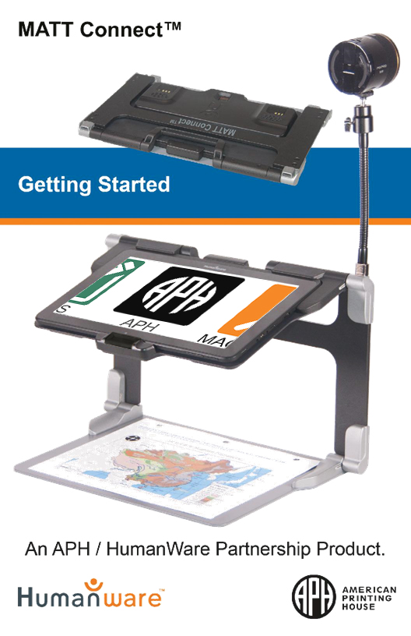

# Getting Started

1. 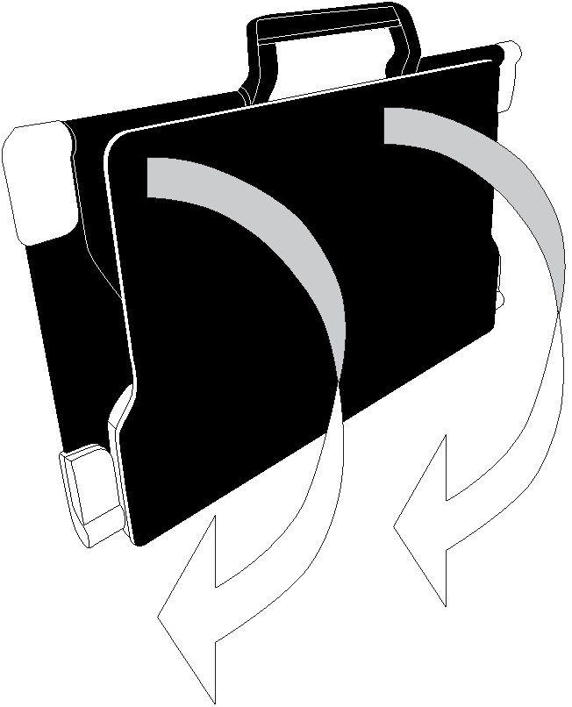On a flat, stable surface, hold your stand upright, ensuring the panel with the word “MATT Connect” faces toward the back. Hold the handle with one hand and unfold the lower panel with the other hand until it is flat on the table.
2. 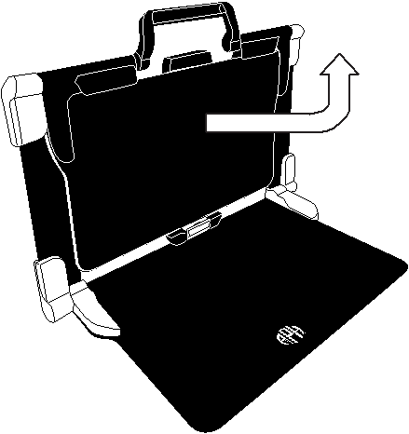Unfold and lift the top panel until it is roughly parallel with the lower panel.
3. 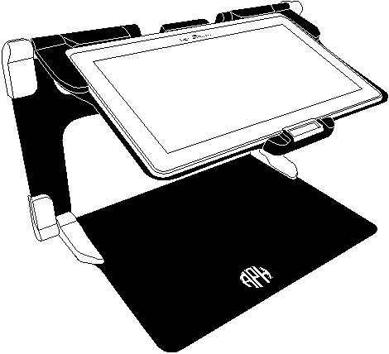tHold your tablet with the screen facing you, ensuring the HumanWare logo is at the top. Carefully insert the top of your tablet into the slot and slide it forward untilyou reach the back end of the slot. Push the bottom part of the tablet down; you will hear a *click* indicating that your tablet is locked into position.
4. Connect the power supply cable to the charging port and plug it into an outlet. The charging port is located on the right side of the tablet. Charge the battery to full capacity. 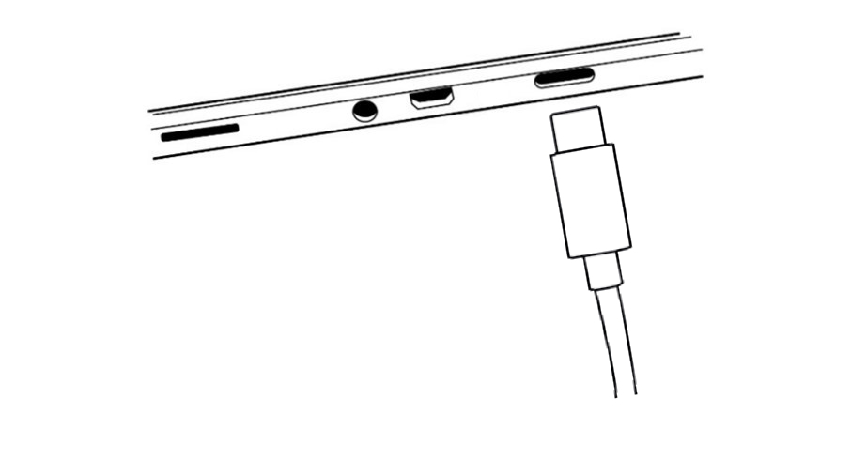

**IMPORTANT:**

* **Only use power adapter and cable supplied with MATT-Connect.**
* **Use caution while inserting the cable into the charging port.**

1. 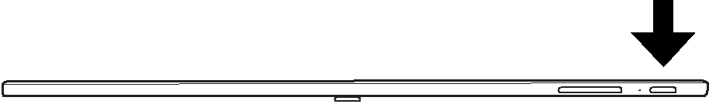Press and hold the power button, located on the bottom edge of the tablet, to power on your tablet. The APH and Android logos will appear on screen. Your tablet will take approximately 45 seconds to initialize.
2. You will be prompted through several setup wizards.

**IMPORTANT:** Visual accessibility settings are available before completing the wizards. Be sure to tap “Vision Settings” at the bottom of the screen and make any required adjustments prior to entering the wizard.

Android Vision Settings icon.


For more information on how to use Prodigi software, please refer to the User Guide.

Back cover with the following information:

APH Logo
AMERICAN PRINTING HOUSE
1839 Frankfort Avenue, Louisville, Kentucky 40206
502-895-2405 ·
800-223-1839
www.aph.org ·
info@aph.org

Customer support

For customer support, please contact the HumanWare office nearest you or view our website at:
www.humanware.com
North America: 1 (800) 722-3393
support@humanware.com
Europe: (0044) 1993 415 800
eu.support@humanware.com
Australia / Asia: (02) 9686 2600
au.sales@humanware.com

HumanWare Logo

**ACCD-0312**

**Rev 03**