Tuesday 23rd May, 2017

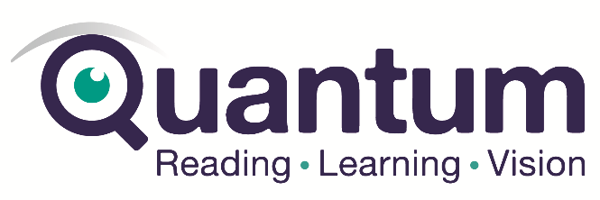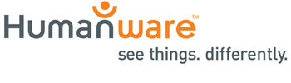
We regret to announce that VFO internationally has made the decision to cease promotion and development of Window-Eyes. Therefore we wish to inform our valued clients that Window-Eyes is now an end-of-line product.

The Distributors of Window-Eyes in Australia and Asia-Pacific, being Quantum RLV and Humanware would like to communicate that VFO are still committed to their customers and will honour existing product purchases and software maintenance agreements. VFO will also continue to provide technical support to end users that have purchased Window-Eyes or a support package. All current users of Window-Eyes can continue to use the software indefinitely; however, as the Windows® operating system and/or applications change over time, Window-Eyes may not function adequately for your needs.

There are a small number of Window-Eyes licenses available at Humanware Sydney so please act quickly and contact Humanware for information.

We understand how important a screen reader is to you and are offering JAWS® for Windows 18 as a replacement. We are committed to providing a smooth transition and will honour existing Window-Eyes product purchases and software maintenance agreements, as follows.
- End-users that have paid, current licenses of Window-Eyes 9.x will be converted to JAWS® for Windows 18 at no charge.
- If you are using an earlier version of Window-Eyes, you can purchase an upgrade to JAWS® for Windows 18.
- If you are using the free version of Window-Eyes you can continue to use it. While there is not an upgrade path from the free version, if you are interested in purchasing JAWS® for Windows 18, please contact either Quantum 1300 883 853 or Humanware: 02 9686 2600 for information.
- Existing Window-Eyes SMAs will be rolled into the JAWS SMA program for end-users that migrate to JAWS® for Windows 18.
Detailed upgrade and SMA pricing information is as follows:
Window-Eyes 8.0 - 8.4 to JAWS Pro | $ 315
Window-Eyes 8.0 - 8.4 to JAWS Home | $ 190
Window-Eyes 7.5 to JAWS Pro | $ 630
Window-Eyes 7.5 to JAWS Home | $ 380
Window-Eyes Older than 7.5 to JAWS Pro | $ 865
Window-Eyes Older than 7.5 to JAWS Home | $ 565
Window-Eyes Offer for Users of Microsoft Office version to JAWS Pro | $ 1,730
Window-Eyes Offer for Users of Microsoft Office version to JAWS Home | $ 1,415
Window-Eyes to JAWS Pro SMA | $ 315
Window-Eyes to JAWS Home SMA | $ 190

To make this process as easy as possible, we ask when you contact us, that you provide your current product serial number and version.

Quantum 1300 883 853 or Humanware: 02 9686 2600

