Contents
1. Setting up Mantis Q40 using JAWS 18-19 2
2. Setting up Mantis Q40 using JAWS 2020 and above 5
3. Pairing with Bluetooth 6
4. Activate USB connection with your screen reader 8
5. Activate Bluetooth connection with your Screen reader. 9
6. JAWS command summary 9
6.1 Writing with your Mantis Q40 keyboard 10
6.1.1 Basic Commands 10

Using Mantis Q40 with JAWS

The Mantis Q40 allows you to control JAWS, giving you the ability to read, write and navigate within a braille environment.

Mantis Q40 offers flexible connectivity options allowing for 5 Bluetooth simultaneous connections and a USB connection. This document will guide you through setting up the Mantis Q40 with JAWS 18 + followed by useful shortcuts while using JAWS. Please note that shortcuts found in this document are proprietary to Freedom scientific. For more related shortcuts, please refer to Freedom Scientific’s support page JAWS Screen Reader - Documentation (freedomscientific.com)

The Mantis Q40 braille displays can be used with the JAWS Screen Reader on a Windows PC. Note that JAWS version 18 or later is required to use the Mantis Q40.

The Mantis Q40 has two available connection types:

- USB
- Bluetooth

Please note if you are using Jaws 18-19, you will be required to install the Braille Terminals tools. For more information on this, please refer to the “Setting up Mantis Q40 using JAWS 18-20,” section of this document.

Setting up Mantis Q40 using JAWS 18-19

The following instructions are for setting up the Mantis Q40 with the JAWS screen reader versions 18-19 where you are required to install drivers. If you are using Jaws 2021 or later, please proceed to “Setting up Mantis Q40 using JAWS 2020 and above”.

Download the JAWS drivers for Mantis Q40 from the HumanWare support page or from the following link: HumanWare Braille Terminal Tools

Once downloaded, extract the folder and run the application called “Braille_terminal_drivers”

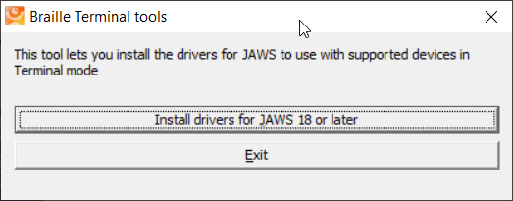

Select the “install drivers for JAWS 18 or later button.

Note: A user account control dialog box may be displayed. If it is, select the Yes button.

An install wizard dialogue box will be displayed.
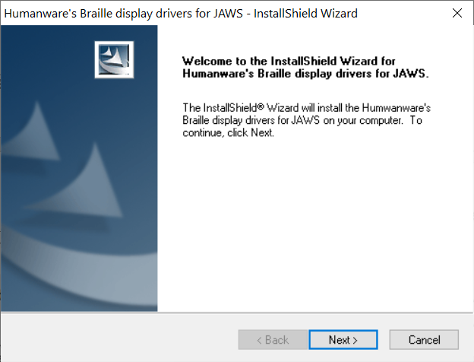

Select the Next button.

A dialogue box is shown, where you are required to select the braille device that you would like to install. First, make sure APH Mantis Q40 is selected, then press the Next button.

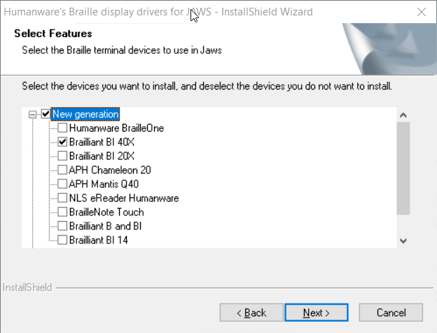

You will then be prompted to select the default braille display to use with Jaws.

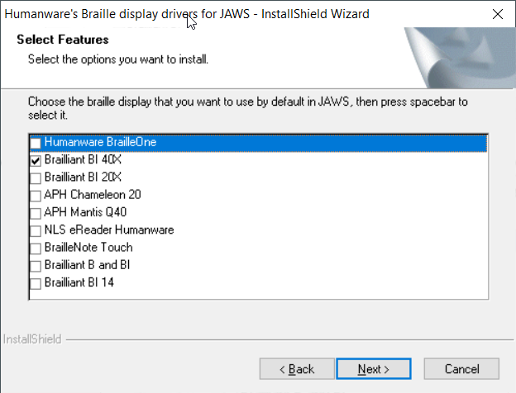

Select the APH Mantis Q40 followed by pressing the Next button.

You will then be prompted “Ready to install” dialog box. Press Install

Once instaled a Wizard complete dialogue box will be displayed.
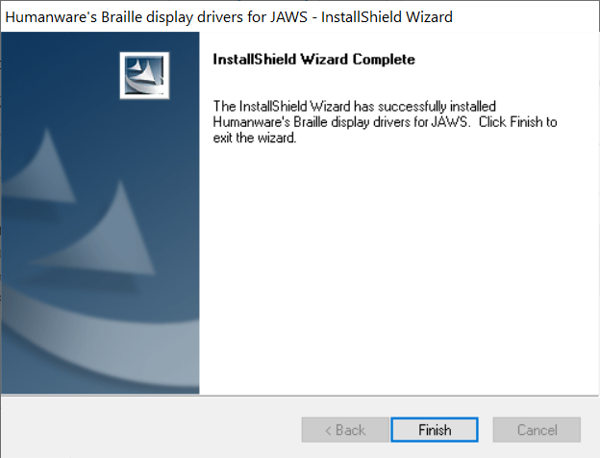

Select the Finish button to complete the Jaws driver installation.

The JAWS drivers for Mantis Q40 has now been successfully installed on the PC.

The next steps are dependent on how you want to connect your braille display to the JAWS.

If you wish to connect your Mantis Q40 via USB Please refer to “Activating USB connection with your screen reader” to get the Mantis Q40 connected.

Alternatively, you can connect to JAWS using Bluetooth; please refer to “Pairing with Bluetooth”.

Setting up Mantis Q40 using JAWS 2020 and above

When using Jaws 2020 or later, the Mantis Q40 driver is already pre-installed and ready to go.
However, it is essential that you ensure JAWS is configured to use the new Mantis Q40 Braille display.

- Move your focus to the JAWS window by pressing the JAWS key + J.
- Open the menu bar by pressing ALT, then press down arrow to activate the option menu and then type the letter l to open Braille options
- Tab to the “add Braille Display…” button and press enter.
- You will be presented with a list of possible Braille displays to add to JAWS, press the letter “A” until you reach the relevant APH Mantis Q40 display and press the spacebar to check the associated checkbox
- Press the tab until you reach the “next” button and press enter to activate
- You will be presented with a dialogue where you will choose how your Mantis Q40 will connect to your computer and you can leave the setting to Bluetooth or USB.
- Tab to the next button and press enter, you will now be placed in a combo box where you can choose which Braille display JAWS activates each time it starts
- Use the arrow keys to move focus to the APH Mantis Q40, and tab to the “Finish” button and press enter
- You will now have to tab to the “ok” button and press enter again to save your changes
- You will now have to turn off and restart JAWS to initiate Braille support

Pairing with Bluetooth

This section will take you through the steps of pairing the Mantis Q40 display with a laptop/desktop computer. Please note that these instructions may differ from computer to computer, in this instance, please refer to your computer manufactures handbook on guidance on pairing Bluetooth devices.

To use your Mantis with your preferred screen reader via Bluetooth, you will first need to make sure the Mantis Q40 is set to be discovered. To do this, follow these steps:

- From the main menu press T for Terminal. Then press Enter.
- Press the letter A to add Bluetooth device. Then press Enter.

Once activated, you will receive a message that says, “activate your device in your host device’s Bluetooth settings”, followed by the Mantis Q40 serial number.

The Mantis Q40 will now be searchable from a host device for 5 minutes.

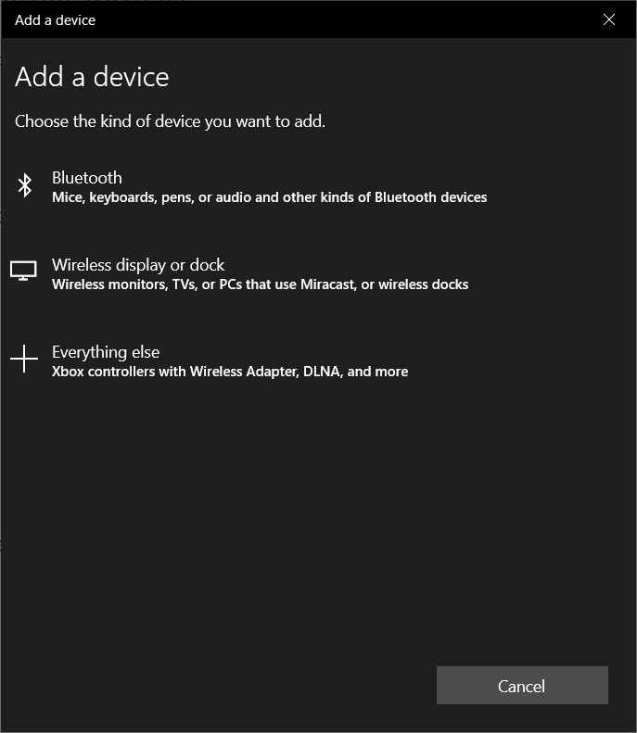
From your computer, open your Bluetooth Manager settings and select the add Bluetooth or other device options. A dialogue box will appear, giving you further options to select.

Select Bluetooth

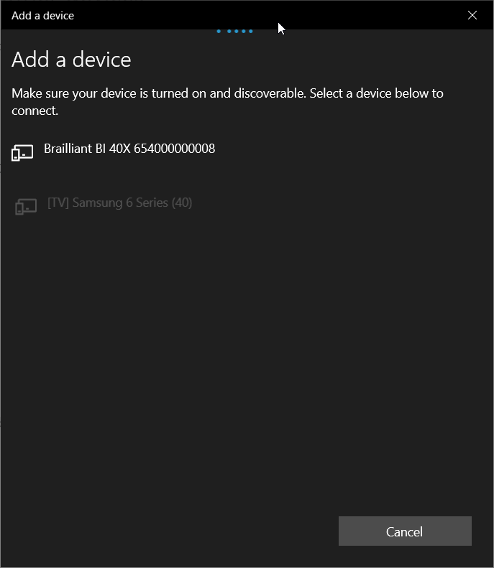
You will next have a dialogue box searching for devices within range. Select the APH Mantis xx, where “xx” is the serial number of your Mantis..

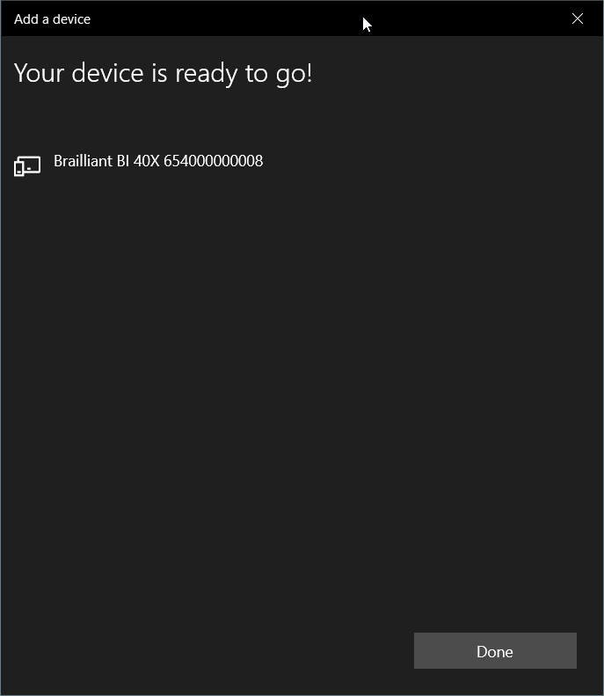

Once paired Press the done button to close the dialogue box.

You have successfully paired your Mantis Q40 display to your computer with Bluetooth.

On your Mantis Q40, you will be prompted with the xxx connected, where “xxx” is the laptop's name and will be placed in the list of connected devices.

To connect to JAWS using your Bluetooth connection please refer to “Activate Bluetooth connection with your screen reader”

Activate USB connection with your screen reader

To connect your braille display to JAWS using USB please ensure you have followed all the necessary steps as per above before continuing this section.

Plug in a type C USB cable into the USB C port located on the left edge of your Mantis. Plug the other end of your USB C cable into your computer

- From the main menu, Press T for terminal. Then press Enter

- Use your Previous and Next thumb key to move to “connected devices” Then press Enter

- Use your Previous or Next Thumb key to navigate to “USB Connection” option;

- Press Enter and the words “Braille Display” will be shown

Note: If the connection is unsuccessful, please restart JAWS. If you cannot connect after restarting JAWS and your PC, please refer to the appropriate setting up guide with JAWS.

Activate Bluetooth connection with your Screen reader.

To use your Mantis Q40 with your preferred screen reader via Bluetooth, you first need to ensure you have paired your display. If you have not already done so, please refer to “Pair with Bluetooth” first before continuing.

Make sure you are relatively close to your computer to avoid loss of Bluetooth connection.

- From the main menu, Press T for terminal. Then press Enter

- Use your Previous or Next thumb key to navigate to “connected devices” Then press Enter

- Use your Previous or Next Thumb key to move to the paired Host. In this case, it will be your computer name.

- Press Enter and the words “Braille Display” will be shown

- Providing you have setup JAWS to use your Mantis Q40 display, you should be successfully connected.

- Make sure you have selected the Mantis Q40 as your default braille display within the JAWS braille settings.

Note at any time if you encounter Bluetooth connection issues, there is a “reconnect devices” option within the connected devices menu. Selecting this item will disconnect and reconnect any active Bluetooth connections that may be of use if you have a paired Bluetooth device that is not connecting.

JAWS command summary

Below are some useful commands for the Mantis Q40 to be used as a refreshable Braille display with JAWS. This includes JAWS commands, Windows commands, reading and navigation commands. Please note this is only a handful of shortcuts that can be applied using your Mantis Q40. As mentioned previously, JAWS commands are proprietary to Freedom scientific. If you have any comments relating to the shortcuts, please refer to JAWS documentation.

You can also define your own commands in the JAWS keyboard manager, available in the utility submenu of JAWS.

Note: When referring to the JAWS key, the Mantis Q40 adopts the laptop layout, thus the Caps lock key will be used as the associated JAWS keys. For example, the Jaws Key + b is caps lock key + b.

Writing with your Mantis Q40 keyboard

You can use your Mantis Q40 keyboard like any other standard keyboard. You can set your preferred Braille code preference within the JAWS braille settings.

Basic Commands

Braille Thumb key Navigation
Prior line: Outer Left Thumb Key key (Previous)
Pan braille left: Inner Left Thumb Key (Left)
Pan braille right: Inner Right Thumb Key (Right)
Next line: Outer Right Thumb Key (Next)
Routing cursors: Route Braille to position of active cursor
Active follows Braille: Outer Left Thumb Key + Outer Right Thumb Key
Braille follows active: Inner Left Thumb Key (Left) + Inner Right Thumb Key (Right)

Windows commands
Start Menu: Windows key
Menu Bar: Alt
Application key: Function key + right control key
Minimize All Apps: Windows key + d
Open list or combo box: Alt + down arrow
Close list or combo box: Alt + up arrow

Navigation commands
Home: Function + left arrow
End: Function + right arrow
Page-Up: Function + up arrow
Page-Down: Function + down arrow
Top of file: Control + home (control + function + left arrow)
Bottom of file: Control + end (control + function + right arrow)
Next document window: Control + tab
Previous Document Window: Control + shift + tab
Close document window: Control + f4
Read dialog box in tab order: JAWS key + b

Reading commands
Say character: JAWS key + comma
Say prior line: Up arrow
Say line: JAWS key + i
Say next line: Down arrow
Say word: JAWS key + k
Spell word: JAWS key + k twice quickly
Say previous word: Control + left arrow
Say next Word: Control + right arrow
Say all: JAWS key + down arrow

Cursor commands
Activate JAWS cursor: JAWS key + p
Activate PC cursor: JAWS key + semicolon
Route JAWS cursor to PC: JAWS key + left bracket
Route PC cursor to JAWS cursor JAWS key + apostrophe

Information commands
Keyboard Help: JAWS key + 1
List task tray icons: JAWS key + f11
Hotkey Help: JAWS key + h
JAWS window: JAWS key + j
Say title of the active window: JAWS key + t
Say system time: JAWS key + f12
Say Date: JAWS key + f12 twice quickly
Say battery status: Shift + JAWS key + b

Edit commands
Cut to clipboard: Control + x
Copy to clipboard: Control + c
Paste from clipboard: Control + v

Internet Explorer commands
Go back: Alt + left arrow
Go forward: Alt + right arrow
List links on a webpage: JAWS key + f7
List headings on a webpage: JAWS key + f6

