Contents
1. Setting up Brailliant using JAWS 18-20 2
2. Setting up Brailliant using JAWS 2021 and above 5
3. Pairing with Bluetooth 6
4. Activate USB connection with your screen reader 8
5. Activate Bluetooth connection with your Screen reader. 9
6. JAWS command summary 10
6.1 Writing with your Brailliant Braille keyboard 11
6.1.1 Basic Commands 11
6.1.2 PC keyboard emulation for Brailliant 13

Using Brailliant BI X Series with JAWS

The Brailliant BI X Series allows you to control JAWS, giving you the ability to read, write and navigate around in a braille environment.

Brailliant BI X Series offers flexible connectivity options allowing for 5 Bluetooth simultaneous connections and a USB connection. This document will guide you through setting up the Brailliant BI X series with JAWS 18 + followed by useful braille shortcuts while using JAWS.

The Brailliant BI X Series braille displays can be used with the JAWS Screen Reader on a Windows PC. Note that JAWS version 18 or later is required to use the Brailliant BI X series.

The Brailliant BI X has two available connection types:

- USB
- Bluetooth

Please note if you are using Jaws 18-20 you will require to install the Brailliant BI X drivers. For more information on this please refer to the “Setting up Brailliant using JAWS 18-20”.
If you are using JAWS 21 or later please refer to “Setting up Brailliant using JAWS 21 and above”

Setting up Brailliant using JAWS 18-20

The following instruction is for setting up the Brailliant with JAWS 18-20 screenreader where you are required to install drivers. If you are using Jaws 2021 or later, please proceed to “Setting up Brailliant on JAWS 2021”.

Download the JAWS drivers for Brailliant BI X series from the HumanWare support page or from the following link: HumanWare Braille Terminal Tools

Once downloaded, extract the folder and run the application called “Braille_terminal_drivers”

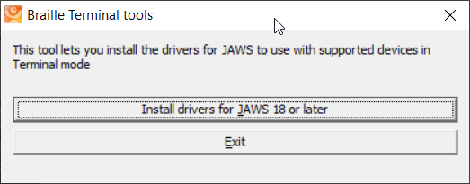

Select the “install drivers for JAWS 18 or later button.

Note: A user account control dialog box may be displayed. If it is, select the Yes button.

An install wizard dialogue box will be displayed.
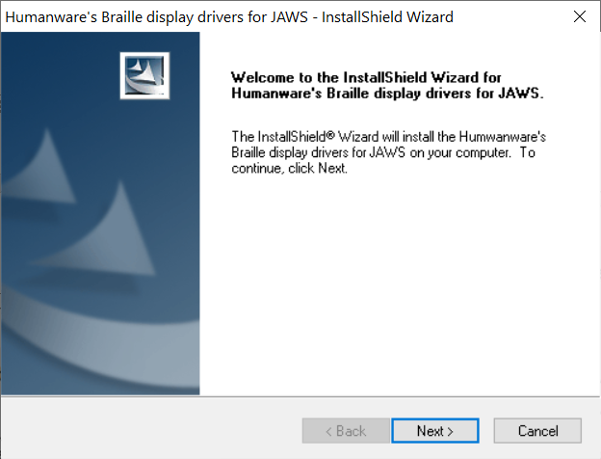

Select the Next button.

A dialogue box is shown, where you are required to select the braille device that you would like to install. Make sure HumanWare Brailliant BI 40X or BI 20X is selected, then press the Next button.

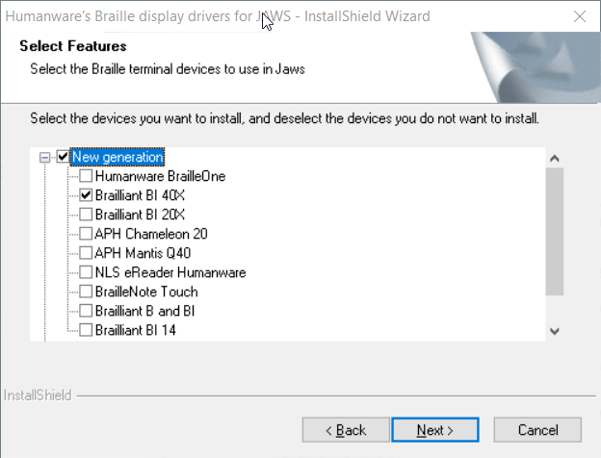

You will then be prompted to select the default braille display to use with Jaws.

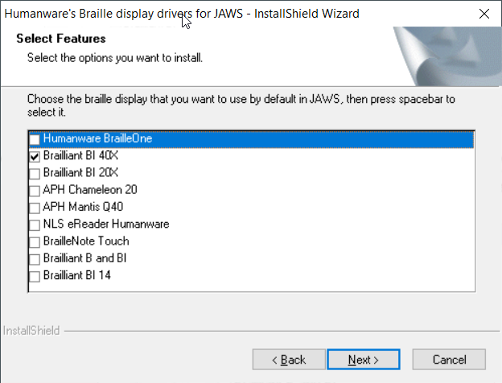

Select the HumanWare Brailliant BI 40X or 20X followed by pressing the Next button.

You will then be prompted “Ready to install” dialog box. Press Install

Once instaled a Wizard complete dialogue box will be display.
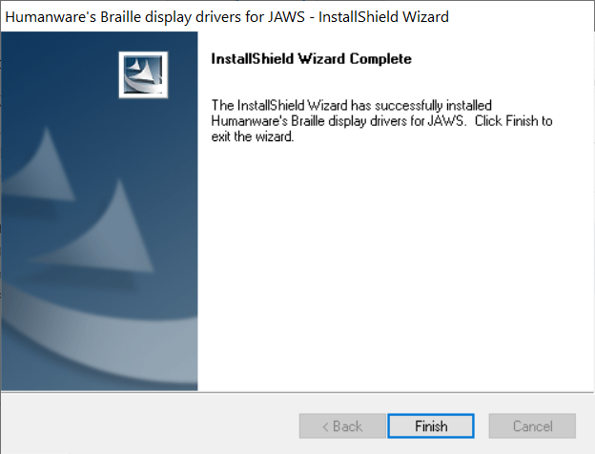

Select the Finish button to complete the Jaws driver installation.

The JAWS drivers for Brailliant BI 40X or 20X is now installed on the PC.

If you wish to connect your Brailliant BI X display via USB Please refer to “Activating USB connection with your screen reader” to get the Brailliant connected.

Alternatively, you can connect to JAWS using Bluetooth; please refer to “Pairing with Bluetooth”.

Setting up Brailliant using JAWS 2021 and above

When using Jaws 2021 or later, the Brailliant BI X Series driver is already pre-installed ready to go.
However, it is essential that you ensure JAWS is configured to use the new Brailliant display.

- Move your focus to the JAWS window by pressing the JAWS key + J
- Open the menu bar by pressing Alt, then press down arrow to activate the option menu and then type the letter l to open Braille options.
- Tab to the “add Braille Display…” button and press enter.
- You will be presented with a list of possible Braille display to add to JAWS, press the letter “H” until you reach the relevant HumanWare Brailliant BI X display and press the spacebar to check the associated checkbox
- Press the tab until you reach the “next” button and press enter to activate
- You will be presented with a dialogue where you will choose how your Brailliant will connect to your computer and you can leave the setting to Bluetooth or USB.
- Tab to the next button and press enter, you will now be placed in a combo box where you can choose which Braille display JAWS activate each time it starts
- Use the arrow keys to move focus to the HumanWare Brailliant BI 40X, and tab to the “Finish” button and press enter
- You will now have to tab to the “ok” button and press enter again to save your changes
- You will now have to turn off and restart JAWS to initiate Braille support

Pairing with Bluetooth

This section will take you through the steps of pairing the Brailliant BI X display with a laptop/desktop computer. Please note that these instructions may differ from computer to computer, in this instance please refer to your computer manufactures handbook on guidance on pairing Bluetooth devices.

To use your Brailliant with your preferred screen reader via Bluetooth, you will first need to make sure the Brailliant is set to be discovered. To do this, follow these steps:

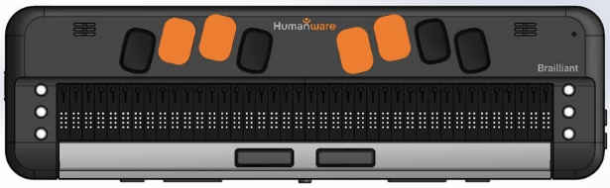
From the main menu press T for Terminal.

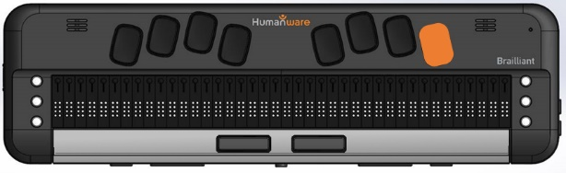

Now press Enter.

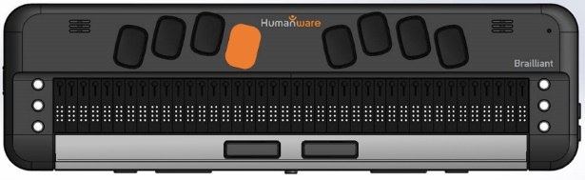

Press the letter A to add Bluetooth device.

Then press Enter.

Once activated, you will receive a message that says, “activate your device in your host device’s Bluetooth settings”. The name of your Brailliant will be HumanWare Brailliant BI 20X or 40X followed by your unit’s serial number.

The Brailliant will now be searchable for 5 minutes.

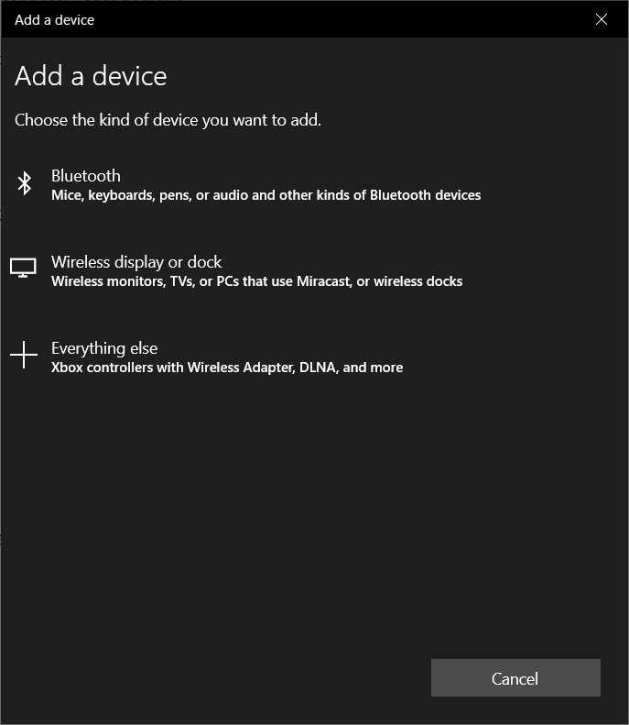
From your computer, open your Bluetooth Manager settings and select the add Bluetooth or other device options. A dialog box will appear, giving you further options to select.

Select Bluetooth

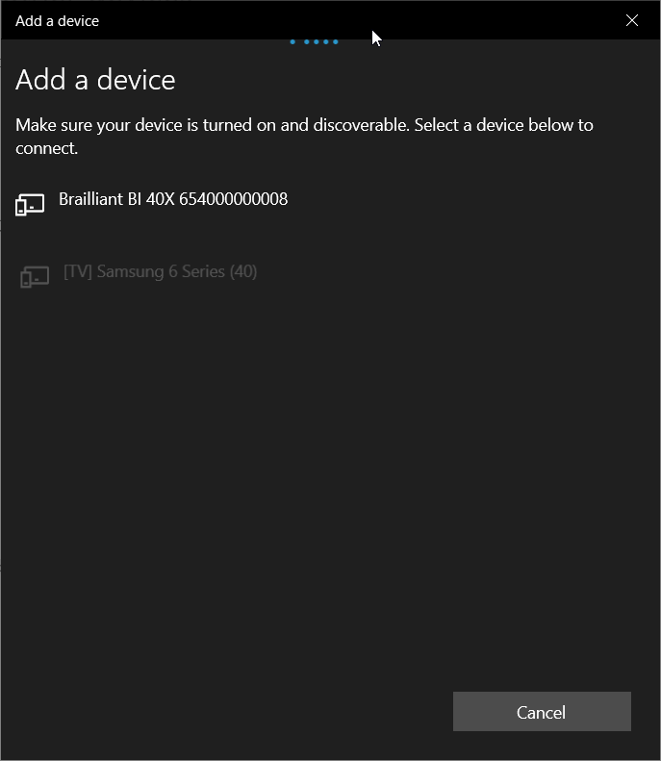
You will next have a dialog box searching for devices within range. Select the HumanWare Brailliant BI X xxxxxxxx, where x is the serial number of your Brailliant.

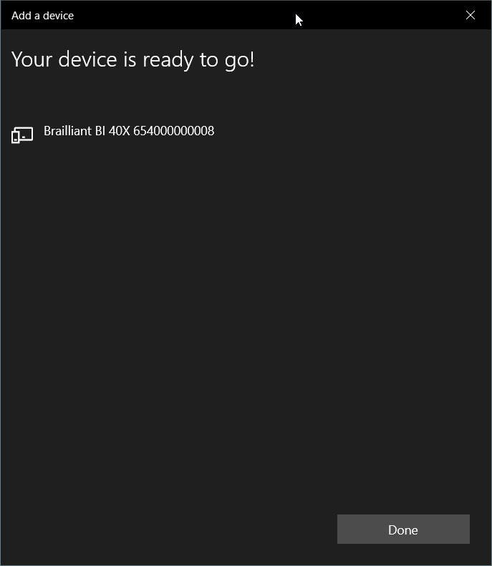

Once paired Press the done button to close the dialogue box.

You have successfully paired your Brailliant BI X display to your computer with Bluetooth.

On your Brailliant, you will be prompted with the xxx is connected, where xxx is the name of the laptop and will be placed in the list of connected devices.

To connect to JAWS please refer to “Activate Bluetooth connection with your screen reader”

Activate USB connection with your screen reader

To connect your braille display to JAWS using USB please ensure you have followed all the necessary steps as per above before continuing this section.

Plug in a type C USB cable into the USB C port located on the left edge of your Brailliant. Plug the other end of your USB C cable into your computer

From the main menu, Press T for terminal.

Then press Enter

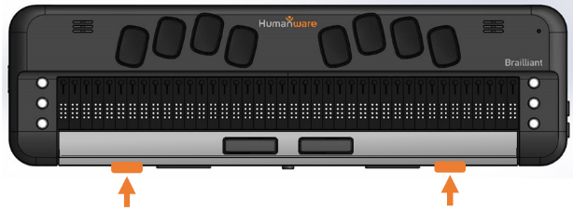
Use your Previous and Next thumb key to move to “connected devices”

Then press Enter

Use your Previous and Next Thumb key to move to “USB Connection” option;

Press Enter and the words “Braille Display” will be shown

Note: If the connection is unsuccessful, please restart JAWS. If after restarting JAWS and your PC you cannot connect, please refer to the appropriate setting up guide with JAWS.

Activate Bluetooth connection with your Screen reader.

To use your Brailliant with your preferred screen reader via Bluetooth, you first need to ensure you have paired your display. If you have not already done so please refer to “Pair with Bluetooth” first before continuing.

Make sure you are relatively close to your computer to avoid loss of Bluetooth connection.
From the main menu, Press T for terminal.

Then press Enter

Use your Previous and Next thumb key to move to “connected devices”

Then press Enter

Use your Previous and Next Thumb key to move to the paired Host. In this case, it will be your computer name.

Press Enter and the words “Braille Display” will be shown

Providing you have setup JAWS to use your Brailliant BI X display, you should be successfully connected.

Make sure you have selected the Brailliant BI X as your default braille display within the JAWS braille settings.

Note at any time if you encounter Bluetooth connection issues, there is a “reconnect devices” option within the menu of the connected device. Selecting this item will disconnect and reconnect any active Bluetooth connections that may be of use if you have a paired Bluetooth device but not connecting.

JAWS command summary

Below are the command summaries for the Brailliant to be used as a refreshable Braille display with JAWS. It includes JAWS commands, Windows commands, reading and navigation commands.
Your Brailliant can also type text into the PC applications or simulate the PC keyboard.

You can also define your own commands in the JAWS keyboard manager, available in the utility submenu of JAWS.

Writing with your Brailliant Braille keyboard

You can use your Brailliant's Braille keyboard to type using several braille table including computer Braille ; US Grade 2 Braille, Unified English Braille, Uncontracted and contracted. You can set your preferred to Braille preference in the JAWS braille settings.

Basic Commands
When this document references “C” this refers to command keys. The six command keys are located on each side of the Braille cells, Dots 1-2-3 to the left and Dots 4-5-6 to the right. To do Command T, you have to press on Command keys 2-3-4-5 for the Braille letter T.

Braille navigation
Prior line: Outer Left Thumb (Previous)
Pan Braille left: Inner Left Thumb Key (Left)
Pan Braille right: Inner Right Thumb Key Right
Next line: Outer Right Thumb Key (Next)
Routing cursors: Route Braille to the position of active cursor
Active follows Braille: Outer Left Thumb Key Up + Outer Right Thumb Key Down
Braille follows active: Inner Left Thumb Key (Left) + Inner Right Thumb Key (Right)

Windows commands
Start Menu: Space with Dots 3-4
Menu Bar: Space with M
Application key: Space with M and Dot 7
Minimize All Apps: C1 + C4 + C5
Enter: Dot 8
Backspace: Dot 7
Escape: Space with E
Alt-Tab: Space with T
Caps lock toggle: Space with Dot 7
Open list or combo box: Space with Dots 1-3-5
Close list or combo box: Space with Dots 2-4-6

Navigation commands
Up Arrow: Space with Dot 1
Down Arrow: Space with Dot 4
Left Arrow: Space with Dot 3
Right Arrow: Space with Dot 6
Home: Space with Dots 2-3
End: Space with Dots 5-6
Page-Up: Space with Dots 1-2
Page-Down: Space with Dots 4-5
Tab: Space with Dots 4-6
Shift-Tab: Space with K
Top of file: Space with L
Bottom of file: Space with Dots 4-5-6
Next document window: Space with N
Previous Document Window: Space with P
Close document window: Space with Dots 2-5-6
Move Braille display to top line of screen: C2 + C3
Move Braille display to bottom line of screen: C5 + C6
Read dialog box in tab order: C2 + C3 + C4 + C6

Reading commands
Say character: C3 + C6
Say prior line: C1
Say line: C1 + C4
Say next line: C3
Say word: C2 + C5
Say previous word: C2
Say next Word: C5
Say all: C1 + C2 + C3 + C4 + C5 +C6
Toggle speech on and off: C1 + C3 + C6
Select a voice profile: C1 + C2 + C3 + C6

Cursor commands
Toggle between the JAWS and PC Cursor: C4
Route JAWS cursor to PC: C2 + C4
Route Braille to active cursor: C6

Braille commands
Braille toggle mode
(Line, Structured, Speech History, Attribute): Space with Dots 2-5
Start Braille Auto Advance: C1 + C2 + C3 + C5
Increase Braille Auto Advance Speed: C3 + C4 + C5
Decrease Braille Auto Advance Speed: C1 +C2 + C6
Change contracted Braille setting: C1 + C2 + C4 + C5
Contracted Braille toggle in JAWS Space with G
Expand current Grade 2 word: C2 + C4 + C5 + C6
Adjust JAWS options: C1 + C3 + C5
Toggle between 6 and 8 dots: C2 + C3 + C5
Adjust Braille verbosity: C1 + C2

Information commands
Keyboard Help: C1 + C2 + C5
List task tray icons: C2 + C3 + C5 + C6
Hotkey Help: C3 + C5 + C6
JAWS window: C2 + C4 + C5
Start JAWS task list: C2 + C3 + C4
Say title of the active window: C2 + C3 + C4 + C5
Say system time: C1 + C3 + C5 + C6

Edit commands
Cut to clipboard: Space with X
Copy to clipboard: Space with C
Paste from clipboard: Space with V

Web browsing commands
Go back: C1+ C2 + C3 + C5 + C6
Go forward: C2 + C3 + C4 + C5 + C6
List links on a webpage: C3 + C4 + C6
List frames on a webpage: C1 + C2 + C4
List headings on a webpage: C2 + C3 + C6

PC keyboard emulation for Brailliant

Entering text using your Brailliant's keyboard is very straightforward. Typing characters, changing lines, deleting characters, entering uppercase characters, and moving inside the text. JAWS simultaneously updates the Braille display to reflect what you type.

With the help of JAWS, you can enter Braille commands and control your computer using sets of keystrokes.

Modifier Keys
Modifier keys are used to emulate keystroke combinations that include CTRL, ALT, WINDOWS Key, SHIFT, the JAWS Key and the INSERT key. To make use of modifiers when entering text, follow these instructions:
- Press and hold SPACE with DOT 8 followed by the corresponding modifier keys.
- Once you've entered the modifier, release the keys then press the remaining portion of the keystroke. To enter CTRL+SHIFT+A, for example, you will need to press SPACE with DOTS 3-7-8, release the keys, then press A (DOT 1).
SHIFT: SPACE with DOTS 7-8
CTRL: SPACE with DOTS 3-8
ALT: SPACE with DOTS 2-8
WINDOWS Key: SPACE with DOTS 1-8
Function Keys (F1 through F12): SPACE with DOTS 4-8
JAWS Key: SPACE with DOTS 5-8
INSERT Key: SPACE with DOTS 6-8

Function Keys
To emulate the Function keys (F1 through F12), press SPACE with DOTS 4-8 followed by the letters A through L (representing 1 through 12). If you wish to emulate the F7 key, press SPACE with DOTS 4-8, followed by G (DOTS 1-2-4-5). If you are combining a function key with another, you just need to enter the necessary modifiers while pressing down SPACE with DOTS 4-8. If you wish to emulate INSERT+F3, press SPACE with DOTS 4-5-8, followed by C (DOTS 1-4).

Modifier commands
The following commands can be used in combination with modifier keys:
Up Arrow: Space with Dot 1
Down Arrow: Space with Dot 4
Left Arrow: Space with Dot 3
Right Arrow: Space with Dot 6
Home: Space with Dots 2-3
End: Space with Dots 5-6
Page-Up: Space with Dots 1-2
Page-Down: Space with Dots 4-5
Enter: Dot 8
Backspace: Dot 7
Minimize all apps: Space with D
Escape: Space with E
Tab: Space with Dots 4-6
Shift-Tab: Space with K

