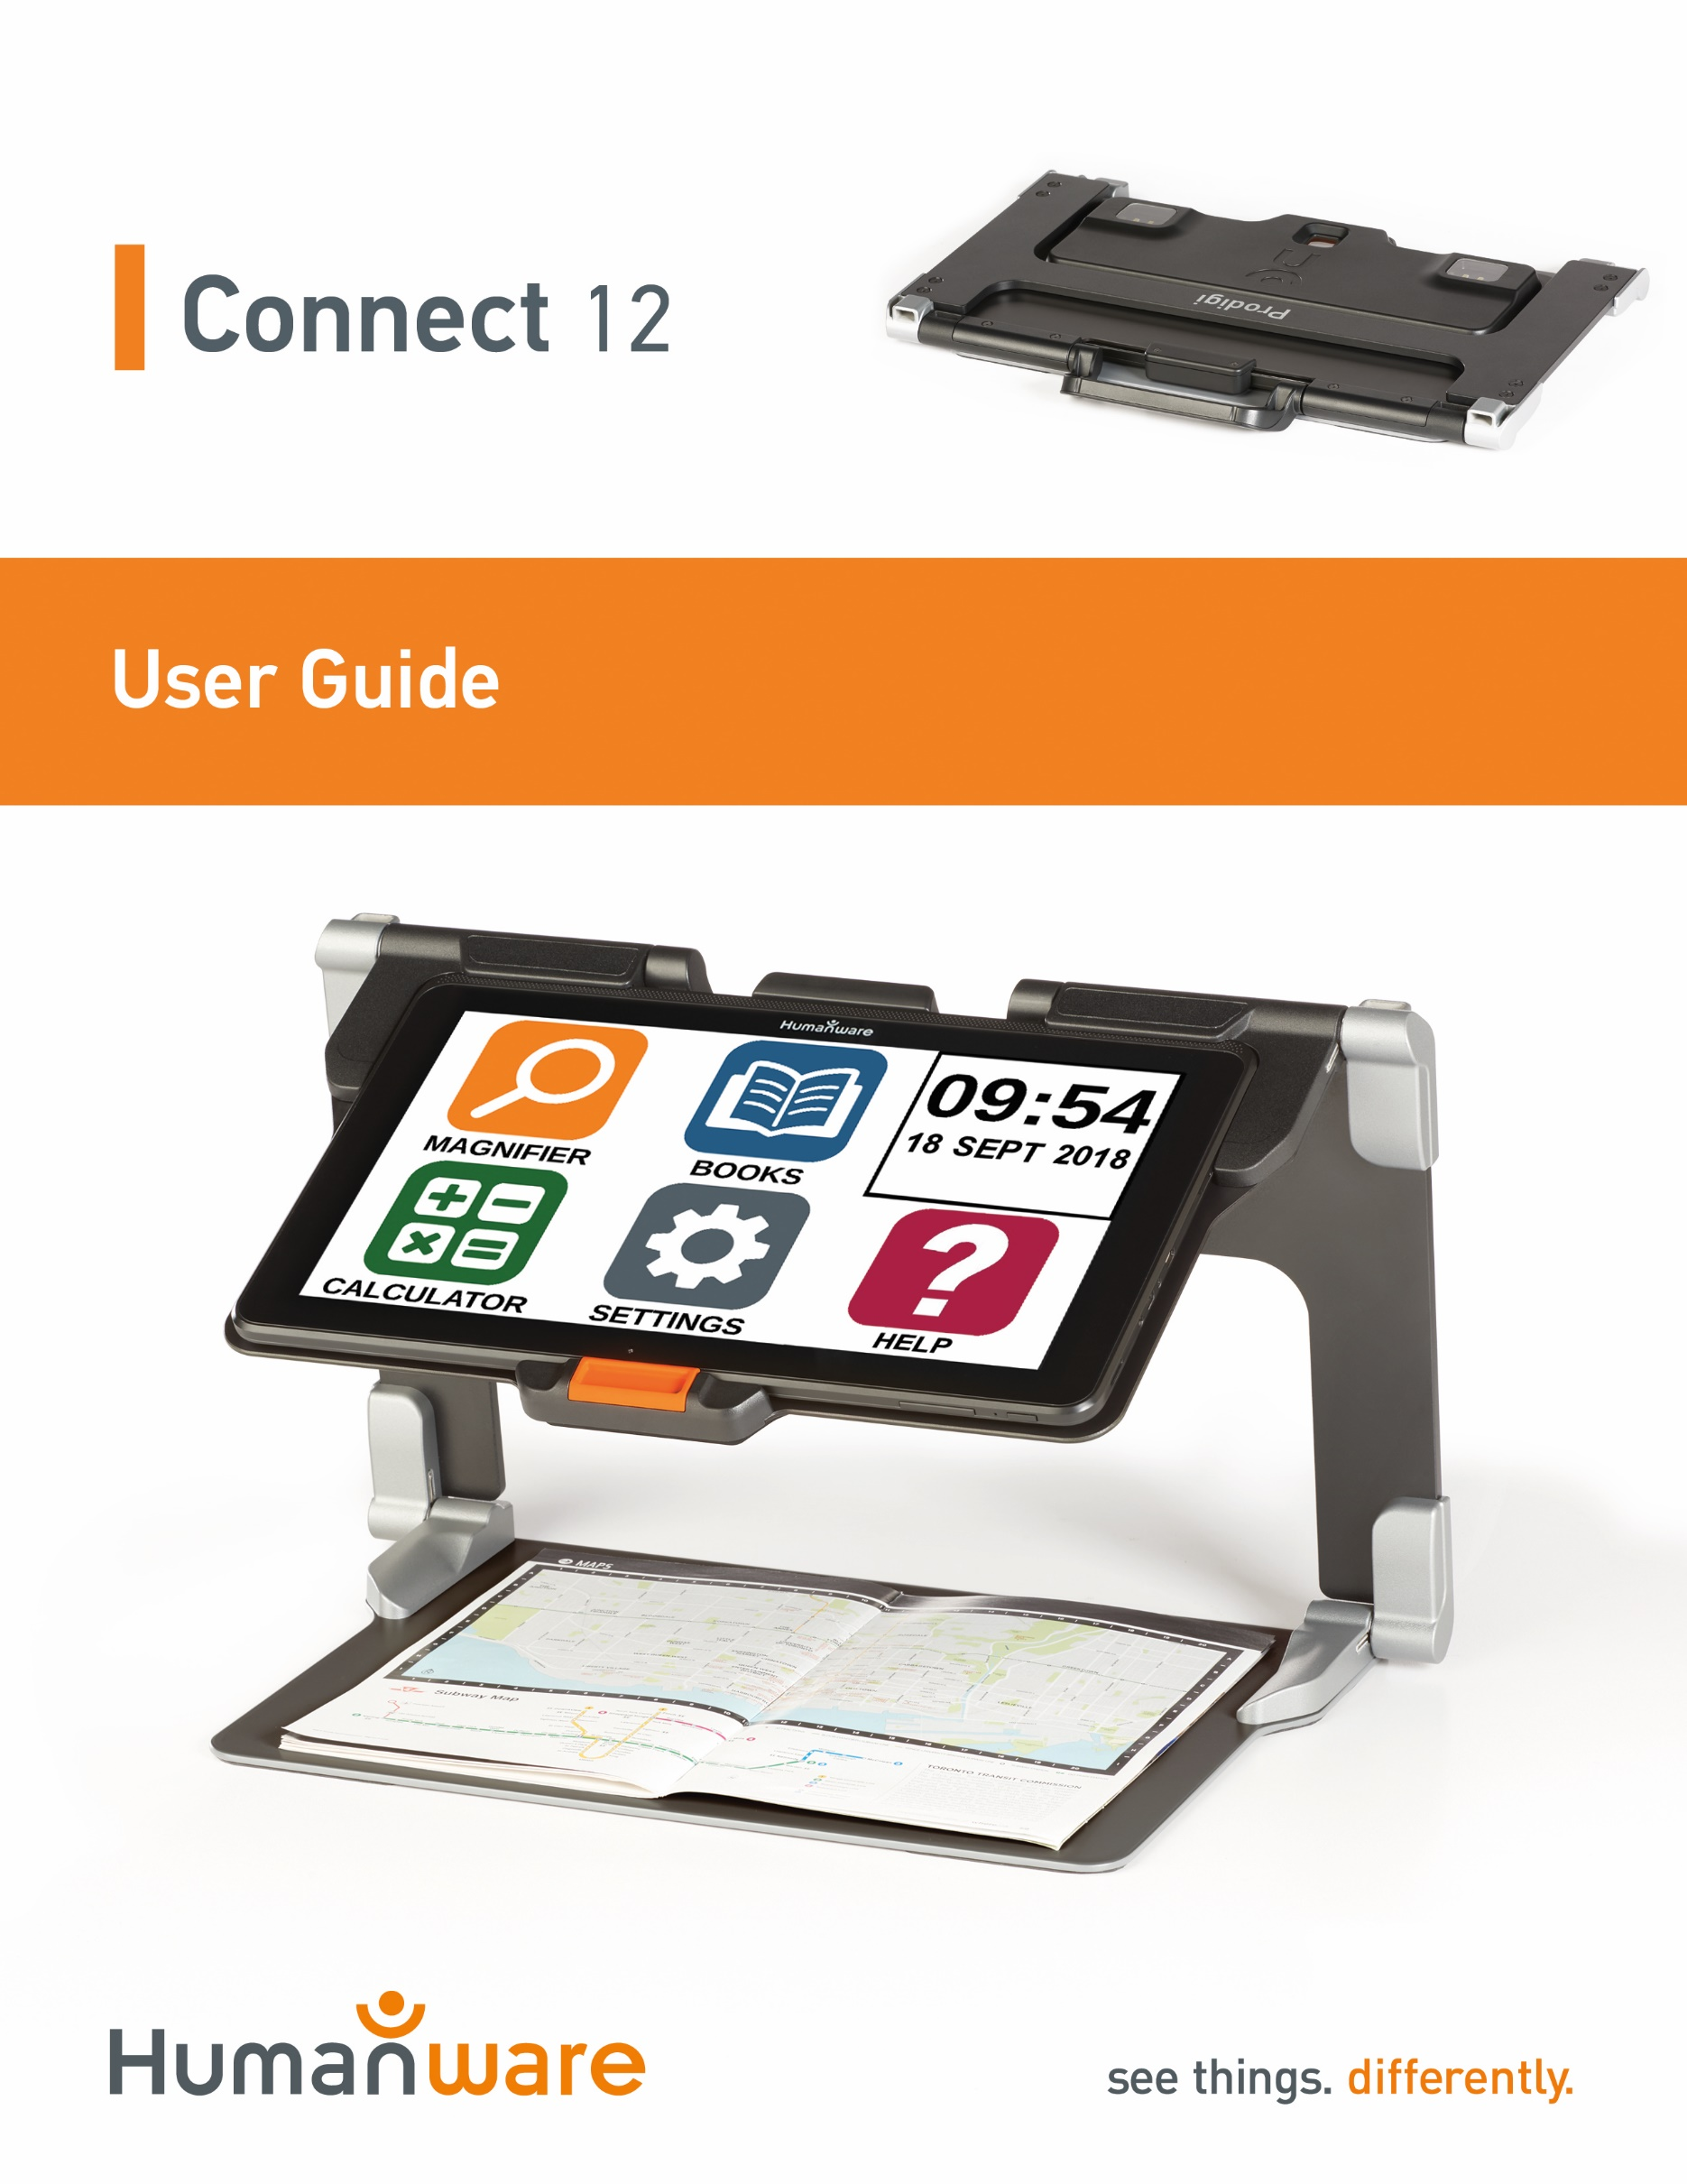

Table of contents
Chapter 1: Introduction 3
Chapter 2: Getting to know your Connect 12 4
Connect 12 at a Glance 5
Chapter 3: Using Prodigi software 18
Initializing the connect 12 tablet 18
The ICON Banner 18
Magnifying Mode 20
Autofocus 21
Capturing Images and Text 22
Full Page Capture 23
Multi-Capture 24
Reading A Document 25
Handwriting Tool 29
Configuring and using the Rapid Toggle Feature 32
Activating the Blue Light Filter 33
Using the Carousel Menu 34
Downloading Books 35
Go to page feature 36
Annotate a book 38
Bookmarks 38
Using Applications Access 39
Using Quick Access 40
Using the Calculator 41
Graphic Calculator Powered by Desmos 42
Dictionary Tool 43
Viewing Saved Documents 46
Gallery Settings Menu 47
Action Menu 48
Using the Distance Camera 53
Toggling between the Distance Camera and Magnifier 55
Using the Distance Camera and Magnifier simultaneously 55
Viewing Distance Camera Images 55
Reading with the Distance Camera 56
Removing Distance Camera from Gooseneck 56
Viewing text files in Prodigi 56
Exam Mode 57
OCR Language Selection 58
Chapter 4: Selecting Contrast 60
Chapter 5: Standard (tile) Mode 61
Chapter 6: Simple Mode 63
Chapter 7: Revising your Settings 64
Chapter 8: Bluetooth External Keyboard 70
The HumanWare Keyboard 70
Connecting a Bluetooth Keyboard 70
Chapter 9: APH Code Jumper® 71
Connecting the Connect 12 to an APH Code Jumper® 71
Chapter 10: Accessing Android 72
Chapter 11: Help Menu 73
Chapter 12: Recharging your Tablet 73
Chapter 13: Recharging the Distance Camera 74
Chapter 14: Software Update 75
Setting up your Wi-Fi 75
Automatic Update 75
Manual Update 75
Release Notes 76
Chapter 15: Troubleshooting 76

Chapter 1: Introduction

Thank you for purchasing the Connect 12 with Prodigi software.
The device is a touch-controlled personal vision assistant system from HumanWare, the global leader in assistive technologies for people with low vision.
The Connect 12 with Prodigi is an intuitive, intelligent, portable and adaptable tablet/system aimed at restoring and maintaining independence for people living with vision loss. Connect 12 is a complete magnification system that will allow you to magnify and read documents a well as capture images when you’re on the go.
We highly recommend reading the operating and safety instructions in this user guide before using your Connect 12. If you have any questions about the system, please contact HumanWare Customer Service (contact information appears at the end of this user guide).
Please note, software updates may have occurred since the printing of this guide. To obtain the most recent version, please visit the Support page at https://www.humanware.com/connectsupport.
Note: Some features described in this user guide may not be available in your language.

Copyright 2022 by Technologies HumanWare Inc., all rights reserved. No part of this publication may be reproduced or distributed in any form or by any means or stored in a database or retrieval system without the prior written permission of Technologies HumanWare Inc.

Chapter 2: Getting to know your Connect 12

Tablet Box Contents

- Connect 12 tablet with Prodigi™ software
- USB to USB-C cable
- AC adapter
- Getting Started guide
- Quick Start guide
- User guide
- Tablet stylus pen
- Warranty
Protective Carrying Case

- Folding stand

Distance Viewing Camera (Optional)

  - Distance Camera
  - AC adapter
  - USB cable
  - Flexible Gooseneck (Distance Camera support)
  - Camera Quick Start guide
  - Camera User Manual
  - Warranty
  - Service card

Note: The wrist strap and cell phone clip may not be included with the optional distance camera as these items have been discontinued by the manufacturer.

Connect 12 at a Glance

Front (image 1)

2
3
4
5
1
6
6

- Front-facing camera
- Micro-SD slot
- USB-C port
- High-Resolution video micro-port
- Headphone jack
- Speakers
Bottom (image 2)

1
2

- Volume Up-Down button
- Power button

Back (image 3)
1

- Rear-facing camera
Icon Banner (image 4)
6
5
4
3
2
1

- Back icon
- Settings icon
- Light icon
- Capture/Read icon
- Zoom Out icon
- Zoom In icon

Open Banner Icon (image 5)

1
- Open Banner Icon

Folding stand (image 6)

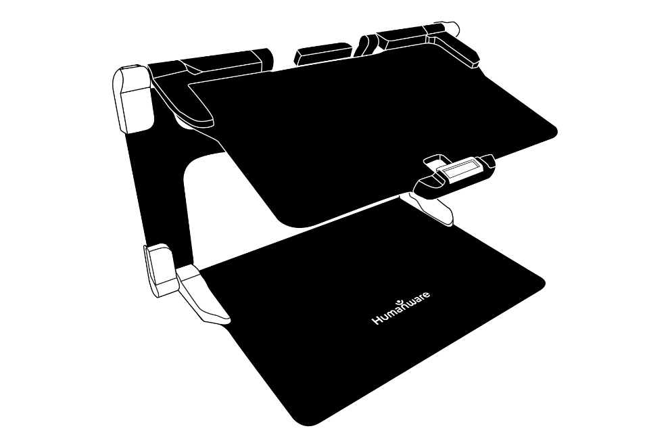

Distance camera (image 7)

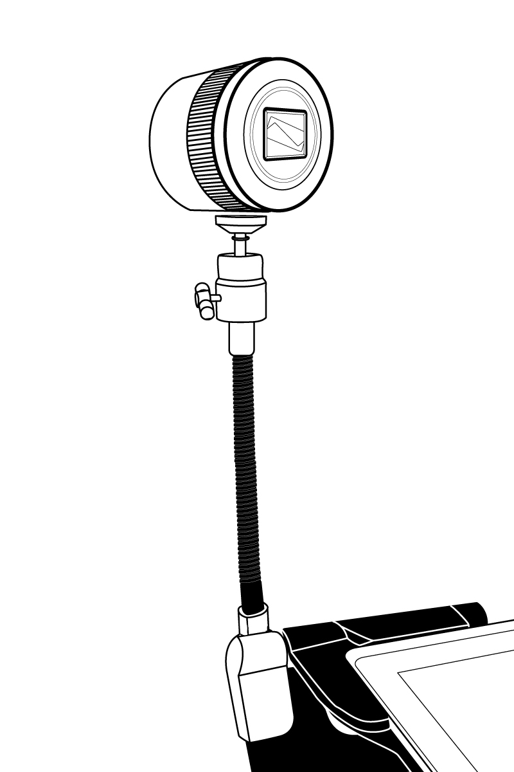
1
2

- Distance camera
- Flexible Gooseneck (Distance Camera support)

Distance Camera, front view (image 8)

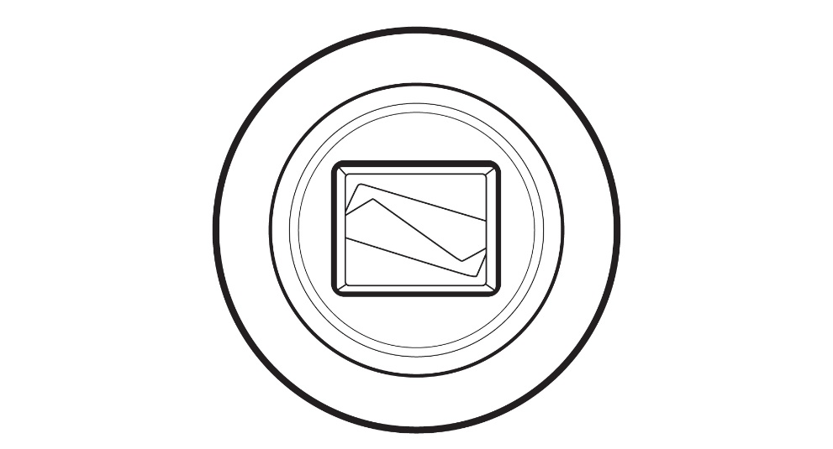

Distance Camera, top view (image 9)

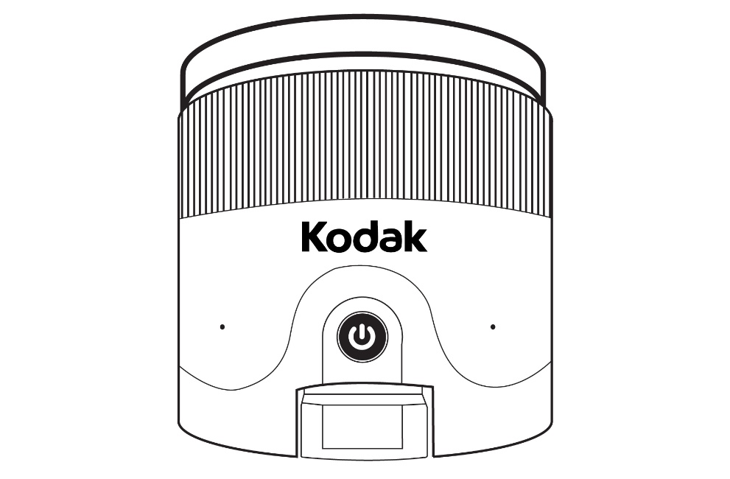
1
2

- Power button
- Microphones
Distance Camera, left view (image 10)
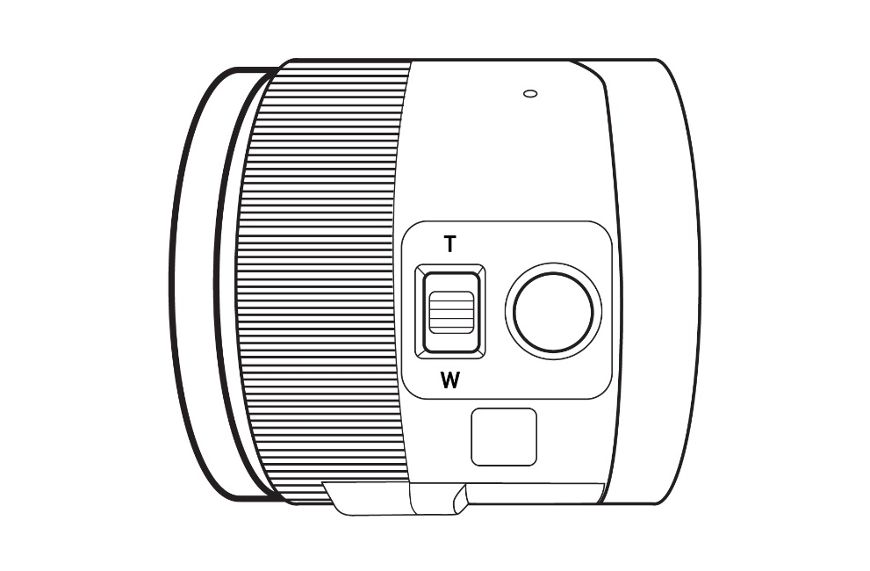
1
2
- Zoom controller
- Shutter button

IMPORTANT: Retain the Quick Start guide provided with your distance camera as it contains the camera’s pairing information.

Setting up

On a flat, stable surface (table, desk) hold the stand upright, making sure the panel with the word “Connect” is facing toward the back. Hold the handle with one hand and unfold the lower panel with your other hand until it lies flat on the table.

Folding stand, closed position (image 11)
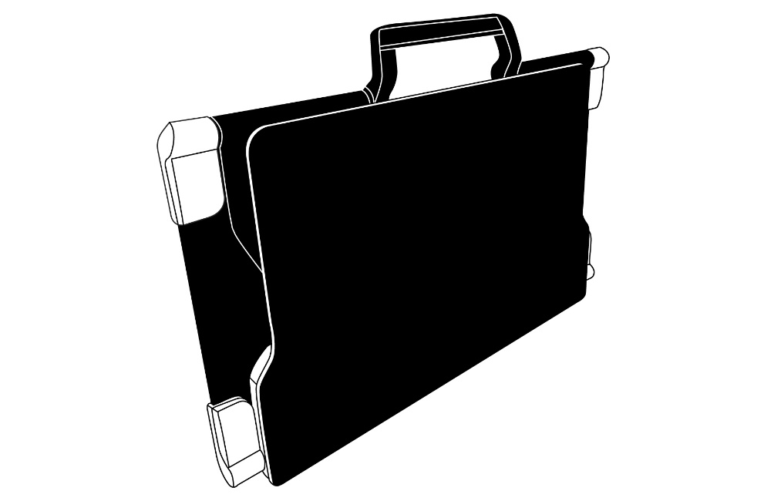

Folding stand (image 12)

Lift and unfold the top panel until it is roughly parallel with the lower panel.

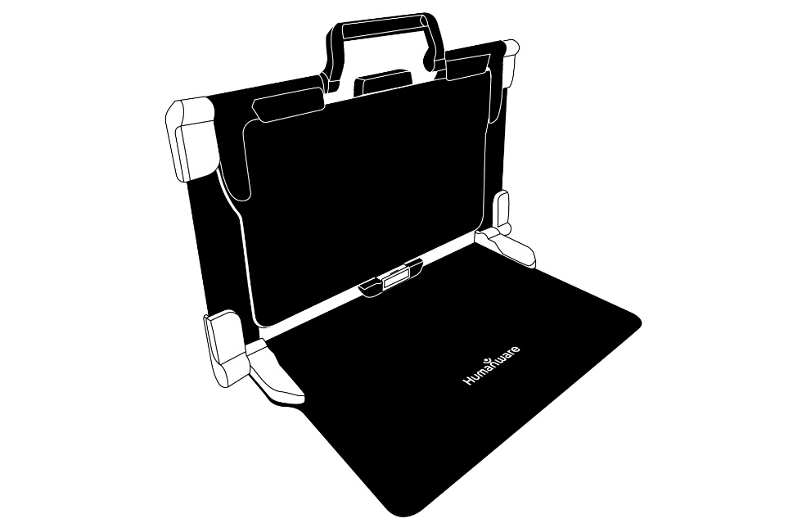

Folding stand, open position (image 13)

Folding stand with Tablet (image 14)

Hold your Connect 12 tablet with the screen side facing you (the HumanWare logo should be at the top, center of the device frame). Carefully align and insert the top of the tablet with the ten connector pins located at the top, center of the stand. Press the bottom of the tablet down until you hear a click indicating that the tablet is secured. To undock the tablet, place your thumb on the orange clip and slide it downward, toward you.

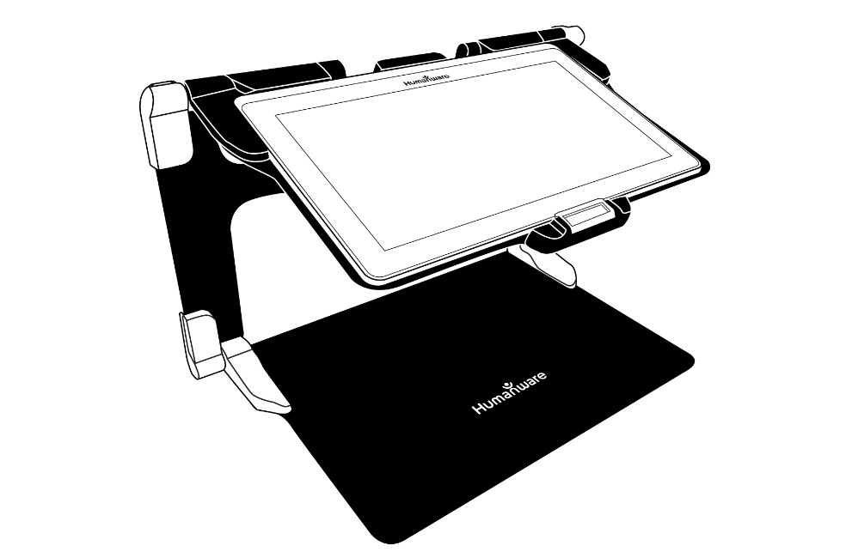

The USB-C port is located on the right side of the tablet. Connect the USB to USB-C cable to the USB-C port and plug it into an outlet using the power supply. Charge the battery to full capacity (a full charge requires approximately 4 hours).

USB-C cable and USB-C port (image 15)
Carefully insert the cable into the USB-C port.

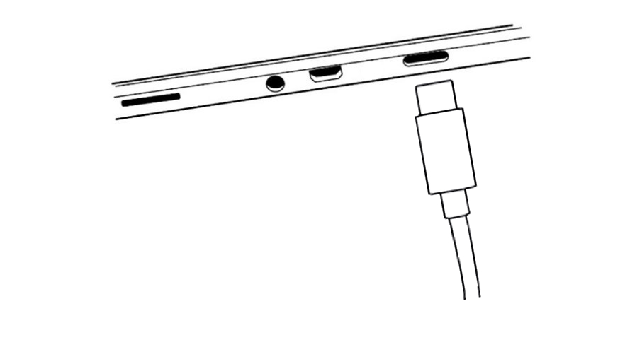
IMPORTANT: Only use the power adapter and cable provided with MATT-Connect. Use caution while inserting the cable into the USB-C port.

Powering On
Press and hold the power button for two to three seconds (refer to image 2) to power On the tablet. The HumanWare and Android logos will appear on screen and the tablet will take approximately 45 seconds to initialize.

Chapter 3: Using Prodigi software

Initializing the connect 12 tablet
To access detailed videos of the tablet initialization process, visit HumanWare’s Connect 12 support page (www.humanware.com/connectsupport) or HumanWare’s YouTube channel.
Note: The Connect 12 tablet must be initialized through the Android set-up wizard before Prodigi software can be used. The process is like setting up any new personal computing device, so be prepared with Wi-Fi and network passwords as well as Google account information. It is recommended to associate both Wi-Fi and Google accounts during this process.
Some steps in this process will take a few minutes.
Upon completion of the Android wizard, you will be prompted to install Prodigi software, simply follow the onscreen prompts.
Once Prodigi software is installed, the system will check for updates, then you will be prompted to choose and install a voice or several voices (four voices, maximum).
Finally, you will be prompted to choose your Home application. In most cases, we recommend Prodigi software.

The ICON Banner
Most of Prodigi’s features are accessed via the Icon banner located at the base of the screen.
Tap the Open Banner icon (refer to image 16) or swipe upward to display the Icon banner.

Open Banner icon (image 16)

To hide the Icon banner (in order to view the entire screen), swipe downward on the Icon. The Icon banner will be replaced by the Open Banner icon at the base of the screen.
Icon banner (image 17)

Magnifying Mode

Step 1: Tap the Magnifier icon

Step 2: Tap the Settings icon (refer to image 4)

Step 3: Scroll to Camera in Settings and toggle between Camera: Rear and Camera: Front

When using the rear-facing camera (image 3), align the tablet above the document or object that you wish to view.
When using the front-facing camera (image 1), place yourself in front of the tablet for a mirror/self-view.
Note: the OCR (Optical Character Recognition) feature is automatically disabled when using the Front-facing camera.
You can also access the front/rear camera option with a long press (3 seconds) on the Camera icon.

Move the object or document under your tablet to localize text or visual features.

Tap the Zoom In or Zoom Out icons to adjust zoom level. The Zoom In icon (+) increases image/character size, the Zoom Out icon (-) decreases image/character size. You can also tap and hold the icons to progressively and incrementally adjust the zoom levels. Release once you reach the desired zoom level.

In addition to the Zoom In/Out icons, you can employ the pinch and zoom gesture to adjust the zoom level. Decrease the distance between 2 fingers to zoom out, and increase the distance to zoom in.

Pinch and Zoom gesture (image 18)

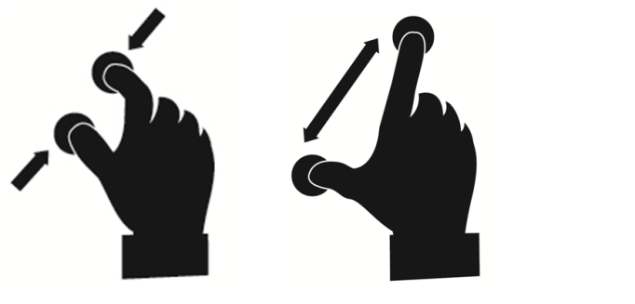

Autofocus
Prodigi software allows you lock or unlock autofocus. This is useful when a document is correctly focused and you need to lock its position, or when you are performing a task like writing on a piece of paper and want to prevent your tablet from refocusing on your hand or pencil.
To lock autofocus, double tap (tap twice quickly) anywhere on the screen. The following icon will appear on the top, right side of your screen.

- Double tap again anywhere on the screen to unlock autofocus. The Autofocus icon will disappear.

Capturing Images and Text
Using the folding stand, position the tablet above a document or object that you wish to capture.
Note: The tablet does not need to be perfectly aligned above the document. By default, Prodigi will automatically correct the angle of your tablet.
On screen, two, dark triangular shapes on each side of your document will indicate angle correction. You can disable this feature this by tapping the Settings icon, swipe up to select Angle Correction and select Enable or Disable. Tap Back to exit.
Tap the Capture icon to capture your document or tap and hold your finger on the screen for 2 seconds. You will hear a camera shutter sound, followed by a clicking sound, indicating that the document has been captured.

Once you make a capture, the Lightbulb icon will be replaced by the Save icon. Tap this icon to save the capture in the Gallery.
- Tap the Save icon to save your document in the Gallery for future use.

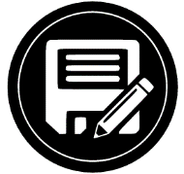

- Tap the Back icon to return to Magnifier Live mode.

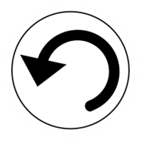

Full Page Capture
Capturing a full page
- Instead of laying your sheet vertically, place your sheet sideways (landscape position) so that the top of the page is located at the left edge of the tablet, and the bottom of your text is located at the right edge of the tablet.
- From Magnifier mode, tap the Zoom Out icon once. This will activate Full Page view and reduce the button banner.
- Align your page under the stand so that all the text is displayed.
- Tap the Capture icon or press and hold your finger down on the screen to perform a capture.
Tip: To capture more text, raise the tablet away from the document, allowing for a wider-angle view.

To return to Live mode and capture smaller objects or documents, tap the Button Banner to open it and press the Zoom In icon once.

Multi-Capture
To capture a multipage document, toggle to Multi-Capture mode by swiping vertically on the left side of the tablet’s screen:

Multi-Capture mode (image 19)

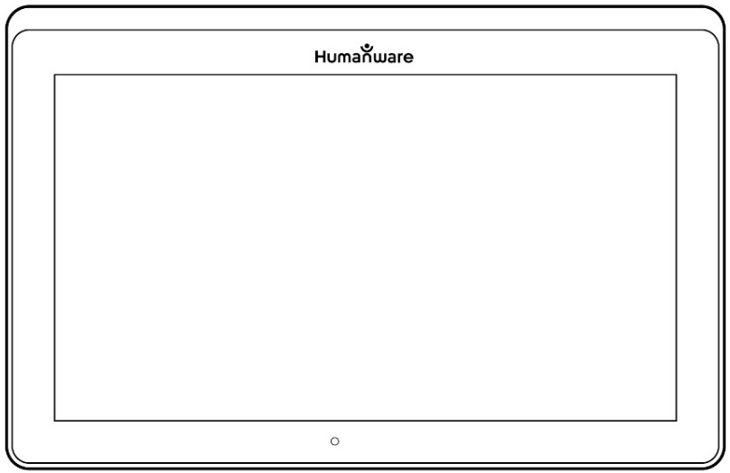

Note: You can also toggle to Multi-Capture mode from Settings. Tap the Settings icon, deliberately swipe up to select Mode, and tap to set it to Multi-Capture. Tap Back to exit Settings.
- You can now capture a multipage document. Align the tablet above the first page of the document that you wish to capture and tap the Capture icon or press and hold your finger down on the screen. Proceed in the same way for each page. Your multipage document will be saved in the Gallery.

- Tap on the Gallery icon to view captures.

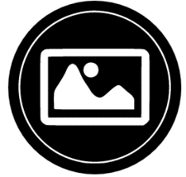

- Tap on the first page of your document to open it.

Reading A Document
Once you make a capture, the Capture icon will change from the Capture icon to a Play icon. This is now the Read icon.

- Tap the Read icon to start reading.

- Tap Read or long press anywhere on screen for 2 seconds to scroll and read aloud the text according to your reading preferences. You can also perform a long press on a specific word in the document to start reading that word.

Note: When you tap the Read icon, the Button banner will collapse to provide a larger view of your image. It can be re-opened by tapping the Open banner icon or by doing an upward swipe on the lower section of the screen.

- To adjust the volume, use the Volume Down-Up button (see image 2).
- To pause, tap the Read icon again or long press anywhere on the screen.
- While paused, tap the Back icon to exit reading view, and Back again to return to the camera view.

- To resume, tap the Read icon again or long press.

When in Magnifier mode, Reading mode allows you to zoom in and out of your captured document.

Zooming in/out of a captured document

- Use the Zoom In/Out icons to adjust the zoom level. To increase character size, tap the Zoom In icon (+). To decrease character size, tap the Zoom Out icon (-). You can also tap and hold the Zoom In/Out icon to adjust the zoom level incrementally and progressively. Release once you reach the desired zoom level.
- In addition to the Zoom In/Out icons, you can use the pinch and zoom gesture to adjust the zoom level.
- To instantly zoom to an area of interest, perform a single tap on an area that you wish to view and the image will zoom in at that location at your preferred zoom level.
- If you zoomed over level 1X, you can move around your zoomed document by doing a Pan Gesture (slowly move your finger on the screen without lifting it).

Pan gesture (image 20)

- You can also pan to reach other parts of an enlarged image.
- To toggle between the different contrasts, deliberately swipe the right edge of the touchscreen or access Settings.

Settings gesture (image 21)

Note: Text can be set up in 3 different formats (Reading Modes). Access Settings to select single line in Line mode, a column in the Column mode (default), or you can read text without losing its configuration in Page mode. Two “greater than” signs will identify the end of a paragraph in Line and Column modes (˃˃).
Prodigi software will beep to announce “End of document” when you reach the end of your document. Tap Read to read from the beginning of the document again.
- To set a different Reading Mode, tap the Settings icon and swipe up to select Reading Mode.

- Tap Reading Mode to toggle the value. Tap Back to exit Settings.
- You can temporarily increase the Speech Rate while reading by sliding and releasing your finger to the left on the touchscreen and decrease the Speech Rate by swiping to the right. Note that changing the Speech Rate will change the reading speed (text scrolling speed) accordingly.

Text Scrolling Speed gesture (image 22)

You can also increase or decrease the Speech Rate permanently from Settings. Tap the Settings icon, select Reading Speed, and select a value. Tap Back twice to exit Settings.

You can change the reading speed (text scrolling speed) by swiping left or right, or from the Settings even when speech is deactivated.
- To toggle between Speech On and Off, simply double-tap on the screen while reading. Alternatively, tap the Settings icon, select Speech, and select Documents Only or Off.
- Prodigi software allows up to 4 different voices that can be used to read text documents aloud. To select a different voice, tap the Settings icon, select Voice, and tap to toggle and select from the 4 voice options.
- Tap Back to return to your document.
- Tap Back to stop reading and return to camera view.

Note: Ensure that the language of the selected voice is the same as in the document that you want to read.

Handwriting Tool
Connect 12 features a handwriting tool that is useful for highlighting, drawing and writing text on your captured images.

Opening the Handwriting Tool
- Open a saved image from the Gallery or save a captured image in the Magnifier.
- Tap the Handwriting Tool icon from the Button banner.

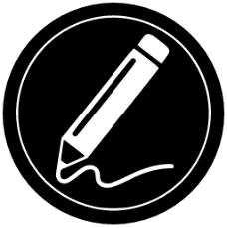

Once in the Handwriting Tool, you will notice 4 new icons (along with the Back icon) in the button banner.
The Tool Selection icon allows you to select between the Pen, Highlighter, or the Text Tool. Tap the icon to toggle until you have the appropriate Handwriting Tool.
The Pen, Highlighter and Text tool icons are shown below.

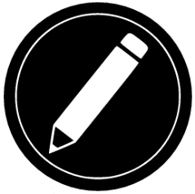

The Eraser Tool is used to erase pen/highlighter strokes and text.

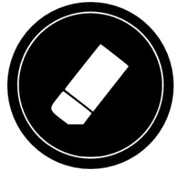

The Highlighter Color icon opens the color menu. Tap it to choose the color of your selected tool.

The Highlighter Width icon opens the width menu. Tap it to choose the width of your text or the pen/highlighter strokes of your selected tool.

Using the pen or highlighter
- Select either the pen or highlighter by tapping the Tool Selection icon on the Button banner. Drag your finger on the screen to draw strokes with the pen or highlighter.

Erasing text or pen/highlighter strokes
- Tap the Eraser Tool icon
- Drag your finger over what you wish to erase.
- When you are done, deselect the Eraser Tool by tapping the Eraser Tool icon again.
Note: The Eraser Tool will only erase strokes of a selected tool type.
Writing text
- Select the Text Tool by tapping the Tool Selection icon on the button banner.
- Press and hold your finger on the screen where you want to write your text.
- A virtual keyboard will appear on screen, use it to enter your text. You can also use a physical Bluetooth keyboard if you have one paired with the Connect 12.
- When you are finished typing, press the Paper Plane icon on the top, right of the screen to validate your text. Alternatively, you can press Ctrl + Enter to validate your text if you are using a Bluetooth keyboard.

Moving text
- Tap the Tool Selection icon.
- Tap once on your text to select it. A red box will appear around your text meaning that it is selected.
- Drag your text to position it.
- Tap anywhere on the screen to deselect your text.

Resizing text
- Tap the Tool Selection icon.
- Tap once on your text to select it. You will see a red rectangle around your text which means it is now selected.
- Change the text size by making a pinch gesture: decrease the distance between 2 fingers to reduce text size, or increase the distance to enlarge your text.
- Tap anywhere on the screen to deselect your text.

Panning in an image that is being edited
- Place two fingers on the image.
- Drag your fingers up, down, right or left.
- When finished, lift your fingers from the image.

Note that if the distance between the fingers varies while panning, the image will zoom in or out.

Configuring and using the Rapid Toggle Feature
Rapid Toggle allows you to quickly access your favorite applications by swiping across the screen.

The Rapid Toggle feature

- From the Carousel Menu, tap the Settings icon, then tap Applications.
- Tap Rapid toggle.

To enable the Rapid Toggle feature, you must select at least one application. You may use Search to manually type the application you wish to add, or select Application to select as many applications you wish from the list.

Place 2 fingers at the middle, left of the screen (refer to image 23), and dragging them towards the right of the screen. Prodigi will detect your swipe and toggle to the next app that you selected from the list.

Rapid Toggle gesture (image 23)
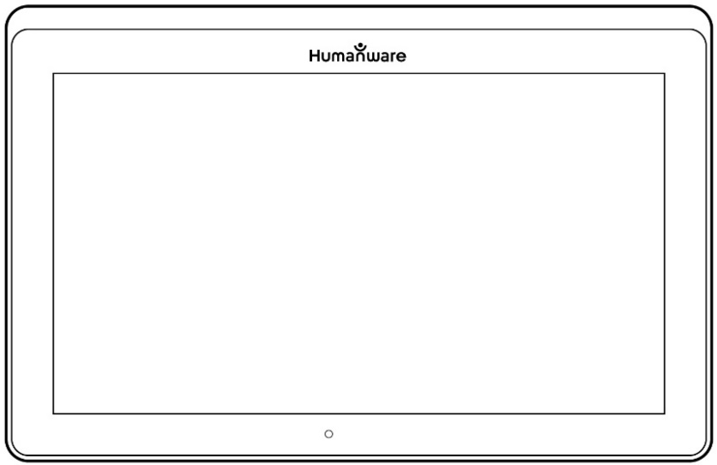

- You must swipe every time that you want to toggle. Rapid Toggle will toggle to the next app using the same order in which you selected them.

The Rapid Toggle can be used from any application.

Activating the Blue Light Filter
Blue light is known to reduce the production of melatonin (a sleep-inducing hormone), so filtering it is a useful way to prevent insomnia.
Prodigi is equipped with an intelligent blue light filter that allows you to reduce the amount of blue light displayed on screen.
- From the Carousel Menu, select Settings icon.
- In the Settings menu, tap User Interface.
- Tap Blue Light Filter.
- Tap one of the five filter levels: Off, Low, Medium, High and Max.

Using the Carousel Menu
Prodigi software offers 10 applications:
- Apps access
- Quick access
- Calculator
- Dictionary
- Books
- Distance camera (optional)
- Magnifier
- Gallery
- Settings
- Help
Application icons appear here, in the same order as listed above:
Accessing the Carousel menu from the Magnifier
- Tap Back icon to shut down the Magnifier app and access the Carousel menu.
Prodigi will announce “Main Carousel” and display the current application.
- Swipe left or right in the Carousel menu to select an application.
- To launch a selected application, tap it.
- To return to the Carousel menu, tap Back icon.
Tip: You can access the Carousel menu from anywhere in the system by double tapping with two fingers anywhere on the screen.

Downloading Books
Prodigi’s Books application allows you to download eBooks, magazines and other periodicals provided by various libraries.
- Select and tap the Books icon in the Carousel menu.
- When launching Books, you must select one of the Books or Subscriptions providers from a list. To do so, select Manage libraries, then select Book providers or Magazine providers.
- Tap any library and authenticate with the username and password that you have been provided with by that organization. First, enter your username and tap the blue button on the right side of the keyboard. Then, enter your password and tap the blue button again. Your login information will be saved.
Note: Your password will be hidden by default. Tap the Eye icon at the right of the password field to show your password in clear text. Tap again to hide your password.
After authentication, tap the Back button twice until you return to the main Books menu. Each library for which you have established a successful login will appear on the list.
Note: Each library has different search fields, they can offer look-ups by Title, New releases, Author, Keyword, Category, Content, ISBN number, etc.
- Tap the Download icon to download a book. The book will be added to My Books submenu.
- To read a downloaded book, select My Books submenu and tap the book title from the list of downloaded books.
To download a magazine or newspaper, you need to subscribe to the periodical by going into the Periodicals submenu, select a category, tap the periodical that you would like to subscribe to. A check mark will appear on the right and a popup window will inform you that you have added the periodical to your library.
- Tap on Back icon twice to go back to the Books main menu.
- To read a downloaded magazine or newspaper, select My Subscriptions, select the magazine or newspaper, tap on the issue that has an arrow on the right of its issue date.
- Once the download has completed, tap Read to start reading.
- Tap Read again to pause. You will then be able to swipe left or right to navigate between the book’s pages.
- You can also navigate by chapter by tapping the Books Navigation icon in the button banner.

- Book chapters will be displayed, swipe up or down to select a chapter.
- Press Back icon to exit and return to your book list.

Go to page feature
The Books application in Prodigi has a Go to Page feature that allows quick, easy navigation to any page within a book.
Note: This function only works for books that have pagination and/or a table of contents.
Navigating a table of content
- When a book is open, tap the Navigation button and select Table of Contents.
- Tap on the section or chapter that you wish to access.

Go to Page Navigation
- Tap the Books Navigation icon. A menu will open.

- Tap Go to Page. A text field will appear.
- Enter the number or the name of the page that you wish to access and tap the check-mark key on the keyboard. Prodigi will access the book at the selected page.

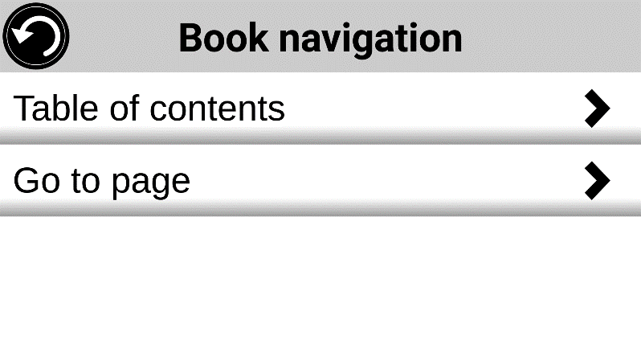
Page list navigation
- Tap the Books Navigation icon. A menu will open.
- Tap Pages List.
- Select the page you wish to access from the list. Prodigi will access the book at the selected page.

Annotate a book
You can add three different types of mark-ups to downloaded books: written notes using the touch screen, highlighting, and typed text notes.

Bookmarks
Use bookmarks to identify specific locations in a book. Once a bookmark is added, you can access it any time, rename it, or delete it.
Adding a bookmark
- Tap the Bookmark icon, located at the top, right of the screen. The bookmark menu will open. Note that if you are navigating in page mode, the Bookmark icon will be visible at the left of the screen.

- Tap Add.
- Enter the bookmark name in the pop-up text field. Tap the Paper plane icon (top, right of the screen) to save the bookmark name.
Note: Bookmark names are limited to 40 characters.

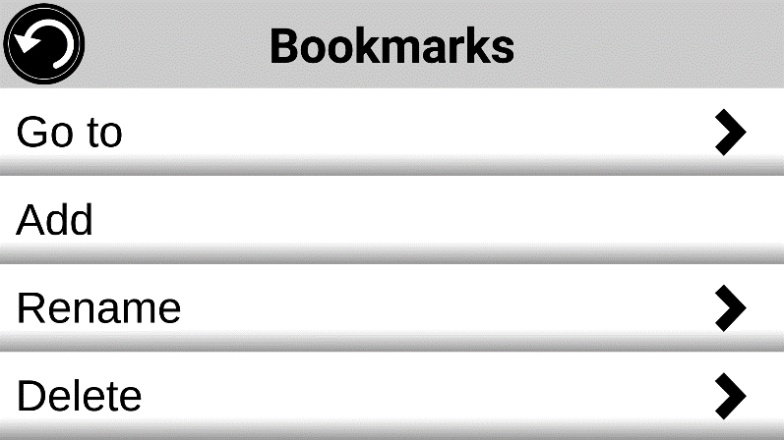

Accessing a bookmark
- While a book is open, tap the Bookmark icon.
- In the Bookmark menu, tap Go to. A submenu will open, listing the bookmarks.
- Select a bookmark from the list. Prodigi will access the book at the bookmark location.
Renaming a bookmark
- While a book is open, tap the Bookmarks icon.
- In the Bookmark menu, tap Rename. A submenu will open listing all the bookmarks.
- Select the bookmark that you wish to rename.
- Enter the new bookmark name in the text field. Press the Paper plane icon to confirm the new bookmark name.
Deleting a bookmark
- While a book is open, tap the bookmarks icon.
- In the bookmark menu, tap Delete. A submenu will open, listing all the bookmarks.
- Select the bookmark that you wish to delete.
- Prodigi will prompt ‘Are you sure you want to delete this bookmark?’. Tap Yes to confirm.
- Alternatively, scroll down to select the item ‘Delete all bookmarks’ to delete all of the bookmarks in the book.

Using Applications Access
Prodigi allows you to access all the applications that you would normally find on an Android smartphone or tablet.
Accessing applications
- Tap the Applications icon in the carousel or the tile menu.

- A new menu appears, offering two different options to access an application: Search and Show All.
  - The Search option allows you access the application that you are looking for by typing its name.
  - The Show All option displays a list of all of the installed apps on your Connect 12 tablet.
- Select an application and tap its icon.
If an application you are looking for does not figure on the list, you can download it from Play Store. Once the download and installation are completed, the application will be added to the list.
- Tap the Back icon to return to the Carousel or Tile menu.

Using Quick Access
Quick access allows access to frequently used applications.
Adding an application to the Quick access menu
- Tap on the Quick access icon in the Carousel or the Tile menu.
- Tap Add icon.
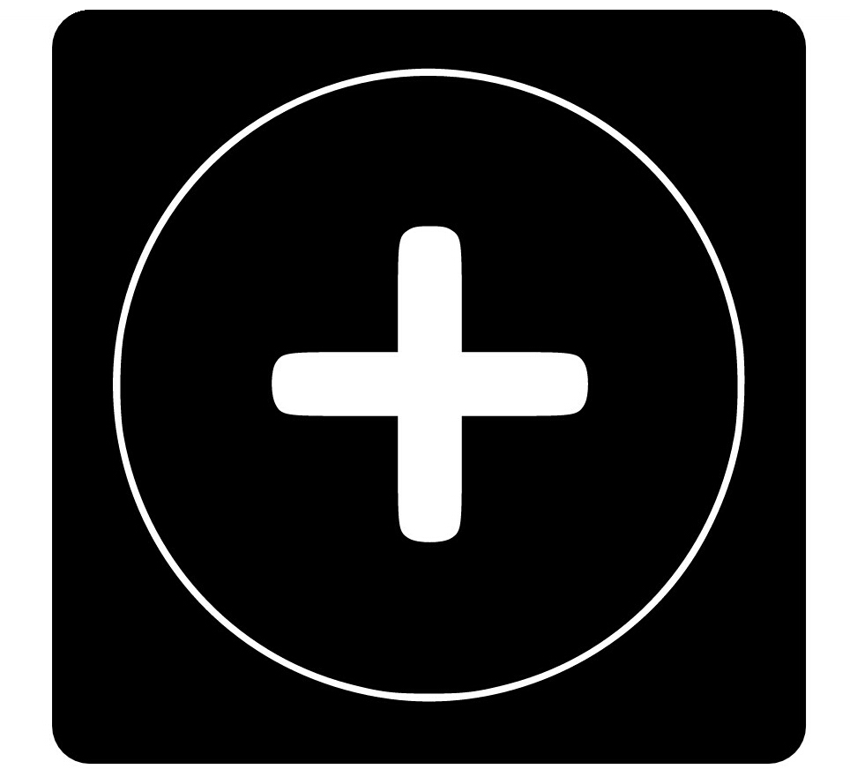
A new menu appears, offering two different options: Search and Show.

  - The Search option allows you access the application that you are looking for by typing its name.
  - The Show All option displays a list of all the installed apps on your Connect 12 tablet.
- Select an application and add it to the Quick access menu by tapping its icon.
- If you wish to remove an application from the Quick access menu, press and hold on the application icon, then tap Delete.
- If you wish to move or delete the application, press and hold the application, then select Switch or Delete.

Using the Calculator
Prodigi software features a Calculator application.
- Select and tap on the Calculator icon in the Carousel or the Tile menu.

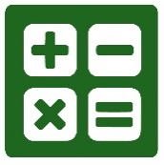

- Tap the numbers and signs. Your calculation will appear at the top, right of the screen.
- Tap DEL to make corrections (one digit at a time).
- Tap CLR to clear the total.

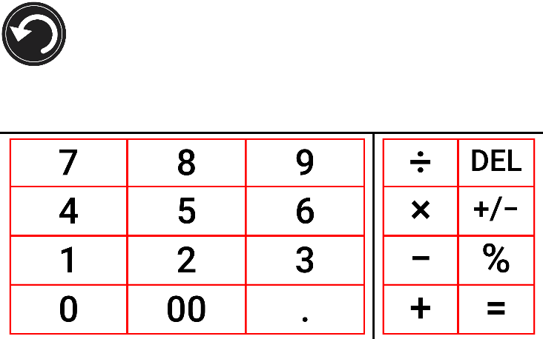

By default, the Calculator is set to standard mode. Tap Settings, then Mode and select from Standard, Scientific or Graphing calculator mode. Tap the Back icon twice to return to the Calculator.

Graphic Calculator Powered by Desmos

By integrating Desmos’ graphic calculator to the Connect 12, users can draw graphs directly on the tablet or by entering their equation.
Note: When in Scientific or Graphing modes, tap the opposing arrows key at the base of the keypad to access scientific or mathematical functions.

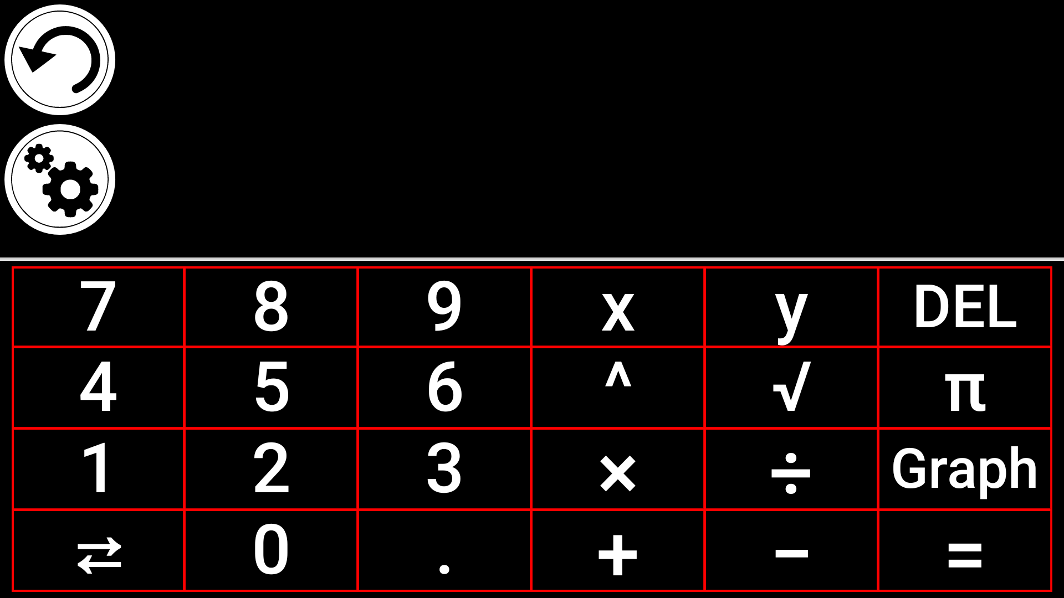

To draw a graph, write a valid equation (example: 3x+2=y) and tap Graph.
The result will display as follows:

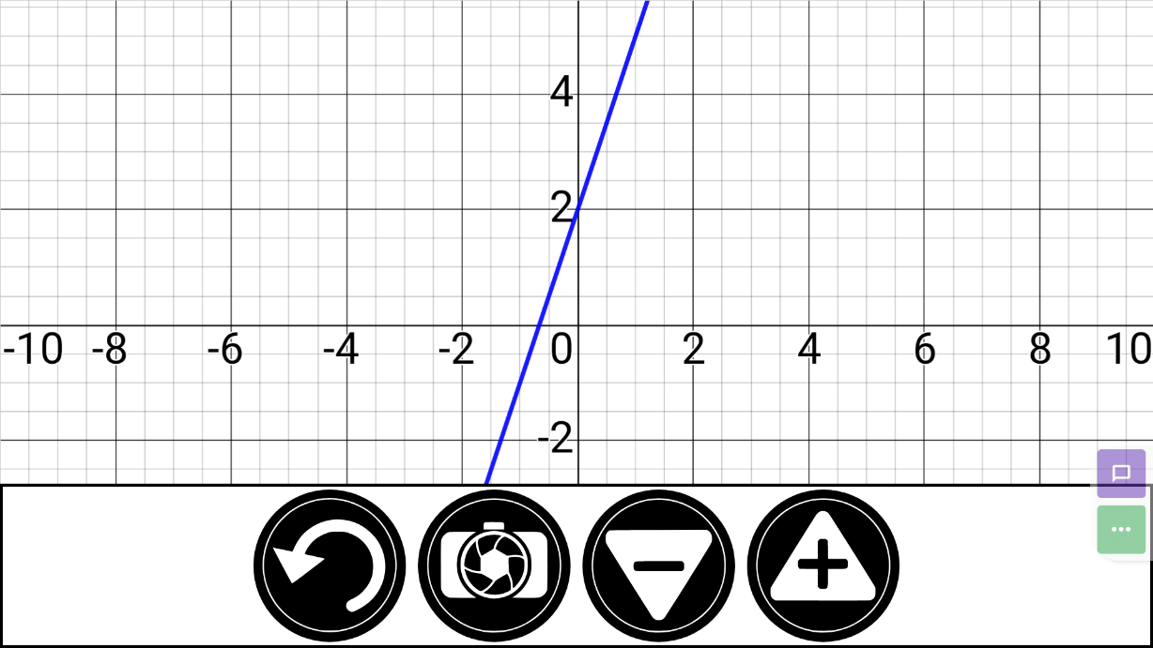

- Tap the Plus and Minus icons to zoom in and out of the graphic. Swipe your finger on screen to pan the graphic.
Additional mathematical operations are available by tapping the opposing arrows key at the base of the keypad.
When a Graph is displayed on the screen, it can be captured and saved in the Gallery under the Screenshots folder.

Dictionary Tool
The Dictionary Tool, developed in partnership with Accessbyte and powered by Oxford Languages, is a convenient, time-saving feature that can be accessed via the Carousel menu and used as any other electronic or on-line dictionary.
Searching for a Word
- Tap ‘Search for a word’ (or the magnifying glass icon at the top, left of the screen), then enter a word in the pop-up keyboard and tap Search.

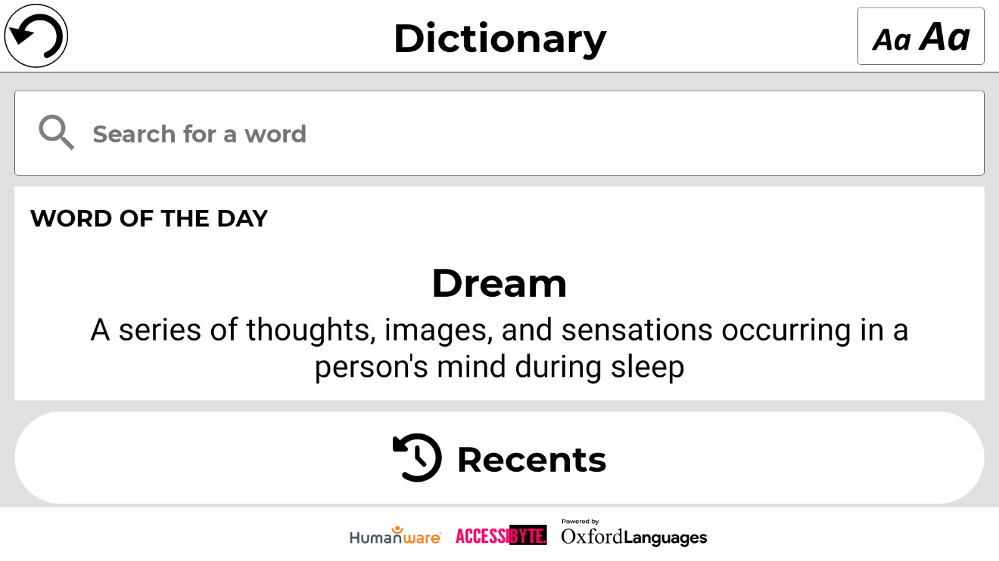
A suggestions list will appear including the word that was typed in the search field (that word appears at the top of the list), as well as other similar words. Note that the suggestions list can vary in length depending upon the number of variants found in the dictionary.
- Tap a word that appears in the suggestions list and the definition will automatically display.
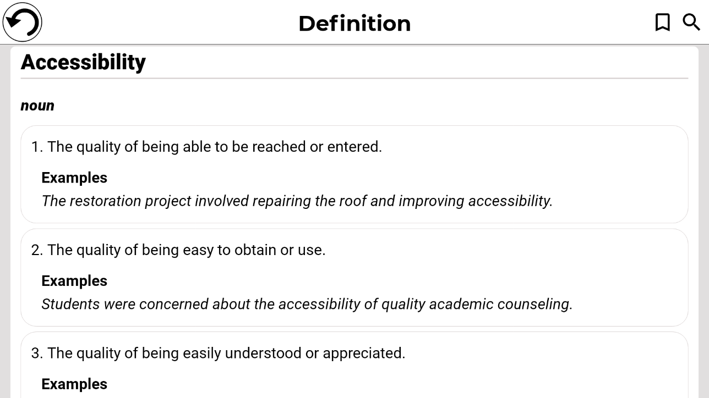

Users can save word definitions to a word list via the Bookmark icon at the top, right of the page.
- Tap the Bookmark icon (top, right of page)
The ‘Add to which list?’ pop-up box will appear.
- Tap Create New List.
- Enter the list name in the ‘Save word to list’ pop-up box.
- Tap Save.
The word will be saved to the list and can be accessed by tapping the Bookmark.
Multiple lists can be created and saved, for example: subject area specific, regularly used words, technical terms, cooking tools or nautical hardware terminology, etc.
Tapping the Magnifying glass icon (next to the Bookmark icon) will take you back to the ”Search for a word” page so that you can search for another word.
Adjusting Font Size in the Dictionary Tool
The main page includes a font size selector icon at the top, right of the page.
- Tap it repeatedly to cycle through three available font sizes (small, medium*, and large). Stop at whichever size suits your needs.
The main page also features a Word of the Day. This is a random word selection and corresponding definition, that updates daily.
On the same page, the Word Lists icon appears below Word of the Day. Tapping it will bring up all word lists that have been created.
The Recents icon appears under Word Lists. Tapping it will display your recent word searches.
Language Selection (default US English)
- On the Dictionary main page tap the “Search for a word” box.
- Change the dictionary language by tapping the oval icon at the top, right of the screen. This will take you to the Dictionary Languages page.
- Select and tap one of the four language options.
- Tap the back arrow (top, left of the page) to return to the “Search for a word” page.

Show / Hide Option
By default, the Dictionary icon is included in the Prodigi Carousel, however, the icon can be hidden to simplify the interface.
- Tap Settings in the Carousel. Scroll to and tap Applications.
- Tap Show (available options are Books, Calculator, Dictionary).
- Uncheck Dictionary.
- Tap the Back icon three times to return to the Carousel menu (the Dictionary icon will no longer appear).
- To return the icon to the Carousel menu, follow the same process, but ensure that Dictionary is checked.

Viewing Saved Documents
All saved documents reside in the Gallery.
- Tap the Gallery icon in the Carousel menu.

- Swipe left or right in the Gallery to flip through saved documents. Note that screenshots taken on the device are saved in a Screenshots folder.
- The currently selected document is in the center of the screen. Prodigi displays the first word contained in the selected document. If the document does not contain words, Prodigi will tag it as an image.

A notebook icon indicates a multipage document.

- Tap to open a selected document.
- Tap somewhere on the document to view that section at your preferred zoom level.
- You can toggle between color, positive, negative, and Diamond Edge™ (if the image contains text) contrasts and adjust the brightness the same way as the Magnifier (refer to Magnifier section for more information).
- When zoomed at 1X or above, you can reposition a document with a Pan gesture.
- Tap Back to return to full image view.
- When in full image view, tap Back twice to close a document and return to the Gallery.

Gallery Settings Menu
To access the Gallery settings, tap the Settings icon at the top right corner of your screen while in the Gallery.
The Gallery’s Settings Menu allows you to:
- Create categories and subcategories (folders)
- Create a new page
- Create a new document
- Import
- Delete gallery content

Action Menu
The Gallery features an Action Menu that includes many useful functions for your saved documents. To access the Action menu, long press on a captured image, a document or category icon in the Gallery. You will be directed to a menu listing available actions for your selected file.
In the Action menu, you can:
- Share an image through other Android applications.
- Renumber the first page of a multi-capture document.
- Rename a document or category.
- Delete a document, category, or specific content in a category.
- Move a document to a category.
- Export a document to a JPG, text or PDF file in the Android file system or an external drive.
- Move an image captured with the distance camera to the Gallery for Diamond Edge processing.
- Delete, replace or insert pages in a multipage document.
- Run the OCR on a PDF document (useful when parts of a PDF document are not properly rendered, usually within tables).

Sharing an image through other Android apps
- Long press on the image that you want to share.
- Tap Share.
- Select PDF or JPG format.
- Select the app through which you wish to share your image (example: Gmail, Maps, Google Drive) and proceed as you normally would with the chosen app.
Deleting a document, a category, or the content of a category
- Long press on the document or category that you want to delete.
- Tap Delete.
- Tap Yes to confirm deletion.
To rename a document
- Long press on the document or category that you wish to rename.
- Tap Rename.
- Enter the new name of your document or category.
- Tap Enter.
To move a document to a category
- Long press on the document you want to move.
- Tap Move.
- Select and tap the new category that you wish to move your image to.
To import a JPG, Text or PDF file from an external drive to the Connect 12
To make your USB key detected by the system, you need to modify the USB settings in the Android system.
  - Press and hold four or five fingers on your screen. A page displaying all the Android apps will appear.
  - From the apps page, select Settings.
  - In the Device list of the Settings menu, select USB.
  - At the top of the screen a message will display: “USB is connected to the computer”. A toggle at the right of the screen allows you to change it to “USB is not connected to the computer”.
  - Tap on the circle at the bottom of the tablet to go back to Prodigi.
- Insert your USB key in the USB-C port at the right of the tablet. If your USB key is not compatible with a USB-C port, use the USB to USB-C connector.
- Select and tap on the Gallery icon in the Carousel menu.

- Tap the Settings icon at the top-right of the screen, then select Import.

- Two storage options will be displayed: the Internal storage and Store N Go, corresponding to your USB key. Tap the Store N Go option.
- Your USB key will appear. Tap its name, then tap Select to open it. All the folders and files stored on your USB key are now accessible.
- Select and tap files to import to the Gallery. They will be automatically downloaded on your Connect 12.
Exporting a document to a JPG, text or PDF file in the Android file system or an external drive
- In the Gallery, press and hold on the document that you wish to export.
- Tap Export.
- Select in which file type you wish to export your document. It is possible to modify some JPG and PDF settings by pressing and holding either the PDF or JPG option (advanced users only).
- Select the Internal storage to export to a specific folder on the device. You can also select the USB device option if a USB key is placed in the USB port of the tablet to export it to the USB thumb drive.
Moving an image captured with the distance camera to the Gallery
- In the Distance folder, hold your finger on the image that you wish to move.
- Tap Move to Gallery.
The image will be analyzed to find text and display Diamond Edge if text was found. The file will be renamed to the first found word in document, if text is found, otherwise, the image will be identified numerically.
The file can also be moved to a different Category, if required.
Deleting, replacing or inserting a page in a multipage document
- Open the multipage document that you wish to modify.
- To delete a page, long press on the page and tap Yes to confirm deletion.
- To replace a page, long press on the page you wish to replace. Tap replace, tap Yes and capture a new page.
- To insert a page, long press on the page where you want to insert a new page. Tap Insert and select New Page, New Capture or New Function Graph.
Adding a function graph in a document
While editing a document, you have the option of adding a function graph.
- Tap the Gallery icon in the carousel menu.
- Open a document.
- Long press on an item inside the document.
- A settings submenu will appear. Select Insert.
- Insert options will appear. Select New Function Graph.
- Prodigi will open the calculator app in the graph mode. Enter a formula and tap the Graph key.
- Prodigi will open the graph view with the user function plotted. Tap Save.
- Prodigi will return to the document with the graph image inserted in the selected position.

Alternatively, if you wish to append a function at the end of a document:
- Tap the Gallery icon in the carousel menu.

- Open a document.
- Tap Settings.
- Tap Append.
- Select New Function Graph.
- Prodigi will open the calculator app in the graph mode. Enter a formula and tap the Graph key.
Prodigi will open the graph view with the user function plotted.
- Tap Save.
The graph will appear at the end of the document.

Using the Distance Camera
The Connect 12 features a distance camera that is useful when you need a better view of something at a distance, such as a slide presentation during a lecture. The distance camera connects wirelessly, has a battery duration of 4 hours and can be positioned up to 30 feet (10 meters) from Connect 12.
IMPORTANT: the distance camera is available as an option and is sold separately. We recommend that you familiarize yourself with its operation by carefully reading the user manual that is supplied with the unit.
- The user manual provides detailed information on how to charge the camera battery before use.
- The distance camera must also be paired with the Connect 12 tablet via Wi-Fi. For detailed pairing instructions, visit the Connect 12 Support page on the HumanWare website. www.humanware.com/connectsupport

Distance Camera set up (image 24)

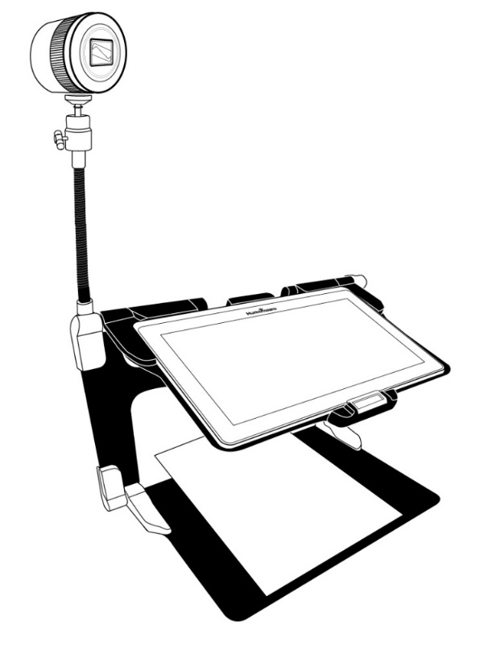
- Refer to image 7: Screw the camera onto the flexible gooseneck and insert the base of the gooseneck into the one of the folding stand tabs (located on the left- and right-hand sides of the folding stand frame.
- Select and tap the Distance Camera icon from the Carousel menu.
- Turn the camera On.
- Align the camera with an object that you wish to view.
You are now in the camera’s live view.
- Refer to image 10: Zoom in or out by adjusting the Zoom controller.
- Press the Shutter button on the camera to take a picture (you will hear a shutter sound).
You can also take a picture by tapping the Camera icon that appears on the Connect 12 screen.

Toggling between the Distance Camera and Magnifier
During a lecture, you may want to switch between the distance camera and magnifier mode to note down what the teacher is writing on the board. To do this, swipe your finger on the screen from left to right (repeat to return to the previous view).

Using the Distance Camera and Magnifier simultaneously
To use the distance camera and magnifier simultaneously, tap the arrow on the right side of the screen and the screen will split horizontally into two with the distance camera in the top section and the magnifier view at the bottom section.
You will notice a red outline around the top or bottom view, this indicates which section is selected. To revert to full screen mode in one of the views, select a view by tapping it twice to return to full screen mode.
To take a capture without leaving split screen mode, select the view that you wish to capture by tapping it, then long-press in the view to take the capture (you will hear a shutter sound).

Viewing Distance Camera Images
Pictures taken with the Distance camera can be viewed in the Gallery.
- Tap the Gallery icon in the carousel menu.

- Swipe to and tap the Distance camera icon.

- Swipe to scroll through the available images.
- Select an image and tap it to obtain an expanded view.

Reading with the Distance Camera
To read a picture taken with the distance camera, you will need to transfer the picture from the Distance category to the root of the Gallery.
- In the Distance category of your Gallery (folder with the spyglass), hold your finger on the image that you wish to move.
- Tap Move to Gallery.
- Your image will now be in the root Gallery where it can be read just as any other document.

Removing Distance Camera from Gooseneck
If you wish to remove the camera from the flexible gooseneck, be sure your camera is turned off, then, with one hand, firmly hold the camera. With your other hand, locate the thumbscrew located underneath the camera and loosen it until the camera is detached from the gooseneck.
Important: The camera is very fragile, be sure that you are holding it properly before removing it from the gooseneck.

Viewing text files in Prodigi
Prodigi allows you to paste text files into the gallery and then open them using the Prodigi interface. Note that this can be done outside Prodigi in Android applications that allow you to copy text (example: Internet browser, Dropbox, or your email).

- Tap the Gallery icon in the carousel menu.

- Swipe to and tap the Text folder icon.

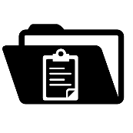

- Swipe to and tap the Paste icon, then tap Paste to enter text copied earlier.

- Your text will appear in Diamond Edge in column reading mode (original layout and images unavailable).
- Tap Back to return to the Text section of the Gallery.
- The text you pasted is saved in the Text section of the Gallery and will be named according the first word of your text.

Exam Mode

Exam mode is used to block certain functions and applications from the Connect 12 for a certain amount of time. While Exam Mode is activated, the blocked functions and applications can only be accessible by entering a predetermined PIN number or by waiting for predetermined time-out.
Activating Exam Mode
- From the Carousel menu, tap the Settings icon.
- In the Settings menu, select Exam Mode item. A submenu will display.
- Adjust the parameters by tapping them and modifying their value. Adjustable parameters include:

  - Exam mode: On, Off.
  - Start Time.
  - Duration: Select a value between 30 minutes and 8 hours.
  - Exit to Android: Tap to enable/disable access to Android while Exam Mode is on.
  - Capture & Gallery: Tap to enable/disable access to the Gallery and the use of captures while in Exam Mode.
  - Calculator: Tap to enable/disable access to the Calculator while in Exam Mode is on.

- Tap the Back icon.
- You will be prompted to enter a PIN code to activate Exam Mode.

Exam Mode is now ready for use.
If you wish to change the parameters or deactivate Exam Mode, follow these steps:
- Tap the Settings icon in the Carousel menu.
- In the Settings menu, tap Exam Mode.
- You will be prompted to enter the PIN number you created when activating Exam Mode.
- You now have access to the Exam Mode submenu, where you can change the parameters or deactivate Exam Mode.

OCR Language Selection
Prodigi allows the use of Optical Character Recognition (OCR) for various languages while using the Magnifier or the Camera.
Enable/disable OCR
- Tap the Settings icon in the Button banner from the Magnifier Application.

- Scroll to and tap OCR, then tap Disabled.

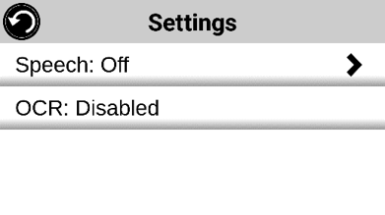

- Prodigi will display in the Settings menu: OCR languages: Installed voices.

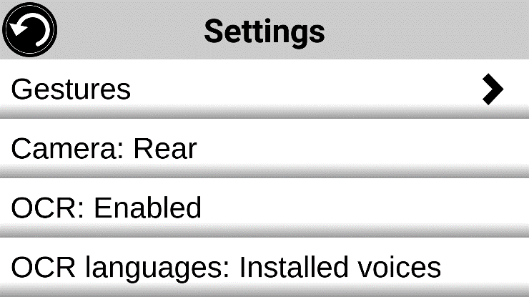

- Tap ‘OCR languages: Installed voices’ to select between Installed voices or Custom. OCR Languages will appear. Tap to view a list of available languages.

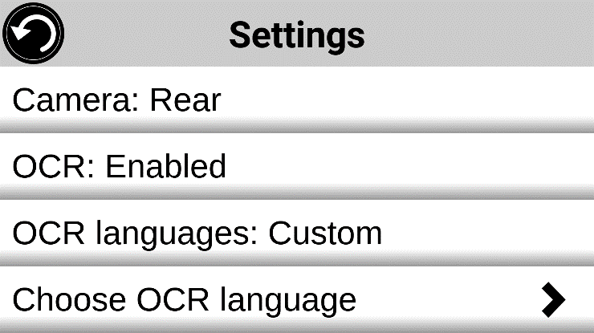

- Select a language from the list.
- Tap the Back icon twice to return to the Magnifier Application.

Chapter 4: Selecting Contrast
Prodigi allows you to view documents, photos and objects in 4 contrast types: color, positive or negative. For text documents, Diamond Edge™ contrast can be used. Positive, negative, and Diamond Edge contrasts enhance the original color of a document or object to improve object/image definition.
Color contrast is useful when viewing documents, objects and photos in their original color.
Positive contrast displays text and images in 2 colors according to your selected color combination (Black on White is the default combination).
Negative contrast displays text and images in reversed contrast as compared to your selected color combination. For example, if your combination is Black on White, negative contrast will show text and images in White on Black. This is useful if you wish to reverse the contrast of text that contains a variety of contrasts or highlights.
Diamond Edge contrast combines the best of both worlds: it displays Diamond Edge Text™ in your selected color combination and images in their original color. This allows you to magnify text to maximum levels without compromising text quality in the best color combination for your vision.
Toggle between different contrasts by vertically swiping the right edge of the touchscreen while magnifying or viewing an image or document.

Swipe for Contrast selection (image 25)

Chapter 5: Standard (tile) Mode
Along with the default Carousel Mode and Simple Mode, Tile Mode is one of the three types of User interfaces that can be used to navigate the Connect 12. Prodigi Tile Mode menu allows you to customize access to the applications that you use most.
Activating Standard Tile Mode
- Swipe to and tap the Settings icon from the Carousel Menu.
- Tap User Interface.
- Select Standard (Tile).
- Tap the Back icon three times to access Tile Mode menu.
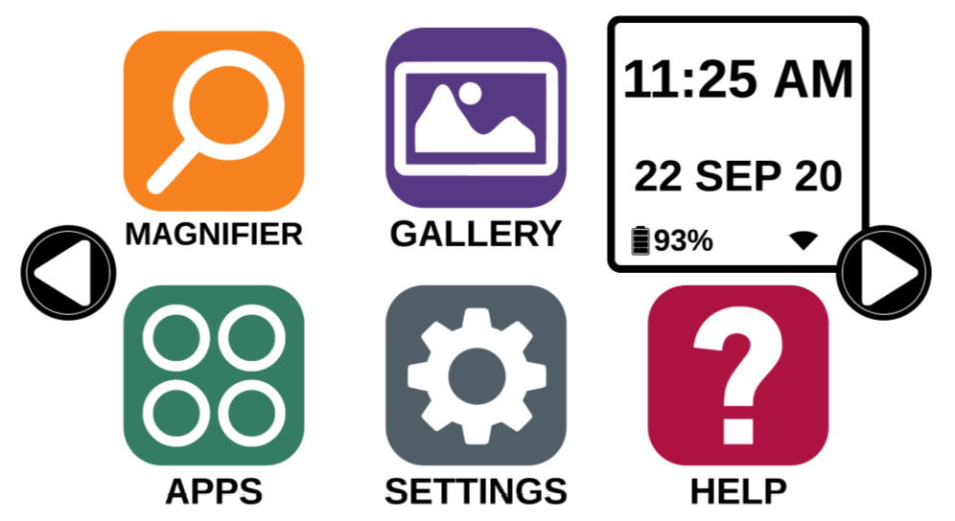
Prodigi applications are now accessible in a series of rotating screens and display six applications per screen rather than one by one. The 9 main Prodigi applications are accessible by default in the Tile menu. Time and date are also displayed at the top, right of the screen.
- Swipe left or right in the Tile menu or tap the right or left arrows on the side of the screen to access the next application screen.
- Tap on any one of the applications to launch it.

If you need to add an application to the Tile menu, tap the Add icon:

A new menu will appear, offering two options to access the application that you wish to add to the Tile menu: Search and Select applications.
The Search option allows you access an application by entering its name via the keyboard pop-up.
The Select applications option displays all the installed apps on the Connect 12 tablet.
- Scroll through the list to find an application to add to the Tile menu by tapping its icon.
- Remove an application from the Tile menu by pressing and holding on the application icon and then tapping Delete when prompted to do so. You also have the Switch option which allows you to switch to a different application.

Chapter 6: Simple Mode

Simple mode allows you to access Prodigi’s applications from the same screen.
Activating Simple Mode
- Swipe to and tap the Settings icon from the Carousel Menu.
- Tap User Interface.
- Select Simple.
- Tap the Back icon three times to access the Simple Mode menu.

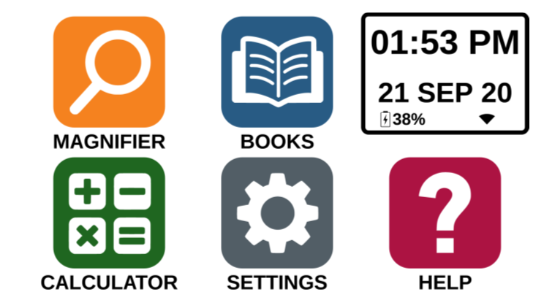

Prodigi applications are now accessible from one screen. Time and date are also displayed at the top, right of the screen.
- Tap on any one of the applications to launch it.
Returning to Carousel (default) Mode
- Swipe to and tap the Settings icon from the Carousel Menu.
- Tap User Interface.
- Select Standard (Carousel).
- Tap the Back icon three times to access the Carousel Mode menu.

Chapter 7: Revising your Settings
Prodigi’s settings menu is contextual, meaning that different settings will be displayed depending on what you are doing or where you are in the system.
- Tap the Settings icon in the Carousel menu.
- Select and tap a setting.
- Tap the Return icon (top, left corner) to return to the Settings icon.

Important: Your navigation mode will be different if your Speech setting is set to Off. There will no longer be a frame, and each menu item will have a shadow below it. In this navigation mode, you can tap an item to select it instead of selecting it with the frame.
Prodigi’s contextual settings are:
Values marked with an asterisk (*) are default settings.
- Screen Brightness: 0 to 100% (50%*)
- Contrast: Diamond Edge (if captured image contains text), Color*, Positive, Negative
- Colors: Black on white*, White on black, Black on gray, Gray on black, Black on yellow, Yellow on black, Black on orange, Orange on black, Black on cyan, Cyan on black, Black on purple, Purple on black, Black on green, Green on black, Blue on yellow, Yellow on blue, White on blue, Blue on white, Beige on black, Black on beige
- Mode (Standard mode only): Live*, Multi-Capture
- Autofocus (Live mode only): Locked, Unlocked*
- Angle Correction: Enabled*, Disabled
- Speech: On, Documents only, Off*
- Voice: Voice 1*, Voice 2, Voice 3, Voice 4
- Speech Rate: Very slow, Slow, Normal*, Fast, Very Fast
- Reading Mode: Page, Column*, Line
- Reading Speed: Very slow, Slow, Normal*, Fast, Very fast
- Diamond Edge: Always*, On Request
- Font Type: Regular, Bold*
- Preferred Zoom: 2x to 35x (4x*)
- Font Size: Minimum, Small, Medium, Standard*, Large, Very large, Extra large, Maximum
- Highlight (Column and Line modes only. Highlight on spoken words): Display*, Hide
- Delete Gallery content (in Gallery): Permanently delete all files in Gallery. Press the Settings button in the Gallery to access this option.
- Wi-Fi Setup: Tap Settings icon to access.
- Wi-Fi: Turn Wi-Fi On or Off.
- Wi-Fi Networks: List of available networks. When connected, displays network that you are connected to. Note that Proxy network connections must be set-up using Android settings.
A more advanced option can be available when selecting a network:
  - Advanced options/IP Settings: Displays the host configuration protocol for the selected network
- Saved Networks: Saved networks configurations. To forget a network configuration, tap network, tap Forget, and tap Yes.
- Mode (in Calculator app, tap Settings to access this option): Standard*, Scientific or Graphing
- Grid (in Calculator app, tap Settings to access this option): Locator color*, Red, Orange, Yellow, Purple, Cyan, Green, Blue
- Usage Data: On*, Off, Details about metrics; you can opt out at any time.
- Gestures (while magnifying, viewing an image, or reading a document, allows you to enable/disable gestures. They are checked by default):
- Swipe on left edge / Mode: Toggle between Live and Multi-Capture modes.
- Swipe on right edge / Contrast: Toggle between Color, Positive, Negative, and Diamond Edge contrasts (The last selection will be saved in Prodigi).
- Pinch and zoom: Adjusts zoom level by decreasing or increasing the distance between two fingers.
- Double tap: Accesses the carousel menu or toggle between Speech On and Off while reading by tapping twice quickly with one finger.
- Tap / Zoom: Tap your finger on the touchscreen to zoom to your preferred zoom level.

You can access other general settings from the Carousel menu by tapping the Settings icon.

Six menus are available: User Interface, Audio, System, Applications, Exam mode, Exit to Android and ‘About’. Scroll through Settings to select a menu or About. Prodigi will automatically display submenus if available and display an arrow on the right edge of the screen. Tap the arrow to access that option in the submenu.
- Tap the Back icon to access a previous screen.
- Tap and hold the Back icon to access the Settings menu.
Prodigi’s general settings are:
(Values marked with an asterisk (*) are default settings.)
User interface
- Interface: Standard (Carousel)*, Standard (Tile) and Simple
- System Language: Language 1*, Language 2, Configuration (connects to the Internet to find downloadable language packs)
- Colors: Black on white*, White on black, Black on gray, Gray on black, Black on yellow, Yellow on black, Black on orange, Orange on black, Black on cyan, Cyan on black, Black on purple, Purple on black, Black on green, Green on black, Blue on yellow, Yellow on blue, White on blue, Blue on white, Beige on black, Black on beige
- Locator color: Red*, Orange, Yellow, Purple, Cyan, Green, Blue
- Blue Light Filter: Off, Low, Medium, High, Max
- Screen Brightness (Change the screen brightness level): 1 to 100% (60%*)
- Button Banner: Auto*, Hide, Always
- Tablet Vibrations: On*, Off
Audio
- Speech: On*, Documents only, Off (see section Speech On to use the Speech On mode)
- Speech Rate: Very Slow, Slow, Normal*, Fast, Very fast
- Sounds: On*, Off
- Tablet/Base Volume: 0 to 15 (9*)
- OCR Sound: On, Off*

System
- Wi-Fi Setup
- Wi-Fi: Turn Wi-Fi On or Off.
- Wi-Fi Networks: List of available networks. When connected, shows network you are connected to.
- Saved Networks: Saved networks configurations. To forget a network configuration, tap network, tap Forget, and tap Yes.
- Bluetooth Setup
- Bluetooth: Turn Bluetooth On or Off. When turned On, your Connect tablet will attempt to discover other Bluetooth devices and be discoverable by other devices.
- Paired devices: Devices currently connected to your Connect 1 and nearby Bluetooth devices discovered by Prodigi.

- Software Update: Cancel, Install
- Tablet Auto Shutoff: 3 min*, 5 min, 10 min, 30 min
- Restore to Factory Defaults: Yes, No

Applications
- Rapid Toggle:
  - Search
  - Select applications

- Books: Checked*, Unchecked
- Calculator: Checked*, Unchecked
- Distance: Checked*, Unchecked (simple mode only)
Exit to Android
Exits Prodigi software. You can return to Prodigi by tapping the Home icon.
About
- Software (Version)
- Voices (Selected voices)
- OCR (Version)
- Books (Version)
- Calculator (Version)
- Distance (Version)
- Prodigi Updater (Version)
- Serial Number
- Model
- Android (Version)
- Android Build (Version)
- Usage Data
  - Anonymous usage data ON
  - Change

Speech On
When Speech is set to On, navigation will be significantly different. Prodigi will read all items visible on the screen for fully assisted guidance.
Within menus
The Speech feature will read the number of items included in the menu and/or submenu selected and then read the first item selected on screen. If that item leads to another submenu, it will also read “submenu”.
Example: Settings Menu > 7 items > User Interface > Submenu
Note that tapping a menu item will not select it. You must swipe up or down to isolate the menu item that you wish to select within the colored frame.
A 2-finger long press anywhere on the screen within a menu will isolate and highlight the Back navigation button. Once Back is highlighted, tap once anywhere on the screen to return to the previous screen.
Within the Tile / Main menu
The speech feature will read the application currently located within the colored frame.
Example, if you open your Connect 12 on the settings icon, Speech mode will read: Main Menu > Settings.
To navigate to other applications, swipe left or right anywhere on the screen. Tap anywhere to launch the application in the colored frame.
To stop using the speech feature and return to regular navigation:
- Tap Settings.
- Select and tap Audio. A submenu will open.
- Select Speech.
- Select Off if you wish to shut down the Speech feature completely, or Documents Only if you wish to use the feature only in documents.

Chapter 8: Bluetooth External Keyboard
The Connect 12 allows you to type and navigate using your own Bluetooth keyboard.

The HumanWare Keyboard
Though any Bluetooth keyboard will work, we recommend the HumanWare keyboard shown below. One of the advantages of using the Humanware keyboard is that all keys are printed in large, easy-to-read characters. In addition, icons of frequently used Prodigi software commands are printed on the keyboard as a quick reminder of the key’s function.
HumanWare Keyboard (image 26)

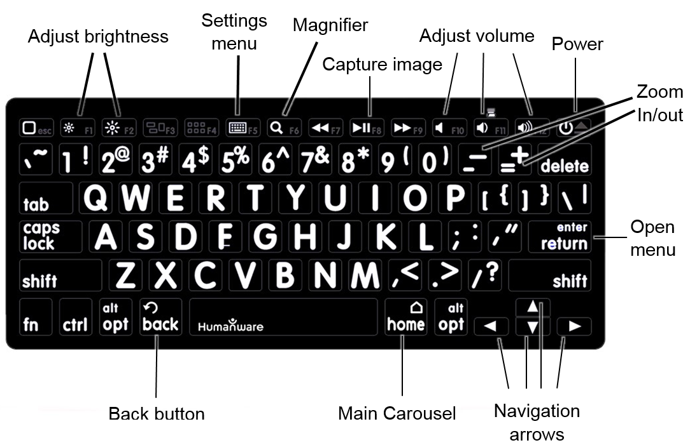

Connecting a Bluetooth Keyboard
- Be sure the Bluetooth keyboard is turned On.
- Access the general settings by tapping the Settings icon in the Carousel menu.
- Select and enter the System submenu.
- Select and enter Bluetooth Setup.
- Bluetooth will be Off by default. Tap On. In a few seconds, additional menu items will appear and the tablet will become discoverable by other devices.
- Select and enter the Devices submenu.
- Select your Bluetooth keyboard.
- Tap Connect.
- The Connect 12 will display a PIN number. Enter the number on your Bluetooth keyboard then press Enter.
- Your Bluetooth keyboard is now paired with your Connect 12 and ready for use.

Chapter 9: APH Code Jumper®

Connecting the Connect 12 to an APH Code Jumper®

To connect an APH Code Jumper® device to your Connect 12:
- Be sure the Code Jumper® is turned on before establishing the connection.
- Access Prodigi settings by tapping the Settings icon in the main Carousel menu.
- Select and enter the System submenu.
- Select and enter Bluetooth Setup.
- Bluetooth will be Off by default. Tap On. In a few seconds, additional menu items will appear and the tablet will become discoverable by other devices.
- Select and enter the Devices submenu.
- Select your APH Code Jumper® device.
- Tap Connect.
- Your Code Jumper® is now paired with your Connect 12 and ready for use.

Chapter 10: Accessing Android
The Connect 12 allows you to access Android applications (note that HumanWare provides limited support for Android and Android applications).
Android is accessible from the Settings in the Carousel menu. Tap the Settings icon and swipe down to select Exit to Android. You can also access Android by placing and holding 4 or 5 fingers on the screen at the same time (this gesture is available anywhere in Prodigi). To return to Prodig, tap the Prodigi Icon.

Create a New User Profile
The Connect 12 allows multiple user profiles to be created.
To add a new User Profile:
- Press and hold four or five fingers on your screen. A page displaying all of the Android apps will appear.
- From the apps page, select Settings.
- In Settings, enter ‘Users’ in the search field.
- On the following screen, select Add User or Profile.
- Select User or Restricted profile in the pop-up.
- Follow Android prompts to complete the user profile.

Chapter 11: Help Menu

The rightmost item in the Carousel menu is the Help Menu (question mark icon), where you will find helpful videos demonstrating how to use your Connect 12.
The help menu consists of:
YouTube tutorials: Access webinars and many useful tutorials on how to use the Connect 12 tablet.
Feedback: Tell us what you think of your Connect 12, what you like, and how you think we can improve Connect 12 features.

Chapter 12: Recharging your Tablet
Maximizing operating efficiency
- In a working situation, when you need the Tablet intermittently, you can enter Standby mode when not using the Tablet by pressing the Power buttton. The screen will power off.
- Wake the Tablet by pressing the Power button.
- If you will not be using the Tablet for an extended period, it is recommended to power off the device by pressing and holding the Power button, then selecting Power Off.
Tap the Settings icon to view the battery charge level. Note that if Speech is set to On in Settings, swiping upward from the first item in the Settings menu will display the charge level.
IMPORTANT: Always use the charging block and cable included with your Connect 12 tablet. Other charging equipment may not charge, work properly, or damage your tablet.
IMPORTANT: The tablet becomes warm during recharging. Do not recharge the tablet near a heat source.
IMPORTANT: Do not close your folding stand while recharging. Doing so may damage the cable and/or the tablet.

Recharging the battery
- Only use power adapter and cable supplied with Connect 12.
- Connect the USB to USB-C cable to the USB-C port and plug it into an outlet using the power supply.
- A full charge requires 4 hours.
Battery safety precautions
- Do not dismantle or modify the battery.
- There is a risk of overheating, fire, or explosion if the battery is put in a fire, heated, subjected to impact, placed in contact with water, or if its terminals are shorted.

Chapter 13: Recharging the Distance Camera
Your camera has a battery life of 4 hours and will eventually require recharging.
Note: Help of a sighted person may be required to charge your camera.
Recharging the camera
- Carefully plug the micro-USB connector into the slot located under the cap.
- Carefully connect the USB connector using the Tablet’s charging block.
- The charge indicator will be orange when your camera is charging and turn blue or green when the battery is fully charged.

Chapter 14: Software Update

Setting up your Wi-Fi
Note: Before initiating a software update, the Wi-Fi network needs to be configured.
- Tap the Settings icon from the carousel menu.
- Tap System.
- Tap Wi-Fi Setup.
- Select Wi-Fi Networks, then select the network you that wish to connect to.
- Tap Wi-Fi: On. A keyboard will pop up.
- Enter your password and tap the blue button, then, tap Connect.

Automatic Update
When Wi-Fi is configured, Prodigi software will automatically check every week for updates. If an update is available, Prodigi will notify you and ask you if you wish to update your tablet.
Updating the tablet
- Tap Install to install the latest update. Prodigi will display download progress.
- A new window will appear informing you that your software is now up to date.
- Tap OK to return to Prodigi.

Manual Update
At times, you may wish to manually update Prodigi on your Connect 12 tablet.
- Access Settings menu.
- Tap System.
- To initiate a software update, select and tap Software Update.
Prodigi will verify if your software is up to date or if an update is available. If an update is available and you wish to install it:
- Tap Install.
Prodigi will download the update and display download progress.
A new window will appear indicating that your software is up to date.
- Tap OK to return to Prodigi.

Release Notes
To view the Prodigi software release notes:
- Access Settings from the main menu.
- Tap System.
- Tap Software Update.
- Select Release notes, if available.

Chapter 15: Troubleshooting
If the screen is blank
- Zoom out of the image for minimum magnification.
- The Tablet might be powered Off or in Standby Mode. Tap Power to power On or to exit Standby Mode.
If colors are difficult to detect
- Check if there is sufficient ambient light.
- Choose a different contrast or color combination in Settings.
- Adjust brightness level in Settings.
If there is a lot of glare
- Tilt objects in a different direction to reduce glare.
- Reduce Brightness level in Settings.
- Reduce external lighting.
- If a captured image is too bright or uneven, turn off the light (in the Button banner) and capture a new image.
If the image/text is out of focus or blurry
- Use the Zoom In/Out buttons to zoom in and then out of the image to trigger the camera’s focus. If required, capture a new image of your document.
- Be sure to hold the camera still while capturing an image.
- Make sure your Tablet is powered Off and wipe the LED lights and camera surface on the back side with a soft cleaning tissue.

If the audio reading does not make sense
- Be sure the voice language setting is the same as your document language. Change it in Settings, if necessary.
If the Tablet is not responding
- Make sure the battery is not depleted. Recharge if necessary.
Other issues
- Restore Prodigi’s default settings in Prodigi’s menu. Note that this procedure will erase your preferences in Prodigi.
- Reset the Android system completely.

WARNING: This procedure will erase your settings and personal data.
IMPORTANT: It is highly recommended that you remove any saved Gmail account from your tablet before resetting the Android settings, as you will not be able to do so after the system reset. Fees may apply if you need to return your tablet to HumanWare to remove a saved email account.
To remove a saved Gmail account
- Open Android Settings.
- Tap Passwords & accounts.
- Tap the account(s) to be removed.
- Tap Remove account.
- Tap Confirm.
To reset the Android system
- Open Android Settings.
- Tap System.
- Tap Reset options
- Tap Erase all data (factory reset).
- Tap Confirm.

If technical issues remain unresolved, please contact your dealer or technical support.

…

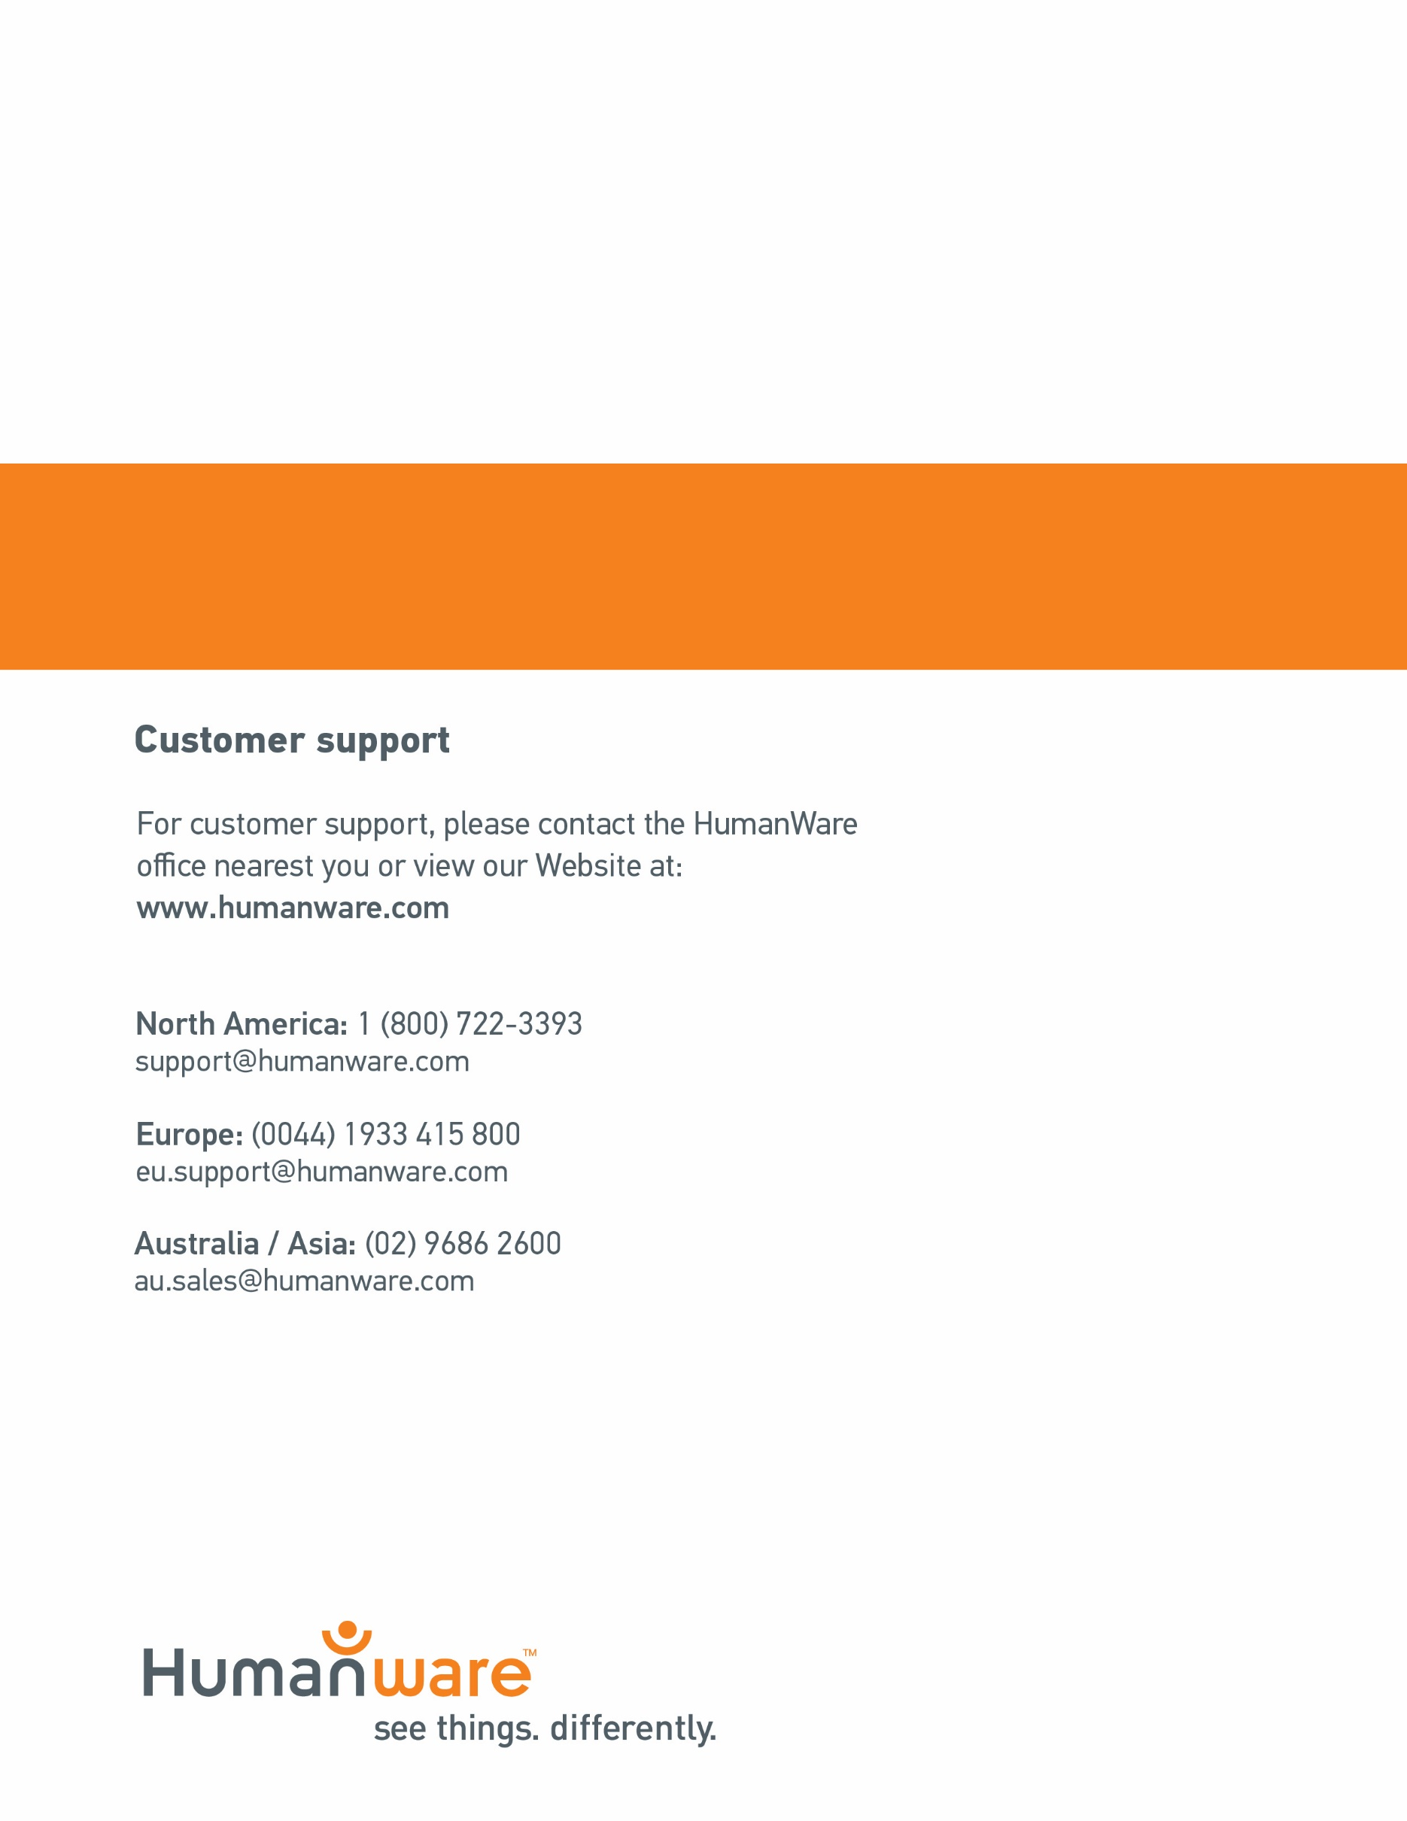

ACCD-0313
Rev 05
ACCD-0171
REV 05

