Installing an update on an explorē 8 device

- Download the update ZIP file.

- Find the downloaded ZIP file, right-click on it, and click “Extract All”.

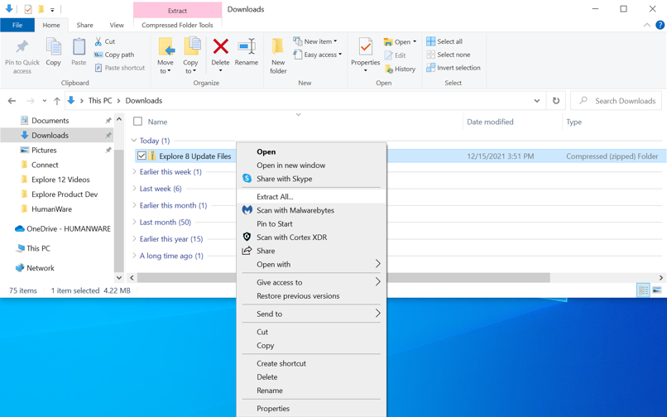

- Using the supplied USB cable, connect the explore device to the computer where the update files are downloaded.

- Copy-paste or drag-drop the two extracted BRN files to the root of the device.
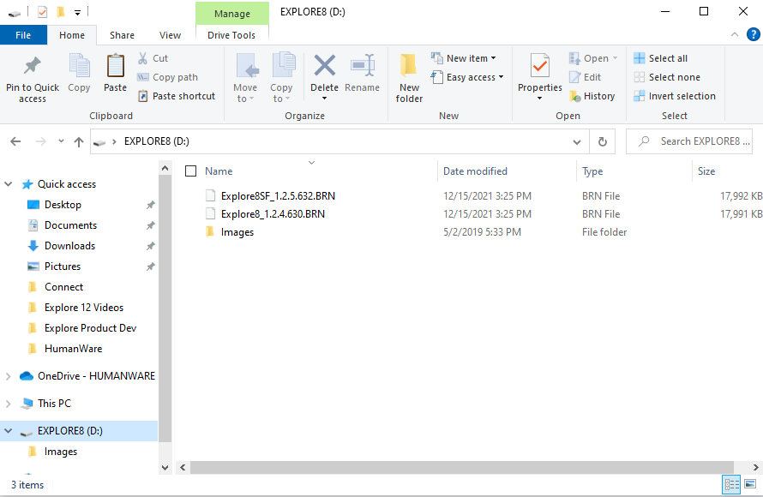
- Disconnect the device from the computer.

- Reboot the device by pressing the power button.

- “Software Update” should appear on the device’s screen.

