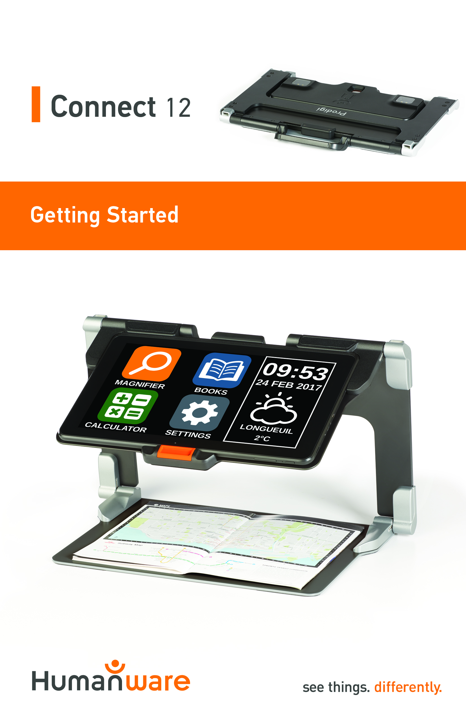

Getting Started
- On a flat and stable surface, hold your stand upright, making sure the panel with the word “Connect” is facing towards the back. Hold the handle with one hand, and unfold the lower panel with your other hand until it is flat on the table.

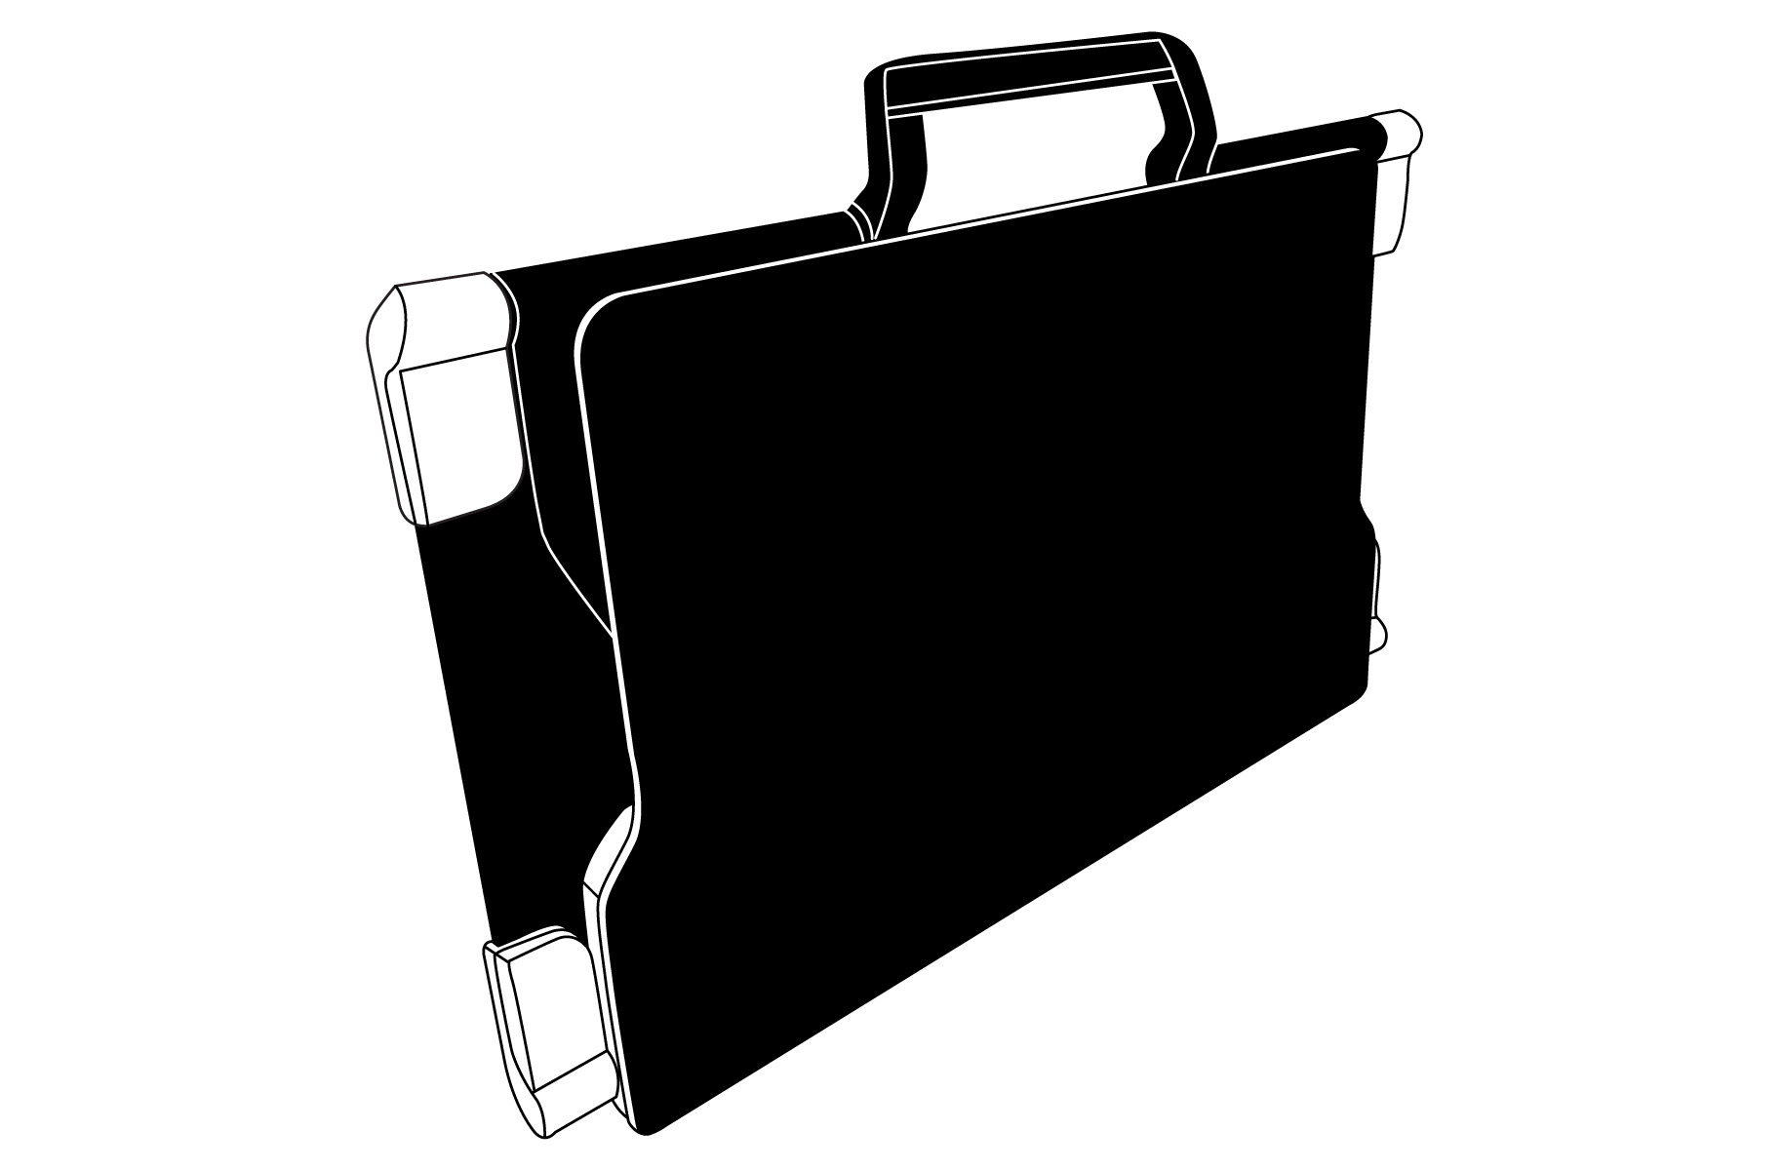

- Unfold the top panel until it is roughly parallel with the lower panel.
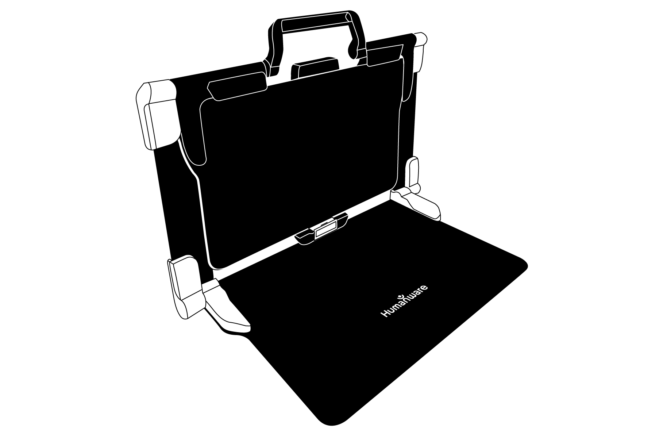
- Hold your tablet with the screen side facing you, making sure the HumanWare logo is at the top. Carefully insert the top of your tablet into the slot and slide it forward until you reach the back end of the slot. Push the bottom part of the tablet down; you will hear a click indicating that your tablet is fastened.
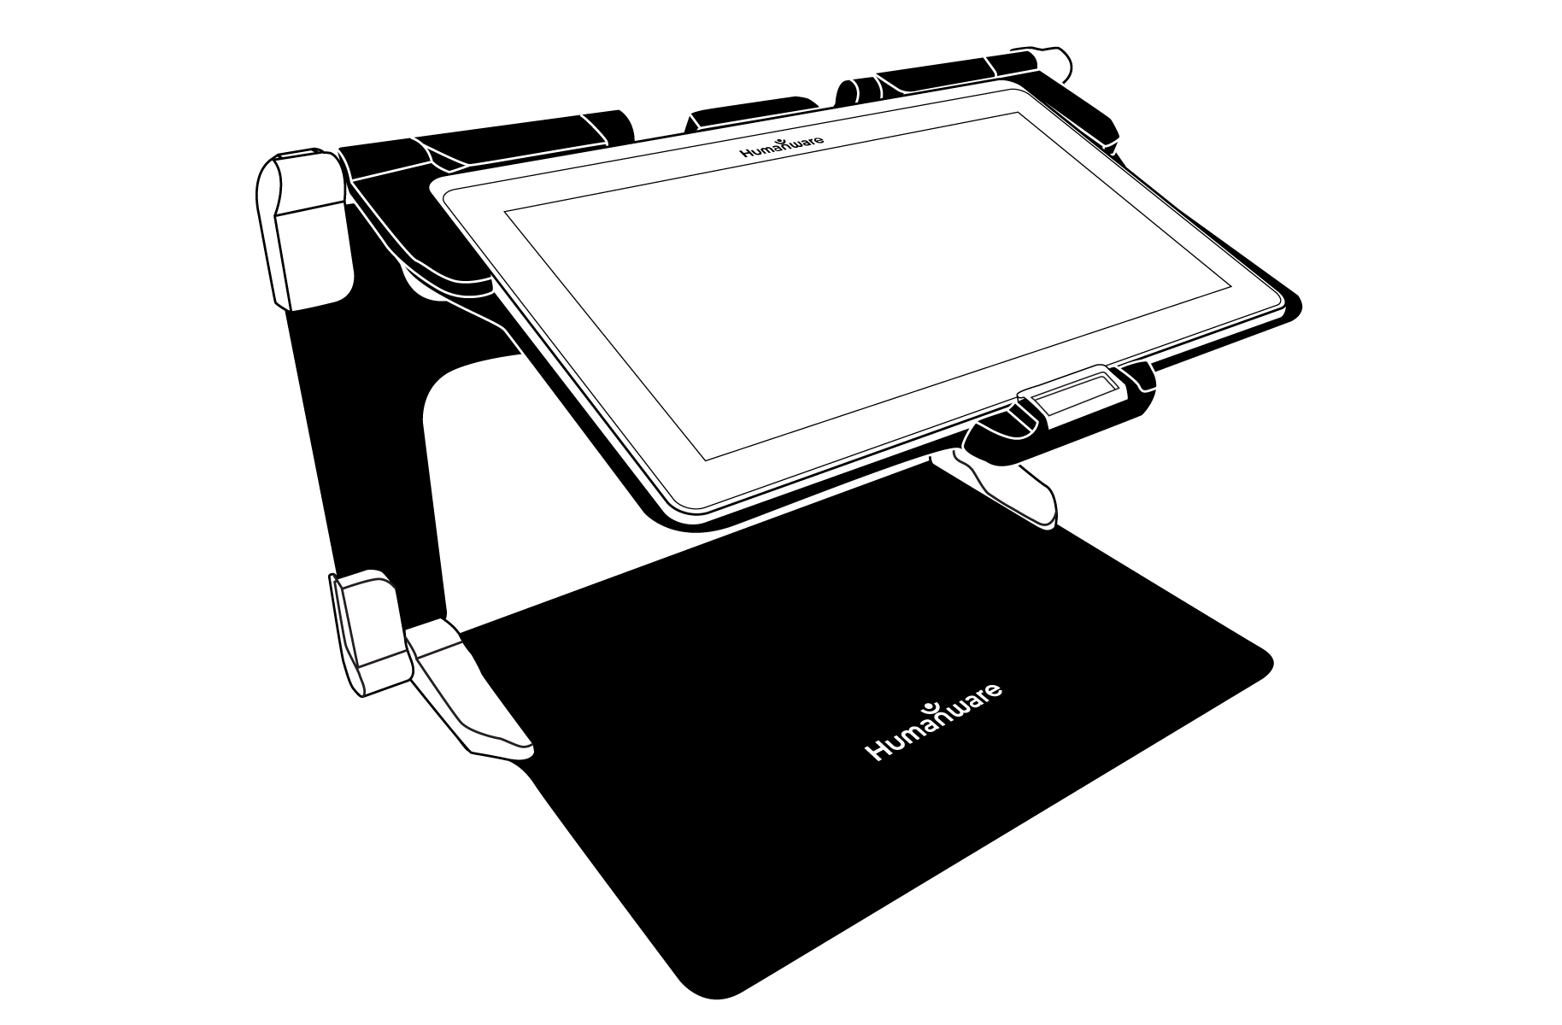
- Connect the power supply cable to the recharge port and plug it to an outlet. The recharge port is located on the right side of the tablet. Allow the tablet to recharge until the battery is full.
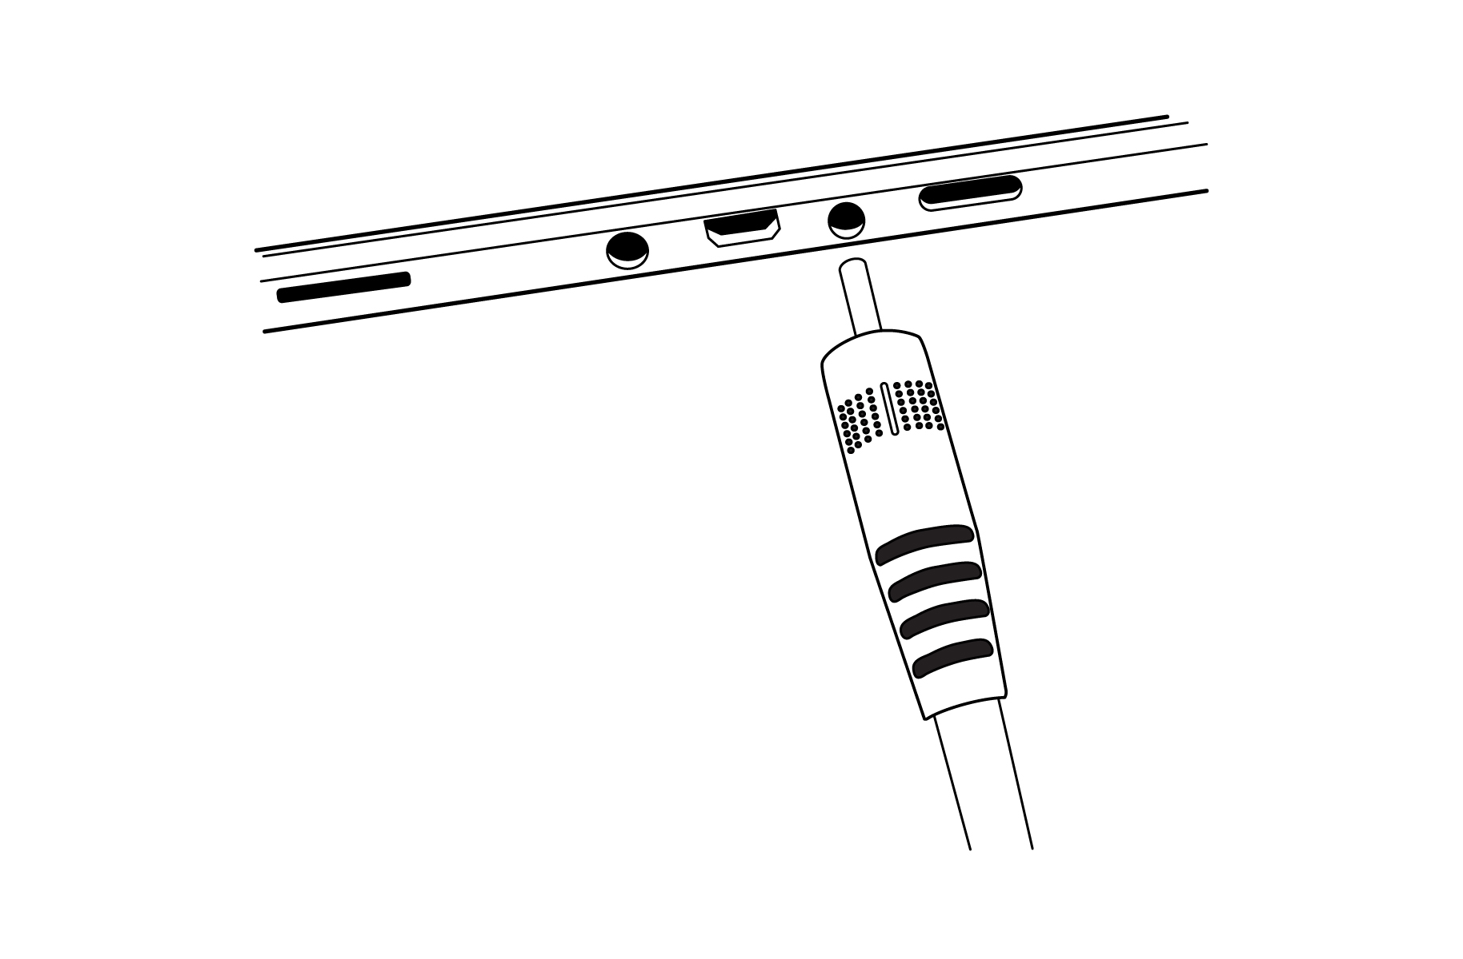
IMPORTANT: Use caution while inserting the cable into the recharge port.
- Press and hold the power button, located on the bottom edge of the tablet, to power on your tablet. The HumanWare and Android logos will appear on screen. Your tablet will take about 30 seconds to initialize.
- Tap the Zoom In-Out buttons to adjust the zoom level. To increase character size, tap the Zoom In button (the right one). To decrease character size, tap the Zoom Out button (the left one). You can also tap and hold the Zoom In-Out buttons to progressively adjust the zoom level, and release once you reach your desired zoom level.

For more information on how to use Prodigi, please refer to the user guide.

[End of document: VER 01-2017-04-21]

ACCD-0172
REV 01

REV01

