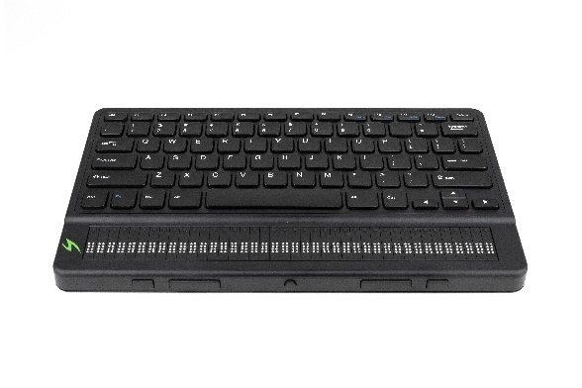

Mantis Q40 and an iOS Device

A Productive Combination.

All of Apple's iOS devices, (iPod touch, iPhone and iPad,) have built-in braille access when using the VoiceOver screen reader. Utilizing this braille access allows a user to receive braille output on a supported braille display, and if the display has input keys, one can actually control the iOS device without ever touching the device's touch screen. For simplicity, the term iPhone will be used throughout this document to represent the line of Apple's iOS devices. It is important to ensure that you have ios version 14.4 installed. If you are unable to install the update due to an older model, it will not be possible to connect the Mantis Q40 as a braille display, this is because the Mantis Q40 is using the latest type of connection from Apple.

The Mantis Q40 is the perfect combination if your primary input is qwerty. The Mantis Braille display brings a sleek, ergonomic, productive and portable design to its user's fingertips.

Once the two tools are paired, the Mantis Q40 can be used to produce braille output, along with providing control over the iPhone without using the touch screen. Users have the capability to:

- Wake up the ios device from your braille device
- Navigate applications, home screens, and other elements using the onboard Standard Keyboard
- Select items
- Enter text into any editable applications such as text messages, emails, note files, etc, using the Mantis Standard keyboard.
- Read in braille from all accessible applications, including reading books from the iBooks application.
- In short, anything that could be accomplished with VoiceOver via the touch screen can be accomplished using the Mantis Standard keyboard

The Mantis Q40 can be paired with all iPhones running iOS 14.4 + as a Bluetooth Braille display. To connect the two devices, the pairing must be initialized from the Mantis, just as you would pair with any other keyboard or Bluetooth device.

To make the connection, do the following:

- From the Mantis Menu, press the letter T, you will be prompted “Terminal”.

- Now Press Enter.

- Use your Up and Down keys to move to “Add Bluetooth device”

- Then press Enter.

- You will be prompted “activate your device in your host device’s Bluetooth settings”, followed by the model and serial number of your device.
Note: The Mantis will now be in a discovery mode state for 5 minutes. Once it exceeds this time the Mantis will not be found, so it is recommended to perform the above actions again.

- On your iPhone, open the Settings application from the home screen.

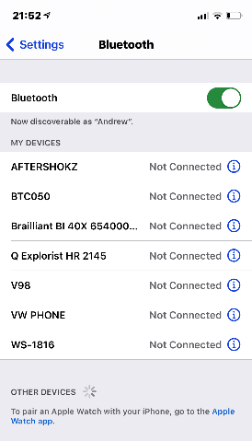

- In settings, move to the Bluetooth Item and double tap to open.

- Your Mantis should be listed at the bottom section under “other devices”

- Select the “APH Mantis xxxxx” by Double tapping on the Mantis Braille display.

The Mantis will prompt you with “xxx connected”, where xx is the name of the iphone.

On the Mantis you will be positioned in the connected devices. Use your Up and Down keys to move through the list of connected devices.

Press Enter on the device you wish to connect to.

The Mantis will now be connected as a braille display

Mantis Q40 iPhone commands
This guide highlights some of the most common shortcuts available with VoicOver using Gesture and Keyboard commands.

When connecting the Mantis to ios or macOS the keyboard will be configured to include the VO key and the following keys will be mapped as the option key.
(VO) key = Ctrl + Win key
Option key = Win key
The below Keyboard shortcuts assume Quick Nav is turned off.

Command | Gesture | Keyboard
Activate Item | Double Tap or Split Tap | VO + Spacebar
Adjust Value | Swipe Up or Down | Up or Down Arrow
App Switcher | Double-Click Home | VO + H + H
Back/Escape | Two-Finger "Z" | Escape
Change Item's Label | Two-Finger Double Tap and Hold | VO + /
Change Rotor Item | Two-Finger Rotate | Up Arrow + Left or Right Arrow
Copy Spoken Text | Three-Finger Quadruple Tap | VO + Shift + C
Home | Click Home | VO + H
Item Chooser | Two-Finger Triple Tap | VO + I
Magic Tap (Pause Music) | Two-Finger Double Tap | VO + -
Mute VoiceOver | Three-Finger Double Tap | VO + S
Next/Previous Rotor Item | Swipe Up or Down | Up or Down Arrow
Pause Speech | Two-Finger Tap | Control
Quick Navigation On/Off * | (Keyboard Only Feature) | Left Arrow + Right Arrow
Read All From Current Position | Two-Finger Swipe Down | VO + A
Read All From Top | Two-Finger Swipe Up | VO + B
Screen Curtain | Three-Finger Triple Tap | VO + Shift + S
Scroll | Three-Finger Swipe | Option + Arrow Keys
Select First Item | Four-Finger Tap Top of Screen | Control + Up Arrow *
Select Item | Tap | VO + Right or Left Arrow
Select Last Item | Four-Finger Tap Bottom of Screen | Control + Down Arrow *
Select Next/Previous Item | Swipe Right or Left | VO + Right or Left Arrow
Show Keyboard |  | Eject
Switch Apps | Double-Click Home | Command + Tab or Shift Tab
Turn Off VO Help | Two-Finger "Z" | Escape
VO (VoiceOver Keys) |  | Control + Option
VoiceOver Help |  | VO + K

Single-Key Quick Nav VO + Q
Navigation Item | Key
ARIA Landmark | W
Button | B
Form Control | C
Heading | H
Heading Level 1 | 1
Heading Level 2 | 2
Heading Level 3 | 3
Heading Level 4 | 4
Heading Level 5 | 5
Heading Level 6 | 6
Image | I
Link | L
List | X
Previous Nav Item | Shift + Key
Static Text | S
Table | T
Text Field | R

