**APH Pre-Install Application Procedure**

1. Activate the developer options by going into settings -> about tablet -> Click 7 times on “Build number” at the bottom of the list.

A screenshot of a cell phone

Description generated with very high confidence

1. Then go back in settings and select Developer options –> Enable USB debugging, tap ok on the pop up.

A screenshot of a cell phone

Description generated with very high confidence

1. Connect the tablet to a computer and check the check box: “Always allow form the computer”, then click ok on the pop up window.
2. Download the InstallAppsForAPH.zip file in a folder on the connected PC.

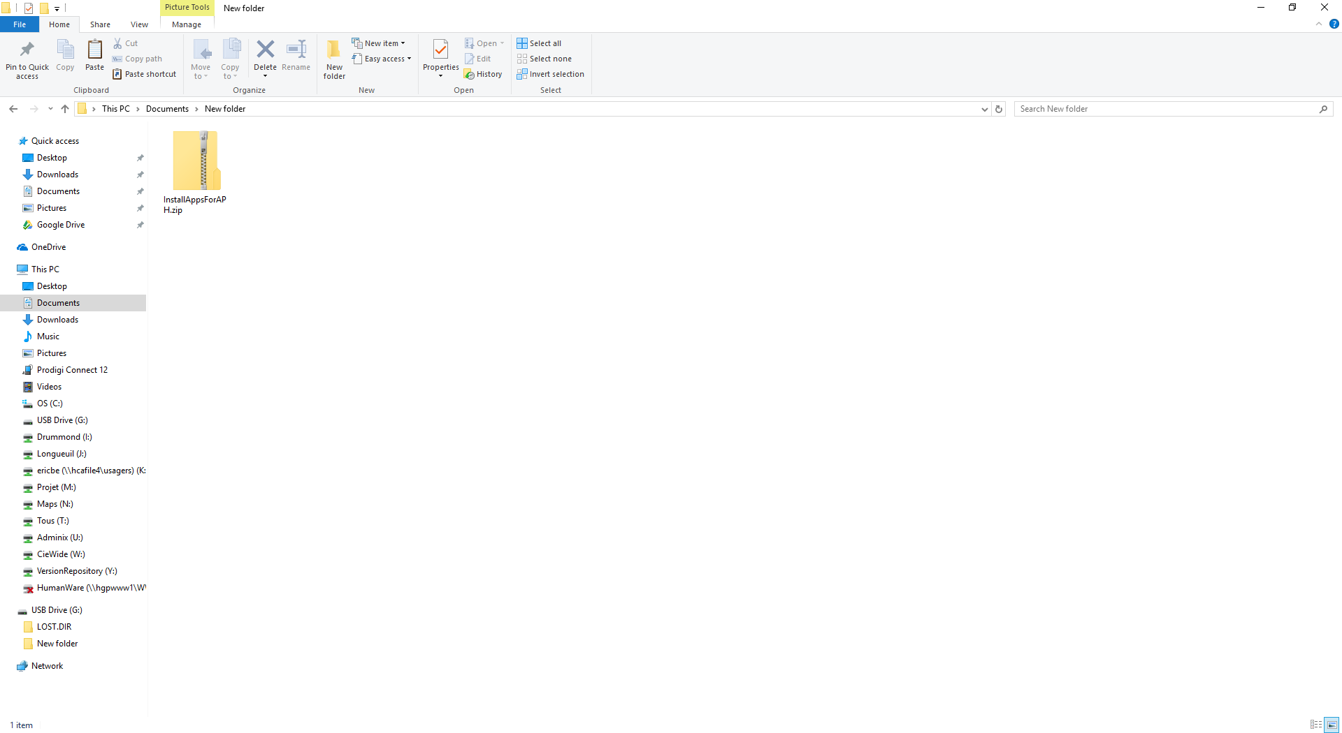

1. Right click on the file and select Extract All. This will extract the file in the folder.

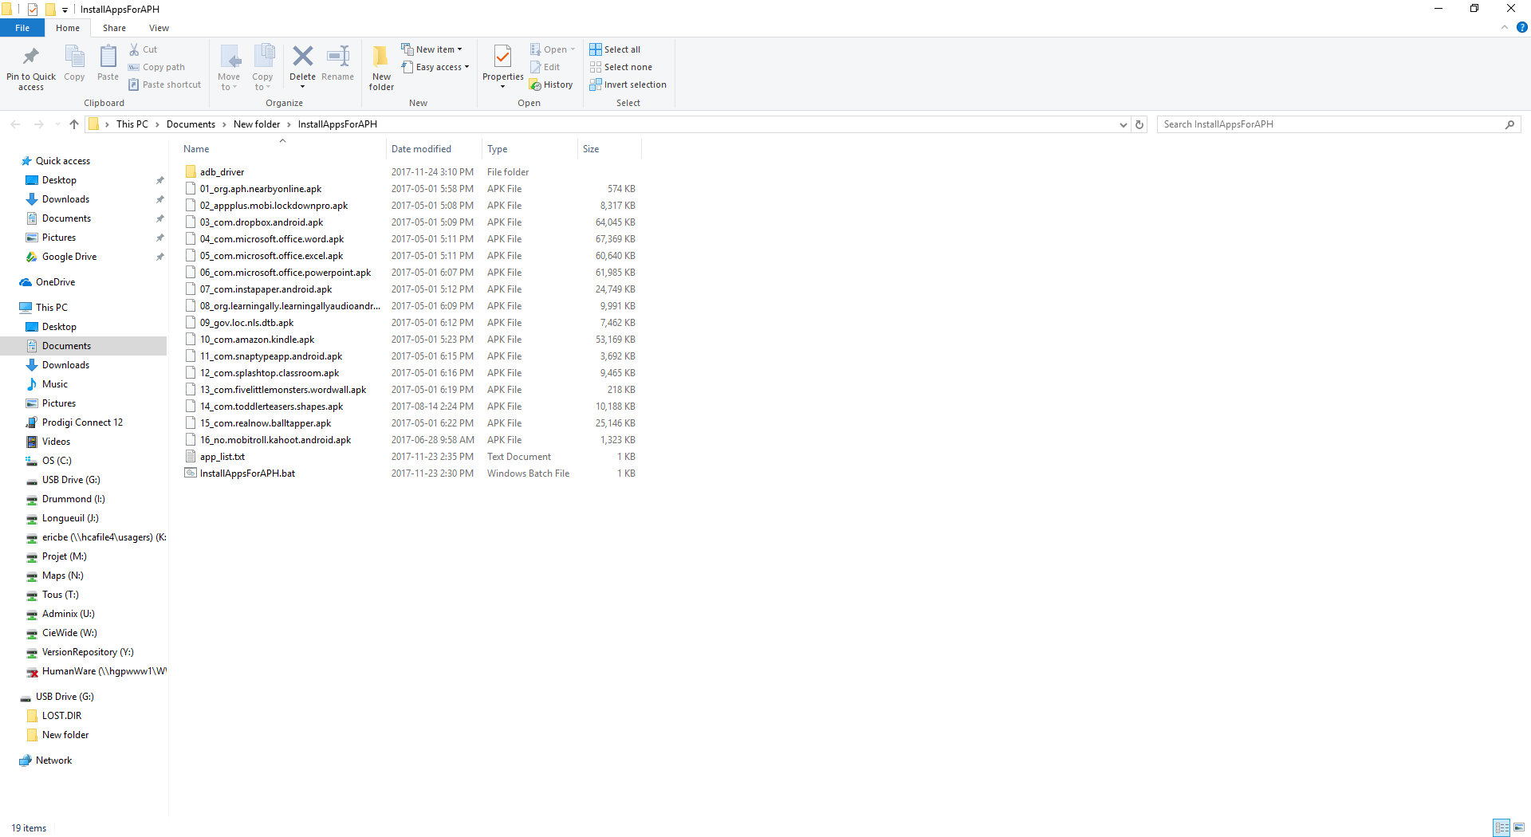

1. In the extracted folder the file InstallAppsForAPH.bat will be found.
2. To install the APH applications double click on the InstallAppsForAPH.bat file this will open a cmd prompt windows.

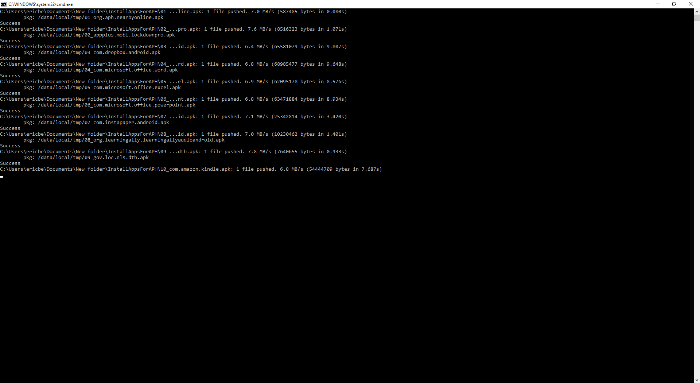

1. Let the script finish.
2. Once the script has finish executing, reboot the tablet. Once the tablet rebooted, Prodigi can be started and the applications should be listed in the APH application.

