**APH Toolbox Applications: Install/Re-install Procedure**

1. Activate the Developer Options by going to Settings: About tablet. Tap 7 times on “Build number” at the bottom of the list to activate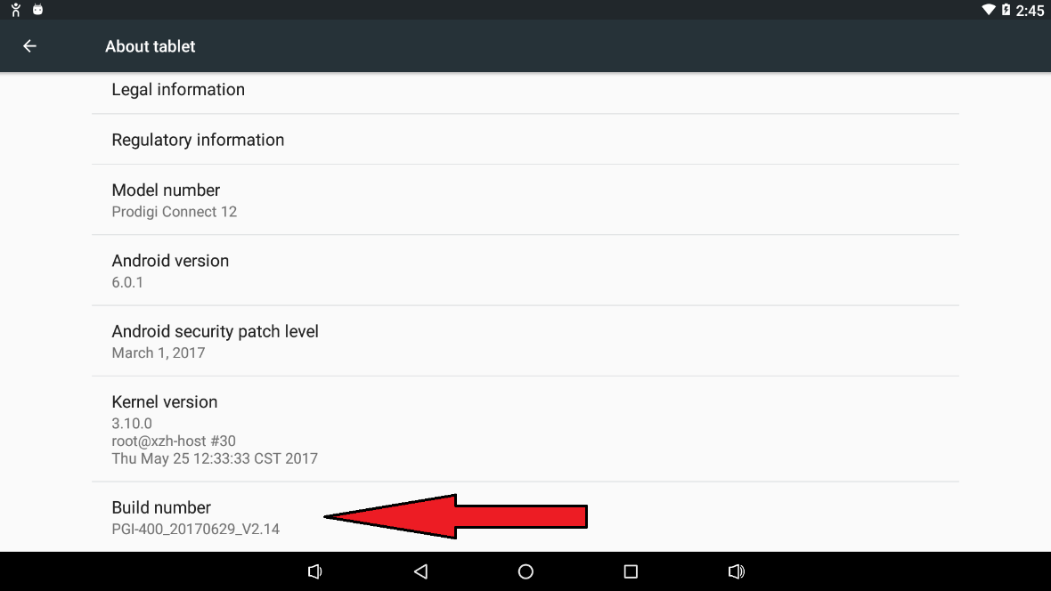
2. Then go back to Settings, tap System, and select: Developer options→USB debugging. Tap to turn this option on. Tap “Ok,” if a pop-up appears.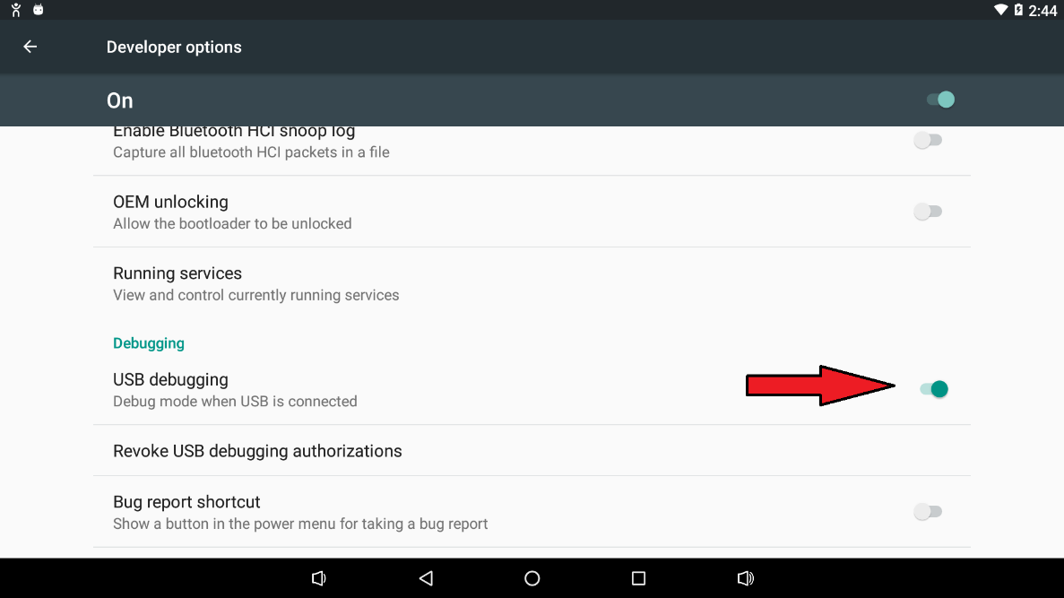
3. Connect the tablet to a computer. If messages appear, select those that provide USB access and/or permissions.
4. Download the InstallAppsForAPH.zip file to the connected PC. 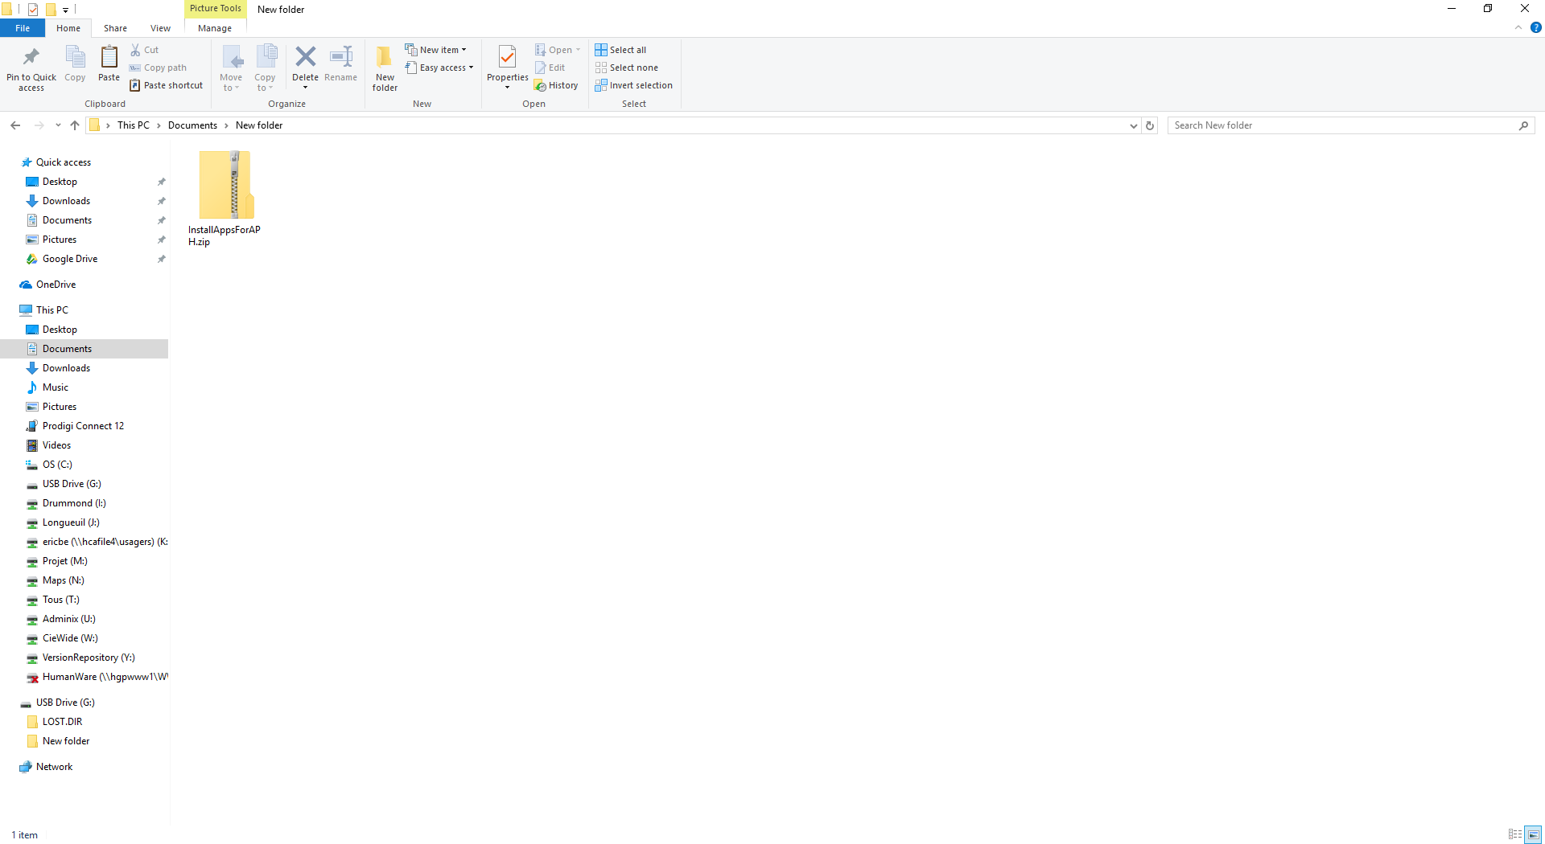
5. Right-click on the file and select Extract All. This will extract the files into a new folder.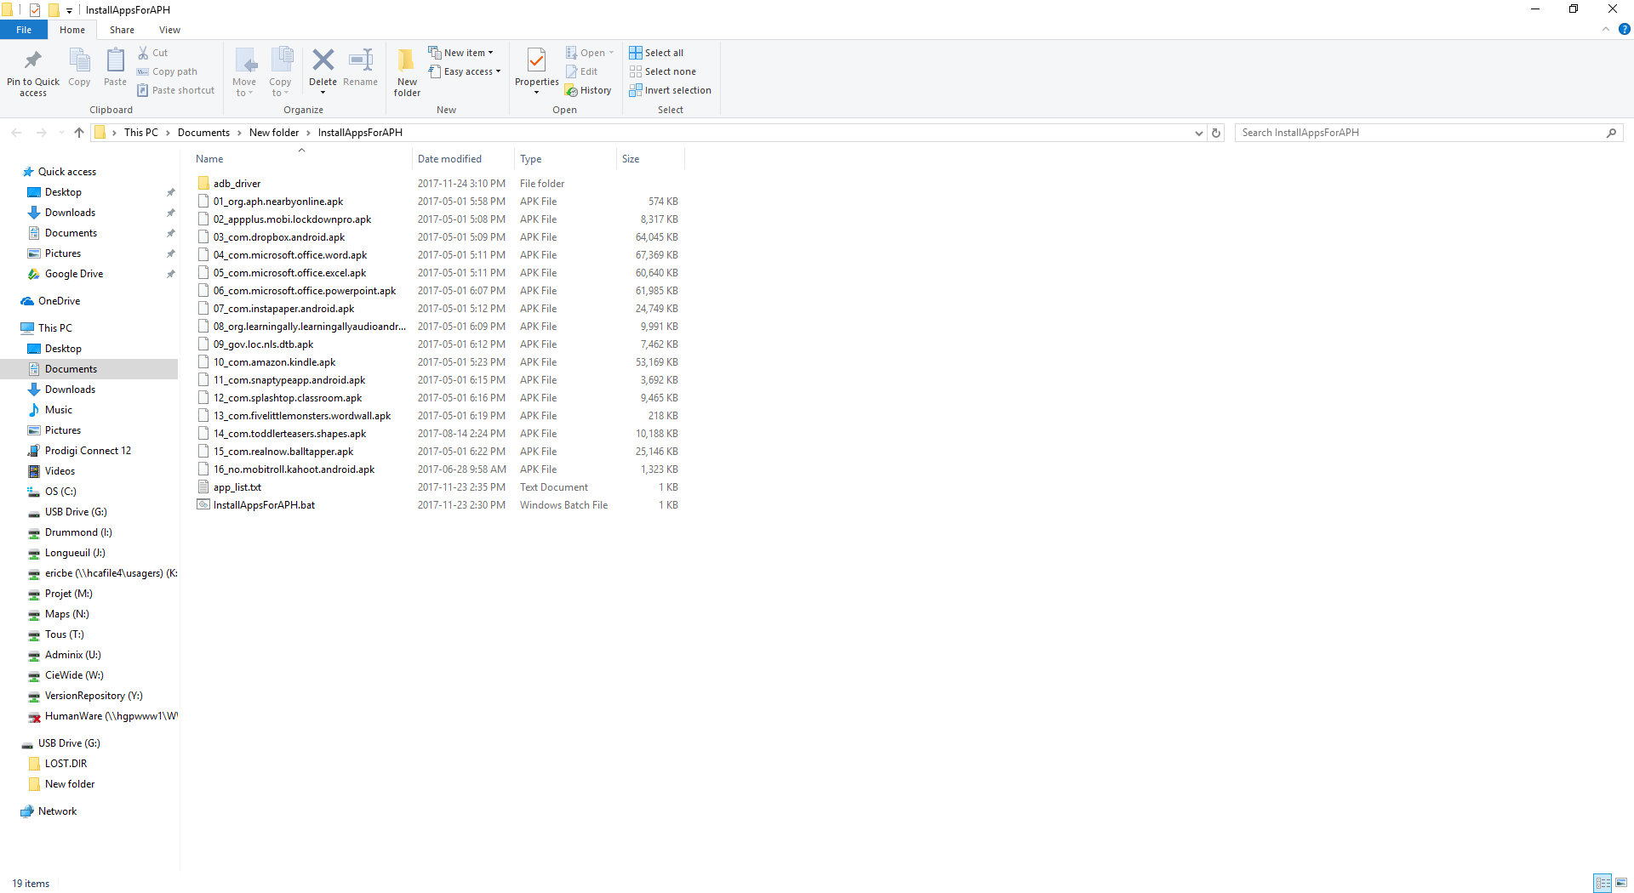
6. In the extracted file folder, find the InstallAppsForAPH.bat file.
7. To install the APH Toolbox applications, double-click the InstallAppsForAPH.bat file. This will open a cmd prompt window and initiate a script.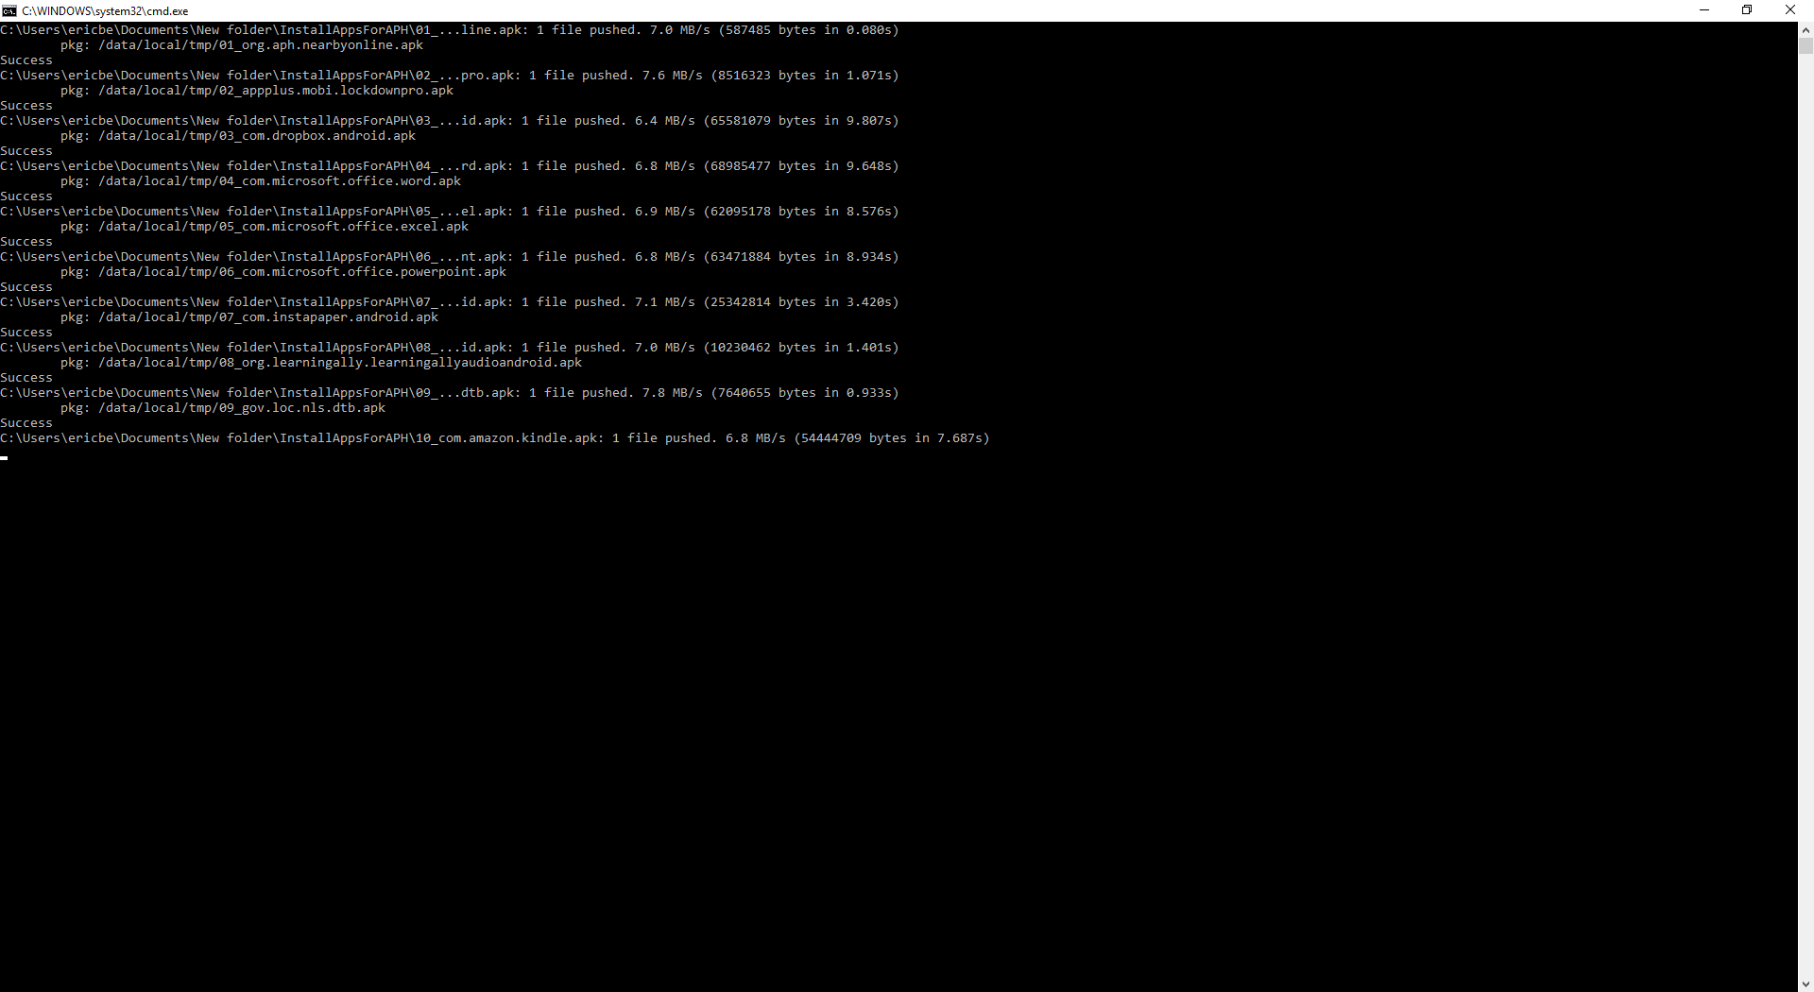
8. Let the script finish. Note 1: If any messages appear on the tablet, click on “More details,” then select “Install anyway.”
9. Once the script has finished executing, reboot the tablet. After the tablet reboots, Prodigi can be started, and the applications should be listed in the APH Tool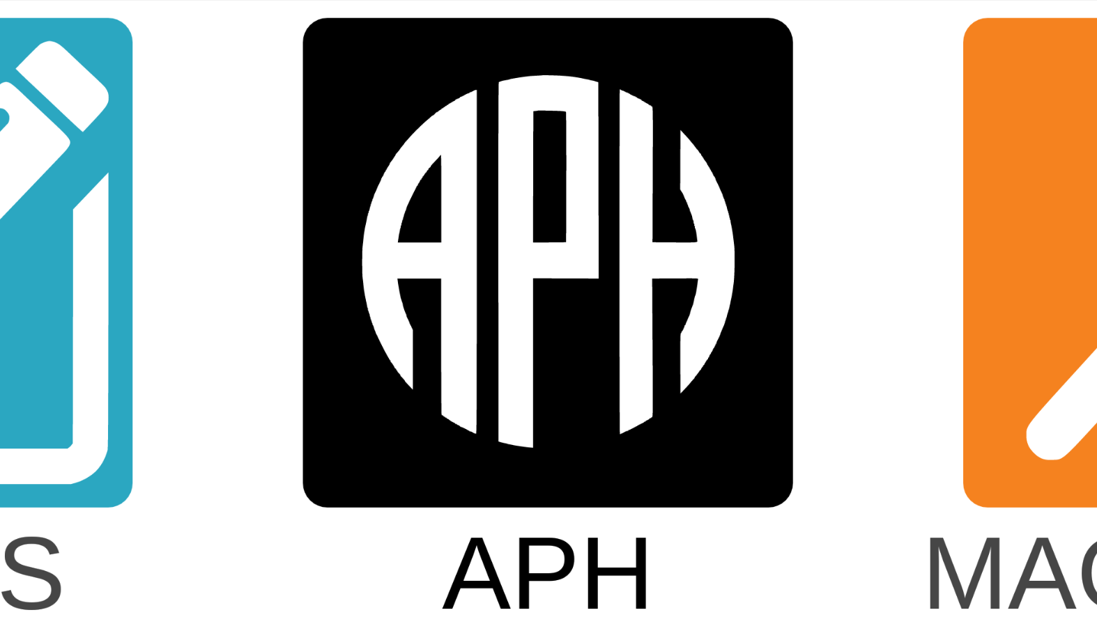

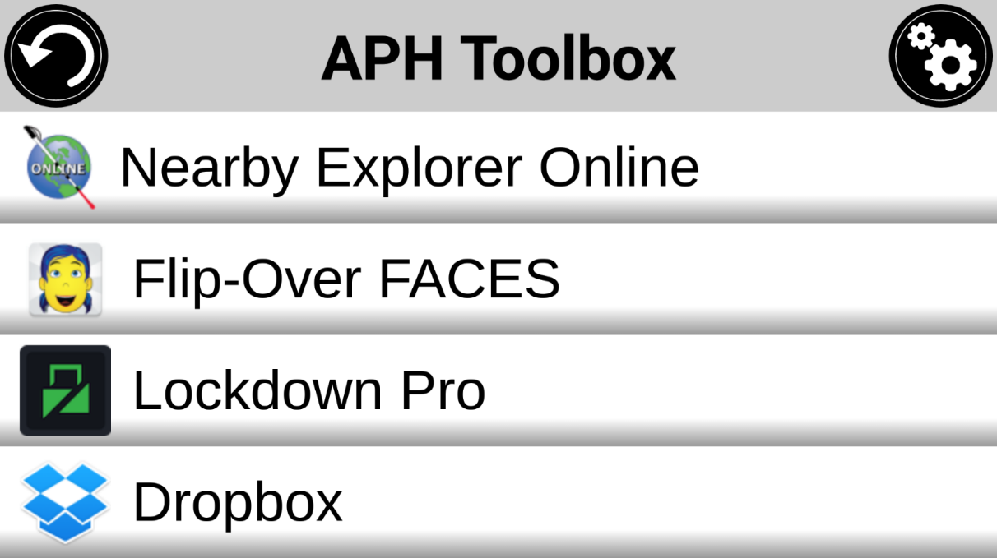

Note: You can show or hide applications and organize them by tapping the gearwheel icon in the upper right corner of the APH Toolbox.