

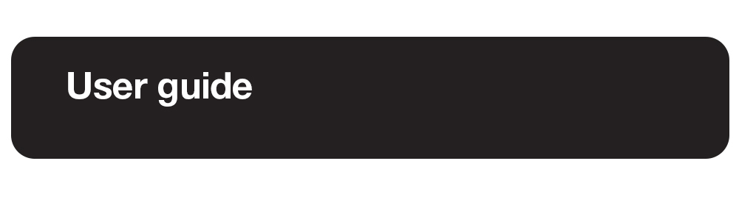

Prodigi Windows 1.3

Rev. 003

Table of Contents

1. Introduction 6

2. Package Options 6

What’s in the Box? 6

Option 1: Prodigi Low Vision Software for Windows 6

Option 2: Prodigi Low Vision Software for Windows: Starter Kit 7

Option 3: Prodigi Low Vision Software for Windows: Complete Kit 7

Option 4: Prodigi Low Vision Software for Windows: All-in-One PC (North America only) 7

2.1 Initializing your Microsoft Surface tablet or All-in-One PC 8

3. Software Install 8

3.1 Quickstart Guide 9

4. Software Updates 9

4.1 UPDATING PRODIGI 10

5. Connecting and Using the HoverCam SOLO 8+ Camera 10

5.1 Connecting to A Windows Device 10

5.2 General Operation 11

6. Using Prodigi Windows Software 11

6.1 Default Interface: The Prodigi Carousel 11

7. Getting Started 12

Orientation to the UI: The Applications Carousel 12

8.Settings Application 13

8.1 Settings Menus 14

8.2 User Interface 14

Interface 14

System Language 15

Uninstalling a Voice 15

Colors 15

Locator Color 16

Mouse Pointer Size 16

Screen Brightness 16

Button Banner 17

8.3 Audio 17

Speech 17

Speech Rate 17

Sounds 18

8.4 System 18

Wi-Fi Setup 18

Bluetooth Setup 18

Accessibility Setup 19

Automatic Software Updates 20

Send Crash Logs 21

Screen Magnifiers 21

Usage Metrics 21

Restore Default Settings 21

8.5 Account 22

8.6 About 23

8.7 Exit to Windows 24

9. Magnifier Application 24

9.1 Magnifier Settings 26

Camera 26

Brightness 26

Contrast 26

Contrast Color 27

Autofocus 27

Capture Modes 27

Speech 28

OCR (toggle) 29

Choose OCR Language 29

9.2 Capturing Images and Text 29

9.3 Zooming In and Out 32

9.4 Reading Settings 33

9.5 Saving an Image or Document 34

9.6 Magnifier / Distance toggle 34

9.7 Split Screen Viewing 35

10. Files Application 36

10.1 Viewing Documents and Images 38

Contrast 38

Contrast Color 38

Brightness 38

Voice 39

Speech 39

Reading Mode 39

Preferred Zoom 40

Rotation 40

10.2 Reading Settings 42

10.3 Action Menu (for Folders) 43

Move 43

Delete 43

Rename 43

Create Folder 44

Delete Folder Content 44

10.4 Action menu (for documents and images) 44

Move 44

Delete 44

Rename 44

Export 45

Import 45

Properties 45

11. Distance application 46

11.1 Distance Settings 47

Camera 47

Brightness 47

Contrast 47

Contrast Color 48

Autofocus (toggle) 48

11.2 Capturing Images 48

11.3 Saving an Image or Document 49

11.4 Zooming In and Out 49

12. Help Application 50

13. Gesture Guide 51

Pinch and zoom gesture 51

Tap gesture (for accessing applications, selecting preferences, etc.) 51

Double tap gesture (header bar, etc.) 52

Long press gesture (image capture, etc.) 52

Toggle from Live to Multi-Capture Mode or Contrasts 52

14. Basic Keyboard Shortcuts 53

15. Glossary 53

16. Troubleshooting 54

17. Prodigi System Recommendations 55

18. Appendix 1 56

18.1 Basic Prodigi Windows Bluetooth Keyboard Commands 56

18.2 General keyboard shortcuts 58

19. Appendix 2 59

Connecting the Kodak Wi-Fi Distance Camera to Prodigi Software 59

20. Technical Specifications 60

Prodigi Low Vision Software for Windows 60

Prodigi Low Vision Software: Starter Kit 61

Prodigi Low Vision Software: Complete Kit 61

Prodigi Low Vision Software: All-in-One PC 62

21. Software Maintenance Agreement and Warranties 62

21.1 Software Maintenance Agreement 62

21.2 Warranties 63

# 1. Introduction

Thank you for purchasing Prodigi Windows software.

The software package is a personal vision assistant system from HumanWare, the global leader in assistive technologies for people with low vision. The intuitive and intelligent user interface offers users unparalleled flexibility and can be controlled via a standard mouse, keyboard, or devices with touch-control screens.

The adaptable system aims to maintain and restore independence for people living with vision loss. Prodigi Windows is a complete magnification system that allows you to magnify and read documents and capture images.

We recommend reading this user guide's operating and safety instructions *before* using Prodigi Windows software. If you have any questions, please contact HumanWare Customer Service (contact information appears at the end of this user guide). To obtain the most recent User Guide, please visit the Support page at <https://www.humanware.com/prodigisoftwaresupport>.

Note: Some features described in this user guide may not be available in your language.

# 2. Package Options

## What’s in the Box?

### Option 1: Prodigi Low Vision Software for Windows

You can access a powerful suite of low-vision tools on your Windows-based device. The base software package provides essential features to improve digital content accessibility. Enjoy magnification, text-to-speech, and more, enhancing your reading and daily tasks. The software-only solution empowers users to use their own computing device and camera, offering a cost-effective option for users with existing hardware.

* Prodigi for Windows software delivered via email and download

### Option 2: Prodigi Low Vision Software for Windows: Starter Kit

The software-plus-camera solution provides a comprehensive solution for users who own a computer but lack a suitable document camera. Prodigi software combined with a SOLO 8Plus document camera for a simplified low-vision solution enables enhanced magnification, OCR, and TTS functionalities, empowering users to engage with printed materials effortlessly.

* Prodigi for Windows software delivered via email and download
* HoverCam SOLO 8+ document camera
* Microsoft Adaptive Kit
* Quick Start Guide
* Carry bag

### Option 3: Prodigi Low Vision Software for Windows: Complete Kit

This is a fully expanded version of the Starter Kit for users seeking convenience and performance. It includes a Microsoft Surface tablet, HoverCam SOLO 8+ camera, and accessories. With this kit, you can enjoy unparalleled magnification, OCR, and TTS capabilities, all in one convenient package.

* Microsoft Surface tablet
* HoverCam SOLO 8+ document camera
* 6-in-2 Microsoft Surface Docking Station
* Bluetooth keyboard
* Bluetooth mouse
* Microsoft Adaptive Kit
* Quick Start Guide
* Carry bag

### Option 4: Prodigi Low Vision Software for Windows: All-in-One PC (North America only)

This turnkey solution boasts the same productivity as a desktop solution. It includes a 24" PC monitor for enlarged viewing, integrated webcam, SOLO 8+ camera, wired keyboard, and mouse, and Microsoft Adaptive Kit.

* 24" AOC All-in-One PC
* HoverCam SOLO 8+ document camera
* USB keyboard and mouse
* Microsoft Adaptive Kit
* Quick Start Guide

## 2.1 Initializing your Microsoft Surface tablet or All-in-One PC

If you have purchased Option 3 (Complete Kit) or Option 4 (All-in-One PC), you will need to initialize your tablet or computer just like any new Windows-based device. Then, you will need to install and activate your Prodigi software. Visit <https://www.humanware.com/prodigisoftwaresupport> to access support videos for getting started with the software.

Note: Microsoft Surface Tablet or All-in-One PC initialization timing varies depending on your Internet connection and Windows updates that need to be installed.

# 3. Software Install

Note: For package options 3 and 4, the user must set up their Microsoft Surface Tablet or All-in-One using Microsoft’s wizard - then install and activate Prodigi for Windows. The Prodigi for Windows software install process is like installing any other software on your computing device. You must download the software and use your credentials (username/password) to activate it. You will be sent an email from HumanWare or your Prodigi License Administrator containing links to create your credentials and download the Prodigi software.

**Download and installation instructions:**

1. Download the software

* Click on the link below to begin downloading the Prodigi software. <https://humanware.s3.us-east-2.amazonaws.com/prodigi/windows/1.0/Prodigi.appxbundle>

1. Run the installer

* Once the download is complete, locate the file in your Downloads folder or your specified location.
* Double-click the installer file to run it.

1. Follow the installation prompts and activate your software

* Follow the on-screen instructions to install the software on your device.
* Accept the End User License Agreement (EULA) to install.
* Enter your software using your Prodigi credentials (username and password).
* Choose your voice(s) for installation. You can choose up to four.
* Select your audio preference for Prodigi.

1. Complete the installation

* Once the installation is complete, you will see a confirmation message.
* Click 'Finish' to exit the installer.

1. Start using your software

* Open Prodigi for Windows from your desktop or the Start menu.



* In the Magnifier application, identify the camera you wish to use.
* In the Distance application, identify the camera you wish to use.

We encourage users to customize Settings to their specific needs.

## 3.1 Quickstart Guide

For users who are in a hurry to start magnifying, please refer to our Quick Start Guide on the [Prodigi Support page](https://www.humanware.com/prodigisoftwaresupport).

# 4. Software Updates

Prodigi software's over-the-air update capability ensures that users with low vision receive continuous improvements, enhanced performance, and new features. This provides a seamless experience, keeping the software at the forefront of accessibility and catering to users' specific needs.

## 4.1 UPDATING PRODIGI

When Prodigi Windows is started, an **Available Updates** window will pop up if an update is available.

1. Click **Update Now** (progress bars for each application will briefly appear).

**The application will now restart** message will appear.

**Your Software is up to date** message will appear.

1. Click **OK.**

Two other options will appear on screen: **Details** (reveals version numbers of each application) and **Remind me later** (a reminder will be issued each time you launch Prodigi Windows).

Alternatively, you can manually check and run updates: Launch Prodigi and go to **Settings → System → Software Update**; run the update to complete the installation.

# 5. Connecting and Using the HoverCam SOLO 8+ Camera

Prodigi Windows software has been optimized for the HoverCam SOLO 8+ camera but can be used with almost any USB-connected document camera (note that other document cameras may not be fully supported).

## 5.1 Connecting to A Windows Device

The HoverCam SOLO 8+ comes with a USB 3.0 cable. Connect it to the HoverCam and connect the opposite end of the cable with a standard USB connection to your computer or tablet (an adapter may be required). If you require help connecting your HoverCam visit the [Solo 8 Plus page](https://www.hovercam.com/solo-8plus). You will note that HoverCam has 5 tactile buttons located at the camera base (auto-focus, auto-focus lock, increase magnification, decrease magnification, and rotate image). The functionality of these buttons has been recreated and appears throughout Prodigi for Windows.

## 5.2 General Operation

The arm of the camera and camera head can be adjusted up/down to increase or decrease the field of view. The camera head can also be rotated if necessary.

The camera also has a gearwheel located in the camera head. Grip the gearwheel by its sides, using your thumb and index fingers, to select the A3 or A4 format for viewing and capturing images. **We recommend the A3 setting for the best user experience.**

Go to the Magnifier application and select a camera:

**Magnifier → Camera → HoverCam Solo 8+**

You can select any USB or integrated camera on your device or a connected camera for the Magnifier or Distance applications.

Users must assign different cameras for different purposes (for example, document magnification or distance viewing).

# 6. Using Prodigi Windows Software

Prodigi Windows software allows users with PCs or touch-enabled tablets to navigate and use their devices via keyboard, mouse, or touchscreen.

## Default Interface: The Prodigi Carousel

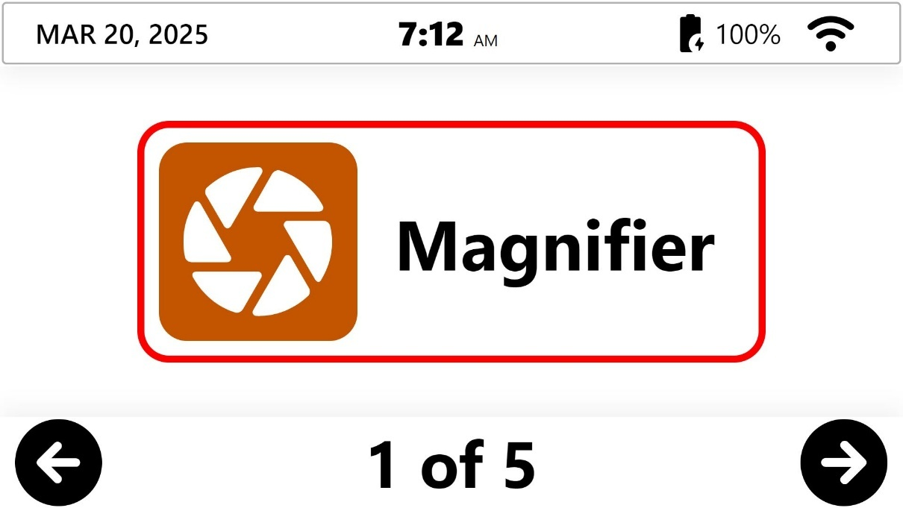

The header bar displays important system information when you are in the software’s Carousel interface.

Starting from the top left side of the screen, the header bar provides the following system information:

* Date (month/day/year)
* Time (hours: minutes)
* Battery level in percentage
* Wi-Fi status

By default, the Application Carousel features one large rectangle positioned in the center of the screen displaying the application. There are five applications in total. Note that the default interface can be customized to display one or several applications. Refer to Settings.

* The left and right arrows appear at their respective bottom corners of the screen. They allow the user to cycle through the applications.
* The bottom center of the screen displays the number of application pages and which is currently open based on the Carousel’s current position.

The user can double-click in the header to close Prodigi and exit to the Windows OS.

Note: The header bar disappears when you enter any application.

# 7. Getting Started

## Orientation to the UI: The Applications Carousel

Prodigi Windows applications are accessed via the Applications Carousel, click any of the applications to access them.

* **Magnifier** (camera shutter icon): The Magnifier application allows users to magnify or manipulate documents and objects. They can also be captured and saved for future viewing.
* **Distance** (mountain icon): The Distance application provides flexibility for users by allowing them to see things further away from them using different cameras, such as a rear-facing PC camera or a portable camera.
* **Files** (file folder icon): Prodigi Windows allows you to store captured documents and images in the Files application, where you can access them at any time. Digital materials (DOCX, TXT, PDF, JPG) can also be imported into Files.
* **Settings** (gear icon): Settings allow users to select and modify user interface features such as audio and system parameters. The Settings application also provides important system information and allows users to exit to the standard Windows environment.
* **Help** (question mark icon): The Help application allows you to easily access Prodigi documentation and videos, provide direct feedback to HumanWare, and make contact for support. Help functions require an Internet connection.

# 8.Settings Application



These are global, system-wide settings that apply throughout the Prodigi Windows environment and allow you to adjust the system according to your needs and preferences. These settings allow you to define a variety of functions, including how many applications appear in the Application Carousel, activating/deactivating system sounds, selecting speech rates, and so forth.

Note: Each application also has its own individual (application-specific) settings. These are discussed in more detail under each application section below.

## 8.1 Settings Menus

Six menus are available in Settings:

1. User Interface
2. Audio
3. System
4. Account
5. About
6. Exit to Windows

Submenus are indicated by arrows at the right edge of the screen. Tap or click the arrow to access options in the submenu. For example:

**Settings → User Interface → Button Banner → Auto✓/Hide/Always**

Current settings selections are indicated with a checkmark to the right of the item.

Some menu items require the User to make manual settings adjustments, for example:

**Settings → User Interface → Screen Brightness → Click the Plus or Minus symbols** that appear at the base of the screen to increase or decrease screen brightness.

Note that you can always click the **Back arrow** (located at the top, left of the screen) to access the previous screen.



## 8.2 User Interface

The Settings application allows users to select, customize, and enable or disable user interface features. This customization allows users to create a comfortable working environment that best suits their needs.

### Interface

Users have a wide range of visual capacities, and some may be able to work with several application icons on the screen. This feature allows you to select how many application icons appear in the Carousel. These icons can be clicked for quick access to their respective applications.

**Settings → User Interface → Interface: Carousel →** select **1✓, 2 or 4 application icons**

### System Language

Displays the current Prodigi system language and voice**✓** and all others currently installed (up to four at any time). The selected language will be reflected throughout the Prodigi interface, and its associated voice will be used for text-to-speech based on selected audio settings.

To install a new language (and voice), follow these steps:

**Settings → User Interface → System Language → Configuration → Select a voice from the alphabetical list of available system languages**

Prodigi has 76 text-to-speech voices, available in 16 languages and dialects. You may want multiple voices (one for pleasure, one for academic/professional), or one for native language and one for language learning (bilingual) – note that the maximum number of installed voices is four. The language selected here will apply to the interface, therefore, if you select German, the interface will be in German.

The languages available are English (US, Canada, UK, India, Australia), Czech, Danish, Dutch, Faroese, Finnish, French (Canada, France), German, Greek, Italian, Norwegian, Polish, Portuguese, Spanish (US, Spain), Swedish, Turkish.

### Uninstalling a Voice

When a user has four voices installed, they must uninstall one before adding another.

Note: If only one voice is installed, users must select a replacement voice before uninstalling a voice.

**Settings → User Interface → System Language → Configuration → deselect the voice that you wish to uninstall → select a new voice to install (if necessary) → click the Back arrow (top, left) → click submit (paper airplane symbol at the top, right) → Apply changes will pop up → click Yes**

**Voice update completed** messagewill appear.Click **OK.**

### Colors

Prodigi Windows allows you to select from 24 different color combinations and contrasts to suit your visual needs and preferences.

Important: This is the color contrast for the user interface and its elements like menus, buttons, etc. It does not apply to captured documents or images.

For example, if your combination is Black on White, negative contrast will show text and images in White on Black. This is useful if you wish to reverse the contrast of text that contains a variety of contrasts or highlights.

Options include:

* Black on white**✓**, White on black, Black on gray, Gray on black, Black on yellow, Yellow on black, Black on orange, Orange on black, Black on cyan, Cyan on black, Black on purple, Purple on black, Black on green, Green on black, Blue on yellow, Yellow on blue, White on blue, Blue on white, Beige on black, Black on beige, Black on Red, Red on Black, White on Red and Red on White

**Settings → User Interface → Colors → select Colors**

### Locator Color

The Locator Colors tell users exactly where they are in the user interface or a sub-menu with a visual boundary (circle, box, etc.). They can be selected to suit individual needs and preferences. Options are:

* Blue, Cyan, Green, Orange, Purple, Red**✓**, Yellow

**Settings → User Interface → Colors → select Locator Color**

### Mouse Pointer Size

Users may find that the default mouse pointer is too small. This setting allows them to adjust the pointer size ( Windows default 1✓) to their liking by clicking the Plus or Minus symbols from 1 (smallest) to 15 (largest).

Note: This setting will change the mouse pointer size throughout the entire Windows OS. Visit Settings → System → Accessibility Setup to make additional changes.

**Settings → User Interface → Mouse Pointer Size → click the Plus or Minus symbols**

### Screen Brightness

Lighting conditions can vary depending on time of day or other factors such as where your device is located in a room. Screen brightness level (Windows default 60**✓)** can be adjusted in increments of five as desired by clicking the Plus or Minus symbols from 5 (low brightness) to 100 (full brightness).

Note: This setting will change the screen brightness throughout the entire Windows OS. Visit Settings → System → Accessibility Setup to make additional changes.

**Settings → User Interface → Screen Brightness → click the Plus or Minus symbols**

### Button Banner

Depending on your preferences, the Button Banner can be configured to display or hide within the Magnifier, Distance, and Files applications.

* When it is set to **Always**, you will never see the up-arrow because the Button Banner is always present
* When set to **Auto** and the Button Banner automatically disappears during a reading activity, the up arrow can be clicked to view the banner
* When set to **Hide**, the Button Banner is always suppressed from the user's view until they click the up arrow

**Settings → User Interface → Button Banner → Auto✓/Hide/Always**

## 8.3 Audio

You can opt to listen to captured documents with OCR and have the user interface read aloud by accessing Audio settings to select/de-select TTS functionality, sounds, and to determine speech rates.

### Speech

Use this setting to select the level of TTS (text-to-speech) support desired. Options are:

* **On** provides audio support (TTS) for everything in the Prodigi interface, including documents
* **Documents only** provides audio support (TTS) only for OCR’d documents
* **Off✓**no audio (TTS) support at all

**Settings → Audio → Speech → On/Documents Only/Off✓**

### Speech Rate

Use this setting to select a speech rate when you are listening to a TTS (text-to-speech) voice. Options are:

* Very Slow
* Slow
* Normal**✓**
* Fast
* Very Fast

**Settings → Audio → Speech → Speech Rate → select Speech rate**

### Sounds

You can toggle Sounds On**✓** or Off. These are the sounds that you hear when clicking or swiping certain parts of the user interface such as the Carousel, interface subcategories or the Applications icons themselves, or when clicking the Camera icon to capture an image (you will hear a camera shutter sound).

**Settings → Audio → Sounds → On✓/Off**

## 8.4 System

Wi-Fi Setup

Note: The Windows OS interface will be opened to configure Wi-Fi, then return to Prodigi upon exit.

Select Wi-Fi Setup todirectlyaccess your Windows OS to adjust Wi-Fi settings and parameters, including:

* Turn Wi-Fi on or off
* Show available networks
* Display hardware properties and manage networks

**Settings → System → Wi-Fi Setup**

* **Click Wi-Fi: On** (a keyboard will pop up if you are using a tablet)
* **Show available networks**, then select the network that you wish to connect to
* **Enter the network password** and **click Connect** when prompted

### Bluetooth Setup

Note: Bluetooth is set up through the Windows OS interface, then returns to Prodigi upon exit.

Select Bluetooth Setup todirectlyaccess your Windows OS to adjust Bluetooth settings and parameters.

When turned On, your computer or tablet will attempt to discover other Bluetooth devices and be discoverable by other devices.

Note: A Bluetooth keyboard and mouse are included in the Complete Kit (Option 3), so it is important that the Bluetooth option be **turned ON**.

**Settings → System → Bluetooth Setup**

### Accessibility Setup

Prodigi Windows allows direct access to Windows accessibility settings so that you can configure mouse pointer color and size, text cursor appearance and thickness, and more.

Note: Some accessibility settings will only apply to the Windows OS. Example: text size, since Prodigi is already optimized for low vision use.

**Settings → System → Accessibility Setup**

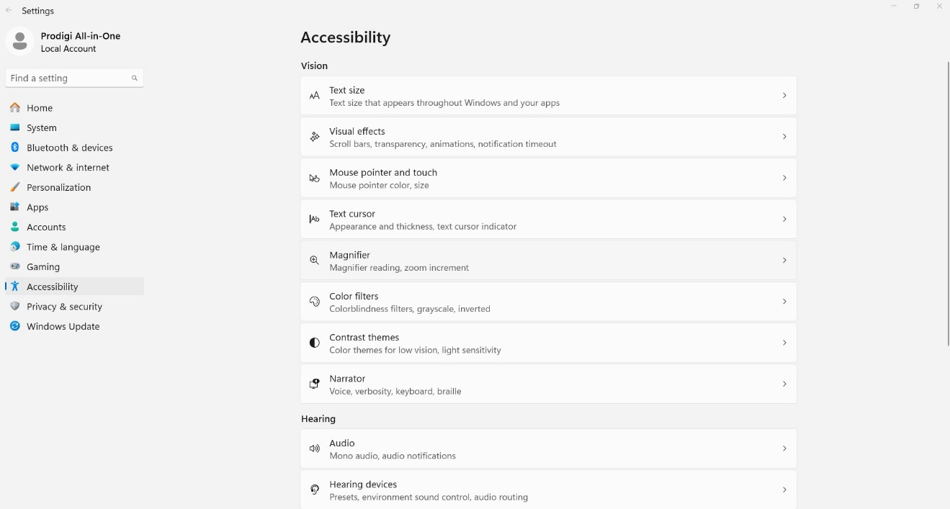

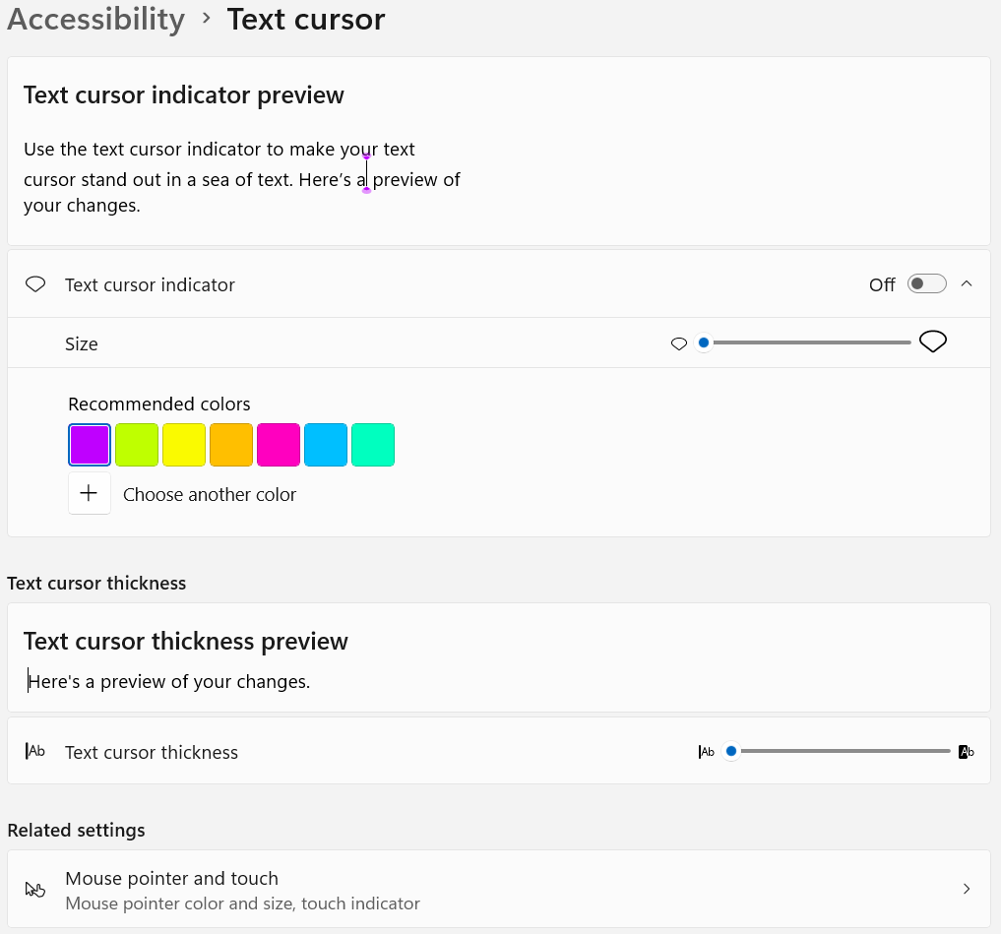

### Automatic Software Updates

When Wi-Fi is configured, Prodigi Windows software will automatically check for updates. If an update is available, you will be notified and asked if you wish to update your software. If you ignore the notifications, you can still verify if you’ve missed an update and perform it manually.

**Settings → System → Software Update**

If a software update is available, an **Available updates** screen will display **Details, Cancel, Update now and View release notes.**

* Click the **down arrow** at the right of the **Details** field to obtain informationon the Magnifier, Distance and Files version numbers.
* Click **Cancel** if you decide to forgo the software update.
* Click **Update now** to update the software.
* Click on **View release** **notes** to view the version release notes.

When updating, several progress bars will appear followed by the message “Prodigi will now restart.”

Once complete, a new window will appear indicating your software is up to date.

Click OK.

When no update is available, the message “Your software is up to date” will be displayed.

### Send Crash Logs

This feature can be defined to send crash event logs automatically or prompt the user each time. We highly recommend users select the **Always** setting.

**Settings → System → Send Crash Logs → Ask Me✓/Always**

### Screen Magnifiers

Prodigi can detect when the following screen magnifiers are turned on: Windows, ZoomText, and SuperNova. When detected, a message will appear asking users if they wish to disable their Windows or ZoomText magnifier. SuperNova users will be prompted with a message containing the keyboard shortcut to turn it off.

**Settings → System → Screen Magnifiers → On/Off/Ask Me✓**

### Usage Metrics

With the user’s permission, Prodigi can send anonymous system setup data, such as voices selected, speech mode used, color contrasts, etc. This information is valuable for understanding how Prodigi is used and the types of enhancements to develop. Ideally, all users will opt-in to share these metrics.

**Settings → System → Usage Data → On/Off✓/Details**

### Restore Default Settings

This feature restores all settings to their system defaults.

**Settings → System → Restore Default Settings → Restore defaults settings? → No/Yes**

Note: Installed voices and saved files and images taken with Magnifier or Distance applications will not be affected. Also, sample files are re-installed.

## 8.5 Account

Click **Account** to obtain account license information.

Users may work with a **Standard** (paid) or **Trial** (14-days free) license.

The **license expiration date** is found here as well.

Your **License ID** can be conveniently copied and shared to help with Customer Service or Technical Support situations. The License ID will help us identify the user’s account in our License Management System.

**Settings → Account → License ID → click the copy symbol**



When copying is successful, you will obtain the following message: “Your license ID has been copied to your clipboard.”

Clicking **Profile** opens a HumanWare web link with your username auto-filled. Again, information here can be shared in support situations when assistance is required. Password may need to be manually entered depending upon the system password security setup. Once you are logged in, you can access and modify Personal information, Contact information and Login name.

**Settings → Account → Profile**

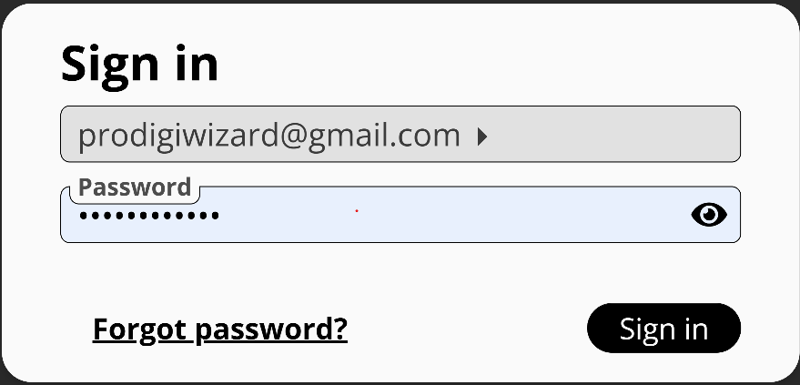

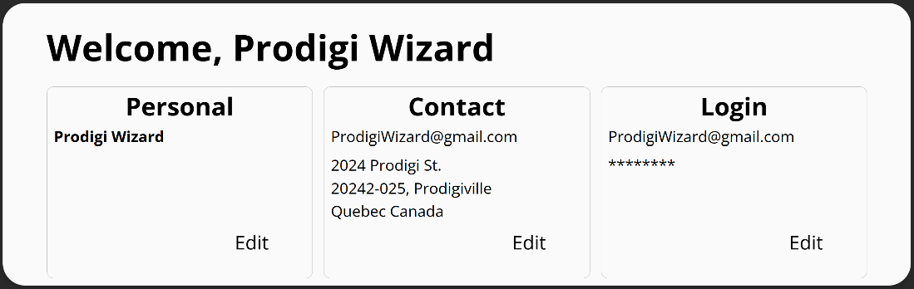

The **Account** section also allows you to log a device off Prodigi. You will be asked **Do you really want to disconnect?** Select **Yes** or **No**. This can be useful if you have more than three devices trying to use your Prodigi license – only three can be actively logged on at any given time.

## 8.6 About

This section displays information about the current Prodigi software and application versions, as well as the currently installed voices.

Important: If you contact our Customer Service or Technical Support Teams, they may ask you for this information to provide accurate assistance.

* Prodigi: version
* Magnifier: version
* Distance: version
* Files: version
* OCR: version
* Text-to-speech: version
* Voices: displays currently installed voices and their versions

For your convenience in a support situation, a download symbol is located at the top, right of the About screen. Clicking it allows you to download a TXT file of all the system information listed above onto your computer’s desktop.



When copying is successful, you will obtain the following message: “Export to Desktop successful.” The information can then be shared with HumanWare Support, as needed.

## 8.7 Exit to Windows

You can Exit Prodigi Windows in multiple ways:

**Settings → Exit to Windows**

or,

if using a tablet device, **Double-tap** the Carousel header bar to exit Prodigi Windows

or,

this action can also be accomplished by **double-clicking** the Carousel header bar using a standard mouse.

Each of the above closes the Prodigi application completely.

You can quickly return to Prodigi Windows by clicking the Prodigi icon (we recommend pinning the icon to your taskbar for quick access).

or,

Use Alt-Tab as another means to leave Prodigi. The benefit of this is that Prodigi continues to run in the background.

# 9. Magnifier Application



The Magnifier application features a broad range of magnification levels (up to 28X) as well as a variety of settings and tools that transform previously inaccessible documents and images into accessible ones.

Note: The first time Prodigi for Windows is used, you will be prompted to select a camera to use for magnification.

**Settings** → **Camera** → **Camera: Rear**, **Camera: Front, Integrated Webcam,** or a **USB-connected camera** such as the HoverCam SOLO 8+ document camera.

If the selected camera is busy in Magnifier, Distance, or another application, a pop-up message notifies the user.

Once the camera has been selected, the button banner will appear at the bottom of the Magnifier application screen.

A back arrow appears at the bottom, left:



Click it to exit the Magnifier application to return to the Application’s Carousel.

By default, there are five additional buttons on the bottom right end of the Magnifier toolbar, listed here from left to right

* the **Settings** symbol (gear)
* the **Rotate image** symbol
* the **Image capture** symbol (camera)
* the **Zoom out (-) and Zoom in (+) magnification** symbols



## 9.1 Magnifier Settings



Once you are in the Magnifier application, click the **Settings** (gear) symbol that appears at the base of your screen. These settings allow you to select how images are captured (camera selection) as well as a variety of other parameters (brightness, contrast, etc.)

Camera

Important: A camera must be selected.

**Magnifier → Settings → Camera →** Options include any **USB-connected camera**, **Front** or **Rear** (tablet) camera, or any other integrated camera. The currently selected camera is indicated with a check**✓** to the right.

Brightness

Image brightness which can be incrementally adjusted from 0 to 100. The default is 60.

**Magnifier → Settings → Brightness → click the plus or minus symbols to increase or diminish brightness** in units of five

Contrast

In live viewing mode, Prodigi Windows allows you to view documents and images in a contrast that best suits your needs. This is accomplished by swiping up or down on the right side of a touchscreen. There are three contrast types to choose from: color✓, positive, or negative.

* **Color** In live viewing mode, contrast is useful when viewing documents, objects, and photos in their original color. Color is the default setting.
* **Positive** contrast displays text and images in 2 colors according to the selected color combination (Black on White is the default combination).
* **Negative** contrast displays text and images in reversed contrast as compared to your selected color combination (White on Black is the default combination). This is useful if you wish to reverse the contrast of text that contains a variety of contrasts or highlights.

**Magnifier → Settings → Contrast → select Contrast**

Contrast Color

Prodigi Windows allows you to select from a variety of contrast color combinations for viewing live and captured documents or images. They include:

* Black on white**✓**, White on black, Black on gray, Gray on black, Black on yellow, Yellow on black, Black on orange, Orange on black, Black on cyan, Cyan on black, Black on purple, Purple on black, Black on green, Green on black, Blue on yellow, Yellow on blue, White on blue, Blue on white, Beige on black, Black on beige, Black on Red, Red on Black, White on Red and Red on White.

**Magnifier → Settings → Contrast Color → select Contrast Color combination**

### Autofocus

When using the SOLO 8+ camera, autofocus can be toggled from Locked to Unlocked with this menu setting. The shortcut to lock autofocus is a double tap anywhere on the screen. The symbol below will appear on the top, right side of your screen. Prodigi Windows allows you lock or unlock (default) autofocus when in Live mode. This is useful when an object or a document is correctly focused and you need to lock its position or when you are performing a task like writing on a piece of paper and want to prevent your camera from refocusing on your hand or pencil.



Double tap again anywhere on the screen to unlock autofocus. The Autofocus symbol will disappear.

Note: Mouse users can double-click to lock/unlock autofocus.

**Magnifier → Settings → Autofocus → Locked/Unlocked✓**

Capture Modes

Images and documents can be captured in Live mode or Multi-capture mode.

In Live mode captures are made one image at a time and if saved become a file with only one image. This is useful for menus or bank statements.

In Multi-capture mode any number of images can be added to create a larger document. This is useful for articles and book chapters.

You can toggle from one mode to the other in **Settings**. Alternatively, you can vertically swipe the left side of the screen. This gesture can also be performed with a mouse click-and-drag on the left side of the screen.

To capture a single image (Live mode), align the camera above the document and press/click the capture (camera) button – or long press anywhere on a touchscreen.

To capture a multipage document (Multi-capture), align the camera above the first page of a document and click camera or press and hold your finger down on the screen. Proceed in the same way for each page. Your multipage document will be saved in the Files application.

**Magnifier → Settings → Mode → select Multi-Capture** or **Live✓**

**Toggle gesture from Live to Multi-Capture Mode (image)**

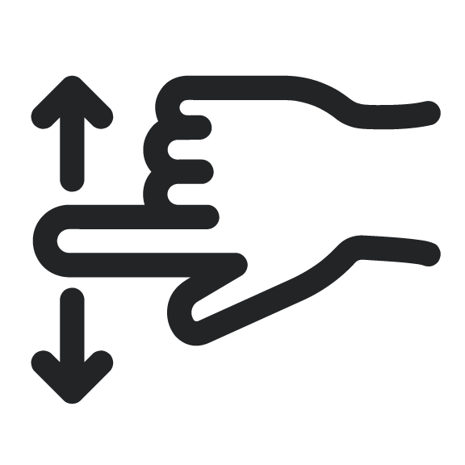

### Speech

Use this setting to select if you want to listen to a TTS (text-to-speech) voice. Options are:

* **On** - provides audio support (TTS) for everything in the Prodigi interface
* **Documents only** - provides audio support (TTS) only for OCR-applied documents
* **Off** (default) – no audio (TTS) support at all

**Settings → Audio → Speech → On/Documents Only/Off**

OCR (toggle)

Prodigi Windows features Optical Character Recognition (OCR) for various languages while using the Magnifier. It can be toggled to Enabled**✓**/Disabled. OCR enables reading text in page, column, or line mode. Disabling OCR is helpful when TTS is not required and accelerates the image capturing process.

**Magnifier → Settings → OCR → Enabled✓/Disabled**

Choose OCR Language

Prodigi can perform OCR (Optical Character Recognition) in 53 languages. Additionally, the Diamond Edge feature can be applied to these languages, enhancing the visual experience at higher magnifications.

Note: While Prodigi supports OCR in 53 languages, not all have corresponding text-to-speech (TTS) voices available for use after recognition.

Click Choose OCR Languages to select any of 53 available languages (default is System language).

* **Current:** displays the OCR language selected
* Other installed languages are listed immediately below **Current**
* Additional available OCR languages are in alphabetical order further below

**Magnifier → Settings → Choose OCR Language → Current: System Language✓/Other Language**.

## 9.2 Capturing Images and Text

When using the document camera, place the document directly under the document camera lens.

When using a rear-facing camera on a tablet, align it above the document or object that you wish to view or capture.

When using a front-facing camera, place yourself in front of the camera for a mirror/self-view.

Note: OCR (Optical Character Recognition) feature is automatically disabled when using a Front-facing camera.



Click the **Capture symbol** to capture an image with your selected camera. You will hear a camera shutter sound (unless the system sounds have been turned off), indicating that the document is being captured. Alternately, you can tap and hold your finger on a touchscreen or click and hold a mouse for 2 seconds on the image to capture. You will hear a camera shutter sound, indicating that the document is being captured (note that it takes a few moments to capture and process the image).

You can cancel the image capture and OCR process by using the **Escape key** on your keyboard or by clicking the **Back arrow** in lower, left corner of the screen.

Once you’ve captured an image or document the Prodigi interface will update for reading, three additional icons will appear at the base of your screen: a Diamond (Diamond Edge) symbol, the Read button (black, right-pointing triangle) and the Save (disk) icon. Several additional Settings (gear) also become available with captured materials.



Additional **Settings** available with captured documents include: Reading Voice, Reading Mode, and Preferred Zoom.

By default, whatever language and Systemvoice you have chosen is used for TTS reading. Captured documents allow the option to change to any other installed TTS voice, including Microsoft Desktop voices. In South Africa, installed Qfrency voices will also be available as TTS reading voices.

The Reading mode of a captured document can also be adjusted. This can be helpful in allowing for greatly enlarged text or when the page layout is not important to comprehension. Three options are available Page, Column**✓**, and Line.

* In Page mode, the entire view of the document is retained during reading. This allows the user to see the layout and structure, which may convey meaning.
* Column mode presents text in a single, long-form column. This can reduce visual clutter and allows for greater text enlargement.
* Line mode shows text in a single, horizontal line while reading with TTS. This is very similar to a teleprompter. It also allows for larger text and less visual clutter while reading.

Lastly, a Preferred Zoom ranging from 2 to 40x can be set and applied automatically when a document is captured (4x**✓**). This can save time, especially when many documents with similar size fonts will be captured.



**Diamond Edge** contrast combines the best of both worlds: it displays Diamond Edge Text**™** in your selected color combination and images in their original color. This allows you to magnify text to maximum levels without compromising text quality in the best color combination for your vision.

* Click Play to start reading the first visible word on the screen.
* If a word is selected, reading will start from that point.



Once you’ve captured a document or an image that contains text, you can click the **Read button** (black, right-pointing triangle) to have the system read the content. When clicked, the Read button will disappear and you will need to click on the up arrow at the bottom center of the screen to access the button banner, which will now display the **Pause icon** (two, vertical parallel lines).

In reading mode, several additional settings (gear symbol) are added to those already covered, including Font Size, Font Type, and Highlight.



Users can also control where reading happens on the page with a long-left mouse press or a long-press on a touch screen. This will move the focus to start reading where the user has performed this action.

## 9.3 Zooming In and Out



You can also increase or reduce the size of your live or captured image by clicking the **Plus or Minus symbols** at the bottom, right of the screen. (**+**) increases image/character size, and (**-**) decreases image/character size. You can also tap and hold the symbols to adjust the zoom levels progressively and incrementally. Release once you reach the desired zoom level.

* Magnification range for a live image is from 1x to 28x.
* Magnification range for a captured image is from 1x to 80x.

In addition to the increase/decrease magnification symbols, you can employ the **pinch and zoom** gesture to increase/decrease magnification on a touchscreen. Decrease the distance between 2 fingers to zoom out, and increase the distance to zoom in.

**Pinch and Zoom gesture** (image)

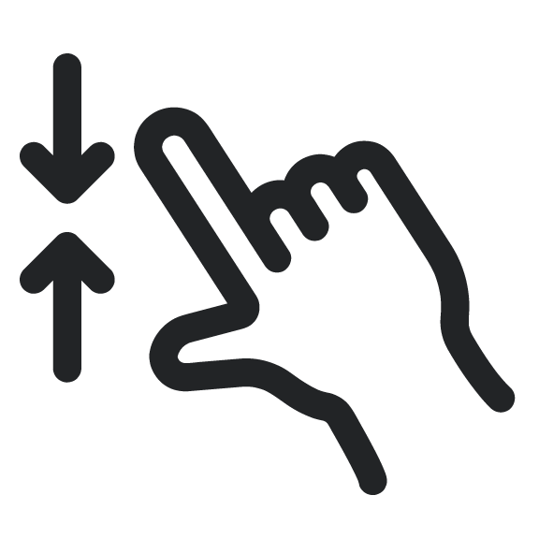 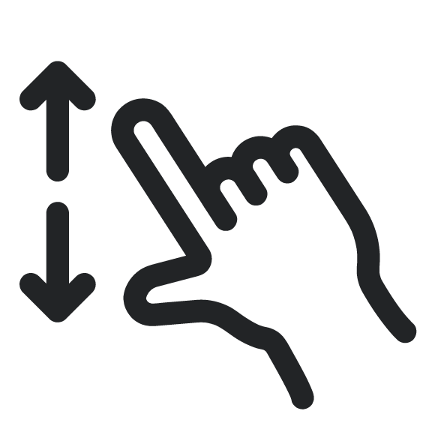

## 9.4 Reading Settings



Clicking the Settings (gear) symbol in reading mode accesses additional options to enhance the reading experience, including some that have been previously detailed.

Font Size: The captured document can have the font of the OCR’d text increased or decreased. This can reduce the need to zoom in or out. Options include Minimum, Small, Medium, Standard**✓**, Large, Very Large, Extra Large, and Maximum.

Font Type: The OCR’d text can be displayed in either Regular or Bold**✓** font type based upon visual needs.

Highlight: While Prodigi is reading aloud with TTS a box is shown around each spoken word. This can be helpful to maintain focus and making connections between the audio and visual presentation of text. The options are Display**✓**, which means the box is visible, or Hide.

## 9.5 Saving an Image or Document



Once you make a capture, the **Save symbol** will appear at the far right of the screen. Click it to save your image or document in Files for future use. Clicking Save will immediately return you to live camera mode.

## 9.6 Magnifier / Distance toggle

The toggle symbols appear as either a Mountain icon **or** a Page icon, depending on which mode you’re in. The toggle symbols appear at the right of the back arrow.

 and

Click them to move between Magnifier and Distance modes.

Note: The toggle symbol does not appear by default. **Both** the Magnifier and Distance cameras need to be set up (using two separate cameras), for the toggle button to appear.

## 9.7 Split Screen Viewing

Similar to the Magnifier/Distance toggle button, the Split Screen button will not appear until a camera is selected for each application. Press the Split Screen buttons to ycle through the following views:

Start: Current application (Magnifier or Distance)

1st press: Side-by-side (Magnification and Distance)2nd press: Top-and-bottom Magnification and Distance)

3rd press: Return to current application

# 10. Files Application



The Files application is where captured images, documents, and imported files are permanently stored, until you decide to delete them. Click it to access folders with saved documents and images.

Note: When Files is launched, the user is placed at the first, non-folder file.

From the Files application, you can also create and rename folders for organization.

A sample folder (labeled “Samples”) is installed with the software. You can click the sample document to see the included files and explore the different settings that are available.

The bottom, center of the screen will indicate your current file number out of a total number of files and folders, for example, “1 of 12”.

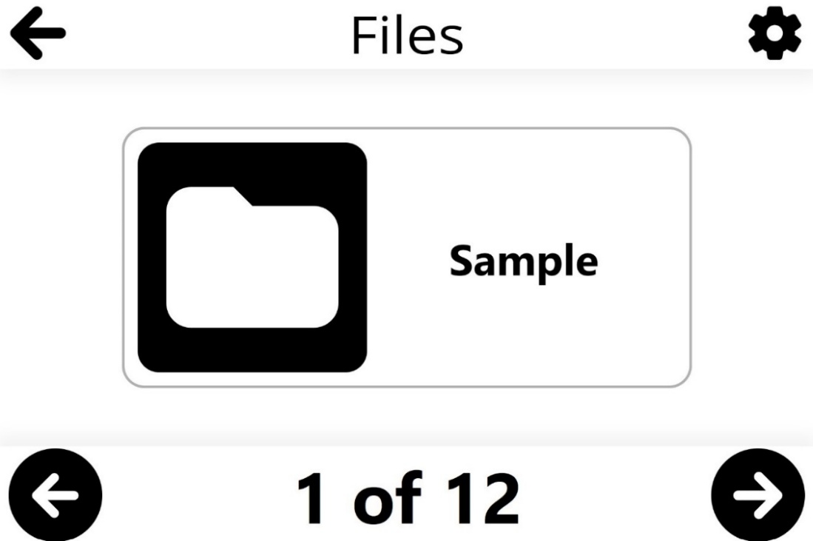

Use the left or right arrows located at the base of the screen to cycle through your files.

The top, right of the screen features a Settings (gear) symbol. Click it to access Sort, Order, Create Folder, Import and Delete All features.

**Sort**: files can be sorted in three ways: Alphabetically, by Creation Date or by Modification Date**✓**.

**Files → Settings → Sort → Alphabetical/Creation Date/Modification Date✓**

**Order**: files order can be toggled between Ascending**✓** or Descending

**Files → Settings → Order → Ascending✓/Descending**

**Create Folder**: new folders can be created by clicking Create Folder. A Create Folder field will appear, simply enter the name of the new folder and click the **Airplane icon** at the top, right of the screen to save the new folder. Use the back arrow to cancel.

**Files → Settings → Create Folder → New Folder → name new folder → click airplane icon**



**Import:** Prodigi allowsDOCX,PDF, TXT, PNG, and JPGfiles to import into your Files folder from elsewhere on your Windows system (example: Downloads).

**Note:** If more information is needed about a file when importing it, perform a long (1-second) click or press to display the file’s details. Click again to close the dialog box.

**Files → Settings → Import → select the location of the file outside of Prodigi to be imported → click submit (paper plane symbol at the top, right of the screen)**

**Delete All**: Permanently deletes all items in the Files application. As a safety feature, you will be asked “Permanently delete all files in Files?” Click Yes or No.

**Files → Settings → Delete All → Yes/No**

## 10.1 Viewing Documents and Images

Click a file or a folder to open it. Once open, you will be able to cycle through your images and documents within a folder. Select and click a document or image file to open it. The Settings (gear) symbol appears at the base of the screen and offers the following functionalities.

Contrast

Prodigi Windows allows you to view documents, photos and objects in 3 contrast types: color, positive or negative.

* **Color** contrast is useful when viewing documents, objects and photos in their original color.
* **Positive** contrast displays text and images in 2 colors according to the selected color combination (Black on White is the default combination).
* **Negative** contrast displays text and images in reversed contrast as compared to your selected color combination (White on Black by default). This is useful if you wish to reverse the contrast of text that contains a variety of contrasts or highlights.

**Files → click open Image or Document → Settings → Contrast → select Contrast color**

Contrast Color

Prodigi Windows allows you to select from a variety of contrast color combinations for captured documents and images. They include:

* Black on white**✓**, White on black, Black on gray, Gray on black, Black on yellow, Yellow on black, Black on orange, Orange on black, Black on cyan, Cyan on black, Black on purple, Purple on black, Black on green, Green on black, Blue on yellow, Yellow on blue, White on blue, Blue on white, Beige on black, Black on beige, Black on Red, Red on Black, White on Red and Red on White.

**Files → click open Image or Document → Settings → Contrast Color → select Contrast Color combination**

Brightness

Image brightness can be incrementally adjusted in units of 5 from 0 to 100.

**Files → click open Image or Document → Settings → Brightness → click the Plus or Minus symbols** that appear at the base of the screen to increase or decrease screen brightness

Voice

Prodigi software allows up to 4 different Acapela voices that can be used to read text documents aloud. Click to select the system voice or another installed Acapela voice.

Additionally, Prodigi allows the option of other installed SAPI voices (Microsoft Desktop) for document reading. This can be helpful where there are unsupported dialects from Acapela, such as Afrikaans.

**Files → click open Image or Document → Settings → Voice → select System voice or installed voice**

### Speech

Use this setting to select if you want to listen to a TTS (text-to-speech) voice. Options are:

* **On** - provides audio support (TTS) for everything in the Prodigi interface
* **Documents only** - provides audio support (TTS) only for OCR’d documents
* **Off✓**– no audio (TTS) support at all

**Settings → Audio → Speech → On/Documents Only/Off✓**

Reading Mode

Readers have different preferences about how they wish text to appear on-screen while it is read, so Prodigi software allows you to select from 3 reading modes: Page, Column**✓** or Line.

**Files → click open Image or Document → Settings → Reading mode → select Page, Column✓, or Line**

Note: You can use your mouse or touchscreen to reposition the cursor at any time during reading mode.

When reading in Column mode, end-of-paragraph markers (>>) will appear, and the reading software automatically inserts a short pause after each paragraph.

When in Page mode, a chime will sound when the reader has reached the end of the page. Pressing Play will restart the reader at the beginning of the page or turn to the next page.

Note: Diamond Edge is the default when Page reading mode is selected, but the user can choose to have the document read in its original layout.

Preferred Zoom

Preferred zoom can be set from 2x magnification to 40x magnification (default is 4x) for all saved documents and images. Set a preferred zoom level, and your file or document will open at that default zoom level when you click to open it.

**Files → click open Image or Document → Settings → Preferred Zoom → click the Plus or Minus symbols** that appear at the base of the screen to increase or decrease Preferred Zoom level.

### Rotation



Select this feature to access the **Rotation symbol** at the bottom, right of the screen. Click the symbol to rotate an image or document clockwise, 90 degrees at a time (clicking 4 times brings a document back to its original position).

**Files → click open Image or Document → Settings → Rotation → click Rotation symbol**

**Diamond Edge (diamond symbol)**



For text documents, toggle the Diamond Edge to enhance the original color of a document or object to improve text/image definition. Diamond Edge contrast combines the best of both worlds: it displays Diamond Edge Text**™** in your selected color combination and images in their original color. This allows you to magnify text to maximum levels without compromising text quality in the best color combination for your vision.

**TTS read-aloud symbol (black, right-pointing triangle)**



Once you’ve captured a document or an image that contains text, you can click the **Read button** and have the system read content aloud. The Read button is immediately replaced by the **Pause icon** (two vertical parallel lines) so that you can toggle between play and pause.

Alternately, users can start reading wherever they like with a long finger press (1 second) or a long mouse click (1 second) on the word where they want the reading to begin.

**Plus and Minus symbols (+/-)**



You can increase or reduce the size of captured images and documents by clicking the **Plus or Minus symbols** at the bottom, right of the screen. (**+**) increases image/character size, and **(-)** decreases image/character size.

Magnification range for a captured image or document is from 1x to 100x.

In addition to the increase/decrease magnification symbols, you can employ the **pinch and zoom** gesture to increase/decrease magnification. Decrease the distance between 2 fingers to zoom out, and increase the distance to zoom in.

**Pinch and Zoom gesture (image)**



## 10.2 Reading Settings



Clicking the **Settings** (gear) symbol in reading mode accesses additional options to enhance the reading experience, including some that have been previously detailed.

* **Font size**: The captured document can have the font of the OCR’d text increased or decreased. This can reduce the need to zoom in or out. Options include: Minimum, Small, Medium, Standard**✓**, Large, Very Large, Extra Large, and Maximum.
* **Font type**: The OCR’d text can be displayed in either Regular or Bold**✓** font type based upon visual needs.
* **Highlight**: While Prodigi is reading aloud with TTS a box is shown around each spoken word. This can be helpful to maintain focus and making connections between the audio and visual presentation of text. The options are Display**✓**, which means the box is visible, or Hide.

## 10.3 Action Menu (for Folders)

The Files application features an **Action Menu** that includes useful functions for your saved folders.

To access the Action menu, **right-click** a Folder. You will be directed to a menu listing available actions for your selected file. This menu can also be accessed by a long, one-finger press on the file or folder.

### Move

Clicking Move leads to the **Create New Folder** option if you want to move a folder to a new folder. All other previously existing folders will appear on the list as well.

**Files → Folder → Action (right-click image or document) → Move →** **Create Folder → enter title of new folder → click Folder symbol located at the top, right of the screen**



### Delete

Permanently deletes all items in the folder. As a safety feature, you will be asked **Permanently delete item?**

**Files → Folder → Action (right-click image or document) → Delete → Yes/No**

### Rename

Files can be renamed by right-clicking them, then selecting **Rename** from the Action menu.

**Files → Folder → Action (right-click folder) → Rename → enter the new name** then click **submit** (paper plane symbol at the top, right of the screen) to save the revised name.



### Create Folder

Follow this process to create and save a new folder:

**Files → Folder → Action (right-click image or document) → Create Folder → enter name of new folder** then click **submit** (paper plane symbol at the top, right of the screen) to save the revised name.

### Delete Folder Content

You can keep a folder but permanently delete all the content in it. As a safety feature, you will be asked **Permanently delete content?**

**Files → Folder → Action (right-click image or document) → Delete → Yes/No**

## 10.4 Action menu (for documents and images)

### Move

Clicking Move leads to the **Create New Folder** option if you want to move saved images into a new folder. All other existing folders will appear on the list as well.

**Files → Folder → Action (right-click image or document) → Move →** **Create Folder → enter name of new folder → click Folder symbol located at the top, right of the screen**

### Delete

Permanently deletes the saved document or image. As a safety feature, you will be asked **Permanently delete item?**

**Files → Action Menu (right-click image or document) → Delete → Yes/No**

### Rename

Documents or images can be renamed by right-clicking them, then selecting **Rename** from the Action menu.

**Files → Folder → Action (right-click image or document) → Rename → enter the new name** and click **submit** (paper plane symbol at the top, right of the screen) to save the revised name.



### Export

Documents or images can be exported elsewhere by right-clicking them, then selecting **Export** from the Action menu.

**Files → Folder → Action (right-click image or document) → Export → select export format (PDF, JPG or Text) → Export → select export destination**

When the export is complete, the “Exported to Downloads” message will appear.

### Import

Documents or images can be imported into your Prodigi library from elsewhere (supported file types: PDF, TXT, JPG, and PNG).

**Files → Folder → select image or document → Settings** → **Import → select import destination → click submit (paper plane symbol at the top, right of the screen)**

When the import is completed, the “Carousel has been refreshed” message will briefly appear.



### Properties

This section identifies and provides information on an image or document, such as name, type (example: JPEG), date created, date modified, and size (example: 344 KB).

**Files → Folder → Action (right-click image or document) → Properties**

Prodigi Windows allows you to paste external text files into the Files application and then open them using the Prodigi Windows interface. Copying can also be done outside Prodigi Windows in Windows applications that allow you to copy text (example: Internet browser, Dropbox, or your email).

# 11. Distance application



The Distance application can be helpful when you need a better view of something far away, such as a slide presentation during a lecture. Different camera options, such as a PC camera or a rear-facing tablet camera, are available in the Distance application. As with the Magnifier application, you must select a camera to use the Distance application.

The base of the page features a Button Banner that includes:

* A **back arrow** appears at the far left, click it to exit the Distance application and return to the Application’s Carousel.
* You can also click the toggle symbol for quick access to the Magnifier app. This appears immediately to the right of the back button.

Four additional icons appear at the right side:

* the **Settings** symbol (gear)
* the **Image capture** symbol (camera)
* the **Plus and Minus magnification** symbols



## 11.1 Distance Settings

Once you are in the Distance application, click the **Settings** (gear) symbol that appears at the base of your screen. These settings allow you to select how images are captured (camera selection) as well as a variety of other image parameters (brightness, contrast, etc.)

Camera

Note that one camera must be selected. A different camera must be used for distance viewing.

**Distance → Settings → Camera →** select **Camera: Rear** or **Camera: Front**, another integrated camera, a USB-connected camera such as the Hovercam SOLO8+, or the **Kodak Wi-Fi distance camera** (refer to Appendix 2 for complete Wi-Fi instructions).

Brightness

Image brightness which can be incrementally adjusted from 0 to 100. 50 is the default.

**Distance → Settings → Brightness → Click the Plus** or **Minus symbols** that appear at the bottom, right of the screen to increase or decrease screen brightness.

Contrast

Live images can be viewed in a contrast that best suits your needs, there are 3 contrast types to choose from: color, positive or negative.

* **Color** (default) In live viewing mode, contrast is useful when viewing documents, objects, and photos in their original color.
* **Positive** contrast displays text and images in 2 colors according to the selected color combination (Black on White is the default combination).
* **Negative** contrast displays text and images in reversed contrast as compared to your selected color combination (White on Black is the default). This is useful if you wish to reverse the contrast of text that contains a variety of contrasts or highlights.

**Distance → Settings → Contrast → Color/Positive/Negative**

Contrast Color

You can select from a variety of contrast color combinations to suit your needs and preferences. They include:

* Black on white**✓,** White on black, Black on gray, Gray on black, Black on yellow, Yellow on black, Black on orange, Orange on black, Black on cyan, Cyan on black, Black on purple, Purple on black, Black on green, Green on black, Blue on yellow, Yellow on blue, White on blue, Blue on white, Beige on black, Black on beige, Black on Red, Red on Black, White on Red and Red on White

**Distance → Settings → Contrast → select a Contrast Color from the list above**

Autofocus (toggle)

Autofocus can be toggled from locked to unlocked (default) when you are in the Distance application. This is useful when an image is correctly focused and you need to lock its position. Alternately, you can double tap (tap twice quickly) anywhere on the screen to focus manually on a particular object when objects are positioned at different distances.

The following symbol will appear at the top, right side of your screen.



Double tap again anywhere on the screen to unlock autofocus. The Autofocus symbol will disappear.

**Distance → Settings → Autofocus (toggle) Locked/Unlocked** (default)

## 11.2 Capturing Images

Point your camera at an object that you wish to view.



Click the **Capture symbol** to capture an image with your selected camera. You will hear a camera shutter sound, indicating that the image is being captured. Alternatively, you can tap and hold your finger on the screen for 2 seconds. You will hear a camera shutter sound, indicating that the image is being captured, it takes a few moments to capture and process the image. Note: Once a capture is initiated, it can be canceled by clicking the back button in the lower left toolbar one time or pressing the Escape key on your keyboard.

## 11.3 Saving an Image or Document



Once you make a capture, the **Save symbol** will appear at the bottom, right of the screen. Click it to save your image or document in the Files application for future use. Clicking Save will immediately return you to the live camera mode.

## 11.4 Zooming In and Out



You can increase or reduce the size of a live image by clicking the **Plus or Minus symbols** at the bottom, right of the screen. (**+**) increases image/character size, and (**-**) decreases image/character size. You can also tap and hold the symbols to adjust the zoom levels progressively and incrementally. Release once you reach the desired zoom level.

Magnification range for a live image is from 1x to 28x.

Magnification range for a captured image or document is from 1x to 100x.

In addition to the increase/decrease magnification symbols, you can employ the **pinch and zoom** gesture to increase/decrease magnification. Decrease the distance between 2 fingers to zoom out, and increase the distance to zoom in.

**Pinch and Zoom gesture**



# 12. Help Application



Note: Internet access is required to use the following tools.

The rightmost item in the Carousel menu is the Help Application (question mark icon). This application is where you will find information on how to operate system software, how to connect cameras and troubleshooting tips. You will also find quick and easy methods to assist you in navigating and personalizing Prodigi Windows to suit your needs and preferences.

Clicking **Feedback** will redirect to our HumanWare web form. Use it to tell us what you think of the Prodigi Windows system, what you like, and how you think we can improve its features.

Clicking **Videos** to go to our HumanWare YouTube video channel, which contains a variety of informative and instructional videos on how to install and operate Prodigi Windows software.

Click **Documentation** to access support documentation, the HumanWare Buddy app and other resources.

# 13. Gesture Guide

Note: the following gestures are for use with touchscreen-enabled devices.

### Pinch and zoom gesture



### Tap gesture (for accessing applications, selecting preferences, etc.)



### Double tap gesture (header bar, etc.)



### Long press gesture (image capture, etc.)



### Toggle from Live to Multi-Capture Mode or Contrasts



# 14. Basic Keyboard Shortcuts

* Copy: **Ctrl** + **C**
* Cut: **Ctrl** + **X**
* Paste: **Ctrl** + **V**
* Maximize Window: **F11** or **Windows logo key** + **Up arrow**
* Minimize application: **Windows logo key** + **M**
* Open Task View: **Windows logo key** + **Tab**
* Display and hide the desktop: **Windows logo key**  + **D**
* Switch between open apps: **Alt**+ **Tab**
* Open the Quick Link menu: **Windows logo key** + **X**
* Lock your PC: **Windows logo key**  + **L**
* Quit: **Ctrl + Q**

Click the following link to access the expanded list of [Keyboard shortcuts in Windows](https://support.microsoft.com/en-us/windows/keyboard-shortcuts-in-windows-dcc61a57-8ff0-cffe-9796-cb9706c75eec)

Prodigi for Windows has keyboard commands that can be used only with HumanWare’s wireless Bluetooth keyboard.

# 15. Glossary

**Auto-focus**: a device or feature that focuses a camera or other piece of equipment automatically.

**Bluetooth**: a telecommunications industry specification that describes how mobile devices, computers and other devices can easily communicate with each other using a short-range [wireless](https://www.techtarget.com/searchmobilecomputing/definition/wireless) connection. **Diamond Edge**: This screen feature allows you to magnify text to maximum levels without compromising text quality in the best color combination for your vision. It displays your selected color combination and images in their original color.

**High-Contrast Viewing**: The software makes text and images more readable for those with low vision. It enhances visual clarity and comfort, especially in documents or environments with poor lighting.

**HoverCam:** The HoverCam document camera is plug-and-play with Prodigi. While Pathway Innovations has developed their own software for the camera, it is NOT required for using the camera with Prodigi.

**OCR (optical character recognition)**: OCR is a technology that recognizes text within a digital image. It is commonly used to recognize text in scanned documents and images. OCR software can be used to convert a physical paper document, or an image into an accessible electronic version with text.

**Reading Mode**: The software includes various reading modes such as full page, column, and line, which adapt to different reading preferences and tasks. Users can choose the mode that best suits their needs, enhancing their reading experience and productivity.

**Text-to-Speech (TTS**): Prodigi can convert printed text into spoken words, providing access to printed materials for individuals with visual impairments. Additionally, text-to-speech can be employed to read all elements of the software interface. This feature promotes literacy, independence, and accessibility.

**User Interface (UI)**: The point of contact between humans and computers. Any technology you interact with as a user is part of the user interface. For example, screens, sounds, overall style, and responsiveness are all elements of UI.

**Windows-Based**: Written for Windows ensures a seamless integration with the user's preferred operating system, making it easy for users to incorporate Prodigi into their existing technology ecosystem. This compatibility provides a familiar and user-friendly experience.

# 16. Troubleshooting

Software will not install.

* Be sure that you have the administrator rights to install on your device
* Update App Installer in the Microsoft Store Library of Apps

No audio when trying to read an OCR document

* Check **Settings → Audio** to see if **Documents Only** or **All** is selected.
* Ensure voices are downloaded and installed in **Settings → User Interface → System Language**
* Verify that tablet/headphone volume has been turned up sufficiently

No image appears in either the Magnifier or Distance applications.

* Check that a camera is selected by **clicking the gear wheel** and **select a camera**
* Check **camera connections** on both ends; disconnect and reconnect

Blank image in Magnifier or Distance application (white or black).

* Check that a camera is selected by **clicking the gear wheel** and **Camera**
* Close and open the application
* Exit and restart Prodigi
* Disconnect and reconnect your camera
* Reboot your system

# 17. Prodigi System Recommendations

What to look for in a PC:

|  |  |
| --- | --- |
| **Description** | **Specification** |
| Operating System (64-bit) | Windows 11, Windows 10 |
| Processor speed | Intel Core i3 (4 CPUs) or better CPU |
| Memory (RAM) | at least 6 GB |
| Required hard disk space | 8 GB free disk space |
| Video | DirectX 11 or newer |
| Sound | Windows compatible sound card (for speech). |

What to look for in a document camera:

|  |  |
| --- | --- |
| **Description** | **Specification** |
| Resolution | 13MP |
| Color | 24-bit color |
| FPS | 60fps@10ADP |
| System | Windows 10+ |
| Connectivity | USB connectivity |

# 18. Appendix 1

## 18.1 Basic Prodigi Windows Bluetooth Keyboard Commands

Note: these keyboard commands are for the Bluetooth Keyboard by HumanWare. They do not apply to other keyboards.

|  |  |
| --- | --- |
| **Key** | **Action** |
| ESC | Back |
| F1 | Brightness down |
| F2 | Brightness up |
| F3 | Open Windows start menu |
| F4 | Show active apps |
| F5 | Open settings (specific to current view) |
| F6 | Open magnifier |
| F7 | Decrease reading speed |
| F8 | Capture image ***or*** start/stop reading |
| F9 | Increase reading speed |
| F10 | Mute/unmute |
| F11 | Decrease volume |
| F12 | Increase volume |
| Power | Sleep/Wake (Not implemented on Windows) |
| Right CMD (HOME) | Return to Prodigi Home |
| Left CMD (BACK) | Back |
| Up Arrow | Move the locator |
| Down Arrow | Move the locator |
| Ctrl + Up Arrow | (Temporary until the Navigation mode is implemented)  Scroll up or page up |
| Ctrl + Down Arrow | (Temporary until the Navigation mode is implemented)  Scroll down or page down |
| Right Arrow | Move the locator |
| Left Arrow | Move the locator |
| Ctrl + Right Arrow | (Temporary until the Navigation mode is implemented)  Scroll right or next page |
| Ctrl + Left Arrow | (Temporary until the Navigation mode is implemented)  Scroll left or go back or previous page |
| Plus | Zoom in or increase text size |
| Minus | Zoom out or decrease text size |
| Right Alt | Prodigi Home |
| Left Alt | Back |
| Enter | Select item |
| Long Press Enter | Open action menu |
| Ctrl + Q | Exit to Android |
| Ctrl + B | Toggle button banner |
| Ctrl + C | Table of content |
| Ctrl + S | Download or Save |
| Ctrl + L | Toggle lights (Not implemented on Windows) |
| TAB | Move the focus |
| Ctrl + Mouse wheel | Zoom In/ Zoom out |

## 18.2 General keyboard shortcuts

|  |  |
| --- | --- |
| **Key** | **Action** |
| Up arrow | Move the locator scroll |
| Down arrow | Move the locator scroll |
| Left arrow | Move the locator scroll |
| Right arrow | Move the locator scroll |
| Ctrl + Up | Pan in an image or Scroll into the text (Column Mode) |
| Ctrl + Down | Pan in an image or Scroll into the text (Column Mode) |
| Ctrl + Left | Pan in an image or Scroll into the text (Line Mode) or Go to previous or next page in a document |
| Ctrl + Right | Pan in an image or Scroll into the text (Line Mode) or Go to previous or next page in a document |
| Plus + | Zoom in / Increase text size |
| Minus - | Zoom out / decrease text size |
| ESC | Back |
| Ctrl + Q | Exit current application |
| Alt + F4 | Exit current application |
| Ctrl + B | Show/hide button banner |
| Ctrl + S | Save picture |
| TAB | Move the locator to next or previous area/item |
| Shift + TAB | Move the locator to next or previous area/item |
| Space | Trigger selected item |
| Enter | Long press opens the contextual menu of selected item |
| Shift + F10 | Open contextual menu of the selected item |
| Mouse wheel | Zoom in/out or Scroll up/down |

# 19. Appendix 2

## Connecting the Kodak Wi-Fi Distance Camera to Prodigi Software

Using the Kodak camera for distance viewing with Prodigi software offers an enhanced visual experience, making it easier to see and magnify distant objects. To get the most from this setup, it's essential to use the included Wi-Fi Dual Band USB Adapter  
which creates a secondary network called Wi-Fi 2. This dedicated network allows a stable connection to the Kodak camera without interrupting your primary Wi-Fi, so you can enjoy seamless distance viewing and maintain access to the Internet on your device.

1. Ensure that your Prodigi software is installed and updated to version 1.1 or later.  
2. Fully charge the Kodak distance camera (SL-10 or SL-25) using the charger.  
3. Attach the Kodak camera to the flexible gooseneck.  
4. Slide the mounting adapter onto the HoverCam SOLO 8+ vertical arm.  
5. Insert the gooseneck with the camera into the adapter.  
6. Plug the Wi-Fi Dual Band USB Adapter into a USB port on your Windows device and  
follow the setup prompts.  
7. Launch the Prodigi software and open the Distance application.  
8. Click the Settings (gear) icon.  
9. Press the power button on the Kodak camera.  
10. Select “Camera,” then choose “Wi-Fi 2” from the list.  
Note: Choosing “Wi-Fi” as your network will disable Internet access, as this is your  
primary network.  
11. Click “Find a camera” and select PIXPRO-SL10_xxxx or PIXPRO-SL25_xxxx.  
12. Enter the Kodak camera password: 12345678. Note: In later units, the password has been changed to 00000000. This will be indicated by a prominent sticker at the bottom of the camera.  
13. Exit the Settings menu to return to the Distance application and begin using the  
Kodak camera for distance viewing and magnification.

If you exit Prodigi, or lose your connection, a message will appear onscreen in  
addition to a Reconnect button in the lower left corner of the Distance application interface to the right of the Magnifier-Distance toggle button. Click the Reconnect button to re-establish your camera.

You can disconnect from the selected Wi-Fi camera by selecting another Wi-Fi, USB, or integrated camera from the Distance application.

To completely remove a Wi-Fi camera, open the Distance application, navigate to the Wi-Fi to which it is connected, click on settings (gear wheel) to manage the Wi-Fi camera, click on the camera to be removed, select “Forget,” and confirm your choice. Use the back arrow in the upper left corner to return to the Carousel.

**Distance → Settings → Camera → Wi-Fi 2 → Settings → PIXPRO-SL 10** or **SL-25 → Forget → Yes/No**

# 20. Technical Specifications

## Prodigi Low Vision Software for Windows

*Note: Prodigi for Windows is optimized for use with the from HoverCam; results with other document cameras may vary.*

Software System Requirements:

* Operating System
  + Windows 10 or greater
  + 64-bit
* Processor: 2.0 GHz i5 dual core or higher processor recommended
* Memory (RAM): 8 GB or more recommended
* Required hard disk space:
  + 2 GB with more space required for additional voices
  + SSD drive recommended
* Video:
  + Video/Graphics card with support for DirectX 9 or later with WDDM 1.0 driver
  + 1024x768 display resolution recommended
* Sound: Windows-compatible sound card (for speech)

Recommended Minimum Document Camera Specifications

* Windows 10 or greater compatibility
* 13MP 1280 x 720, or greater
* 60 frames per second
* USB connectivity

## Prodigi Low Vision Software: Starter Kit

Prodigi Low Vision Software for Windows (above)

[HoverCam Solo 8+](https://static1.squarespace.com/static/5cba2f437980b375230d6a96/t/633b68dcb29fdd4d7ea1744e/1664837852731/220926+HoverCam+Solo+8Plus+%28Web%29.pdf)(above)

* 13MP
* 4224x3156 (4K HD)
* 24-bit color
* Image capture 13”x21”, A3, A4, 11”x17”, US Letter & US Legal
* Focus, Auto-focus, Auto-focus Lock, Selective Focus, 5 cm Minimum Focal Distance
* Video resolution 4K @30fps, 1080p @60fps, 720p @120fps
* 2.2lbs
* [Full specifications from HoverCam](https://www.hovercam.com/solo-8plus)

## Prodigi Low Vision Software: Complete Kit

Prodigi Low Vision Software for Windows (above)

[HoverCam Solo 8+](https://static1.squarespace.com/static/5cba2f437980b375230d6a96/t/633b68dcb29fdd4d7ea1744e/1664837852731/220926+HoverCam+Solo+8Plus+%28Web%29.pdf)(above)

Microsoft Surface Pro 9

* Operating System: Windows Pro 11
* CPU: Intel Core i5 (12th Gen) 1245U / 1.6 GHz
* Memory (RAM): 8GB; LPDDR5 SDRAM
* Storage: 128GB SSD
* Display: 13" touchscreen (10-point multi-touch); 2880 x 1920
* Audio/Video: Intel Iris Xe Graphics, Cameras: 4K (rear); 1080p (front), Resolution: 10 Megapixel (rear), Stereo speakers, dual far-field studio microphones, Dolby Atmos compliant
* Wireless: Bluetooth 5.1, 802.11a/b/g/n/ac/ax (Wi-Fi 6E)
* Battery: Up to 15.5 hours
* Connections: 2 x USB4 (supports Thunderbolt 4) (Type C)
* Dimensions: 11.3 in x 8.2 in x 0.4 in
* Weight: 31 oz

## Prodigi Low Vision Software: All-in-One PC

Prodigi Low Vision Software for Windows (above)

[HoverCam Solo 8+](https://static1.squarespace.com/static/5cba2f437980b375230d6a96/t/633b68dcb29fdd4d7ea1744e/1664837852731/220926+HoverCam+Solo+8Plus+%28Web%29.pdf)(above)

AOC UPS All-in-One PC

* Operating System: Windows Pro 11
* Processor: Intel® Core™ i3-12100
* Memory: DDR 16GB
* Storage: 512GB SSD
* UPS Battery: 60 minutes
* LED Monitor: 23.8", IPS Full HD, 1920x1080, matte
* LAN: Realtek 8111EL&F 100/1000M
* Ethernet: RJ45 port
* Audio: Realtek ALC662, Azalia Code support
* 5.1 channel output,2 Jacks, MIC in/line out
* Wi-Fi: 802.11b/g/n/ac 2.4GHz & 5Ghz
* Dual-band WI-FI 5 and Bluetooth 4.0
* Speakers: Two 3W
* Height adjustable stand with quick-release function
* Color: Black
* Camera: 3MP
* Keyboard: AOC USB
* Mouse: AOC USB
* Power Adapter: 13.5/19V
* I/O: 1 line out and 1 Mic in, COM Port, 2 - USB 2.0 Ports, 4 USB 3.0 Ports, LAN RJ45, HDMI, DC-In port
* Display dimensions 21.25” x 14.9-19.8” x 8.15” (W x H x D)
* Weight: Display only 11lbs; with keyboard and mouse 18.1lbs

# 21. Software Maintenance Agreement and Warranties

## Software Maintenance Agreement

* 1st year of ownership all upgrades* and updates** at no cost
* Starts at software activation
* Available options after 1st year
  + 1-year Software Maintenance Agreement (SMA)
  + 2-year Software Maintenance Agreement (SMA)
* Without SMA, users receive updates only.
* If coverage lapses, a portion (or even all) of any SMA purchase will be applied to bring coverage current

*Upgrades include new features, compatibility, and bug-related fixes

**Updates include compatibility and bug-related fixes only

## 21.2 Warranties

Microsoft Surface Pro 9: 1-year limited manufacturer’s warranty

AOC All-in-One PC: 1-year limited manufacturer's warranty

Bluetooth Keyboard and Mouse: 1-year limited manufacturer's warranty

6-in-2 Microsoft Surface Docking Station: 1-year limited manufacturer's warranty

Hovercam SOLO 8+ document camera, 2-year limited manufacturer’s warranty