Using the Prodigi for Windows License Manager

Table of Contents

1.0 Logging into the OrgAdmin Portal 2

2.0 Creating User Groups 3

3.0 Inviting Users 3

4.0 Assigning Licenses to Users 5

5.0 Revoking Licenses 6

## 

## **Logging into the OrgAdmin Portal**

To gain access to the portal, you must be a License Manager and have an account with administration rights to the portal. Go to <https://id.humanware.com/orgadmin> and input your credentials on the *Sign in* page (Figure 1). Once logged in, a dashboard will be shown with all license management information available: *User groups, Users, Invitations*, and *Licenses* (Figure 2).

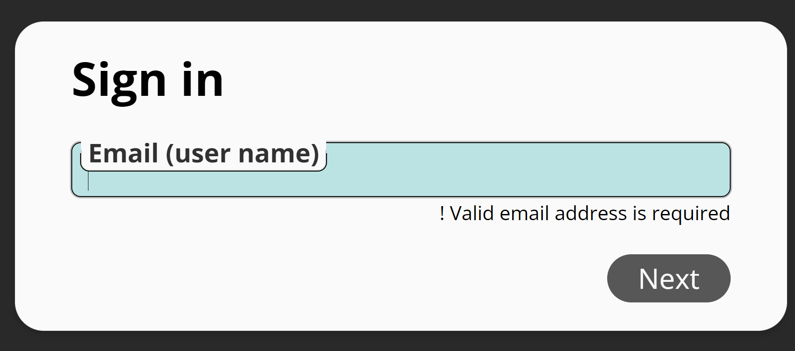

**Figure:1**

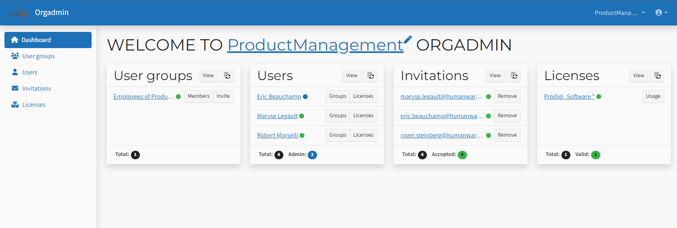

**Figure: 2**

## **Creating User Groups**

At least one User group is required in order to invite users. One User group is generated by default when your account is activated. You can change the name of the default group to something that makes sense within your organization by clicking on its name, then clicking the Edit button, and then overtyping the existing name. You can also add a Type (e.g., students, teachers, administrators, etc.) and a Description (e.g., This group is for all LV students.) See Figure 3.

User Groups must have a license Entitlement assigned to them. In this case, it is Prodigi Software.

You can create additional groups by clicking Create on the Manage User Groups page.

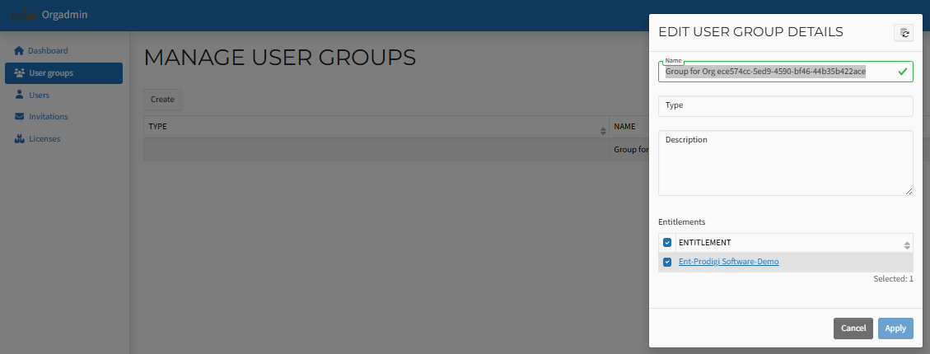

**Figure: 3**

## **3.0 Inviting Users**

There are several ways to invite a User to create an account and obtain their license. The easiest method is to select *Invitations* from the menu on the left of the screen (Figure 4).

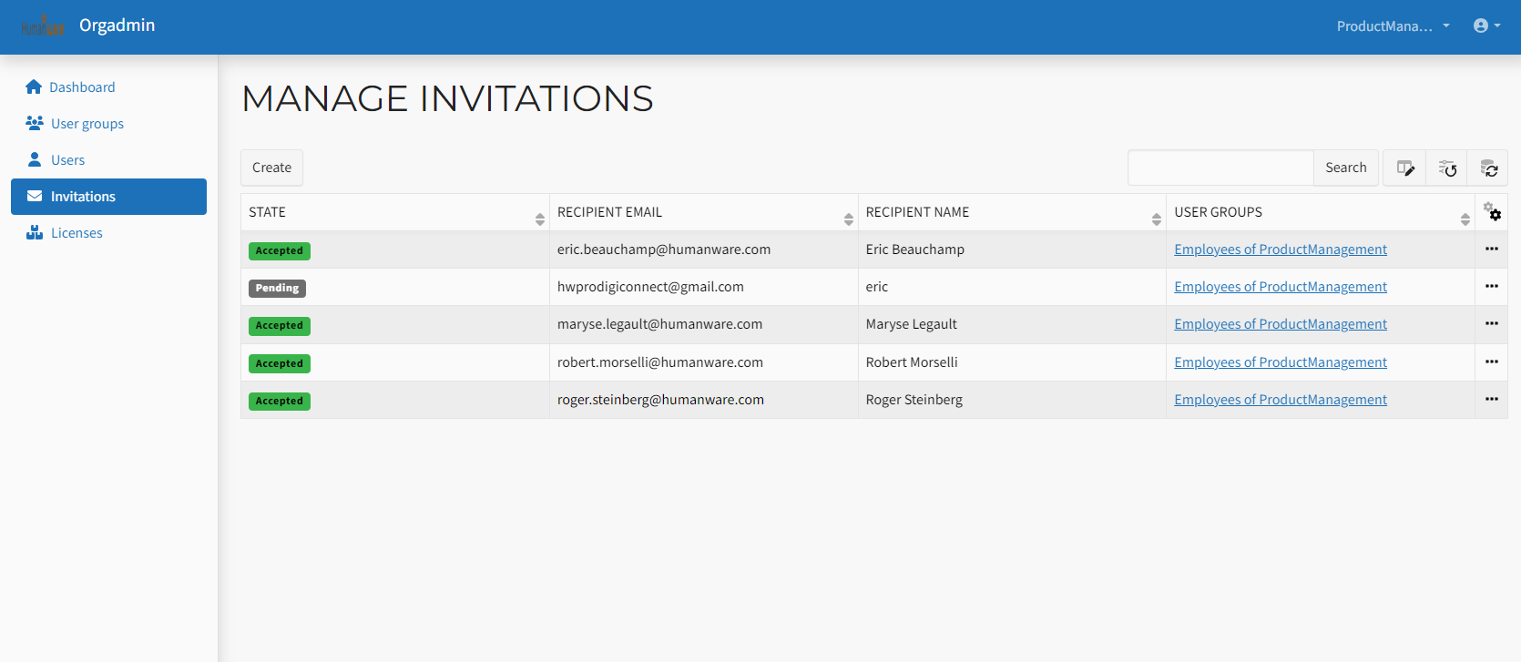

**Figure: 4**

Then click on the *Create* button. A popup window will show the following information (Figure 5):

* *Recipient name* field
* *Recipient email* field
* *USER GROUP* check box
* *Assign Admin access* check box
* Custom *Message* field

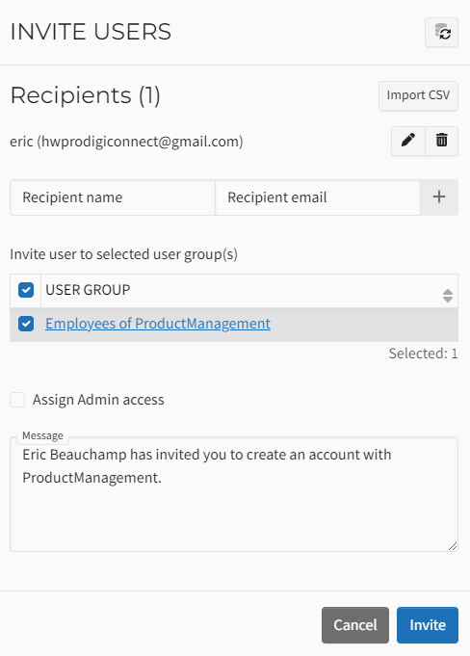

**Figure: 5**

Invitations can be sent one by one by entering the recipient's name and email address, selecting the user group to which they will be added, and then selecting if they have administrator rights by checking the corresponding box. Once all the information is entered and verified, the *Invite* button can be clicked at the bottom right corner of the popup.

Alternatively, a CSV file can be imported to invite multiple users simultaneously. The file must contain two columns without any headers. The first column will contain the user's name (first and last), and the second column will contain the user's email address (Figure 6). Save the CSV as "Comma delimited." To import the file, click the *Import CSV* button near the upper right corner of the popup window. Another popup window will appear to navigate and select the file.

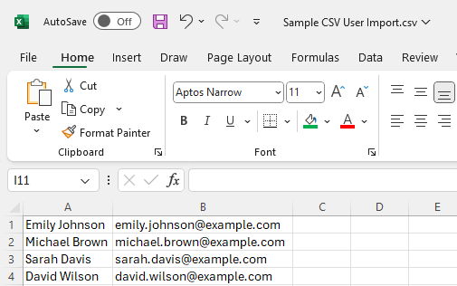

**Figure 6**

## **Assigning Licenses to Users**

When a user accepts their invitation and creates an account, the license manager can reserve a license for the new user. This is done by clicking the *Licenses* option on the left side of the screen and then clicking the three dots in the last column of the new screen. (Figure 7).

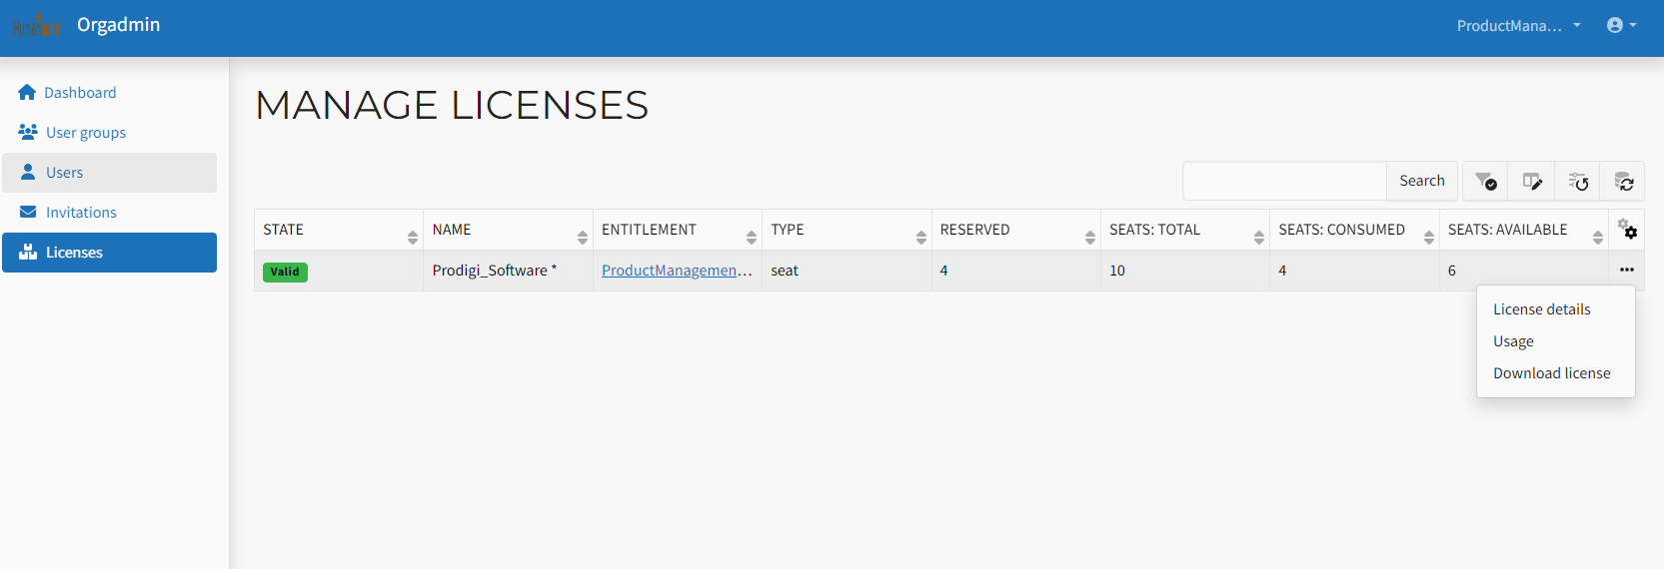

**Figure 7**

A smaller popup window will appear. Choose *Usage* from the available options, and a new window will open (Figure 8).

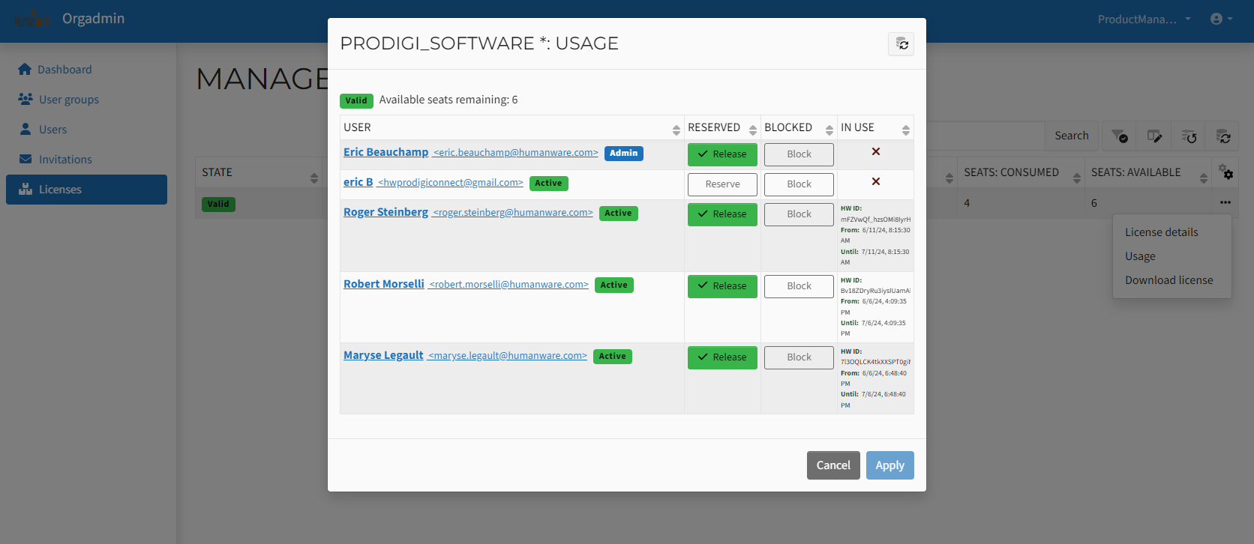

**Figure 8**

In the *RESERVED* column, click the *Reserve* button for each user you want to assign a license. The button color will change to green for each. When finished, click apply.

## **Revoking Licenses**

To revoke a user’s license and keep the user in the system, follow these steps (Figure 9):

1. In section 3.0 go to License, click on the three dots and then Usage.
2. In the popup click on the green Release button of the user that needs to be revoked.
3. Again, in the popup click on the Block button of the user that needs to be revoked.
4. Click on apply.
5. Click confirm on the next popup.

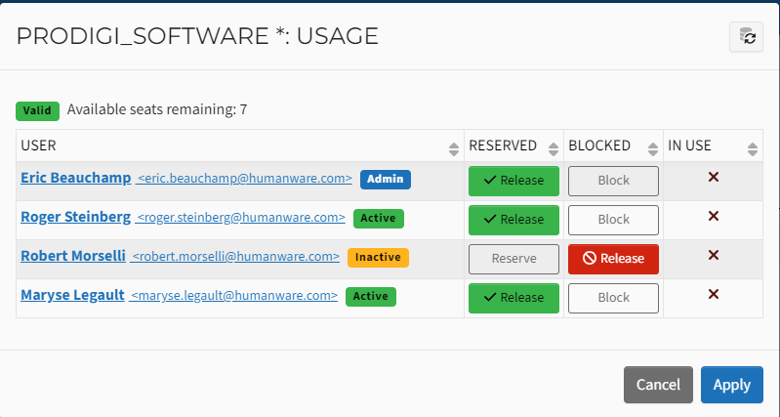

**Figure 9**

If a user or users are not found in any tables shown, click the *Refresh* button found at the top right of each window or popup, and the information will update. (Figure 10).

Refresh button screenshot.

**Figure 10**

Alternatively, a user can be removed from an organization, follow the following steps:

1. Select *Users* on the left of the portal window.
2. In the table, click the three dots at the end of the user's row to be removed.
3. Click on *Remove from organization* in the popup (Figure 11).

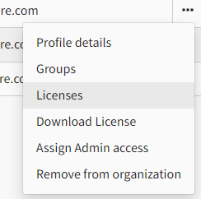

**Figure 11**