
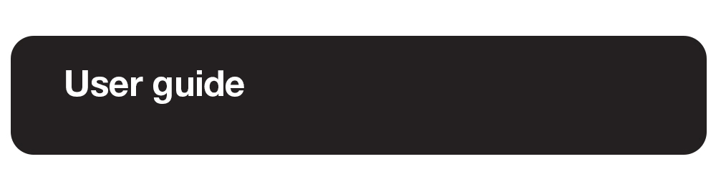
Prodigi for Windows 1.6
Rev. 006

Table of Contents
1. Introduction 7
2. Package Options 7
What’s in the Box? 7
Option 1: Prodigi Low Vision Software for Windows 7
Option 2: Prodigi for Windows: Starter Kit 7
Option 3: Prodigi for Windows: Complete Kit 8
Option 4: Prodigifor Windows: All-in-One PC (North America only) 8
2.1 Initializing your Microsoft Surface tablet or All-in-One PC 8
3. Software Install 9
3.1 Quickstart Guide 10
4. Software Updates 10
4.1 UPDATING PRODIGI 10
5. Connecting and Using the HoverCam SOLO 8+ Camera 11
5.1 Connecting to A Windows Device 11
5.2 General Operation 11
6. Using Prodigi FOR Windows Software 11
6.1 Default Interface: The Prodigi Carousel 12
7. Getting Started 13
Orientation to the UI: The Applications Carousel 13
8.Settings Application 14
8.1 Settings Menus 15
8.2 User Interface 15
Interface 15
System Language 16
Uninstalling a Voice 17
Colors 17
Locator Color 18
Mouse Pointer Size 18
Screen Brightness 18
Button Banner 18
8.3 Audio 19
Speech 19
Speech Rate 19
Sounds 19
8.4 System 20
Wi-Fi Setup 20
Bluetooth Setup 20
Accessibility Setup 21
Feature Lock 22
Automatic Software Updates 22
Send Crash Logs 22
Screen Magnifiers 23
Usage Data 23
Restore Default Settings 23
8.5 Account 23
8.6 About 25
8.7 Exit to Windows 25
9. Magnifier Application 27
9.1 Magnifier Settings 28
Camera 28
Brightness 28
Contrast 29
Contrast Color 29
Autofocus 29
Capture Modes 30
Speech 31
OCR (toggle) 31
Choose OCR Language 31
9.2 Zooming in and out 32
9.3 rotating view 32
9.4 Capturing Images and Text 33
9.5 Reading Settings 35
9.6 Saving an Image or Document 36
9.7 magnifier AI Assistant 36
9.8 Magnifier / Distance toggle 40
9.9 Split Screen Viewing 41
10. DISTANCE APPLICATION 42
10.1 Distance Settings 43
Camera 43
Brightness 43
Contrast 43
Contrast Color 43
Autofocus (toggle) 44
10.2 Distance AI Assistant 45
10.3 Capturing Images 45
10.4 Saving an Image or Document 46
10.5 Zooming In and Out 46
11. AI Assistant application 47
11.1 Opening the AI Assistant and Home Screen 47
11.2 Starting and Using a New Chat 48
11.2.1 Bottom toolbar in the chat 49
11.2.2 AI Assistant Settings (gear icon) 50
11.3 Chat History 52
11.3.1 Managing chats in Chat History 53
12. Books Application 54
12.1 CHOOSING BOOKS OR MAGAZINE PROVIDERS 54
12.2 Searching and downloading titles 56
12.3 Opening and Reading Downloaded Titles 56
12.3.1 Reading and navigating text-based books 57
12.3.2 Table of Contents and page navigation 58
12.3.3 Reading and navigating audiobooks 60
12.4 Importing EPUB Files 62
13. Apps application 64
13.1 Launching an Application 64
13.2 Pinning an Application 65
13.3 Launching a Pinned application 66
13.4 Unpinning a Pinned Application 67
13.5 Organizing Applications 67
14. files Application 69
14.1 Viewing Documents and Images 71
Contrast 71
Contrast Color 72
Brightness 72
Reading Voice 72
Speech 72
Speech Rate 73
Adjust the speed of TTS to a rate that is comfortable with this setting. 73
Reading Mode 73
Preferred Zoom 73
Rotation 74
AI Assistant (callout with three stars) 74
Diamond Edge (diamond symbol) 75
TTS read-aloud symbol (black, right-pointing triangle) 76
Plus and Minus symbols (+/-) 76
14.2 Reading Settings 77
14.3 Action Menu (for Folders) 77
Move 77
Delete 78
Rename 78
Create Folder 78
Delete Folder Content 78
14.4 Action menu (for documents and images) 78
Move 78
Delete 78
Rename 79
Export 79
Import 79
Properties 79
15. Help Application 80
16. Gesture Guide 81
Pinch and zoom gesture 81
Tap gesture (for accessing applications, selecting preferences, etc.) 81
Double tap gesture (header bar, etc.) 81
Long press gesture (image capture, etc.) 82
Toggle from Live to Multi-Capture Mode or Contrasts 82
17. Basic Keyboard Shortcuts 83
18. Glossary 83
19. Troubleshooting 85
20. Prodigi System Recommendations 86
21. Appendix 1 87
20.1 Basic Prodigi FOR Windows Bluetooth Keyboard Commands 87
21.2 General keyboard shortcuts 88
22. Appendix 2 90
Connecting the Kodak Wi-Fi Distance Camera to Prodigi Software 90
23. Technical Specifications 92
Prodigi Low Vision Software for Windows 92
Prodigi Low Vision Software: Starter Kit 93
Prodigi Low Vision Software: Complete Kit 93
Prodigi Low Vision Software: All-in-One PC 94
24. Software Maintenance Agreement and Warranties 95
24.1 Software Maintenance Agreement 95
24.2 Warranties 95

1. Introduction
Thank you for purchasing Prodigi for Windows software.
The software package is a personal vision assistant system from HumanWare, the global leader in assistive technologies for people with low vision. The intuitive and intelligent user interface offers users unparalleled flexibility and can be controlled via a standard mouse, keyboard, or devices with touch-control screens.
The adaptable system aims to maintain and restore independence for people living with vision loss. Prodigi is a complete magnification software that allows you to magnify and read documents, capture images, and much more.
We recommend reading this user guide's operating and safety instructions before using the Prodigi software. If you have any questions, please contact HumanWare Customer Service (contact information appears at the end of this user guide). To obtain the most recent User Guide, please visit the Support page at https://www.humanware.com/prodigisoftwaresupport.
Note: Some features described in this user guide may not be available in your language.

2. Package Options

What’s in the Box?

Option 1: Prodigi Low Vision Software for Windows
You can access a powerful suite of low-vision tools on your Windows-based device. The base software package provides essential features to improve digital content accessibility. Enjoy magnification, text-to-speech, and more, enhancing your reading and daily tasks. The software-only solution empowers users to use their own computing device and camera, offering a cost-effective option for users with existing hardware.

- Prodigi software delivered via email and download

Option 2: Prodigi for Windows: Starter Kit
The software-plus-camera solution provides a comprehensive solution for users who own a computer but lack a suitable document camera. Prodigi software combined with a SOLO 8Plus document camera for a simplified low-vision solution enables enhanced magnification, OCR, and TTS functionalities, empowering users to engage with printed materials effortlessly.
- Prodigi software delivered via email and download
- HoverCam SOLO 8+ document camera
- Microsoft Adaptive Kit
- Quick Start Guide
- Carry bag

Option 3: Prodigi for Windows: Complete Kit
This is a fully expanded version of the Starter Kit for users seeking convenience and performance. It includes a Microsoft Surface tablet, HoverCam SOLO 8+ camera, and accessories. With this kit, you can enjoy unparalleled magnification, OCR, and TTS capabilities, all in one convenient package.
- Microsoft Surface tablet
- HoverCam SOLO 8+ document camera
- 6-in-2 Microsoft Surface Docking Station
- Bluetooth keyboard
- Bluetooth mouse
- Microsoft Adaptive Kit
- Quick Start Guide
- Carry bag

Option 4: Prodigifor Windows: All-in-One PC (North America only)
This turnkey solution boasts the same productivity as a desktop solution. It includes a 24" PC monitor for enlarged viewing, integrated webcam, SOLO 8+ camera, wired keyboard, and mouse, and Microsoft Adaptive Kit.

- 24" AOC All-in-One PC
- HoverCam SOLO 8+ document camera
- USB keyboard and mouse
- Microsoft Adaptive Kit
- Quick Start Guide

2.1 Initializing your Microsoft Surface tablet or All-in-One PC
If you have purchased Option 3 (Complete Kit) or Option 4 (All-in-One PC), you will need to initialize your tablet or computer just like any new Windows-based device. Then, you will need to install and activate your Prodigi software. Visit https://www.humanware.com/prodigisoftwaresupport to access support videos for getting started with the software.
Note: The initialization timing for Microsoft Surface Tablet or All-in-One PC varies depending on your Internet connection and the Windows updates that need to be installed.

3. Software Install

Note: For package options 3 and 4, the user must set up their Microsoft Surface Tablet or All-in-One using Microsoft’s wizard - then install and activate Prodigi for Windows. The Prodigi software installation process is like installing any other software on your computing device. You must download the software and use your credentials (username/password) to activate it. You will be sent an email from HumanWare or your Prodigi License Administrator containing the information you need to complete activation and installation.

Download and installation instructions:
- Download the software
- Click on the link below to begin downloading the Prodigi software. https://humanware.s3.us-east-2.amazonaws.com/prodigi/windows/public/Prodigi.appxbundle

- Run the installer
- Once the download is complete, locate the downloaded file on your device.
- Double-click the installer file to run it.

- Follow the installation prompts and activate your software
- Follow the on-screen instructions to install the software .
- Accept the End User License Agreement (EULA) to install.
- Click on the Activate button. Choose Activation Key or Invitation based upon the email you received. NOTE: If you have already activated Prodigi on another device, you will choose Existing User for this step.
- The installer will guide you to create your credentials, as needed.
- Choose your System Language voice(s) for installation (max 4).
- Select your Speech preferences for Prodigi.
- Choose a Usage Data option.

- Start using your software
- Open Prodigi from your desktop or the Start menu.

- In the Magnifier application, identify the camera you wish to use.
We encourage users to customize Settings to their specific needs.

3.1 Quickstart Guide
For users who are in a hurry to start magnifying, please refer to our Quick Start Guide on the Prodigi Support page.

4. Software Updates
Prodigi software's over-the-air update capability ensures that users with low vision receive continuous improvements, enhanced performance, and new features. This provides a seamless experience, keeping the software at the forefront of accessibility and catering to users' specific needs.

4.1 UPDATING PRODIGI

When Prodigi starts, an Available Updates window will pop up if an update is available.
- Click Update Now (progress bars for each application will briefly appear).

The application will now restart message will appear.

Your Software is up to date message will appear.
- Click OK.

Two other options will appear on screen: Details (reveals version numbers of each application) and Remind me later (a reminder will be issued each time you launch Prodigi).

Alternatively, you can manually check and run updates: Launch Prodigi and go to Settings → System → Software Update; run the update to complete the installation.

5. Connecting and Using the HoverCam SOLO 8+ Camera

The Prodigi software has been optimized for the HoverCam SOLO 8+ camera but can be used with almost any USB-connected document camera (note that other document cameras may not be fully supported).

5.1 Connecting to A Windows Device
The HoverCam SOLO 8+ comes with a USB 3.0 cable. Connect it to the HoverCam and connect the opposite end of the cable with a standard USB connection to your computer or tablet (an adapter may be required). If you require help connecting your HoverCam visit the Solo 8 Plus page. You will note that HoverCam has 5 tactile buttons located at the camera base (auto-focus, auto-focus lock, increase magnification, decrease magnification, and rotate image). The functionality of these buttons has been recreated in Prodigi.

5.2 General Operation
The arm of the camera and camera head can be adjusted up/down to increase or decrease the field of view. The camera head can also be rotated if necessary.
The camera also has a gearwheel located in the camera head. Grip the gearwheel by its sides, using your thumb and index fingers, to select the A3 or A4 format for viewing and capturing images. We recommend the A3 setting for the best user experience.
Go to the Magnifier application and select a camera:

Magnifier → Settings (gear icon) → Camera → HoverCam Solo 8+

You can select any USB or integrated camera on your device or a connected camera for the Magnifier or Distance applications.
Users must assign different cameras for different purposes (for example, document magnification or distance viewing).

6. Using Prodigi FOR Windows Software

Prodigi allows users with PCs or touch-enabled tablets to navigate and use the software via keyboard, mouse, or touchscreen.

Default Interface: The Prodigi Carousel

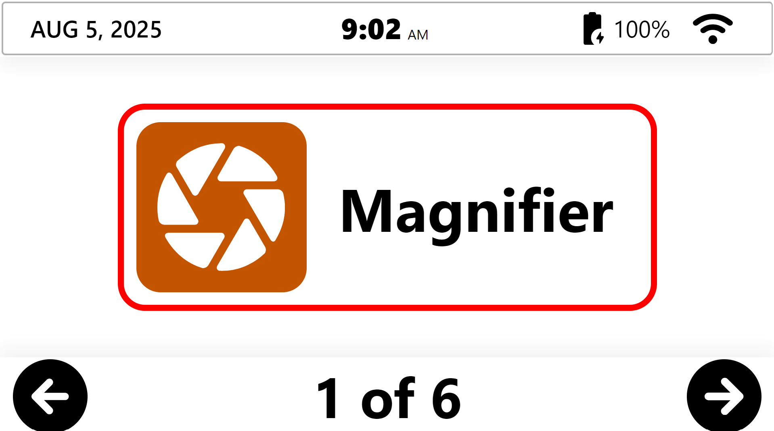
The header bar displays important system information when you are in the software’s Carousel interface.
Starting from the top left side of the screen, the header bar provides the following system information:
- Date (month/day/year)
- Time (hours: minutes)
- Battery level in percentage
- Wi-Fi status
By default, the Application Carousel features one large rectangle positioned in the center of the screen displaying the application. There are five applications in total. Note that the default interface can be customized to display one or several application icons. Refer to Settings.
- The left and right arrows appear at their respective bottom corners of the screen. They allow the user to cycle through the applications.
- The bottom center of the screen displays the number of application pages and which is currently open based on the Carousel’s current position.
The user can double-click in the header to close Prodigi and exit to the Windows OS.
Note: The header bar disappears when you enter any application.

7. Getting Started

Orientation to the UI: The Applications Carousel

Prodigi applications are accessed via the Applications Carousel, click any of the applications to access them.
- Magnifier (camera shutter icon): The Magnifier application allows users to magnify or manipulate documents and objects. They can also be captured and saved for future viewing. It also includes the Prodigi AI Assistant to ask questions about magnified materials.
- Distance (mountain icon): The Distance application provides flexibility for users by allowing them to see things further away from them using different cameras, such as a rear-facing PC camera or a portable camera. It also includes direct access to the Prodigi AI Assistant so users can ask questions about what is displayed on screen.
Distance is turned off by default. Go to Settings→ User Interface→ Interface→ Applications to turn it on.
- AI Assistant (3-star speech bubble icon): Users can type or speak questions and receive answers on screen or spoken aloud, depending on Audio settings. It can explain, summarize, and even translate pasted content; chat sessions can be saved and opened again later from the Assistant’s history.
- Books (open book icon): Users can access several online libraries to download reading materials. Some are available to everyone, like Project Gutenberg, while others require user credentials from the provider, like Bookshare.org. Users can also import EPUB book files received directly from publishers. The Prodigi AI Assistant is available to ask questions about books, with chats saved for future reference.
- Apps (domino icon): Quick access to other installed Windows applications is available through Apps. Users have the option to simply open another application or to pin it to Apps for even quicker access in the future.
Apps is turned off by default. Go to Setting→ User Interface→ Interface→ Applications to turn it on.
- Files (file folder icon): Prodigi allows you to store captured documents and images in the Files application, where you can access them at any time. Digital materials (DOCX, TXT, PDF, JPG) can also be imported into Files. The Prodigi AI Assistant can be used with these saved or imported files, and its chats are stored with each file so users can return to them for ongoing support.
- Settings (gear icon): Settings allow users to select and modify user interface features such as audio and system parameters. The Settings application also provides important system information and allows users to exit to the standard Windows environment.
- Help (question mark icon): The Help application allows you to easily access Prodigi documentation and videos, provide direct feedback to HumanWare, and make contact for support. Help functions require an Internet connection.

8.Settings Application


These are global, system-wide settings that apply throughout the Prodigi environment and allow you to adjust the system according to your needs and preferences. These settings allow you to define a variety of functions, including how many applications appear in the Application Carousel, activating/deactivating system sounds, selecting speech rates, and so forth.
Note: Each application also has its own individual (application-specific) settings. These are discussed in more detail under each application section below.

8.1 Settings Menus
Six menus are available in Settings:
- User Interface
- Audio
- System
- Account
- About
- Exit to Windows
Submenus are indicated by arrows at the right edge of the screen. Tap or click the arrow to access options in the submenu. For example:
Settings → User Interface → Button Banner → Auto✓/Hide/Always
Current settings selections are indicated with a checkmark to the right of the item.
Some menu items require the User to make manual settings adjustments, for example:
Settings → User Interface → Screen Brightness → Click the Plus or Minus symbols that appear at the base of the screen to increase or decrease screen brightness.
Note that you can always click the Back arrow (located at the top, left of the screen) to access the previous screen.


8.2 User Interface
The Settings application allows users to select, customize, and enable or disable user interface features. This customization allows users to create a comfortable working environment that best suits their needs.

Interface
Users have a wide range of visual capacities and preferences. This feature allows you to customize how the Prodigi interface appears and behaves. You can choose how many application icons are shown in the Carousel and select which Prodigi applications are available. You can also choose between the default full-screen Prodigi interface or a more Windows-like interface that includes standard window controls such as minimize, resize, and close.

Settings → User Interface → Interface:
- Carousel → select 1✓, 2 or 4 application icons
- Applications → select AI Assistant✓, Books✓, Distance, or Apps
- Mode: Fullscreen✓ or Windows

Windows-interface mode can also be activated with the keyboard shortcut Alt + W. The image below shows an example of the Prodigi carousel in Windows-interface mode.
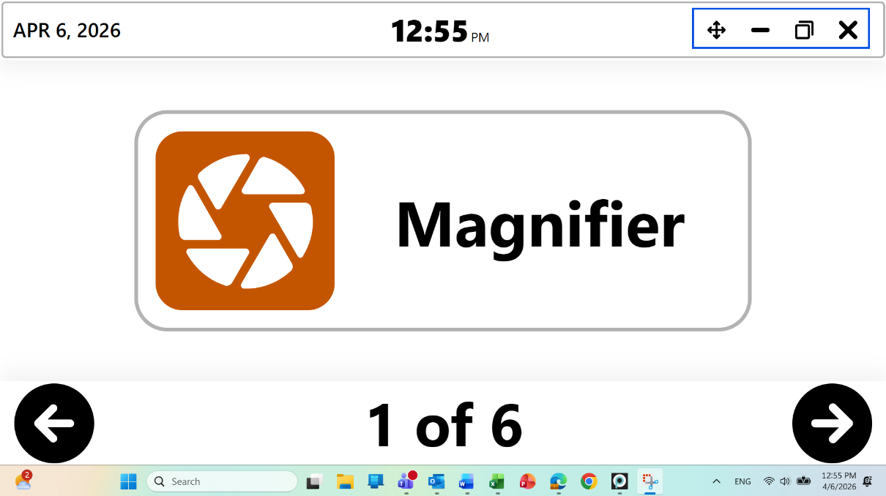

System Language
Displays the current Prodigi system language and voice✓ and all others currently installed (up to four at any time). The selected language will be reflected throughout the Prodigi interface, and its associated voice will be used for text-to-speech based on selected audio settings.
To install a new language (and voice), follow these steps:
Settings → User Interface → System Language → Configuration → Select a voice from the alphabetical list of available system languages
Prodigi has 86 text-to-speech voices, available in 16 languages and dialects. You may want multiple voices (one for pleasure, one for academic/professional), or one for native language and one for language learning (bilingual) – note that the maximum number of installed voices is four. The language selected here will apply to the interface, therefore, if you select German, the interface will be in German.

The languages available are English (US, Canada, UK, India, Australia, Seychelles), Czech, Danish, Dutch (Belgium, Netherlands), Faroese, Finnish, French (Canada, France), German, Greek, Italian, Norwegian, Polish, Portuguese (Brazil, Portugal), Spanish (US, Spain), Swedish (Sweden, Suomi), Turkish.

Uninstalling a Voice
When a user has four voices installed, they must uninstall one before adding another.
Note: If only one voice is installed, users must select a replacement voice before uninstalling a voice.
Settings → User Interface → System Language → Configuration → deselect the voice that you wish to uninstall → select a new voice to install (if necessary) → click the Back arrow (top, left) → click submit (paper airplane symbol at the top, right) → Apply changes will pop up → click Yes
Voice update completed message will appear. Click OK.

Colors
Prodigi allows you to select from 24 different color combinations and contrasts to suit your visual needs and preferences.
Important: This is the color contrast for the user interface and its elements like menus, buttons, etc. It does not apply to captured documents or images.
For example, if your combination is Black on White, negative contrast will show text and images in White on Black. This is useful if you wish to reverse the contrast of text that contains a variety of contrasts or highlights.
Options include:
- Black on white✓, White on black, Black on gray, Gray on black, Black on yellow, Yellow on black, Black on orange, Orange on black, Black on cyan, Cyan on black, Black on purple, Purple on black, Black on green, Green on black, Blue on yellow, Yellow on blue, White on blue, Blue on white, Beige on black, Black on beige, Black on Red, Red on Black, White on Red and Red on White
Settings → User Interface → Colors → select Colors

Locator Color
The Locator Colors tell users exactly where they are in the user interface or a sub-menu with a visual boundary (circle, box, etc.). They can be selected to suit individual needs and preferences. Options are:
- Blue, Cyan, Green, Orange, Purple, Red✓, Yellow
Settings → User Interface → Colors → select Locator Color

Mouse Pointer Size
Users may find that the default mouse pointer is too small. This setting allows them to adjust the pointer size ( Windows default 1✓) to their liking by clicking the Plus or Minus symbols from 1 (smallest) to 15 (largest).
Note: This setting will change the mouse pointer size throughout the entire Windows OS. Visit Settings → System → Accessibility Setup to make additional changes.
Settings → User Interface → Mouse Pointer Size → click the Plus or Minus symbols

Screen Brightness
Lighting conditions can vary depending on time of day or other factors such as where your device is located in a room. Screen brightness level (Windows default 60✓) can be adjusted in increments of five as desired by clicking the Plus or Minus symbols from 5 (low brightness) to 100 (full brightness).
Note: This setting will change the screen brightness throughout the entire Windows OS. Visit Settings → System → Accessibility Setup to make additional changes.
Settings → User Interface → Screen Brightness → click the Plus or Minus symbols

Button Banner
Depending on your preferences, the Button Banner can be configured to display or hide within the Magnifier, Distance, and Files applications.
- When it is set to Always, you will never see the up-arrow because the Button Banner is always present
- When set to Auto and the Button Banner automatically disappears during a reading activity, the up arrow can be clicked to view the banner
- When set to Hide, the Button Banner is always suppressed from the user's view until they click the up arrow
Settings → User Interface → Button Banner → Auto✓/Hide/Always

8.3 Audio
You can opt to listen to captured documents with OCR and have the user interface read aloud by accessing Audio settings to select/de-select TTS functionality, sounds, and to determine speech rates.

Speech
Use this setting to select the level of TTS (text-to-speech) support desired. Options are:
- On provides audio support (TTS) for everything in the Prodigi interface, including documents
- Documents only provides audio support (TTS) only for documents
- Off✓no audio (TTS) support at all

Settings → Audio → Speech → On/Documents Only/Off✓

Speech Rate
Use this setting to select a speech rate when you are listening to a TTS (text-to-speech) voice. Options are:
- Very Slow
- Slow
- Normal✓
- Fast
- Very Fast

Settings → Audio → Speech → Speech Rate → select Speech rate

Sounds
You can toggle Sounds On✓ or Off. These are the sounds that you hear when clicking or swiping certain parts of the user interface such as the Carousel, interface subcategories or the Applications icons themselves, or when clicking the Camera icon to capture an image (you will hear a camera shutter sound).
Settings → Audio → Sounds → On✓/Off

8.4 System

Wi-Fi Setup
Note: The Windows OS interface will be opened to configure Wi-Fi, then return to Prodigi upon exit.
Select Wi-Fi Setup to directly access your Windows OS to adjust Wi-Fi settings and parameters, including:
- Turn Wi-Fi on or off
- Show available networks
- Display hardware properties and manage networks
Settings → System → Wi-Fi Setup
- Click Wi-Fi: On/Off
- Show available networks, then select the network that you wish to connect to
- Enter the network password and click Connect when prompted

Bluetooth Setup
Note: Bluetooth is set up through the Windows OS interface, then returns to Prodigi upon exit.
Select Bluetooth Setup to directly access your Windows OS to adjust Bluetooth settings and parameters.
When turned On, your computer or tablet will attempt to discover other Bluetooth devices and be discoverable by other devices.
Note: A Bluetooth keyboard and mouse are included in the Complete Kit (Option 3), so it is important that the Bluetooth option be turned ON.
Settings → System → Bluetooth Setup

Accessibility Setup
Prodigi allows direct access to Windows accessibility settings so that you can configure mouse pointer color and size, text cursor appearance and thickness, and more.
Note: Some accessibility settings will only apply to the Windows OS. Example: text size, since Prodigi is already optimized for low vision use.
Settings → System → Accessibility Setup
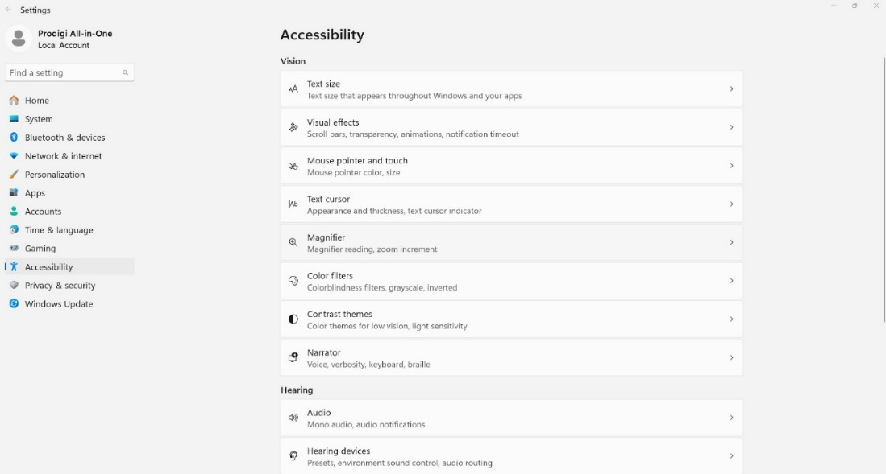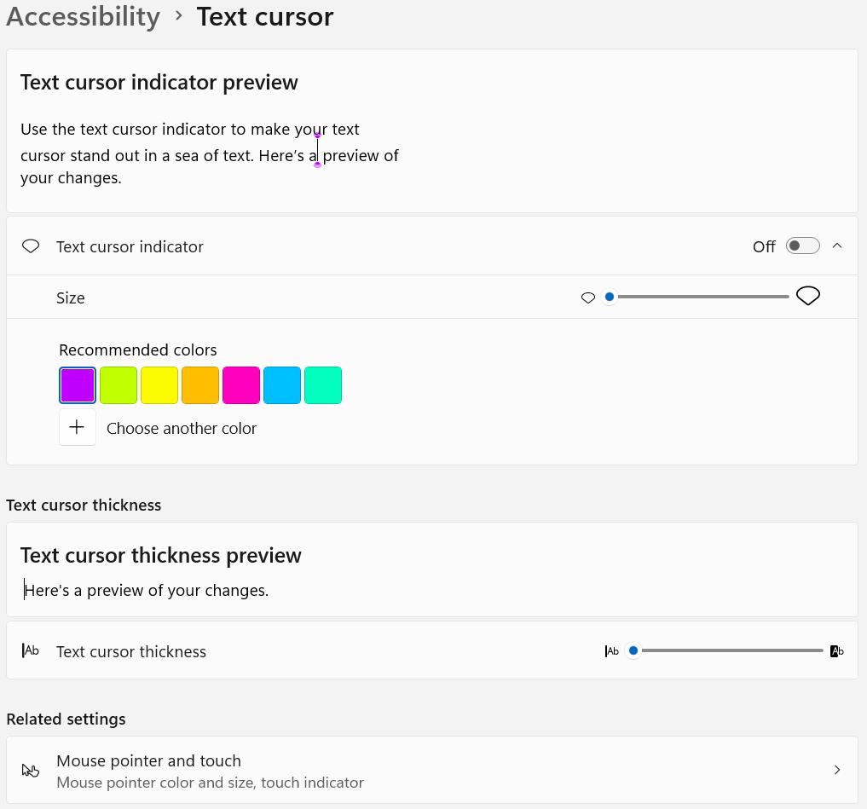

Feature Lock
If necessary, a feature can be locked to prevent users from accessing or using it. By default, all features are enabled.
Settings → System → Feature Lock
In the Feature Lock menu, click on any feature to change its status from “Unlocked” to “Locked”. Then toggle “Feature Lock” to “On”. When the back arrow in the upper left corner is tapped a password will be required to prevent users from re-enabling locked features. Be sure to remember the password. It will be required to access and adjust locked features in the future.

Automatic Software Updates
When Wi-Fi is configured, Prodigi software will automatically check for updates. If an update is available, you will be notified and asked if you wish to update your software. If you ignore the notifications, you can still verify if you’ve missed an update and perform it manually.
Settings → System → Software Update
If a software update is available, an Available updates screen will display Details, Cancel, Update now and View release notes.
- Click the down arrow at the right of the Details field to obtain information on the Magnifier, Distance and Files version numbers.
- Click Cancel if you decide to forgo the software update.
- Click Update now to update the software.
- Click on View release notes to view the version release notes.
When updating, several progress bars will appear followed by the message “Prodigi will now restart.”
Once complete, a new window will appear indicating your software is up to date.
Click OK.
When no update is available, the message “Your software is up to date” will be displayed.

Send Crash Logs
This feature can be defined to send crash event logs automatically or prompt the user each time. We highly recommend users select the Always setting.
Settings → System → Send Crash Logs → Ask Me✓/Always

Screen Magnifiers
Prodigi can detect when the following screen magnifiers are turned on: Windows, ZoomText, and SuperNova. When detected, a message will appear asking users if they wish to disable their Windows or ZoomText magnifier. SuperNova users will be prompted with a message containing the keyboard shortcut to turn it off.
Settings → System → Screen Magnifiers → On/Off/Ask Me✓

Usage Data
With the user’s permission, Prodigi can send anonymous system setup data, such as voices selected, speech mode used, color contrasts, etc. This information is valuable for understanding how Prodigi is used and the types of enhancements to develop. Ideally, all users will opt-in to share these metrics.
Settings → System → Usage Data → On/Off✓/Details

Restore Default Settings
This feature restores all settings to their system defaults.
Settings → System → Restore Default Settings → Restore defaults settings? → No/Yes
Note: Installed voices and saved files and images taken with Magnifier or Distance applications will not be affected, and sample files are re-installed. Importantly, all feature locks will remain in place.

8.5 Account
Click Account to obtain account license information.
Users may work with a Standard (paid) or Trial (14-days free) license.
The SMA (Software Maintenance Agreement) end date is found here as well. After the SMA date, the software will continue to work, but updates will no longer be received.
Your License ID can be conveniently copied and shared to help with Customer Service or Technical Support situations. The License ID will help us identify the user’s account in our License Management System.
Settings → Account → License ID → click the copy symbol

When copying is successful, you will obtain the following message: “Your license ID has been copied to your clipboard.”
Clicking Profile opens a HumanWare web link with your username auto-filled. Again, information here can be shared in support situations when assistance is required. Password may need to be manually entered depending upon the system password security setup. Once you are logged in, you can access and modify Personal information, Contact information and Login name.
Settings → Account → Profile
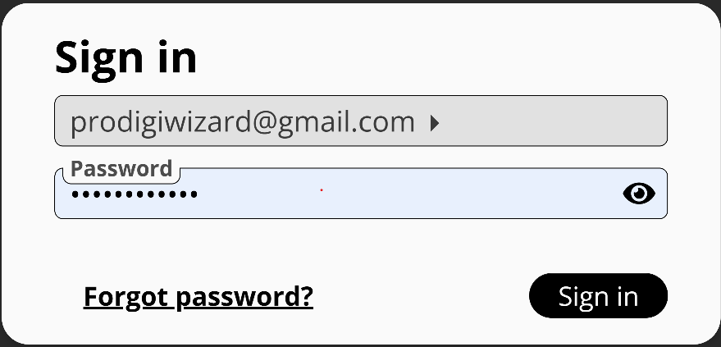

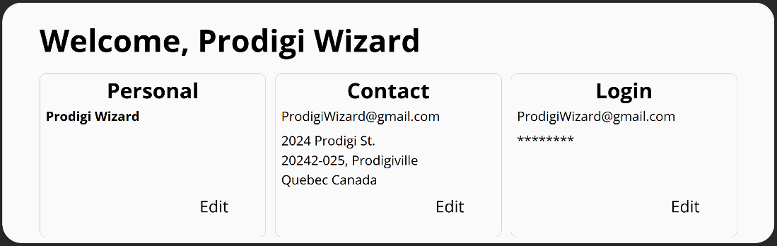
The Account section also allows you to log a device off Prodigi. You will be asked Do you really want to disconnect? Select Yes or No. This can be useful if you have more than three devices trying to use your Prodigi license – only three can be actively logged on at any given time.

8.6 About
This section displays information about the current Prodigi software and application versions, as well as the currently installed voices.
Important: If you contact our Customer Service or Technical Support Teams, they may ask you for this information to provide accurate assistance.
- Prodigi: version
- Magnifier: version
- Distance: version
- Files: version
- Books: version
- AI Assistant: version
- OCR: version
- Text-to-speech: version
- Voices: displays currently installed voices and their versions
For your convenience in a support situation, a download symbol is located at the top, right of the About screen. Clicking it allows you to download a TXT file of all the system information listed above onto your computer’s desktop.

When copying is successful, you will obtain the following message: “Export to Desktop successful.” The information can then be shared with HumanWare Support, as needed.

8.7 Exit to Windows
You can Exit Prodigi in multiple ways:
Settings → Exit to Windows
or,
if using a tablet device, Double-tap the Carousel header bar to exit Prodigi

or,

this action can also be accomplished by double-clicking the Carousel header bar using a standard mouse.

Each of the above closes the Prodigi application completely.

You can quickly return to Prodigi by clicking the Prodigi icon (we recommend pinning the icon to your taskbar for quick access).
or,
Use Alt-Tab as another means to leave Prodigi. The benefit of this is that Prodigi continues to run in the background.
or,
If user interface is set to Windows mode, the taskbar is visible, and typical options exist to minimize, resize, or close out Prodigi are available.

9. Magnifier Application

The Magnifier application offers a wide range of magnification levels (up to 28X), along with various settings and tools that transform previously inaccessible documents and images into accessible ones.
Note: The first time Prodigi is used, you will be prompted to select a camera to use for magnification.
Settings → Camera → Camera: Rear, Camera: Front, Integrated Webcam, or a USB-connected camera such as the HoverCam SOLO 8+ document camera.
If the selected camera is busy in Magnifier, Distance, or another application, a pop-up message notifies the user.
Once the camera has been selected, the button banner will appear at the bottom of the Magnifier application screen.
A back arrow appears at the bottom, left:

Click it to exit the Magnifier application to return to the Application’s Carousel.

By default, there are six additional buttons on the bottom right end of the Magnifier toolbar, listed here from left to right
- the Settings symbol (gear)
- the AI Assistant symbol (callout bubble)
- the Image capture symbol (camera)
- the Rotate image symbol (interlocking arrows)
- the Zoom out (-) and Zoom in (+) magnification symbols


9.1 Magnifier Settings
Once you are in the Magnifier application, click the Settings (gear) symbol that appears at the base of your screen. These settings allow you to select how images are captured (camera selection) as well as a variety of other parameters (brightness, contrast, etc.)
Camera
Important: A camera must be selected.
Magnifier → Settings → Camera → Options include any USB-connected camera, Front or Rear (tablet) camera, or any other integrated camera. The currently selected camera is indicated with a check✓ to the right.
Brightness
Image brightness which can be incrementally adjusted from 0 to 100. The default is 60.
Magnifier → Settings → Brightness → click the plus or minus symbols to increase or diminish brightness in units of five

Contrast
In live viewing mode, Prodigi allows you to view documents and images in a contrast that best suits your needs. This is accomplished by swiping up or down on the right side of a touchscreen. There are three contrast types to choose from: color✓, positive, or negative.
- Color In live viewing mode, contrast is useful when viewing documents, objects, and photos in their original color. Color is the default setting.
- Positive contrast displays text and images in 2 colors according to the selected color combination (Black on White is the default combination).
- Negative contrast displays text and images in reversed contrast as compared to your selected color combination (White on Black is the default combination). This is useful if you wish to reverse the contrast of text that contains a variety of contrasts or highlights.
Magnifier → Settings → Contrast → select Contrast
Contrast Color
Prodigi allows you to select from a variety of contrast color combinations for viewing live and captured documents or images. They include:
- Black on white✓, White on black, Black on gray, Gray on black, Black on yellow, Yellow on black, Black on orange, Orange on black, Black on cyan, Cyan on black, Black on purple, Purple on black, Black on green, Green on black, Blue on yellow, Yellow on blue, White on blue, Blue on white, Beige on black, Black on beige, Black on Red, Red on Black, White on Red and Red on White.
Magnifier → Settings → Contrast Color → select Contrast Color combination

Autofocus
When using the SOLO 8+ camera, autofocus can be toggled from Locked to Unlocked with this menu setting. The shortcut to lock autofocus is a double tap anywhere on the screen. The symbol below will appear on the top, right side of your screen. Prodigi allows you lock or unlock (default) autofocus when in Live mode. This is useful when an object or a document is correctly focused and you need to lock its position or when you are performing a task like writing on a piece of paper and want to prevent your camera from refocusing on your hand or pencil.

Double tap again anywhere on the screen to unlock autofocus. The Autofocus symbol will disappear.
Note: Mouse users can double-click to lock/unlock autofocus.
Magnifier → Settings → Autofocus → Locked/Unlocked✓
Capture Modes
Images and documents can be captured in Live mode or Multi-capture mode.
In Live mode captures are made one image at a time and if saved become a file with only one image. This is useful for menus or bank statements.
In Multi-capture mode any number of images can be added to create a larger document. This is useful for articles and book chapters.
You can toggle from one mode to the other in Settings. Alternatively, you can vertically swipe the left side of the screen. This gesture can also be performed with a mouse click-and-drag on the left side of the screen.
To capture a single image (Live mode), align the camera above the document and press/click the capture (camera) button – or long press anywhere on a touchscreen.
To capture a multipage document (Multi-capture), align the camera above the first page of a document and click camera or press and hold your finger down on the screen. Proceed in the same way for each page. Your multipage document will be saved in the Files application.
Magnifier → Settings → Mode → select Multi-Capture or Live✓
Toggle gesture from Live to Multi-Capture Mode (image)
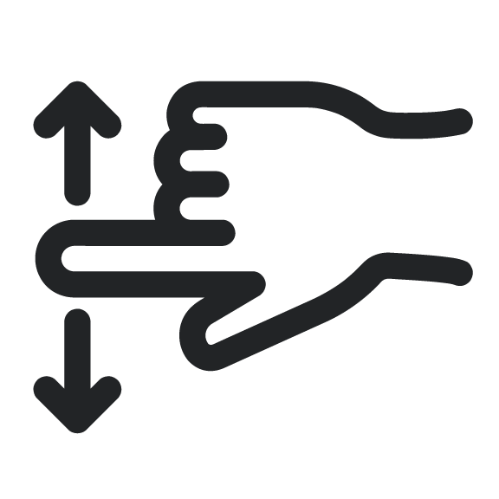

Speech
Use this setting to select if you want to listen to a TTS (text-to-speech) voice. Options are:
- On - provides audio support (TTS) for everything in the Prodigi interface
- Documents only - provides audio support (TTS) only for OCR-applied documents
- Off (default) – no audio (TTS) support at all

Settings → Audio → Speech → On/Documents Only/Off

OCR (toggle)
Prodigi features Optical Character Recognition (OCR) for various languages while using the Magnifier. It can be toggled to Enabled✓/Disabled. OCR enables reading text in page, column, or line mode. Disabling OCR is helpful when TTS is not required and accelerates the image capturing process.
Magnifier → Settings → OCR → Enabled✓/Disabled
Choose OCR Language
Prodigi can perform OCR (Optical Character Recognition) in 53 languages. Additionally, the Diamond Edge feature can be applied to these languages, enhancing the visual experience at higher magnifications.
Note: While Prodigi supports OCR in 53 languages, not all have corresponding text-to-speech (TTS) voices available for use after recognition.
Click Choose OCR Languages to select any of 53 available languages (default is System language).
- Current: displays the OCR language selected
- Other installed languages are listed immediately below Current
- Additional available OCR languages are in alphabetical order further below
Magnifier → Settings → Choose OCR Language → Current: System Language✓/Other Language.

9.2 Zooming in and out

You can also increase or reduce the size of live (or captured) images by clicking the Plus or Minus symbols at the bottom, right of the screen. (+) increases image/character size, and (-) decreases image/character size. You can also tap and hold the symbols to adjust the zoom levels progressively and incrementally. Release once you reach the desired zoom level.
- Magnification range for a live image is from 1x to 28x.
- Magnification range for a captured image is from 1x to 80x.
In addition to the increase/decrease magnification symbols, you can employ the pinch and zoom gesture to increase/decrease magnification on a touchscreen. Decrease the distance between 2 fingers to zoom out, and increase the distance to zoom in.
Pinch and Zoom gesture (image)
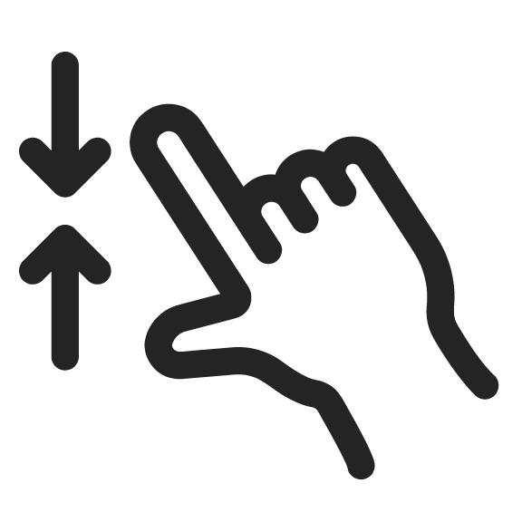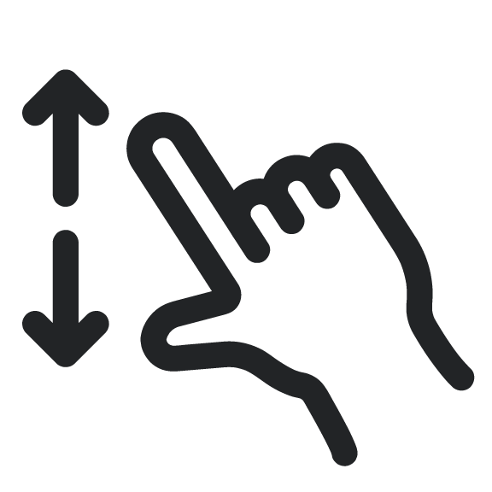

9.3 rotating view

The third button icon from the bottom right corner of the Magnifier interface performs a 180-degree image rotation with each click or tap. This can be used to avoid readjusting magnified materials or use of physical buttons on a document camera.

9.4 Capturing Images and Text
When using the document camera, place the document directly under the document camera lens.
When using a rear-facing camera on a tablet, align it above the document or object that you wish to view or capture.
When using a front-facing camera, place yourself in front of the camera for a mirror/self-view.
Note: OCR (Optical Character Recognition) feature is automatically disabled when using a Front-facing camera.

Click the Capture symbol to capture an image with your selected camera. You will hear a camera shutter sound (unless the system sounds have been turned off), indicating that the document is being captured. Alternately, you can tap and hold your finger on a touchscreen or click and hold a mouse for 2 seconds on the image to capture. You will hear a camera shutter sound, indicating that the document is being captured (note that it takes a few moments to capture and process the image).

You can cancel the image capture and OCR process by using the Escape key on your keyboard or by clicking the Back arrow in lower, left corner of the screen.

Once you’ve captured an image or document the Prodigi interface will update for reading, this includes the Zoom In/Out buttons, and three additional icons also appear at the base of the screen: a Diamond (Diamond Edge) symbol, the Read button (black, right-pointing triangle) and the Save (disk) icon. Several additional Settings (gear) also become available with captured materials.


Additional Settings become available with captured documents include: Reading Voice, Reading Mode, and Preferred Zoom.
By default, whatever language and System voice you have chosen is used for TTS reading. Captured documents allow the option to change to any other installed TTS voice, including Microsoft Desktop voices. In South Africa, installed Qfrency voices will also be available as TTS reading voices.
The Reading mode of a captured document can also be adjusted. This can be helpful in allowing for greatly enlarged text or when the page layout is not important to comprehension. Three options are available Page, Column✓, and Line.
- In Page mode, the entire view of the document is retained during reading. This allows the user to see the layout and structure, which may convey meaning.
- Column mode presents text in a single, long-form column. This can reduce visual clutter and allows for greater text enlargement.
- Line mode shows text in a single, horizontal line while reading with TTS. This is very similar to a teleprompter. It also allows for larger text and less visual clutter while reading.
Lastly, a Preferred Zoom ranging from 2 to 40x can be set and applied automatically when a document is captured (4x✓). This can save time, especially when many documents with similar size fonts will be captured.

Diamond Edge contrast combines the best of both worlds: it displays Diamond Edge Text™ in your selected color combination and images in their original color. This allows you to magnify text to maximum levels without compromising text quality in the best color combination for your vision.

- Click Play to start reading the first visible word on the screen.
- If a word is selected, reading will start from that point.

Once you’ve captured a document or an image that contains text, you can click the Read button (black, right-pointing triangle) to have the system read the content. When clicked, the Read button will disappear and you will need to click on the up arrow at the bottom center of the screen to access the button banner, which will now display the Pause icon (two, vertical parallel lines).

In reading mode, several additional settings (gear symbol) are added to those already covered, including Font Size, Font Type, and Highlight.
Users can also control where reading happens on the page with a long-left mouse press or a long-press on a touch screen. This will move the focus to start reading where the user has performed this action.

9.5 Reading Settings
Clicking the Settings (gear) symbol in reading mode accesses additional options to enhance the reading experience, including some that have been previously detailed.
Font Size: The captured document can have the font of the OCR’d text increased or decreased. This can reduce the need to zoom in or out. Options include Minimum, Small, Medium, Standard✓, Large, Very Large, Extra Large, and Maximum.
Font Type: The OCR’d text can be displayed in either Regular or Bold✓ font type based upon visual needs.
Highlight: While Prodigi is reading aloud with TTS a box is shown around each spoken word. This can be helpful to maintain focus and making connections between the audio and visual presentation of text. The options are Display✓, which means the box is visible, or Hide.

9.6 Saving an Image or Document

Once you make a capture, the Save symbol will appear at the far right of the screen. Click it to save your image or document in Files for future use. Clicking Save will immediately return you to live camera mode.

9.7 magnifier AI Assistant
The Prodigi AI Assistant is a built-in chat helper that can explain, summarize, or translate whatever is placed under the document camera. After the Assistant icon is selected, a question can be entered or chosen from the Popular Searches list. The assistant replies on-screen and through speech when audio is enabled. An image is shared only after permission is granted, so control always remains with the user.
Note: Prodigi AI Assistant provides helpful guidance, but it is not perfect and is not a substitute for professional advice. Results may be incomplete or inaccurate, especially for medical or legal topics or when handwriting, glare, or poor image quality is involved. For important matters, key details should be verified against the original document or a trusted source.

To activate the AI Assistant, click its icon in the live Magnifier toolbar.

An AI chat dialog will appear to type in questions about materials placed under the camera. There is also an option to choose from nine “Popular Searches” (long press to read longer questions).
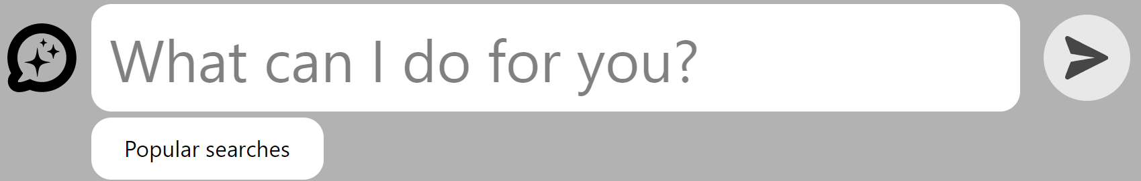
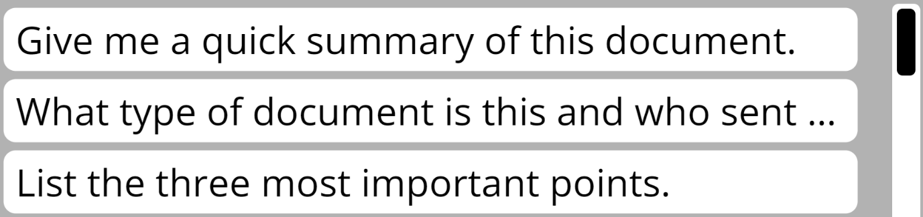
Once a question is entered, simply click the submit button (airplane) in the upper right corner of the chat box and an answer will be generated.
If it is the first time using the Prodigi Assistant, a message will appear alerting the user that an image of the camera’s view will be sent to our secure AI services.
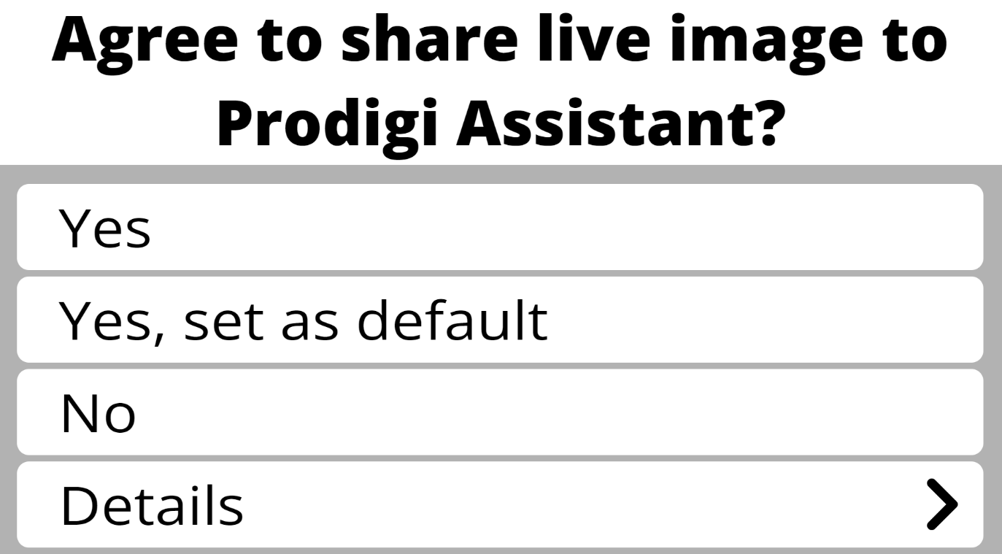
Future behavior of the AI Assistant will be based upon the response entered.
If “Yes” is selected, permission is granted to send an image just one time to AI services.
If “Yes, set as default” is selected, the Assistant will always send images without the alert.
If “No” is selected, the Assistant will close automatically and no image will be shared.
“Details” can be clicked to learn more about how the Prodigi AI Assistant functions.
When a question is submitted, the Prodigi Assistant chat window will appear with a toolbar at the bottom:

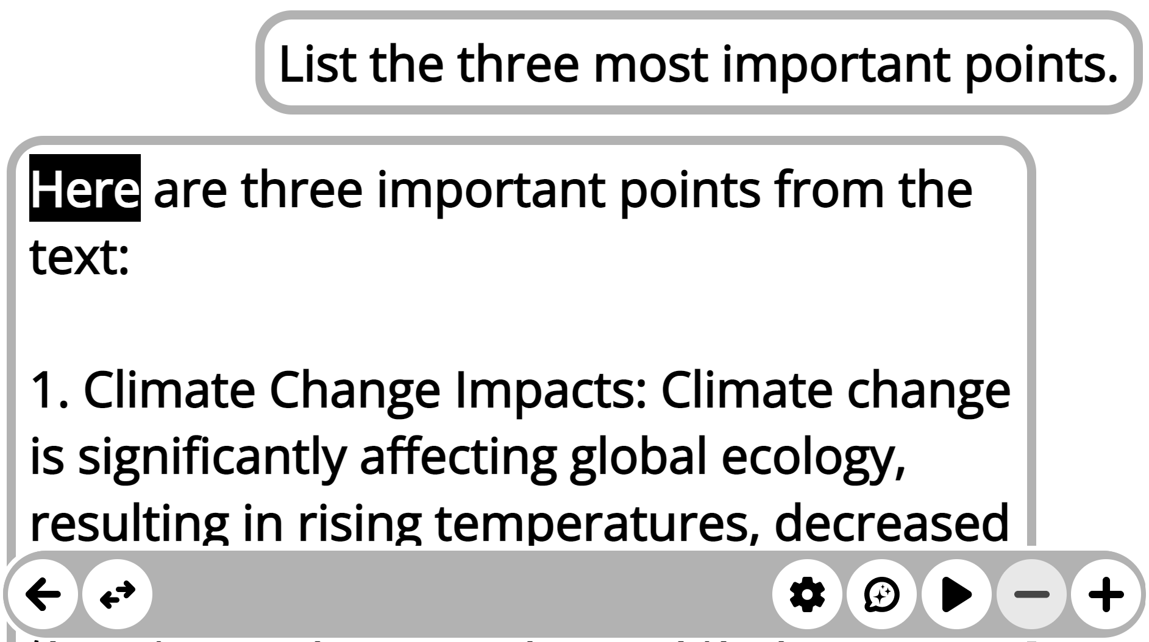
Use the toolbar to interact with the Prodigi AI Assistant’s reply. Increase or decrease the font size by clicking the plus (+) or minus (-) signs at the far right of the toolbar. Click the right-facing triangle to start and stop reading within the selected chat box. Reading can also be with a 1-second press-hold or click-hold where the user would like reading to begin. A second 1-second press or click will stop reading.

To ask follow-up questions, click on the AI Assistant icon (callout bubble with three stars). An entry dialog box will appear. It includes: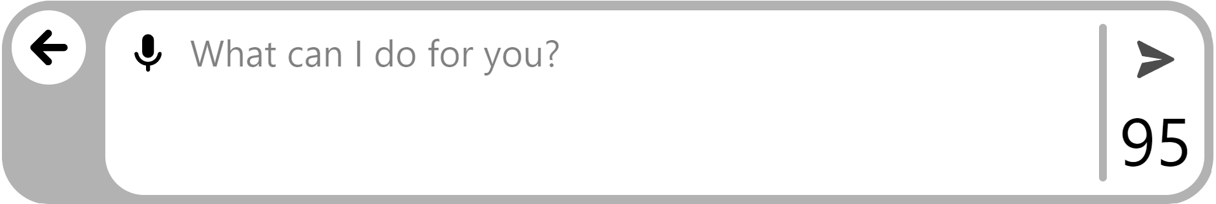
- A microphone icon that allows voice input. Click once to start recording. Click again to stop. The spoken words will appear in the textbox to the right.
- An open text field for typed entries.
- A submit button (airplane icon) to the far right. Click it to send a question.
- A daily question counter in the lower right corner.
- A back button (←) to return to the existing chat without asking a question.
Settings for the AI Assistant can be adjusted by clicking the Settings gear wheel from the main chat window. Available setting’s adjustments are:
- Speech: On, Documents Only, Off✓.
- Reading Voice: System✓, or another installed and selected voice.
- Speech Rate: Very Slow, Slow, Normal✓, Fast, Very Fast.
- Font Size: Minimum, Small, Medium, Standard✓, Large, Very Large, Extra Large, Maximum.
- Font Type: Regular✓, Bold.
To toggle the view between the AI chat and the captured image, press the double arrow button in the lower left corner of the screen.
This will show the image being used by AI services and can be zoomed in or out on using the plus (+) and minus (-) buttons in the lower right corner of the screen. The image can also be rotated 90-degrees at a time. Click the double arrow button in the lower left of the toolbar to return to the AI chat.
To return to the AI chat, click the double arrow toggle button in the lower left corner.
To copy a message from the AI Assistant:
- With a mouse: Right-click the chat bubble, then click “Copy to Clipboard.”
- On a touchscreen: Press and hold the chat bubble with two fingers, then tap “Copy to Clipboard.”
The text is now on the clipboard and can be pasted into any other application.
To exit the Prodigi Assistant, click the left facing arrow in the lower left corner of the chat window screen. You will be prompted to save your chat. If “Yes” is selected, the chat will be saved with the image to the Files application automatically. Following either selection, the user is returned to the live Magnifier view.
To disable the Prodigi AI Assistant reference Settings → System → Feature Lock.

9.8 Magnifier / Distance toggle
The toggle symbols appears when both a Magnifier and Distance camera are selected. It is either a Mountain icon or a Page icon, depending on which mode you’re in. The toggle symbols appear to the right of the back arrow.
 and
Click them to move between Magnifier and Distance modes.
Note: The toggle symbol does not appear by default. Both the Magnifier and Distance cameras need to be set up (using two separate cameras), for the toggle button to appear.

9.9 Split Screen Viewing
Similar to the Magnifier/Distance toggle button, the Split Screen button will not appear until a camera is selected for each application. Press the Split Screen buttons to cycle through the following views:
Start: Current application (Magnifier or Distance)
1st press: Side-by-side (Magnification and Distance)2nd press: Top-and-bottom (Magnification and Distance)
3rd press: Return to current (in focus) application

10. DISTANCE APPLICATION

The Distance application can be helpful when users have a second camera to view things that are far away, such as a slide presentation during a lecture. Different camera options, such as a PC camera or a rear-facing tablet camera, are available in the Distance application. As with the Magnifier application, you must select a camera to use the Distance application.
The Distance application is turned off by default. To turn it on go to:
Settings→User Interface→Interface→Applications
and click on Distance. A ✓ will appear to the right.
In the Carousel, open the Distance application. The base of the Distance page features a Button Banner that includes:
- A back arrow at the far left, click it to exit the Distance application and return to the Application’s Carousel.
- You can also click the toggle symbol for quick access to the Magnifier app. This appears immediately to the right of the back button. See Section 9.8.
- Split screen viewing is also available. See Section 9.9.
Five additional icons appear to the right side:
- Settings (gear)
- AI Assistant (callout with three stars)
- Image capture (camera)
- Plus and Minus magnification

10.1 Distance Settings
Once you are in the Distance application, click the Settings (gear) symbol that appears at the base of your screen. These settings allow you to select how images are captured (camera selection) as well as a variety of other image parameters (brightness, contrast, etc.)
Camera
A camera must be selected for the Distance application. It must be different from the camera used with Magnifier.Distance → Settings → Camera → select Camera: Rear or Camera: Front, another integrated camera, a USB-connected camera such as the Hovercam SOLO8+, or the Kodak Wi-Fi distance camera (refer to Appendix 2 for complete Wi-Fi instructions).
Brightness
Image brightness which can be incrementally adjusted from 0 to 100. 50 is the default.
Distance → Settings → Brightness → Click the Plus or Minus symbols that appear at the bottom, right of the screen to increase or decrease screen brightness.
Contrast
Live images can be viewed in a contrast that best suits your needs, there are 3 contrast types to choose from: color, positive or negative.
- Color (default) In live viewing mode, contrast is useful when viewing documents, objects, and photos in their original color.
- Positive contrast displays text and images in 2 colors according to the selected color combination (Black on White is the default combination).
- Negative contrast displays text and images in reversed contrast as compared to your selected color combination (White on Black is the default). This is useful if you wish to reverse the contrast of text that contains a variety of contrasts or highlights.
Distance → Settings → Contrast → Color/Positive/Negative
Note: In addition to the Settings menu, a swipe up or down on the right side of the screen will rotate through all three options: Color↔Positive↔Negative.
Contrast Color
You can select from a variety of contrast color combinations to suit your needs and preferences. They include:
- Black on white✓, White on black, Black on gray, Gray on black, Black on yellow, Yellow on black, Black on orange, Orange on black, Black on cyan, Cyan on black, Black on purple, Purple on black, Black on green, Green on black, Blue on yellow, Yellow on blue, White on blue, Blue on white, Beige on black, Black on beige, Black on Red, Red on Black, White on Red and Red on White
Distance → Settings → Contrast → select a Contrast Color from the list above
Autofocus (toggle)
Note: This setting is only available with cameras optimized for use with Prodigi (Hovercam and Kodak distance).
Autofocus can be toggled from locked to unlocked (default) when you are in the Distance application. This is useful when an image is correctly focused and you need to lock its position. Alternately, you can double tap (tap twice quickly) anywhere on the screen to focus manually on a particular object when objects are positioned at different distances.
The following symbol will appear at the top, right side of your screen.
Double tap again anywhere on the screen to unlock autofocus. The Autofocus symbol will disappear.
Distance → Settings → Autofocus (toggle) Locked/Unlocked (default)

10.2 Distance AI Assistant
The AI Assistant is available to describe and answer questions about whatever is in view of your distance camera.
Click the AI Assistant icon to begin asking questions.
Unlike Magnifier, there are no prepared AI prompts in Distance; type a question in the text field and click submit to get a result. Functionally, it works the same as in the Magnifier application. Reference section 9.7 to review how to use the AI Assistant.

10.3 Capturing Images
Point your camera at an object that you wish to view.
Click the Capture symbol to capture an image with your selected camera. You will hear a camera shutter sound, indicating that the image is being captured. Alternatively, you can tap and hold your finger on the screen for 2 seconds. You will hear a camera shutter sound, indicating that the image is being captured, it takes a few moments to capture and process the image. Note: Once a capture is initiated, it can be canceled by clicking the back button in the lower left toolbar one time or pressing the Escape key on your keyboard.

10.4 Saving an Image or Document
Once you make a capture, the Save symbol will appear at the bottom, right of the screen. Click it to save your image or document in the Files application for future use. Clicking Save will immediately return you to the live camera mode.

10.5 Zooming In and Out
You can increase or reduce the size of a live image by clicking the Plus or Minus symbols at the bottom, right of the screen. (+) increases image/character size, and (-) decreases image/character size. You can also tap and hold the symbols to adjust the zoom levels progressively and incrementally. Release once you reach the desired zoom level.
Magnification range for a live image is from 1x to 28x.
Magnification range for a captured image or document is from 1x to 100x.
In addition to the increase/decrease magnification symbols, you can employ the pinch and zoom gesture to increase/decrease magnification. Decrease the distance between 2 fingers to zoom out, and increase the distance to zoom in.
Pinch and Zoom gesture

11. AI Assistant application

The Prodigi AI Assistant is a stand-alone chat application in the Applications Carousel. It works like other AI helpers and lets you ask questions in plain language, then read or listen to the answers. You can start new chats, save and rename them, and return later to continue where you left off.
Note: Internet access is required to use the AI Assistant.
The AI Assistant application is turned on by default. To turn it off go to: Settings→User Interface→Interface→Applications

11.1 Opening the AI Assistant and Home Screen
From the Applications Carousel, click or tap the AI Assistant icon (dark blue callout bubble with three stars).
The AI Assistant home screen shows two options:
- New Chat – start a new conversation.
- Chat History – open a list of your saved chats.
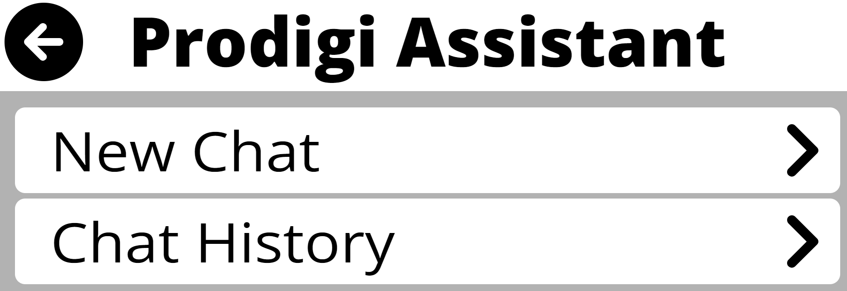

11.2 Starting and Using a New Chat
- On the AI Assistant home screen, select New Chat.
- A chat screen opens with a text entry box at the bottom.
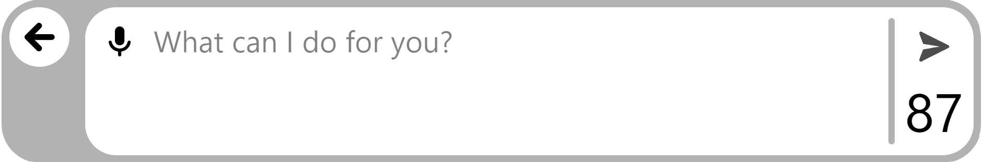
You can enter your question in two ways:
- By voice: Click or tap the microphone icon, then speak your question.
- By keyboard: Type your question in the text entry box.
When your question is ready, click or tap the submit (airplane) icon to the right of the text box. The question is sent to the AI service and the answer appears on screen.
- Your question moves to the upper right of the page.
- The AI Assistant’s answer appears below it, aligned to the left.
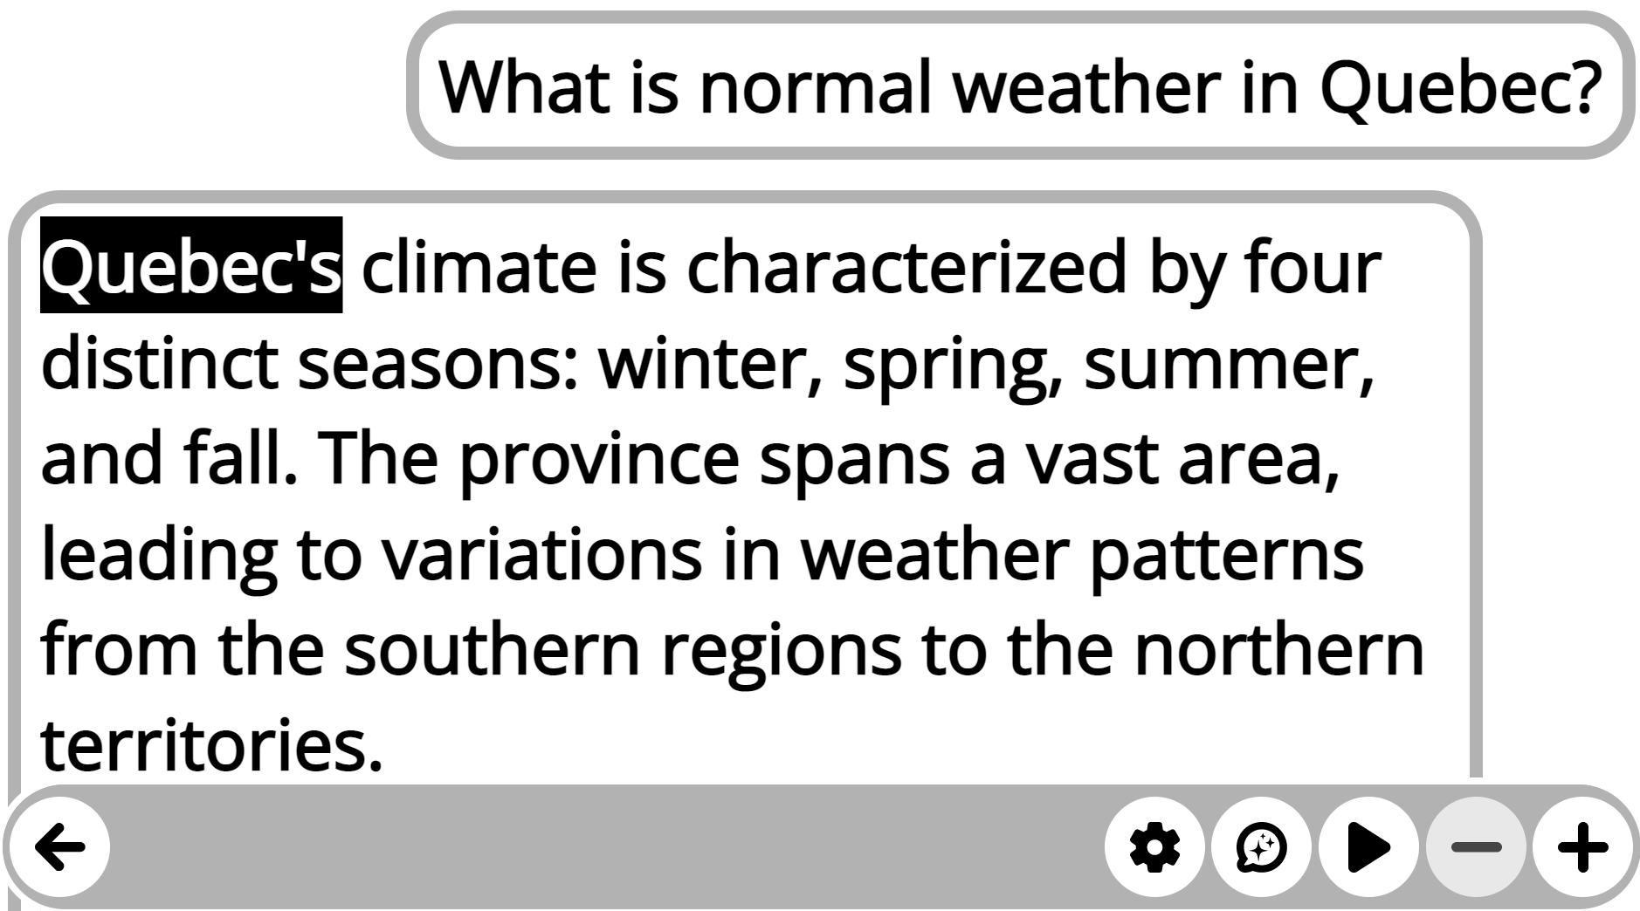

11.2.1 Bottom toolbar in the chat
At the bottom of the chat screen is a toolbar with several controls:
- Back (left arrow):
Returns to the Applications Carousel.
  - If you have an active chat, you are asked whether to save it.
    - Yes – saves the chat to Chat History with the current date.
    - No – deletes the chat and it cannot be recovered.
- Settings (gear icon):
Opens the AI Assistant settings for chats (see 11.2.2 below).
- AI Assistant (callout bubble with three stars):
Opens the voice or text entry box so you can ask follow-up questions and continue the conversation.
- Reading play / pause (right-facing triangle):
Controls text-to-speech reading of the AI Assistant’s answer.
  - Click or tap Play to start reading from the highlighted word.
  - During reading, the button becomes Pause. Click or tap again to pause.
  - You can also start reading by pressing and holding on a word for 1 second. A second press stops reading.
- Font size (+ / –):
Click or tap + or – to increase or decrease the text size in the chat.

11.2.2 AI Assistant Settings (gear icon)
When you click or tap the Settings (gear) icon in a chat, you can adjust several options:
- New Chat
Use this to start a new chat on a different topic.
When selected, you must choose what to do with the current chat:
  - Cancel – Do not start a new chat. Return to the current chat.
  - Save Chat – Save the current chat to Chat History, then open a new blank chat.
  - Delete Chat – Remove the current chat completely, then open a new blank chat.
- Chat History (more details in 11.3 below)
Opens the Chat History list.
  - Before switching, you are asked whether to save the current chat.
    - Yes – Saves the current chat to Chat History.
    - No – Deletes the current chat.
- Speech
Controls when text-to-speech (TTS) is used. Options are:
  - On – TTS is used throughout the Prodigi interface, including documents.
  - Documents Only – TTS is used only for documents.
  - Off✓ – No TTS support.
Speech settings are global and affect all Prodigi applications. See Section 8.3 Audio for more information.
- Reading Voice
Select which TTS voice is used to read AI Assistant messages.
  - The default is the System voice.
  - Any other installed voice can be selected.
Changing this voice also affects TTS reading in documents and files, but not the Prodigi interface itself.

- Speech Rate
Sets how fast the TTS voice reads. Options are:
  - Very Slow
  - Slow
  - Normal✓
  - Fast
  - Very Fast
- Font Size
Sets the size of text in the chat. Options include:
  - Minimum, Small, Medium, Standard✓, Large, Very Large, Extra Large, Maximum.
- Font Type
Sets the weight of the text in the chat:
  - Regular✓, Bold
11.2.3 Copying chat text to the clipboard
You can copy the contents of any chat bubble to the Windows clipboard for use in a word processor or other applications.
- Find the chat bubble you want to copy.
- Do one of the following:
  - Mouse: Right-click the bubble.
  - Touchscreen: Press and hold the bubble with two fingers for 1 second.
- Select Copy to Clipboard.
A brief on-screen message appears: “Copied to clipboard.”

11.3 Chat History
Over time, you may save chats that you want to keep for reference or to continue later.
- Open the AI Assistant from the Applications Carousel.
- On the home screen, select Chat History.
A list of all saved chats appears, arranged from most recent activity to oldest.
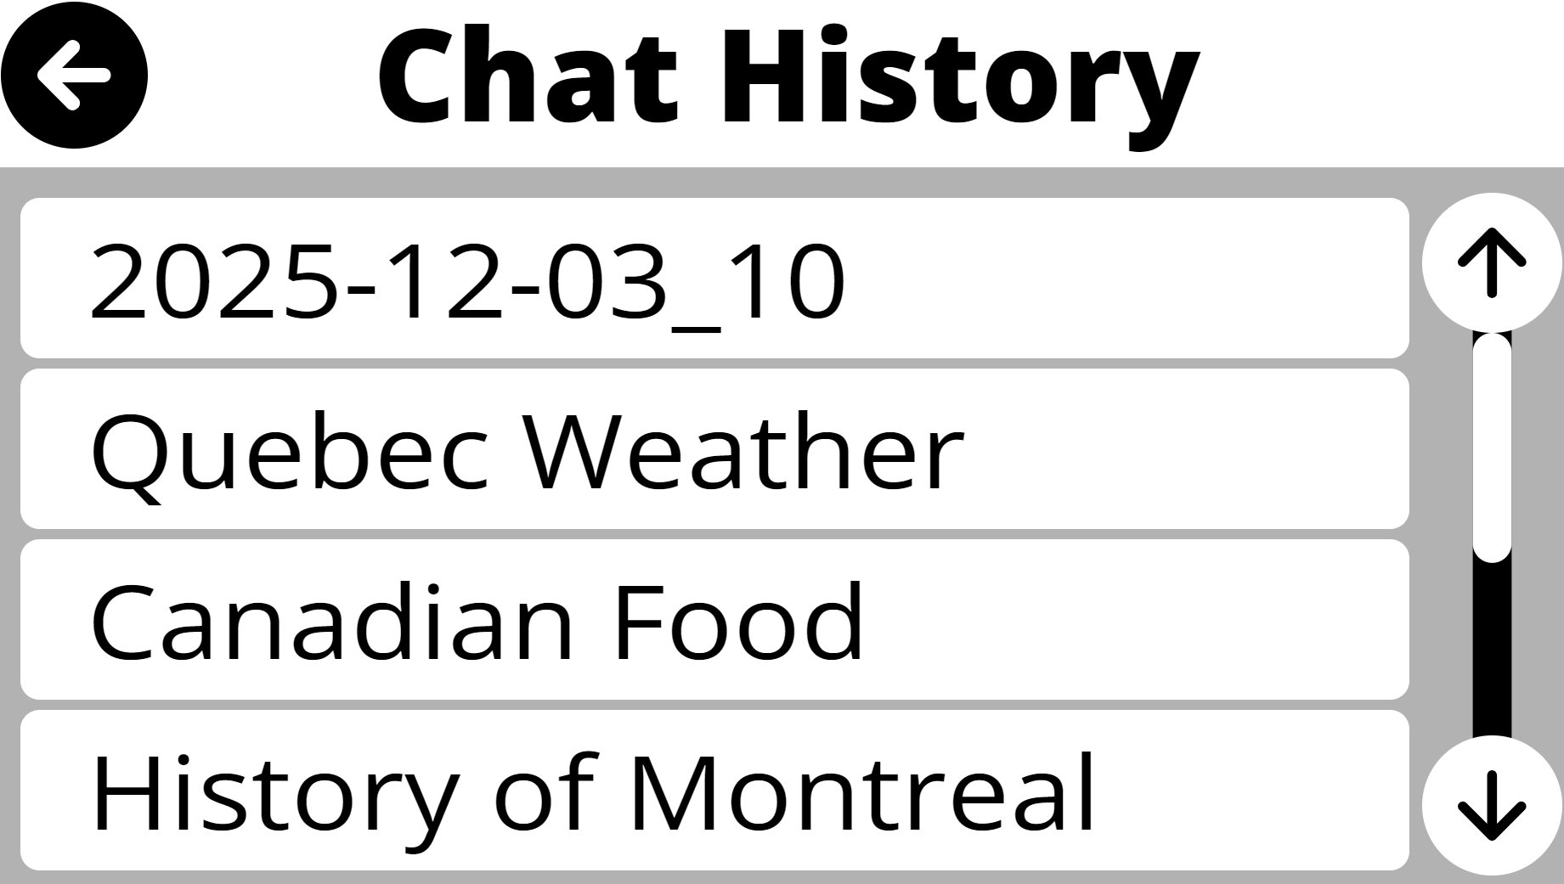
- Scroll or swipe to find the chat you want.
- Click or tap the chat name to open it.
The chat reopens with the last answer at the top and a text entry box at the bottom so you can continue the conversation. The same toolbar and controls are available as in a new chat.

11.3.1 Managing chats in Chat History
On the Chat History page, you can manage individual chats:
- Right-click the chat name (mouse), or press and hold it for 1 second (touchscreen).
- A small menu appears with these options:
- Copy to Clipboard
Copies the name of the chat to the clipboard.
- Delete
Removes the chat from Chat History.
  - A confirmation prompt appears before deletion.
- Rename
Opens a text entry dialog with the current chat name.
  - Edit the name or replace it with a new one, then confirm to save the change.

12. Books Application

Note: Internet access is required to use Books.
Prodigi’s Books application gives access to multiple online libraries. Search by title, author, or topic, then choose a book to add it to My Books. When the book opens, Prodigi’s magnification, high-contrast, and read-aloud tools are ready to use, as well as the AI Assistant. Bookmarks and the table of contents make it easy to jump to any page or chapter, and to organize reading.

12.1 CHOOSING BOOKS OR MAGAZINE PROVIDERS
Note: Most book and magazine providers require credentials. You must contact the provider to register for a username and password.

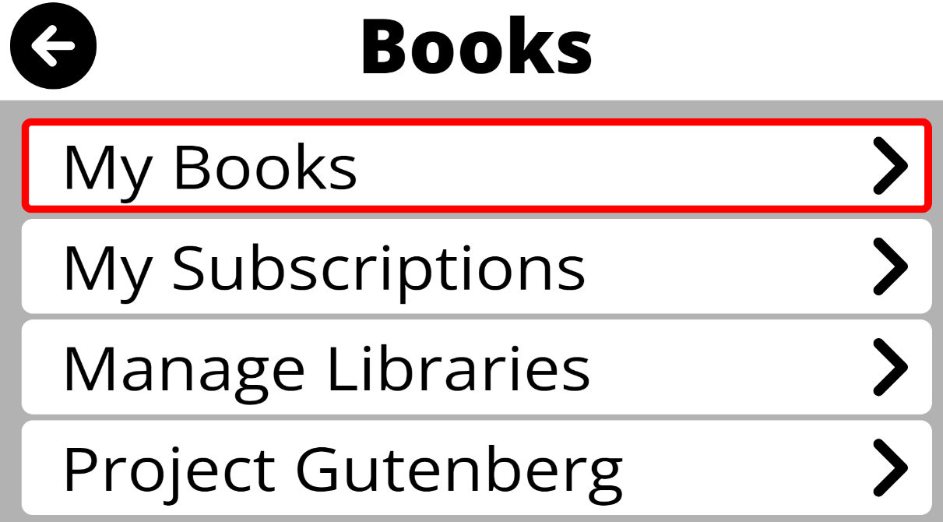
The Project Gutenberg library is turned on by default and can be searched immediately to find available content.
To activate and use other libraries, choose Manage Libraries, then select Book providers or Magazine providers to see the available services.

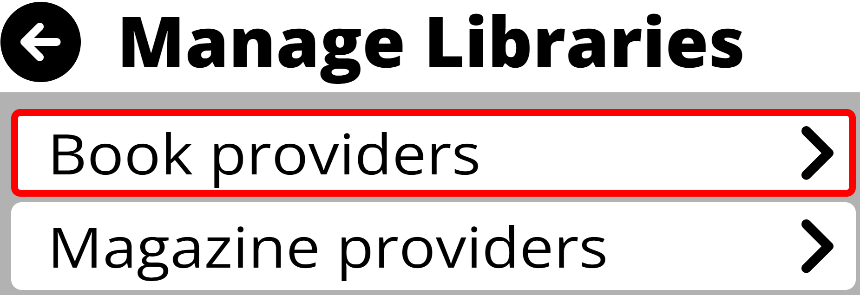
Scroll the list to select a library, then enter the username and password supplied by the service provider. The password is hidden—click the Eye icon to view it if needed, then click again to hide it. Both entries are confirmed with the submit button (airplane icon) in the upper right corner and saved automatically.

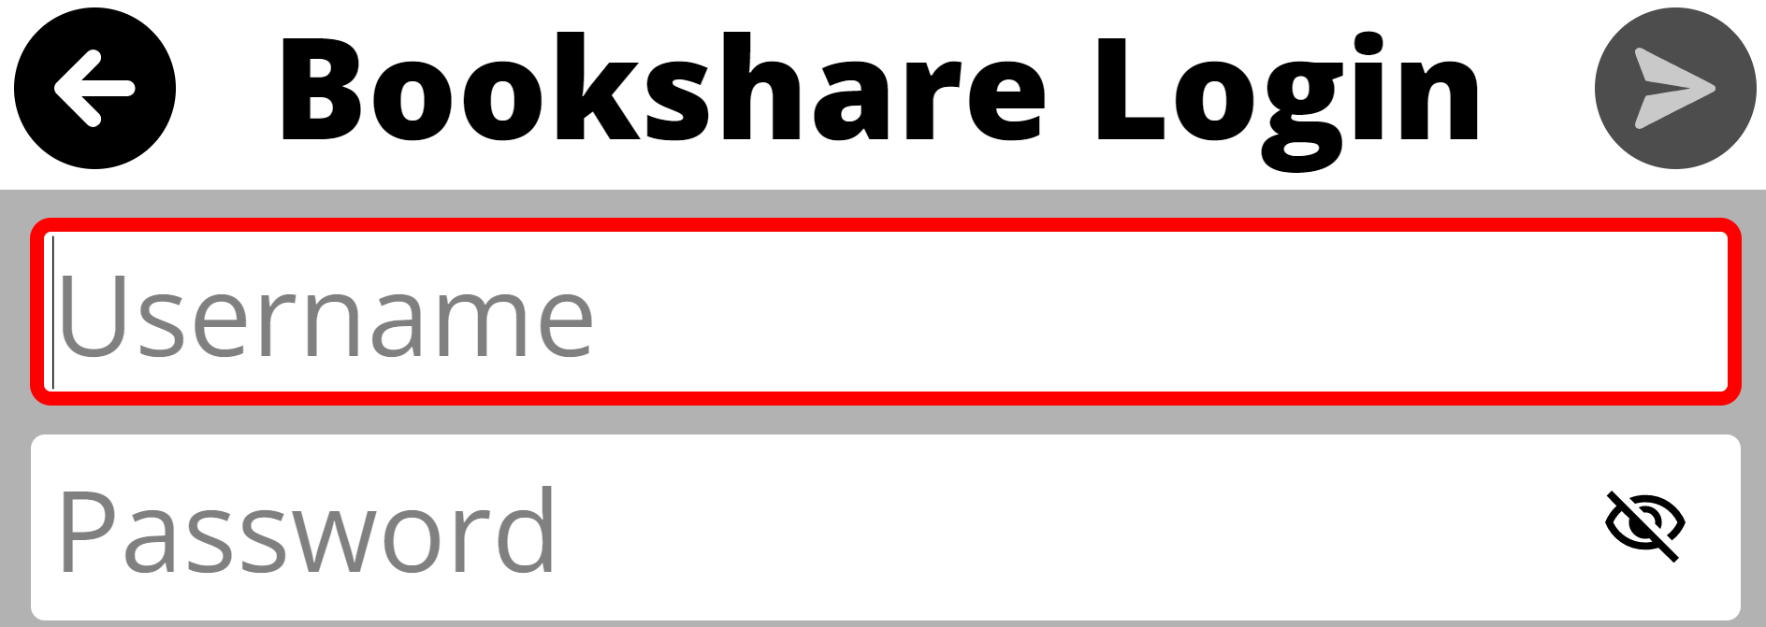
After authentication, a check mark will appear next to the provider. Press the back arrow (upper left corner) once to select additional Book or Magazine providers, twice to return to the main Books menu; each successfully linked provider now appears at the bottom of the Books page and is ready for searching and downloading titles.

12.2 Searching and downloading titles
From the Books page, select a provider from the list at the bottom of the page and a search page will open. Search options vary by library and may include an open search field, Title, Author, New Releases, Popular, Category, ISBN, etc.
After starting a search, results can be navigated. Most books will be in text format. However, Prodigi also supports audiobooks, which are indicated with a speaker icon.

When a book selection is made, a preview will be provided. To save a book for offline reading, select the Download icon; the title is added to My Books.
To begin reading later, open My Books and select the downloaded title from the list.
When a magazine or periodical selection is made, a check mark will appear. As new issues become available, they can be found and opened in My Subscriptions.

12.3 Opening and Reading Downloaded Titles
From the Books page open My Books and select a title to begin reading. Books downloaded in Section 12.2 are available immediately.Magazines and newspapers. Open My Subscriptions to view available issues for each subscription. Select an issue, then choose the Download button at the far right of the issue title.
When the download finishes, the issue opens automatically and can be read.

12.3.1 Reading and navigating text-based books
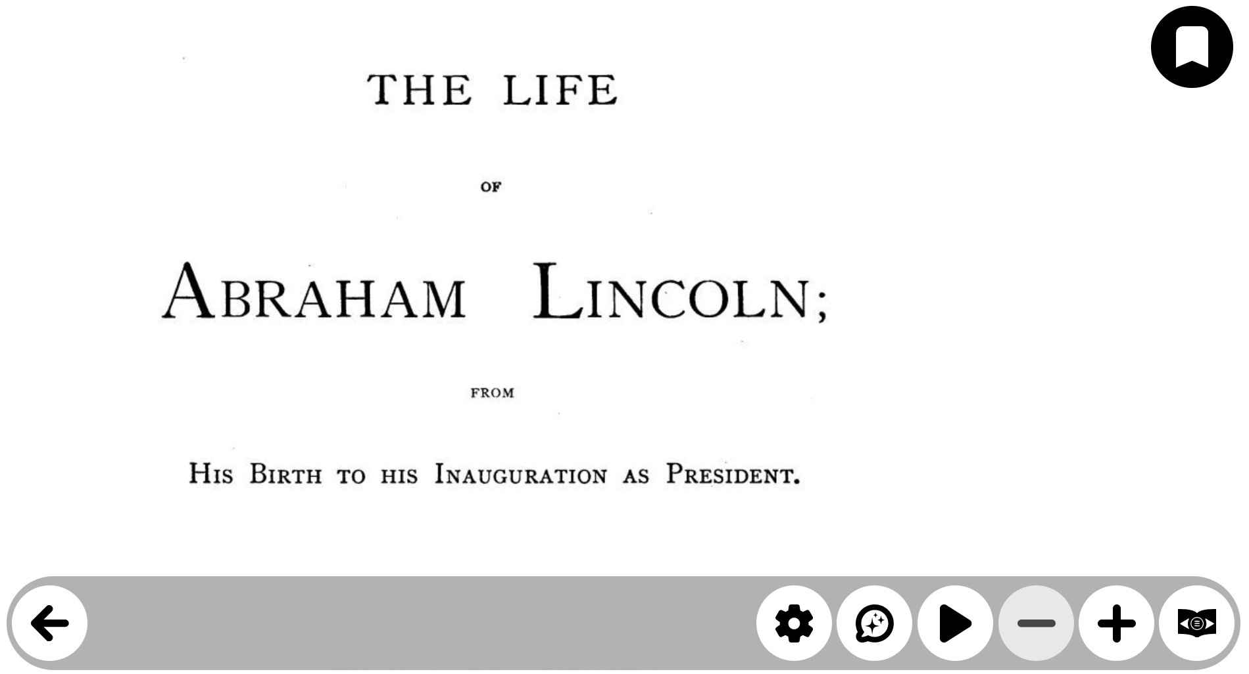
The text reading toolbar in Books uses the same controls as the Files application (gear wheel forsettings, callout with stars for AI, right-facing triangle for play/pause, and – or + for zoom in or out). Refer to the Files section of this guide for details about each control and setting.
During reading, pages will automatically change as the end of a page is reached until the end of the file. Additionally, pages can be turned forward and back using a one-finger swipe right-to-left to advance or a left-to-right to go back a page. This gesture can also be mimicked with a mouse click-and-drag in a similar motion.
When the AI Assistant is used responses are based upon content found on the current page and functions in the same question-and-response fashion as the Magnifier (reference section 9.7). AI chats are saved automatically with each book file.

12.3.2 Table of Contents and page navigation

Open Book navigation using the icon to the far right of the toolbar at the bottom. Use Table of contents to jump to a chapter or section. Use Go to Page to enter a page number directly. The Pages list presents all page numbers, include forematter, that can be navigated and selected.
Note: Book navigation is dependent upon the service provider and may not always be present.
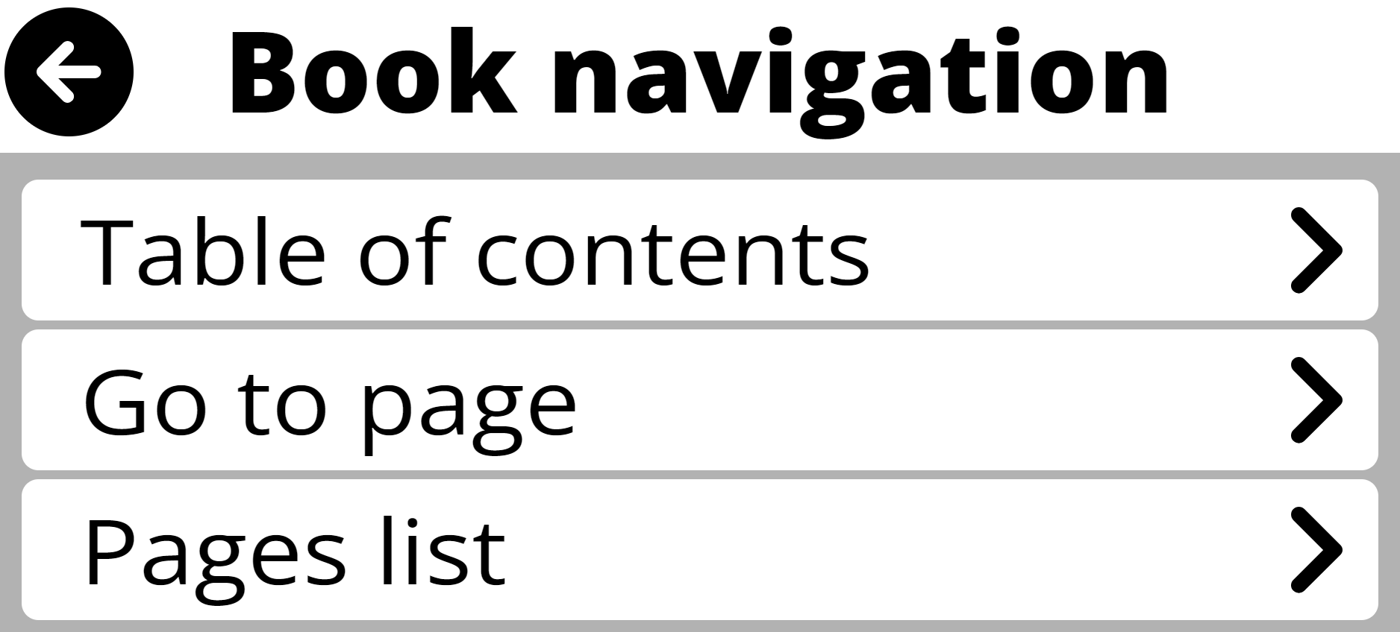

Bookmarks

Open the Bookmark tool (upper right corner) to save a location in the text. Select Add to create a bookmark and give it a short name. Later, re-open the Bookmark tool to Go to, Add, Rename, or Delete a saved bookmark. There is also an option to Delete all bookmarks, if desired.
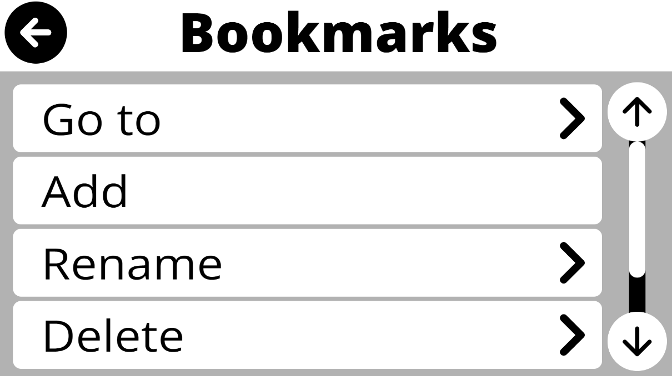
When a book or periodical is closed, Prodigi will remember the page were reading stopped and return to it the next time the file is re-opened.
12.3.3 Reading and navigating audiobooks
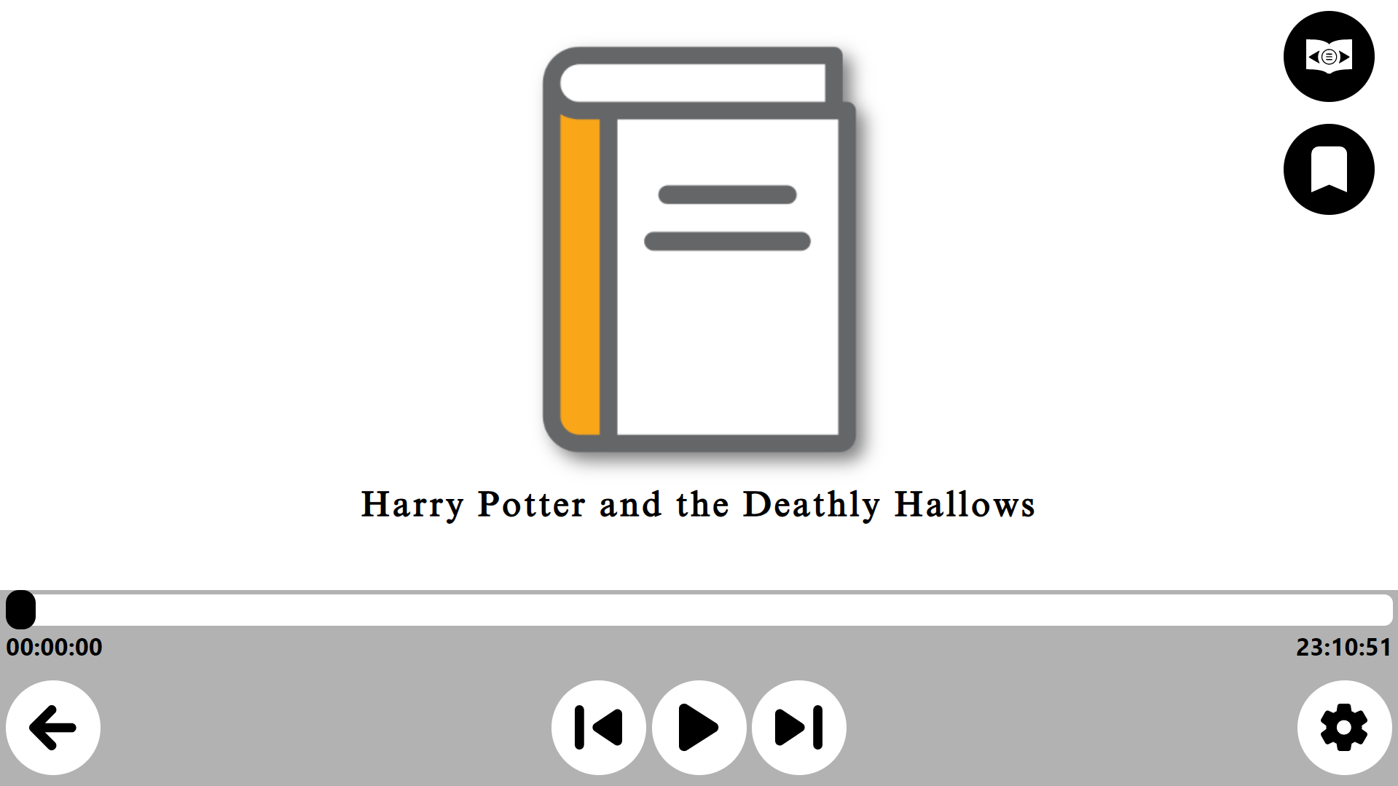
The toolbar for audiobooks is located at the bottom of the screen, but is different from others in Prodigi. It includes:
- Reading progress bar – Located at the top of the toolbar, it includes reading time elapsed on the left, and remaining to the far right. There is also a slider that can be moved forward and back in the book with a tap, hold, and drag gesture for touchscreens or a click, hold, and drag with a mouse.
- Exit the audiobook using the left-facing arrow to the bottom right.
- Reading control buttons are found to the center of the toolbar, they are from left to right:

  - Go back (15-seconds is default)
  - Play/pause
  - Go forward (15-seconds is default)
- Audiobook settings (gear wheel) are found to the far right of the toolbar
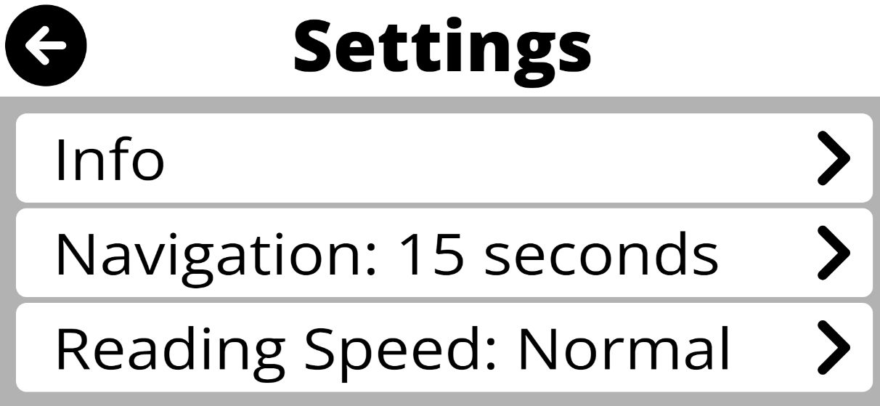
  - Info has a submenu with details about the audiobook that includes:
    - The percent of reading progress
    - Full title
    - Edition
    - Author(s)
    - File size
    - File type
    - Book provider
  - Navigation controls the Go back and Go forward buttons, available timings are:
    - 15 seconds ✓
    - 2 minutes
    - 5 minutes
    - Heading
    - Bookmark
  - Reading speed can also be adjusted to one of five options:
    - Very Slow
    - Slow
    - Normal ✓
    - Fast
    - Very Fast

In the upper right of the audiobook reading interface are the Table of Contents and Page Navigation tool (top)and Bookmark tool (bottom).

These function the same in audiobooks as they do in text-based files (section 12.3.1), but bookmarks do not have any visual indicators onscreen.

12.4 Importing EPUB Files
There are times where publishers may provide books directly in EPUB format. These can be imported and added to My Books in Prodigi. To do so, open the Books application, click on My Books, and then the Settings gear at the top right.
Books → My Books → Settings


This will open a simple dialog.
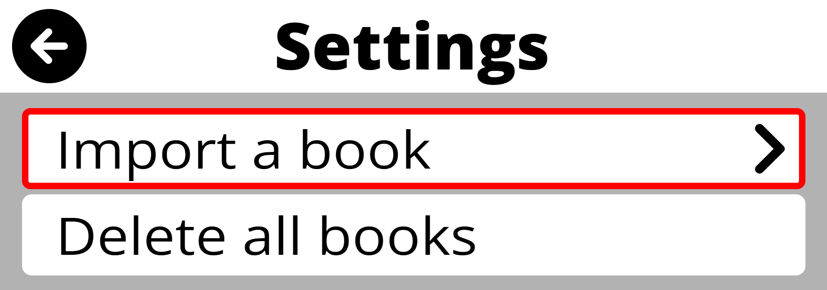

Click or tap on “Import a book,” navigate to the location of the EPUB file, and select the file.
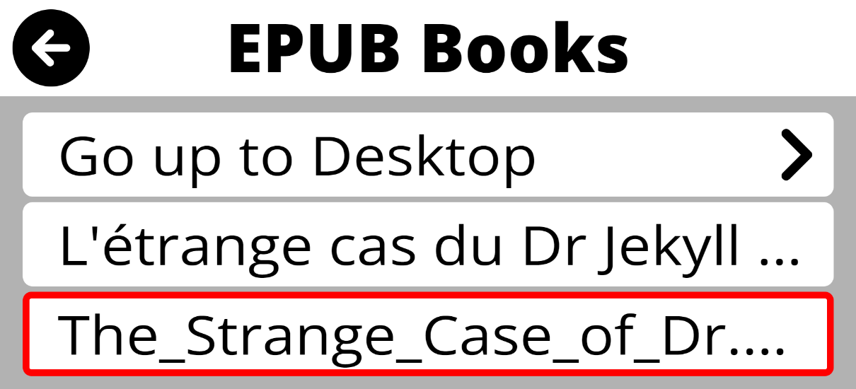
An import message will appear briefly, and the imported fill will be moved to My Books in Prodigi.
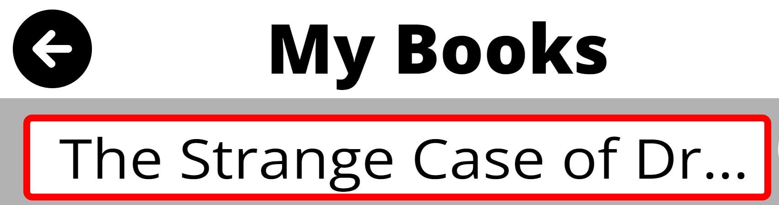
Click or tap on the file name to begin reading it like books imported from library or magazine providers.

13. Apps application

The Apps application allows users to quickly find and open Windows applications from within the Prodigi environment. This can be especially helpful for users who want simple access to commonly used programs without first navigating the standard Windows interface. Apps can also be used to pin selected applications for faster access later. The Apps application is turned off by default.
To turn it on, go to Settings → User Interface → Interface → Applications.
The first icon shown in Apps will always be “Find app”. As quick access apps are added to the application, the number of application pages will update at the bottom of the interface and navigation arrows will activate to the left and right.
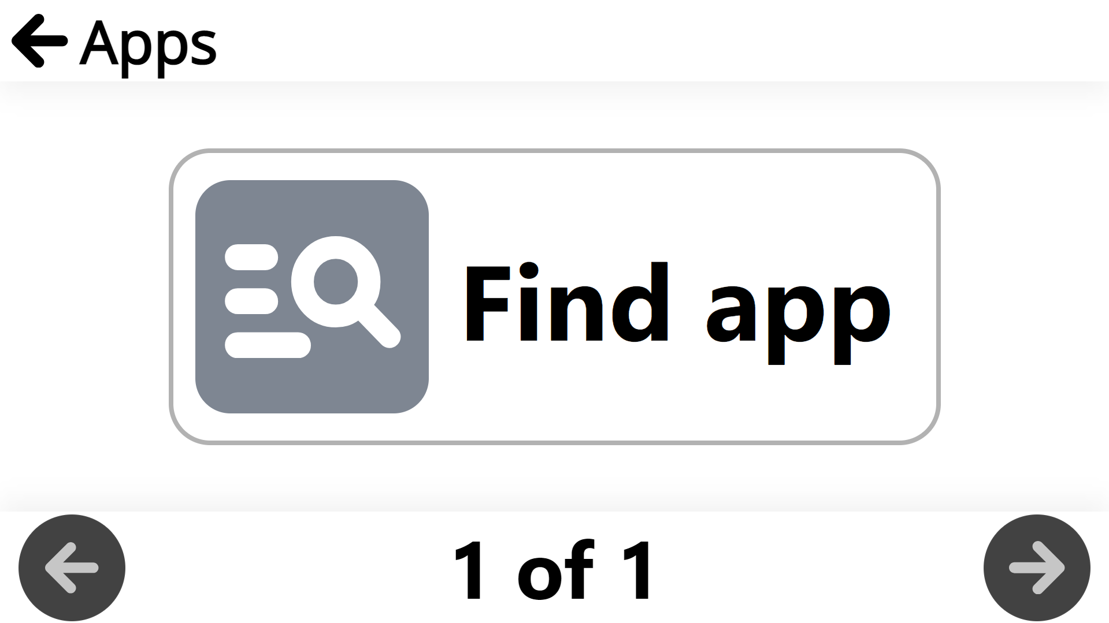

13.1 Launching an Application
Click on the “Find app” icon.


A search window will open.
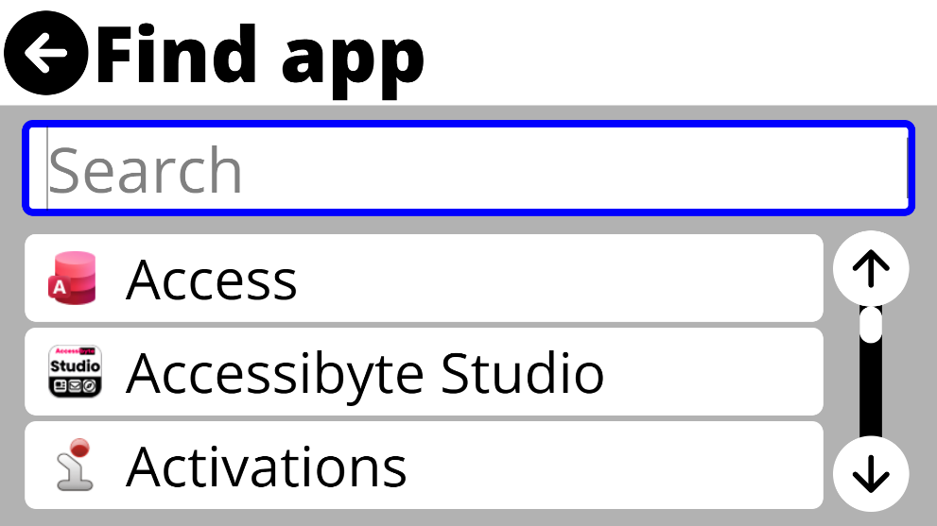
Type in the name of an application or use the scroll bar on the left to find the desired application.
Click on the name of the desired application. Options to “Launch” or “Pin” will be presented. Click on Launch to start the application.
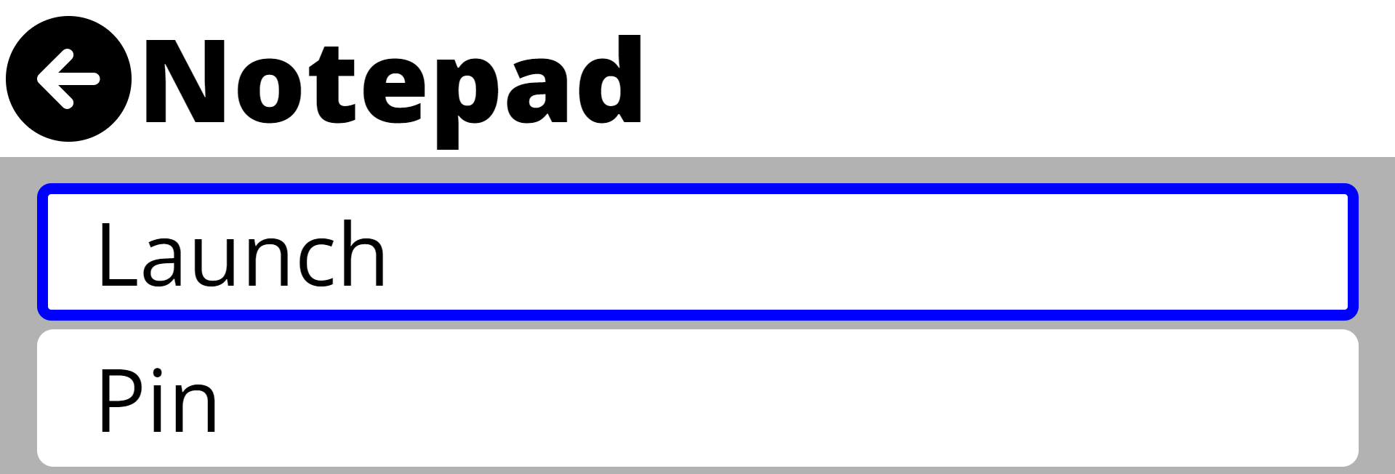
The application will start normally.

13.2 Pinning an Application
For faster access to frequently used applications, especially when Windows-interface mode is turned off, it is helpful to pin them in Apps.
Open Apps and click “Find app.” Use the search bar or scroll bar to find the desired application(s). Click on the application’s name, then choose “Pin” from the options.
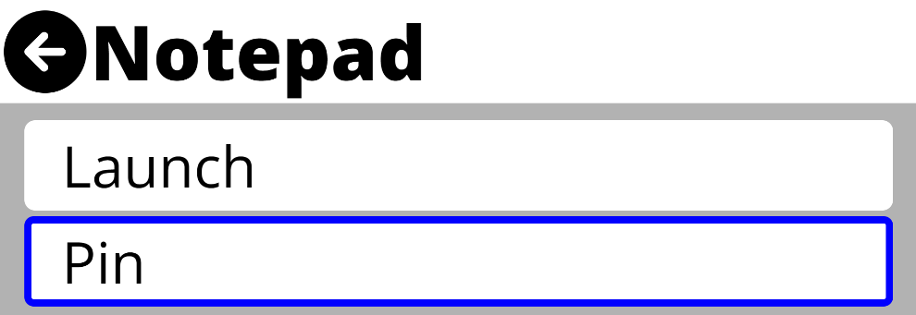
The application will be added to Apps for quick access and return to the search window.
Applications added to Apps are indicated with a check mark ✓ to the right of their name in the search window.
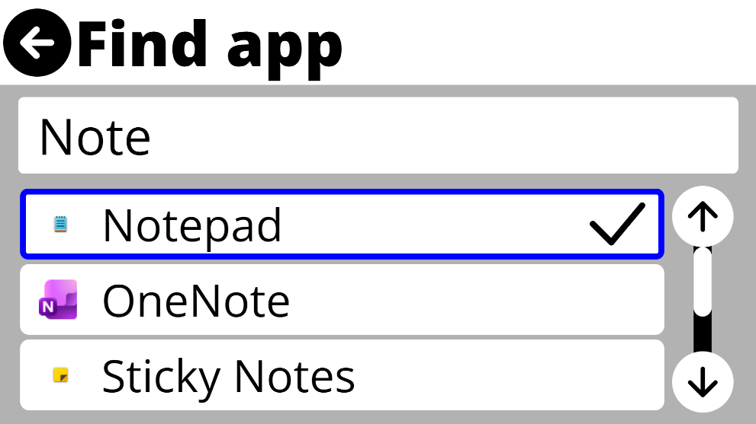
Pinned applications will show in the main screen of Apps.
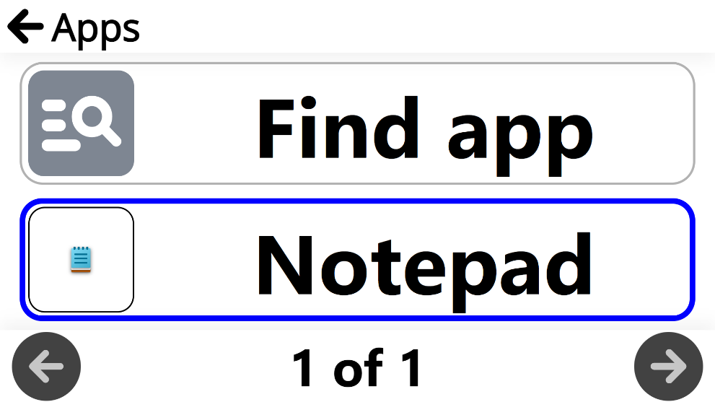

13.3 Launching a Pinned application
Enter Apps and navigate through pinned applications. Click or tap on the desired application’s name or icon and it will immediately start.

13.4 Unpinning a Pinned Application
Enter Apps and navigate through pinned applications. Right-click on the application to be unpinned. Options to “Unpin” or “Copy to Clipboard” will appear.
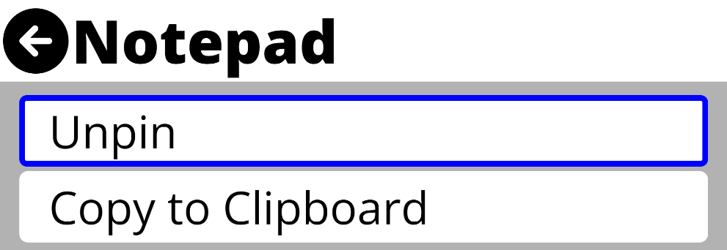
Click or tap “Unpin.” The application will be removed from Apps immediately.

13.5 Organizing Applications
Applications added to Apps are organized by default in the order in which they are added. As multiple applications are added to Apps it may be helpful to organize them for even faster access.
To organize applications, open Apps, navigate to the application you would like to move and right-click.
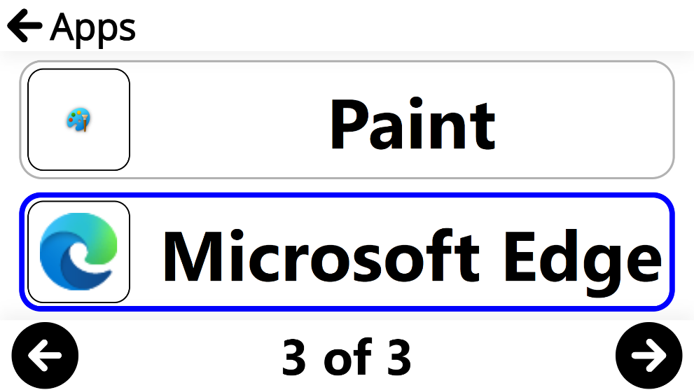

A third option has been added to “Switch” the applications location with another. Tap or click “Switch” to move the application.
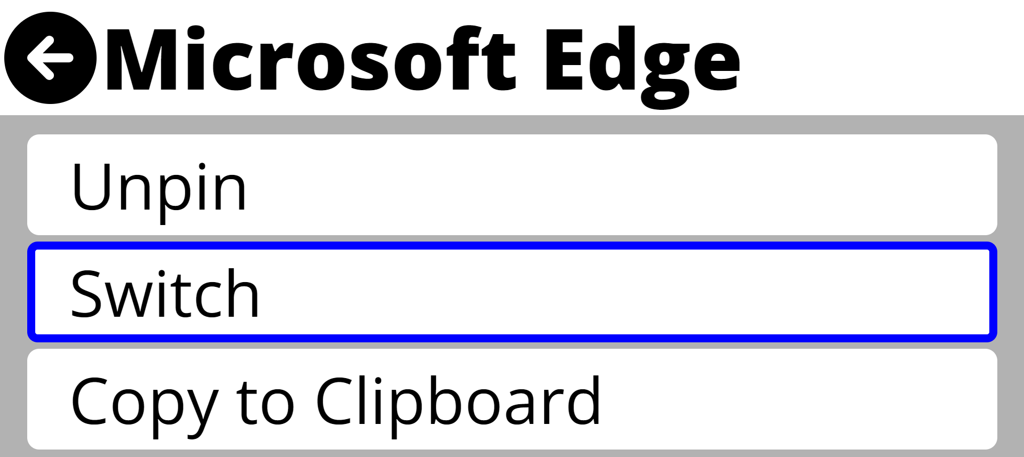
A list of applications will appear in the current order they are stored in Apps. Choose desired location in the list to switch application positions and click or tap. The apps window will immediately update with the new organization.
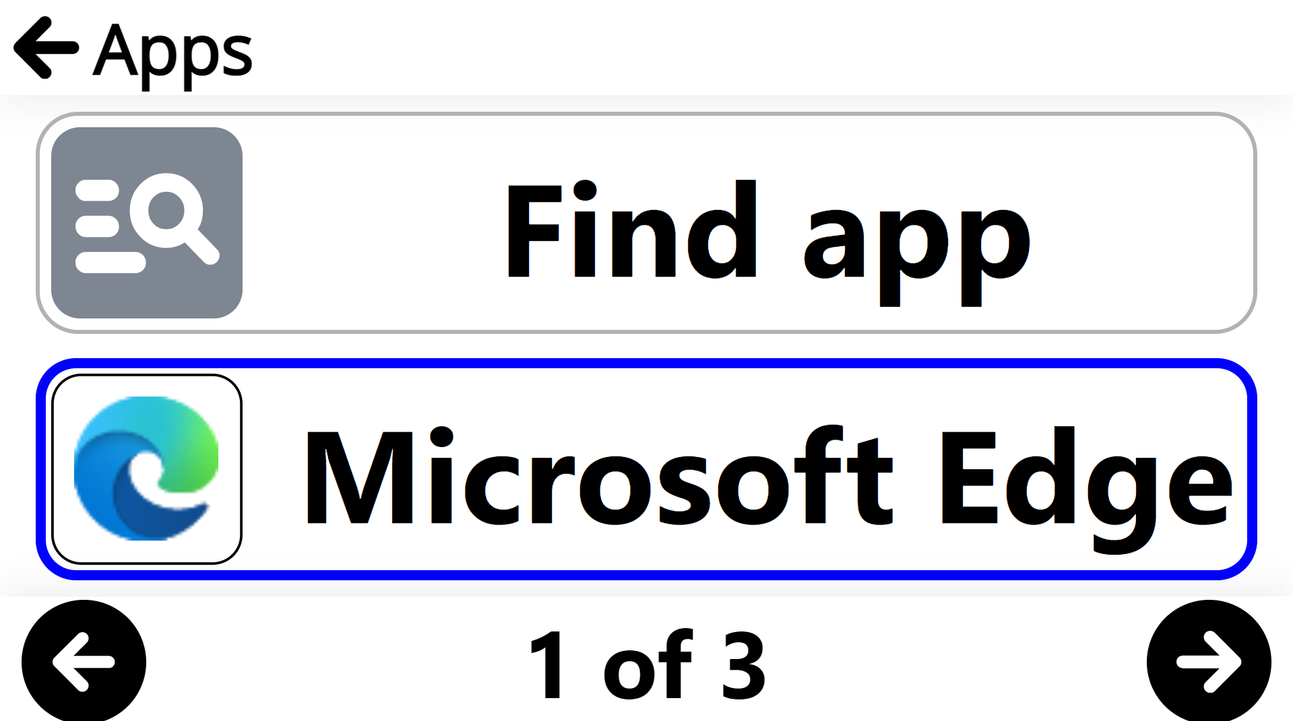

14. files Application

The Files application is where captured images, documents, and imported files are permanently stored, until you decide to delete them. Click it to access folders with saved documents and images.
Note: When Files is launched, the user is placed at the first, non-folder file.

From the Files application, you can also create and rename folders for organization.
A sample folder (labeled “Samples”) is installed with the software. You can click a sample document folder to view the included files and explore the available settings.
The bottom, center of the screen will indicate your current file number out of a total number of files and folders, for example, “1 of 12”.
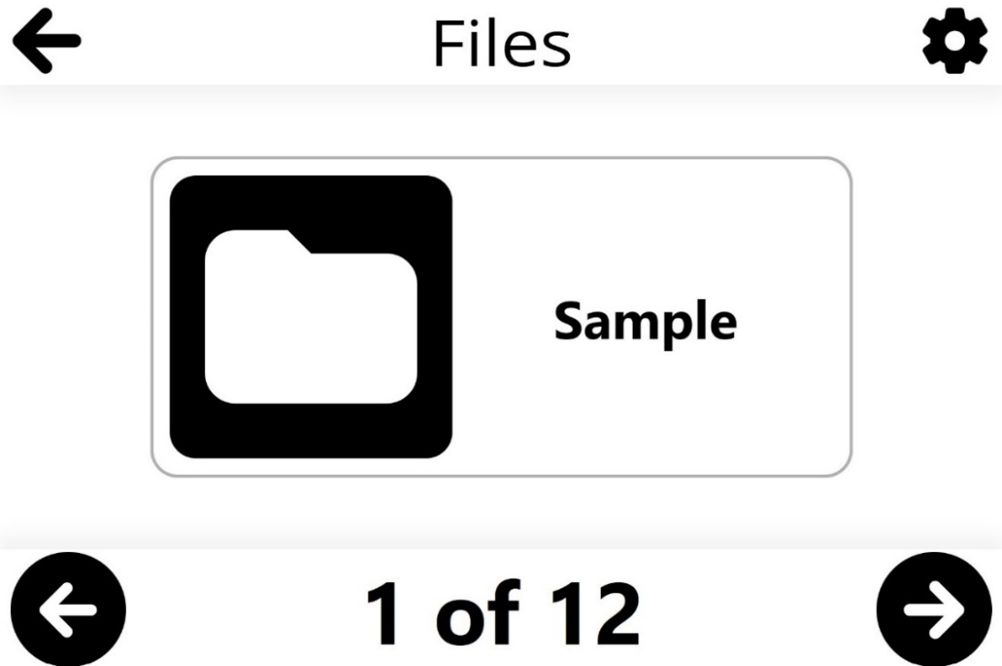
Use the left or right arrows located at the base of the screen to cycle through your files.
The top, right of the screen features a Settings (gear) symbol. Click it to access Sort, Order, Create Folder, Import and Delete All features.
Sort: files can be sorted in three ways: Alphabetically, by Creation Date or by Modification Date✓.
Files → Settings → Sort → Alphabetical/Creation Date/Modification Date✓
Order: files order can be toggled between Ascending✓ or Descending
Files → Settings → Order → Ascending✓/Descending
Create Folder: new folders can be created by clicking Create Folder. A Create Folder field will appear, simply enter the name of the new folder and click the Airplane icon at the top, right of the screen to save the new folder. Use the back arrow to cancel.
Files → Settings → Create Folder → New Folder → name new folder → click airplane icon


Import: Prodigi allows DOCX, PDF, TXT, PNG, and JPG files to import into your Files folder from elsewhere on your Windows system (example: Downloads).

Note: If more information is needed about a file when importing it, perform a long (1-second) click or press to display the file’s details. Click again to close the dialog box.
Files → Settings → Import → select the location of the file outside of Prodigi to be imported → click submit (paper plane symbol at the top, right of the screen)
Delete All: Permanently deletes all items in the Files application. As a safety feature, you will be asked “Permanently delete all files in Files?” Click Yes or No.
Files → Settings → Delete All → Yes/No

14.1 Viewing Documents and Images
Click a file or a folder to open it. Once open, you will be able to cycle through your images and documents within a folder. Select and click a document or image file to open it. The file will appear at the top of the screen with a toolbar at the bottom.
From left to right it includes:
- Back button to return to Files
- Settings (gear)
- AI Assistant (callout with three stars)
- Diamond Edge (diamond)
- Start/stop reading (right-facing triangle)
- Zoom out/in (-/+)
Settings (gear) offers the following functional adjustments.
Contrast
Prodigi allows you to view documents, photos and objects in 3 contrast types: color, positive or negative.
- Color contrast is useful when viewing documents, objects and photos in their original color.
- Positive contrast displays text and images in 2 colors according to the selected color combination (Black on White is the default combination).
- Negative contrast displays text and images in reversed contrast as compared to your selected color combination (White on Black by default). This is useful if you wish to reverse the contrast of text that contains a variety of contrasts or highlights.
Files → click open Image or Document → Settings → Contrast → select Contrast color

Contrast Color
Prodigi allows you to select from a variety of contrast color combinations for captured documents and images. They include:
- Black on white✓, White on black, Black on gray, Gray on black, Black on yellow, Yellow on black, Black on orange, Orange on black, Black on cyan, Cyan on black, Black on purple, Purple on black, Black on green, Green on black, Blue on yellow, Yellow on blue, White on blue, Blue on white, Beige on black, Black on beige, Black on Red, Red on Black, White on Red and Red on White.
Files → click open Image or Document → Settings → Contrast Color → select Contrast Color combination
Brightness
Image brightness can be incrementally adjusted in units of 5 from 0 to 100.
Files → click open Image or Document → Settings → Brightness → click the Plus or Minus symbols that appear at the base of the screen to increase or decrease screen brightness

Reading Voice
Prodigi software allows up to 4 different Acapela voices that can be used to read text documents aloud. Click to select the system voice or another installed Acapela voice.

Additionally, Prodigi allows the option of other installed SAPI voices (Microsoft Desktop) for document reading. This can be helpful where there are unsupported dialects from Acapela, such as Afrikaans.

Files → click open Image or Document → Settings → Voice → select System voice or installed voice

Speech
Use this setting to select if you want to listen to a TTS (text-to-speech) voice. Options are:
- On - provides audio support (TTS) for everything in the Prodigi interface
- Documents only - provides audio support (TTS) only for OCR’d documents
- Off✓– no audio (TTS) support at all

Files → click open Image or Document → Settings → Speech → On/Documents Only/Off✓

Speech Rate
Adjust the speed of TTS to a rate that is comfortable with this setting.

Files → click open Image or Document → Settings → Speech Rate → Very Slow/Slow/Normal✓/Fast/Very Fast

Reading Mode
Readers have different preferences about how they wish text to appear on-screen while it is read, so Prodigi software allows you to select from 3 reading modes: Page, Column✓ or Line.

Files → click open Image or Document → Settings → Reading mode → select Page, Column✓, or Line

Note: You can use your mouse or touchscreen to reposition the cursor at any time during reading mode.

When reading in Column mode, end-of-paragraph markers (>>) will appear, and the reading software automatically inserts a short pause after each paragraph.

When in Page mode, a chime will sound when the reader has reached the end of the page. Pressing Play will restart the reader at the beginning of the page or turn to the next page.

Note: Diamond Edge is the default when Page reading mode is selected, but the user can choose to have the document read in its original layout.
Preferred Zoom
Preferred zoom can be set from 2x magnification to 40x magnification (default is 4x) for all saved documents and images. Set a preferred zoom level, and your file or document will open at that default zoom level when you click to open it.
Files → click open Image or Document → Settings → Preferred Zoom → click the Plus or Minus symbols that appear at the base of the screen to increase or decrease Preferred Zoom level.

Rotation

Select this feature to access the Rotation symbol at the bottom, right of the screen. Click the symbol to rotate an image or document clockwise, 90 degrees at a time (clicking 4 times brings a document back to its original position).
Files → click open Image or Document → Settings → Rotation → click Rotation symbol

AI Assistant (callout with three stars)
The AI Assistant can be used to ask questions about saved files. Click or tap the icon to start a chat session. A text entry box will appear on screen.
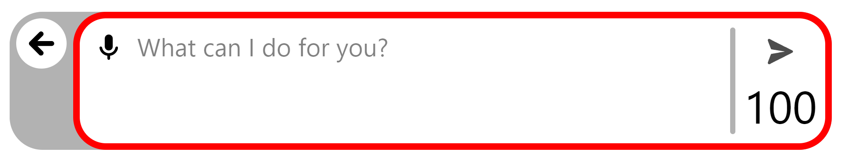
Text can be entered into the box with a keyboard, or the microphone symbol can be used to ask a question using voice input. After the question is typed of voiced, click the submit button (arrow) to get a response from the AI Assistant service.
In the lower right corner, the remaining number of daily questions is shown.
After a question is asked and the answer is returned, the interface updates with a new toolbar.

To the right are Settings (gear wheel) for the chat, the AI Assistant button (callout with three stars), Reading play/pause (right-facing triangle), and Zoom Out or In (-/+).
Settings offers the following:
- New Chat, when activated, allows the user to
  - Cancel the New Chat and return to the current chat
  - Save Chat: Closes and attaches the current chat to the file’s Chat History, then starts a new chat.
  - Delete Chat: Removes the current chat completely and starts a new chat.
- Chat History: Contains a list of chats saved with the document. By default, these are saved in the following format: year-month-date-hour-minute.
- Options for Speech adjustment.
  - On – reads everything in the Prodigi interface.
  - Documents only – TTS is only provided for documents.
  - Off✓ - no TTS support is provided.
- Reading Voice can be changed to any installed voice on your system.
- Speech Rate can be customized from Very Slow, Slow, Normal✓, Fast, and Very Fast options.
- Font Size adjustments are available and range from Minimum, Small, Medium, Standard✓, Large, Very Large, Extra Large, and Maximum.
- Font Type can be toggled between Regular✓ and Bold.
Click or tap the AI Assistant icon to enter another prompt.
AI messages can be read using the right-facing play/pause toggle button and the text size can be adjusted using the zoom in/out buttons (+ and -).
At the far left is a back button (left-facing arrow) that will return to the file. Chats are automatically attached and saved with the file.

Diamond Edge (diamond symbol)

For text documents, toggle the Diamond Edge to enhance the original color of a document or object to improve text/image definition. Diamond Edge contrast combines the best of both worlds: it displays Diamond Edge Text™ in your selected color combination and images in their original color. This allows you to magnify text to maximum levels without compromising text quality in the best color combination for your vision.

TTS read-aloud symbol (black, right-pointing triangle)
Once you’ve captured a document or an image that contains text, you can click the Read button and have the system read content aloud. The Read button is immediately replaced by the Pause icon (two vertical parallel lines) so that you can toggle between play and pause.
Alternately, users can start reading wherever they like with a long finger press (1 second) or a long mouse click (1 second) on the word where they want the reading to begin.

Plus and Minus symbols (+/-)
You can increase or reduce the size of captured images and documents by clicking the Plus or Minus symbols at the bottom, right of the screen. (+) increases image/character size, and (-) decreases image/character size.
Magnification range for a captured image or document is from 1x to 100x.
In addition to the increase/decrease magnification symbols, you can employ the pinch and zoom gesture to increase/decrease magnification. Decrease the distance between 2 fingers to zoom out, and increase the distance to zoom in.
Pinch and Zoom gesture (image)

14.2 Reading Settings
Clicking the Settings (gear) symbol in reading mode accesses additional options to enhance the reading experience, including some that have been previously detailed.
- Font size: The captured document can have the font of the OCR’d text increased or decreased. This can reduce the need to zoom in or out. Options include: Minimum, Small, Medium, Standard✓, Large, Very Large, Extra Large, and Maximum.
- Font type: The OCR’d text can be displayed in either Regular or Bold✓ font type based upon visual needs.
- Highlight: While Prodigi is reading aloud with TTS a box is shown around each spoken word. This can be helpful to maintain focus and making connections between the audio and visual presentation of text. The options are Display✓, which means the box is visible, or Hide.

14.3 Action Menu (for Folders)
The Files application features an Action Menu that includes useful functions for your saved folders.
To access the Action menu, right-click a Folder. You will be directed to a menu listing available actions for your selected file. This menu can also be accessed by a long, one-finger press on the file or folder.

Move
Clicking Move leads to the Create New Folder option if you want to move a folder to a new folder. All other previously existing folders will appear on the list as well.
Files → Folder → Action (right-click image or document) → Move → Create Folder → enter title of new folder → click Folder symbol located at the top, right of the screen


Delete
Permanently deletes all items in the folder. As a safety feature, you will be asked Permanently delete item?
Files → Folder → Action (right-click image or document) → Delete → Yes/No

Rename
Files can be renamed by right-clicking them, then selecting Rename from the Action menu.
Files → Folder → Action (right-click folder) → Rename → enter the new name then click submit (paper plane symbol at the top, right of the screen) to save the revised name.


Create Folder
Follow this process to create and save a new folder:
Files → Folder → Action (right-click image or document) → Create Folder → enter name of new folder then click submit (paper plane symbol at the top, right of the screen) to save the revised name.

Delete Folder Content
You can keep a folder but permanently delete all the content in it. As a safety feature, you will be asked Permanently delete content?
Files → Folder → Action (right-click image or document) → Delete → Yes/No

14.4 Action menu (for documents and images)

Move
Clicking Move leads to the Create New Folder option if you want to move saved images into a new folder. All other existing folders will appear on the list as well.
Files → Folder → Action (right-click image or document) → Move → Create Folder → enter name of new folder → click Folder symbol located at the top, right of the screen

Delete
Permanently deletes the saved document or image. As a safety feature, you will be asked Permanently delete item?
Files → Action Menu (right-click image or document) → Delete → Yes/No

Rename
Documents or images can be renamed by right-clicking them, then selecting Rename from the Action menu.
Files → Folder → Action (right-click image or document) → Rename → enter the new name and click submit (paper plane symbol at the top, right of the screen) to save the revised name.

Export
Documents or images can be exported elsewhere by right-clicking them, then selecting Export from the Action menu.
Files → Folder → Action (right-click image or document) → Export → select export format (PDF, JPG or Text) → Export → select export destination
When the export is complete, the “Exported to Downloads” message will appear.

Import
Documents or images can be imported into your Prodigi library from elsewhere (supported file types: PDF, TXT, JPG, and PNG).
Files → Folder → select image or document → Settings → Import → select import destination → click submit (paper plane symbol at the top, right of the screen)
When the import is completed, the “Carousel has been refreshed” message will briefly appear.

Properties
This section identifies and provides information on an image or document, such as name, type (example: JPEG), date created, date modified, and size (example: 344 KB).
Files → Folder → Action (right-click image or document) → Properties
Prodigi allows you to paste external text files into the Files application and then open them using the Prodigi interface. Copying can also be done outside Prodigi in Windows applications that allow you to copy text (example: Internet browser, Dropbox, or your email).

15. Help Application

Note: Internet access is required to use the following tools.
The rightmost item in the Carousel menu is the Help Application (question mark icon). This application is where you will find information on how to operate system software, how to connect cameras and troubleshooting tips. You will also find quick and easy methods to assist you in navigating and personalizing Prodigi to suit your needs and preferences.
Clicking Feedback will redirect to our HumanWare web form. Use it to tell us what you think of the Prodigi system, what you like, and how you think we can improve its features.
Clicking Videos to go to our HumanWare YouTube video channel, which contains a variety of informative and instructional videos on how to install and operate Prodigi software.
Click Documentation to access support documentation, the HumanWare Buddy app and other resources.

16. Gesture Guide

Note: the following gestures are for use with touchscreen-enabled devices.

Pinch and zoom gesture

Tap gesture (for accessing applications, selecting preferences, etc.)


Double tap gesture (header bar, etc.)
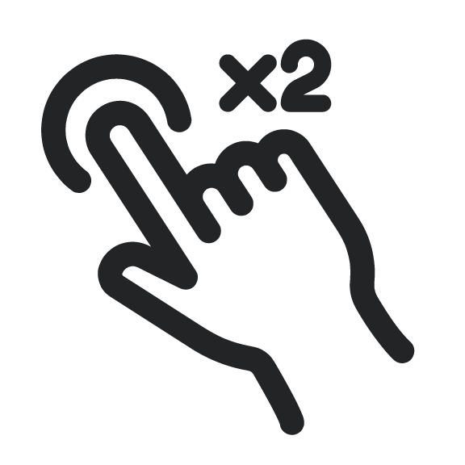

Long press gesture (image capture, etc.)



Toggle from Live to Multi-Capture Mode or Contrasts

17. Basic Keyboard Shortcuts

- Copy: Ctrl + C
- Cut: Ctrl + X
- Paste: Ctrl + V
- Maximize Window: F11 or Windows logo key + Up arrow
- Minimize application: Windows logo key + M
- Open Task View: Windows logo key + Tab
- Display and hide the desktop: Windows logo key + D
- Switch between open apps: Alt + Tab
- Open the Quick Link menu: Windows logo key + X
- Lock your PC: Windows logo key + L
- Speech input: Windows + H
- Quit: Ctrl + Q
Click the following link to access the expanded list of Keyboard shortcuts in Windows
Prodigi has keyboard commands that can be used only with HumanWare’s wireless Bluetooth keyboard.

18. Glossary

AI (Artificial Intelligence): Computer technology that learns from data to carry out human-like tasks such as interpreting images, text, or speech without explicit step-by-step programming.
Auto-focus: a device or feature that focuses a camera or other piece of equipment automatically.
Bluetooth: a telecommunications industry specification that describes how mobile devices, computers and other devices can easily communicate with each other using a short-range wireless connection. Diamond Edge: This screen feature allows you to magnify text to maximum levels without compromising text quality in the best color combination for your vision. It displays your selected color combination and images in their original color.
High-Contrast Viewing: The software makes text and images more readable for those with low vision. It enhances visual clarity and comfort, especially in documents or environments with poor lighting.
HoverCam: The HoverCam document camera is plug-and-play with Prodigi. While Pathway Innovations has developed their own software for the camera, it is NOT required for using the camera with Prodigi.

OCR (optical character recognition): OCR is a technology that recognizes text within a digital image. It is commonly used to recognize text in scanned documents and images. OCR software can be used to convert a physical paper document, or an image into an accessible electronic version with text.

Reading Mode: The software includes various reading modes such as full page, column, and line, which adapt to different reading preferences and tasks. Users can choose the mode that best suits their needs, enhancing their reading experience and productivity.
Text-to-Speech (TTS): Prodigi can convert printed text into spoken words, providing access to printed materials for individuals with visual impairments. Additionally, text-to-speech can be employed to read all elements of the software interface. This feature promotes literacy, independence, and accessibility.
User Interface (UI): The point of contact between humans and computers. Any technology you interact with as a user is part of the user interface. For example, screens, sounds, overall style, and responsiveness are all elements of UI.

Windows-Based: Written for Windows ensures a seamless integration with the user's preferred operating system, making it easy for users to incorporate Prodigi into their existing technology ecosystem. This compatibility provides a familiar and user-friendly experience.

19. Troubleshooting

Software will not install.

- Be sure that you have the administrator rights to install on your device
- Update App Installer in the Microsoft Store Library of Apps

No audio when trying to read an OCR document

- Check Settings → Audio to see if Documents Only or All is selected.
- Ensure voices are downloaded and installed in Settings → User Interface → System Language
- Verify that tablet/headphone volume has been turned up sufficiently

No image appears in either the Magnifier or Distance applications.

- Check that a camera is selected by clicking the gear wheel and select a camera
- Check camera connections on both ends; disconnect and reconnect

Blank image in Magnifier or Distance application (white or black).

- Check that a camera is selected by clicking the gear wheel and Camera
- Close and open the application
- Exit and restart Prodigi
- Disconnect and reconnect your camera
- Reboot your system

20. Prodigi System Recommendations

What to look for in a PC:

Description | Specification
Operating System (64-bit) | Windows 11, Windows 10
Processor* | Intel Core i3 (4 CPUs) or better CPU
Memory (RAM) | at least 8 GB
Required hard disk space | 8 GB free disk space
Video | DirectX 11 or newer
Sound | Windows compatible sound card (for speech).
*ARM64 may not support optional Kodak distance camera.

What to look for in a document camera:

Description | Specification
Resolution | 13MP
Color | 24-bit color
FPS | 60fps@10ADP
System | Windows 10+
Connectivity | USB connectivity

21. Appendix 1

20.1 Basic Prodigi FOR Windows Bluetooth Keyboard Commands

Note: these keyboard commands are for the Bluetooth Keyboard by HumanWare. They do not apply to other keyboards.
Key | Action
ESC | Back
F1 | Brightness down
F2 | Brightness up
F3 | Open Windows start menu
F4 | Show active apps
F5 | Open settings (specific to current view)
F6 | Open magnifier
F7 | Decrease reading speed
F8 | Capture image or start/stop reading
F9 | Increase reading speed
F10 | Mute/unmute
F11 | Decrease volume
F12 | Increase volume
Power | Sleep/Wake (Not implemented on Windows)
Right CMD (HOME) | Return to Prodigi Home
Left CMD (BACK) | Back
Up Arrow | Move the locator
Down Arrow | Move the locator
Ctrl + Up Arrow | (Temporary until the Navigation mode is implemented)  Scroll up or page up
Ctrl + Down Arrow | (Temporary until the Navigation mode is implemented)  Scroll down or page down
Right Arrow | Move the locator
Left Arrow | Move the locator
Ctrl + Right Arrow | (Temporary until the Navigation mode is implemented)  Scroll right or next page
Ctrl + Left Arrow | (Temporary until the Navigation mode is implemented)  Scroll left or go back or previous page
Plus | Zoom in or increase text size
Minus | Zoom out or decrease text size
Right Alt | Prodigi Home
Left Alt | Back
Enter | Select item
Long Press Enter | Open action menu
Ctrl + Q | Exit to Android
Ctrl + B | Toggle button banner
Ctrl + C | Table of content
Ctrl + S | Download or Save
Ctrl + L | Toggle lights (Not implemented on Windows)
TAB | Move the focus
Ctrl + Mouse wheel | Zoom In/ Zoom out

21.2 General keyboard shortcuts

Key | Action
Up arrow | Move the locator scroll
Down arrow | Move the locator scroll
Left arrow | Move the locator scroll
Right arrow | Move the locator scroll
Ctrl + Up | Pan in an image or  Scroll into the text (Column Mode)
Ctrl + Down | Pan in an image or  Scroll into the text (Column Mode)
Ctrl + Left | Pan in an image or  Scroll into the text (Line Mode) or  Go to previous or next page in a  document
Ctrl + Right | Pan in an image or  Scroll into the text (Line Mode) or  Go to previous or next page in a  document
Plus + | Zoom in / Increase text size
Minus - | Zoom out / decrease text size
ESC | Back
Ctrl + Q | Exit current application
Alt + F4 | Exit current application
Ctrl + B | Show/hide button banner
Ctrl + S | Save picture
TAB | Move the locator to next or previous area/item
Shift + TAB | Move the locator to next or previous area/item
Space | Trigger selected item
Enter | Long press opens the contextual menu of selected item
Shift + F10 | Open contextual menu of the selected item
Mouse wheel | Zoom in/out or Scroll up/down
Windows + H | Speech input
Alt + W | Start/stop Windows-interface mode

22. Appendix 2

Connecting the Kodak Wi-Fi Distance Camera to Prodigi Software
Using the Kodak camera for distance viewing with Prodigi software offers an enhanced visual experience, making it easier to see and magnify distant objects. To get the most from this setup, it's essential to use the included Wi-Fi Dual Band USB Adapter
which creates a secondary network called Wi-Fi 2. This dedicated network allows a stable connection to the Kodak camera without interrupting your primary Wi-Fi, so you can enjoy seamless distance viewing and maintain access to the Internet on your device.
1. Ensure that your Prodigi software is installed and updated to version 1.1 or later.
2. Fully charge the Kodak distance camera (SL-10 or SL-25) using the charger.
3. Attach the Kodak camera to the flexible gooseneck.
4. Slide the mounting adapter onto the HoverCam SOLO 8+ vertical arm.
5. Insert the gooseneck with the camera into the adapter.
6. Plug the Wi-Fi Dual Band USB Adapter into a USB port on your Windows device and
follow the setup prompts.
7. Launch the Prodigi software and open the Distance application.
8. Click the Settings (gear) icon.
9. Press the power button on the Kodak camera.
10. Select “Camera,” then choose “Wi-Fi 2” from the list.
Note: Choosing “Wi-Fi” as your network will disable Internet access, as this is your
primary network.
11. Click “Find a camera” and select PIXPRO-SL10_xxxx or PIXPRO-SL25_xxxx.
12. Enter the Kodak camera password: 12345678. Note: In later units, the password has been changed to 00000000. This will be indicated by a prominent sticker at the bottom of the camera.
13. Exit the Settings menu to return to the Distance application and begin using the
Kodak camera for distance viewing and magnification.
If you exit Prodigi, or lose your connection, a message will appear onscreen in
addition to a Reconnect button in the lower left corner of the Distance application interface to the right of the Magnifier-Distance toggle button. Click the Reconnect button to re-establish your camera.
You can disconnect from the selected Wi-Fi camera by selecting another Wi-Fi, USB, or integrated camera from the Distance application.
To completely remove a Wi-Fi camera, open the Distance application, navigate to the Wi-Fi to which it is connected, click on settings (gear wheel) to manage the Wi-Fi camera, click on the camera to be removed, select “Forget,” and confirm your choice. Use the back arrow in the upper left corner to return to the Carousel.
Distance → Settings → Camera → Wi-Fi 2 → Settings → PIXPRO-SL 10 or SL-25 → Forget → Yes/No

23. Technical Specifications

Prodigi Low Vision Software for Windows
Note: Prodigi is optimized for use with the from HoverCam; results with other document cameras may vary.

Software System Requirements:
- Operating System
  - Windows 10 or greater
  - 64-bit
- Processor
  - 2.0 GHz i5 dual core or higher processor recommended
  - ARM64 processors are not compatible with optional distance camera
- Memory (RAM): 8 GB or more recommended
- Required hard disk space:
  - 2 GB with more space required for additional voices
  - SSD drive recommended
- Video:
  - Video/Graphics card with support for DirectX 9 or later with WDDM 1.0 driver
  - 1024x768 display resolution recommended
- Sound: Windows-compatible sound card (for speech)

Internet: For installation, activation, some features (example – AI Assistant), and ongoing updates.

Recommended Minimum Document Camera Specifications*
- Windows 10+ compatibility
- 13MP resolution
- 24-bit color
- 60fps @10ADP
- USB connectivity
* Prodigi is optimized for the Solo 8+. Results may vary with other cameras.

Prodigi Low Vision Software: Starter Kit
Prodigi Low Vision Software (above)
HoverCam Solo 8+(above)
- 13MP
- 4224x3156 (4K HD)
- 24-bit color
- Image capture 13”x21”, A3, A4, 11”x17”, US Letter & US Legal
- Focus, Auto-focus, Auto-focus Lock, Selective Focus, 5 cm Minimum Focal Distance
- Video resolution 4K @30fps, 1080p @60fps, 720p @120fps
- 2.2lbs
- Full specifications from HoverCam

Prodigi Low Vision Software: Complete Kit
Prodigi Low Vision Software (above)
HoverCam Solo 8+(above)
Microsoft Surface Pro 9
- Operating System: Windows Pro 11
- CPU: Intel Core i5 (12th Gen) 1245U / 1.6 GHz
- Memory (RAM): 8GB; LPDDR5 SDRAM
- Storage: 128GB SSD
- Display: 13" touchscreen (10-point multi-touch); 2880 x 1920
- Audio/Video: Intel Iris Xe Graphics, Cameras: 4K (rear); 1080p (front), Resolution: 10 Megapixel (rear), Stereo speakers, dual far-field studio microphones, Dolby Atmos compliant
- Wireless: Bluetooth 5.1, 802.11a/b/g/n/ac/ax (Wi-Fi 6E)
- Battery: Up to 15.5 hours
- Connections: 2 x USB4 (supports Thunderbolt 4) (Type C)
- Dimensions: 11.3 in x 8.2 in x 0.4 in
- Weight: 31 oz

Prodigi Low Vision Software: All-in-One PC
Prodigi Low Vision Software (above)
HoverCam Solo 8+(above)
AOC UPS All-in-One PC
- Operating System: Windows Pro 11
- Processor: Intel® Core™ i3-12100
- Memory: DDR 16GB
- Storage: 512GB SSD
- UPS Battery: 60 minutes
- LED Monitor: 23.8", IPS Full HD, 1920x1080, matte
- LAN: Realtek 8111EL&F 100/1000M
- Ethernet: RJ45 port
- Audio: Realtek ALC662, Azalia Code support
- 5.1 channel output,2 Jacks, MIC in/line out
- Wi-Fi: 802.11b/g/n/ac 2.4GHz & 5Ghz
- Dual-band WI-FI 5 and Bluetooth 4.0
- Speakers: Two 3W
- Height adjustable stand with quick-release function
- Color: Black
- Camera: 3MP
- Keyboard: AOC USB
- Mouse: AOC USB
- Power Adapter: 13.5/19V
- I/O: 1 line out and 1 Mic in, COM Port, 2 - USB 2.0 Ports, 4 USB 3.0 Ports, LAN RJ45, HDMI, DC-In port
- Display dimensions 21.25” x 14.9-19.8” x 8.15” (W x H x D)
- Weight: Display only 11lbs; with keyboard and mouse 18.1lbs

24. Software Maintenance Agreement and Warranties

24.1 Software Maintenance Agreement

- 1st year of ownership all upgrades* and updates** at no cost
- Starts at software activation
- Available options after 1st year
  - 1-year Software Maintenance Agreement (SMA)
  - 2-year Software Maintenance Agreement (SMA)
- Without SMA, users receive updates only.
- If coverage lapses, a portion (or even all) of any SMA purchase will be applied to bring coverage current

*Upgrades include new features, compatibility, and bug-related fixes
**Updates include compatibility and bug-related fixes only

24.2 Warranties

Microsoft Surface Pro 9: 1-year limited manufacturer’s warranty
AOC All-in-One PC: 1-year limited manufacturer's warranty
Bluetooth Keyboard and Mouse: 1-year limited manufacturer's warranty

6-in-2 Microsoft Surface Docking Station: 1-year limited manufacturer's warranty

Hovercam SOLO 8+ document camera, 2-year limited manufacturer’s warranty

