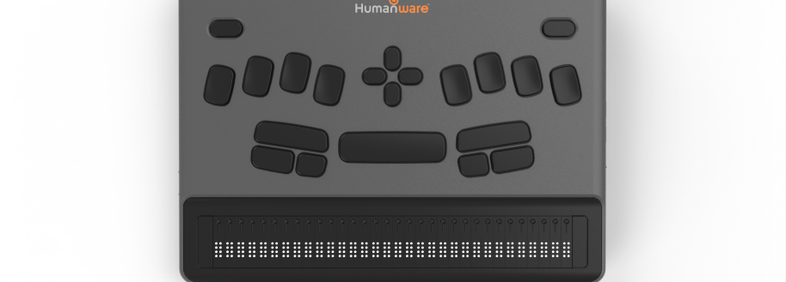
BrailleNote evolve Knowledge Levels

Setting up and using JAWS on BrailleNote evolve
Contents
Setting up and using JAWS on BrailleNote evolve 1
How to claim your 6 months Free trial of JAWS 2
Installing JAWS on the BrailleNote evolve 2
Using JAWS to Navigate the Desktop 2
Modifier Keys 2
Common Tasks with JAWS and Modifier Keys 3
Editing Text Commands 4
Navigation Commands 4
Commands for Outlook 4
File Management Commands 4
HTML Web Browser Commands 5
Commands that don’t have a Direct Keyboard Equivalent 5
Using JAWS with KeySoft 5
Saving files with office applications 5
Additional Help 5
Support 6

The BrailleNote evolve is fully equipped to run the JAWS for Windows screen reader. Should you wish to install and work with JAWS on the device, HumanWare has included a 6-month free trial of JAWS, and once activated, the clock will start to count down.
If at any point, (during the trial), you wish to subscribe to JAWS for BrailleNote, this can be purchased at a special discounted price from HumanWare.

How to claim your 6 months Free trial of JAWS
When you are ready to take the next step towards transitioning to a screen reader, you can begin by trying JAWS. Every BrailleNote evolve includes a free six-month JAWS trial licence.
To claim your licence, you will need to contact HumanWare or your local dealer and provide your device serial number along with your details. Please note that this is a one-time offer and the licence is linked directly to your device serial number.

Installing JAWS on the BrailleNote evolve
JAWS is not pre-installed on the BrailleNote evolve. To ensure you always have access to the latest version of JAWS, a shortcut is available in the KeySoft menu under All Applications, allowing you to quickly download and install the most recent release.

Using JAWS to Navigate the Desktop
Once JAWS has been set up you can begin to use it on your device. You may wish to configure the onboard NVDA preventing it from starting up as you may have both screen reader running at the same time. When started you will be placed on the Windows desktop, and can navigate the environment with familiar methods. These include:
- Next/previous thumb keys, (outer left/right), as up/down arrows
- Space + dot 1 to simulate the up arrow, and space + dot 4 to simulate the down arrow
- D-pad located in the center, (between keys 1-4) as up/down/left/right arrows
- First-letter navigation

Modifier Keys
The modifier keys on the BrailleNote evolve are as follows, starting from the top left corner of the device:
- Top left: Escape
- Top right: Delete
- D-pad: located in the center, (between keys 1-4), functions as up/down/left/right arrows
- To the left of the spacebar, (long rectangular key: shift
- Below shift, on the left-hand side: ctrl
- To the right of ctrl: alt
- To the right of the spacebar, (long rectangular key): insert/JAWS key
- Below insert, closest to the spacebar: FN, (use this in conjunction with keys A-L to simulate F1-F12)
- FN + dropped keys, (dot 2, 2-3), to simulate numbers, if needed
- To the right of FN: Windows
- Tab: space + dots 4-5
- Shift + Tab: space + dots 1-2
- Alt + tab: alt + space + dots 4-5

Common Tasks with JAWS and Modifier Keys
You can perform common tasks running JAWS and using the modifier keys. These include:
Task | Command
Access the JAWS menu if JAWS is running from the System Tray | INSERT + J (dots 2-4-5)
Alt+F4 | FN + ALT + D (dots 1-4-5)
Access the Windows desktop | SPACE + D (dots 1-4-5)
read the current window title | SPACE + T (dots 2-3-4-5)
Access the Start menu/search box | Windows key
Stop speech | CTRL
Toggle speech on/off: | FN + INSERT + SPACE, followed by S, (dots 2-3-4)
Adjust speech rate: | CTRL + ALT + FN + Windows + up/down arrow, (page up/down)
Access the Windows menu bar | ALT or SPACE + Y, (dots 1-3-4-5-6)
Windows Explorer | Windows + E, (dots 1-5)
Keyboard help | SPACE + DOTS 1-4-5-6 (Th sign)
App switcher | SPACE + DOTS 3-5-6
Context menu | SHIFT + FN + J, (dots 2-4-5)
Battery status | INSERT + SHIFT + B, (dots 1-2)
Adjust JAWS typing echo | INSERT+ FN + Dots 2-3
Read status bar | INSERT + PAGE DOWN (FN+down arrow)

Editing Text Commands
To edit text in any field in Windows with JAWS:
Task | Command
Delete, deletes forward by a character, or any selected text | Delete
Read currently selected text | INSERT + SHIFT + DOWN ARROW
Undo | CTRL + Z, (dots 1-3-5-6)
Copy | CTRL + C, (dots 1-4)
Cut | CTRL + X, (dots 1-3-4-6)
Paste | CTRL + V, (dots 1-2-3-6)

Navigation Commands
Task | Command
Home | SPACE + DOTS 1-3 or FN + LEFT ARROW
End | SPACE + DOTS 4-6 or FN + RIGHT ARROW
Ctrl + home | SPACE + DOTS 1-2-3 or ctrl + FN + left arrow
Ctrl + end | SPACE + DOTS 4-5-6 or ctrl + FN + right arrow
Page up | FN + UP ARROW
Page down | FN + DOWN ARROW
Next paragraph | CTRL + DOWN ARROW
Previous paragraph | CTRL + UP ARROW
Read all | SPACE + DOTS 1-2-4-5-6

Commands for Outlook
Task | Command
New message | CTRL + N
Reply | CTRL + R
Reply all | CTRL + SHIFT + R
Forward | CTRL + F
Send | ALT + S/CTRL + enter
Access various folders | CTRL+ Y
Access attachments from an email | INSERT + A or SHIFT + TAB, (space + dots 1-2) while in a message

File Management Commands
Task | Command
New folder | CTRL + SHIFT + N, (dots 1-3-4-5)
Copy | CTRL + C, (dots 1-4)
Cut | CTRL + X, (dots 1-3-4-6)
Paste | CTRL + V, (dots 1-2-3-6)

HTML Web Browser Commands
Task | Command
Links list | SPACE + DOTS 2-3-5-6
Next link | TAB, (space + dots 4-5)
Previous link | SHIFT + TAB, (space + dots 1-2)
Next/previous radio button | A and BACKSPACE + A, (dot 1)
Next/previous article | O and BACKSPACE + O, (dots 1-3-5)

Commands that don’t have a Direct Keyboard Equivalent
- Change braille grade
- Sort in File Manager
- Increase/decrease font size: ctrl + shift + period and ctrl + shift + comma don’t seem to work on braille keyboard
- JAWS does not work in KeyMath/Equation editor. In order to use JAWS with math input through word you will need to disable the KeySoft word Add in. This can be done through the keysoft control centre.

Using JAWS with KeySoft
If you are wanting to use JAWS in addition to KeySoft you will find that certain braille shortcuts will not work. This is because KeySoft is optimised to work with NVDA. However, commons JAWS shortcuts can be used.

Saving files with office applications
If you have the keysoft add-ins enables, then you will likely face some changes when it comes to saving files. When using office applications such as Word, PowerPoint and Excel the file explorer being used is intercepted with Keysoft’s file manager KeyFiles. Currently there is no way to change this if you still want to use the KeySoft Addin. However if you prefer the traditional windows dialog then you will need to disable the add-in which can be done through KeySoft control centre.

Additional Help
If you need additional help using JAWS, FSCompanion is a free resource from Vispero that you can access at any time. Please visit:
FS Companion

Support
If you require any further support with JAWS for BrailleNote, please contact the supplier from whom you purchased the licence. For customers who purchased their licence through HumanWare UK, all JAWS support is provided by Sight and Sound.
To contact Sight and Sound call 0800 085 6055 or you can raise a ticket through https://sastltd.zohodesk.eu/portal/en/myarea

