Prodigi for Windows Accessibility Guide

Appendix A: Keyboard Shortcuts and Mouse Actions
This appendix lists all keyboard shortcuts and mouse actions for Prodigi for Windows. The standard keyboard and HumanWare Bluetooth keyboard share the same key assignments for all Prodigi functions.

Note: This appendix reflects the Prodigi for Windows Accessibility Guide dated May 2026. Keyboard assignments are consistent between the standard keyboard and the HumanWare Bluetooth keyboard for all Prodigi functions.

A.1 Keyboard Shortcuts
Standard | HumanWare Bluetooth | Action
Ctrl + C | Ctrl + C | Copy
Ctrl + X | Ctrl + X | Cut
Ctrl + V | Ctrl + V | Paste
Ctrl + Q | Ctrl + Q | Quit / Exit current application
Ctrl + B | Ctrl + B | Show or hide Button Banner
Ctrl + S | Ctrl + S | Save image
ESC | ESC | Back
Alt + F4 | Alt + F4 | Exit current application
Alt + Tab | Alt + Tab | Switch between open applications
Alt + W | Alt + W | Start or stop Windows-interface mode
TAB | TAB | Move locator focus to next area or item
Shift + TAB | Shift + TAB | Move locator focus to previous area or item
Enter / Space | Enter / Space | Confirm a selection or action. Long press (1 second) and release opens context menu.
Shift + F10 | Shift + F10 | Open context menu of selected item
F1 | F1 | Open Settings for current view
F2 | F2 | Open AI Assistant application
F3 | F3 | Open Magnifier application
F4 | F4 | Open Distance application
F5 | F5 | Open Books application
F6 | F6 | Open Files application
F7 | F7 | Decrease reading speed
F8 | F8 | Capture image / Start or stop reading
F9 | F9 | Increase reading speed
F10 | F10 | Decrease volume
F11 | F11 | Mute or unmute
F12 | F12 | Increase volume
Arrow keys | Arrow keys | Move locator up, down, left, right; scroll
Ctrl + Up arrow | Ctrl + Up arrow | Pan in a captured image. Scroll text in Column reading mode. Change app focus in split screen.
Ctrl + Down arrow | Ctrl + Down arrow | Pan in a captured image. Scroll text in Column reading mode. Change app focus in split screen.
Ctrl + Left arrow | Ctrl + Left arrow | Pan in a captured image. Scroll text in Line reading mode. Go to previous page. Change app focus in split screen.
Ctrl + Right arrow | Ctrl + Right arrow | Pan in a captured image. Scroll text in Line reading mode. Go to next page. Change app focus in split screen.
Plus (+) | Plus (+) | Zoom in / increase text size
Minus (−) | Minus (−) | Zoom out / decrease text size
Windows + H | Windows + H | Open Windows speech input (voice-to-text for any text field)
Windows + Up arrow | Windows + Up arrow | Maximize window
Windows + M | Windows + M | Minimize application
Windows + Tab | Windows + Tab | Open Task View
Windows + D | Windows + D | Display or hide desktop
Windows + X | Windows + X | Open Quick Link menu
Windows + L | Windows + L | Lock your PC
M | M | Selector in markup tools
P | P | Pencil in markup tools
H | H | Highlighter in markup tools
E | E | Eraser in markup tools

A.2 Mouse Actions
Mouse action | Result
Left-click | Select an item (application, menu item, file, etc.)
Right-click | Open context menu for files and folders in Files, and pinned applications in Apps
Double-click | In Magnifier: enable or disable autofocus. In an open file: enable or disable speech.
Click-hold (~1 second) and release | In Magnifier: capture an image. In an open file: start or stop reading from that word.
Click and drag (left side of Magnifier screen) | Toggle between Live and Multi-Capture modes
Click and drag (right side of Magnifier or open file) | Cycle through contrast types: Color, Positive, Negative
Scroll wheel | In Magnifier: zoom in and out. In menus and files: scroll up and down, move locator.
Ctrl + Scroll wheel | Zoom in or out

Appendix B: Touchscreen Gesture Guide
The following gestures apply to touchscreen-enabled devices. All gestures can be replicated using a mouse or keyboard; see Appendix A for equivalent actions.

Pinch and Zoom (2-fingers)
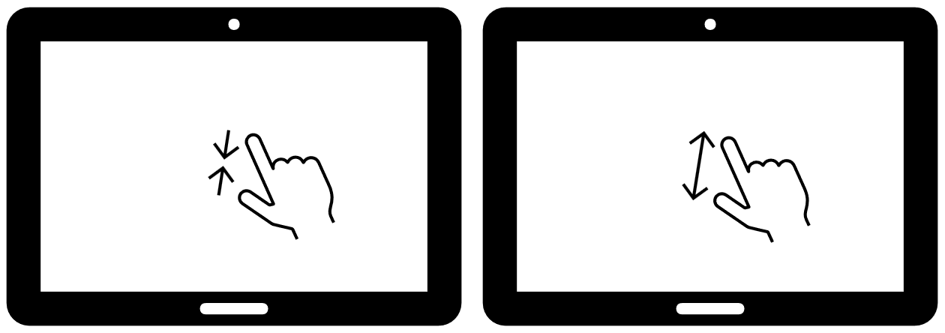
Place two fingers on the screen and move them apart to zoom in, or bring them together to zoom out. Used in Magnifier, Distance, and Files to adjust magnification.
Tap (1-finger)
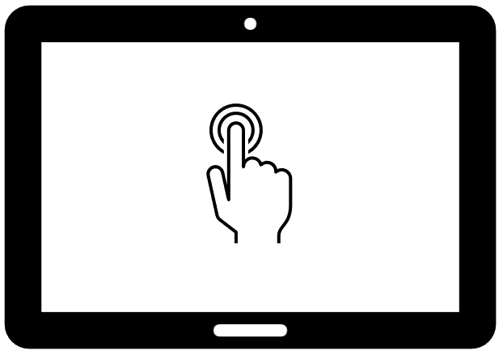
Touch the screen once with one finger. Used to select applications, menu items, files, and to confirm choices.

Tap (2-fingers)
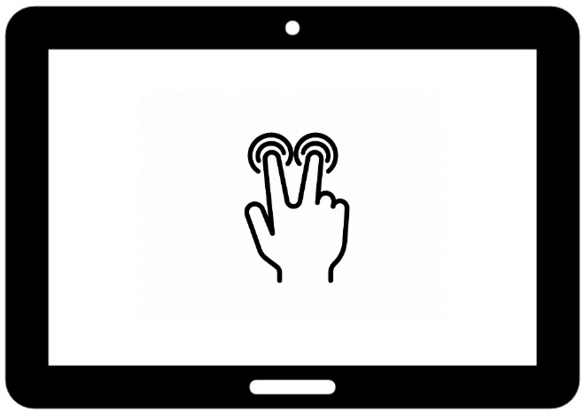
Tap two fingers on the screen to open the context menu for an item. For example, a file that you wish to rename or delete.

Double Tap (1-finger)
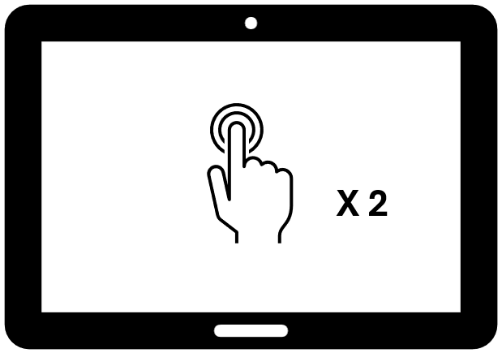
Touch the screen twice quickly with one finger. In the Carousel header bar, double tap exits to Windows. In the Magnifier application, double tap on the live image enables or disables autofocus with a supported camera.
Long Press (1-finger)
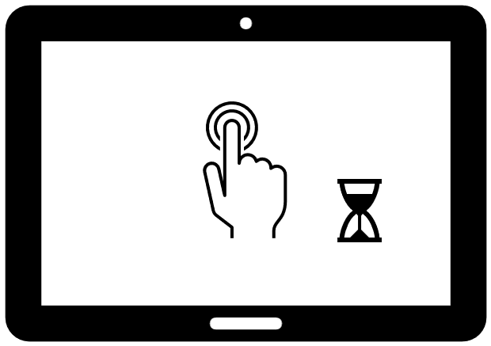
Press and hold one finger on the screen for approximately one second. In Magnifier, long press captures an image. In Files and other menus, it expands the full text of a selected item, such as a long file name or menu entry, in a pop-up display. In a reading session, the long press on a word starts TTS reading from that word.

Swipe (1-finger)
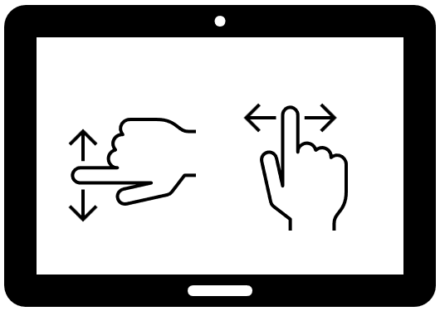
Slide one finger across the screen in the desired direction. Used throughout Prodigi to scroll and navigate.
- In Magnifier, swipe up or down on the left side of the screen to toggle between Live and Multi-Capture modes.
- In Magnifier or any open file, swipe up or down on the right side of the screen to cycle through contrast types: Color, Positive, and Negative.
- In Books, swipe right to left to advance one page, or left to right to go back one page.

Let us know how we are doing!

